SHORT TERM PLAN OF THE LESSON

Subject: English language |  |  | School: KIS “ Bayterek”
Date: |  |  | 26.10.2022
Teacher’s name: |  |  | Semikhvostova Ye.V
Grade: 5 V |  |  | Number present:11 |  | Number absent:2
Unit: |  |  | Living things
Theme of the lesson: |  | Living things
Learning objectives |  | 5.L6 deduce meaning from context in short, supported talk on an increasing range of general and curricular topics  5.R5deduce meaning from context in short texts on a limited range of familiar general and curricular topics  5.W8 spell most high-frequency words accurately for a limited range of general topics
Lesson objectives |  | Review the material
Plan
Planned timings | Planned activities |  |  | Learners’ activities |  | Evaluation | Resourses
Beginning 5 min. | Greeting.  The teacher greets the students  The teacher explains the aims of the lesson  The teacher shows the riddles and the students guess the theme of the lesson  For each correct answer you will be given a picture with a smile. At the end of the lesson we will count your pictures. |  |  | Greeting  The students guess the theme of the lesson ( Living things) |  |  | PP Slide 1-5
Middle  35 min | - The teacher asks the questions about living things:  - What can the living things do that non-living things cannot?  - What do all living things need to stay alive?  - The teacher shows the cards with words and the students make up sentences with these words. (trunk/pick up/hop/tail/scales/roots/nocturnal/produce/hatch/breathe/tongue/teeth/skeleton/skull/joints/bones)  (For each correct sentence the teacher gives the picture with a smile)  Pre-writing  - The teacher shows the words on the screen and the students name the words after the teacher  Mammals/reptiles/ vertebrate/ hatch/ cold-blooded/warm-blooded/ fur/ feathers/bill/ fins/gills/ backbone/ roots/ stems, flowers/seeds/ carry/grow/ sunlight/provide/  - The teacher suggest the students to play a game “ Is it…..?”  One student chooses a paper with a word and all the rest students should guess what the word is written on the paper. ( The teacher gives a smile for each correct answer)  - The teacher suggests the students to write 7 words from the list and play bingo ( The teacher gives 2 smiles for the first bingo and 1 smile for the second bingo)  - The teacher suggests the students to write quiz on these words and then swap the copybooks and check the classmate’s quiz  (The teacher gives the smile for 90% and 100%)  Reading  - The teacher asks the students to read the text on the slides about hamsters  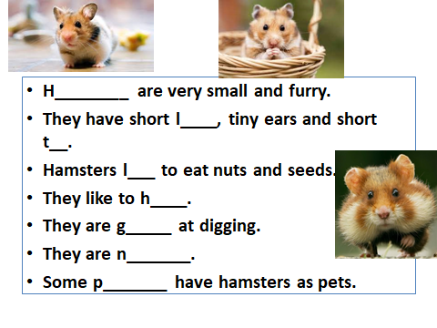  Then the teacher turns over the slide to another where some words from the text are missed and the students should guess what the words are.  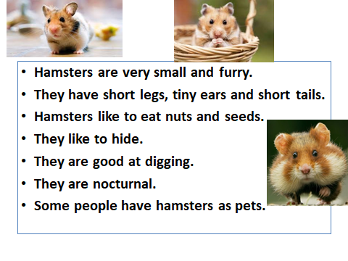  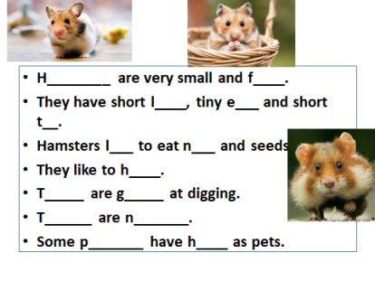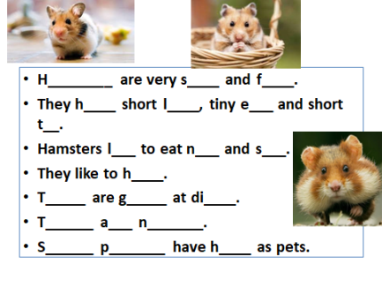  Then the teacher shows only the picture of hamsters and the students retell what they have learnt about them.  - The teacher asks the students to read the text about plants  Plants are very important. They are living organisms such as flowers, trees, herbs, bushes, grass, ferns, mosses and seaweeds. They provide us with food, wood and oxygen. Plants cover most of the land and can be big or small. They come in many colors, but they are not animals. They can’t move from place to place. They move their leaves and flowers to the sunlight. They breathe a different kind of air – carbon dioxide. Plants make their own food from water, sunlight and minerals from the soil.  Animals cannot make their own food. Flowers have beautiful petals and attract insects to make seeds. Plants are green because of the chlorophyll.  Plants reproduce with seeds.  - The teacher asks the questions about the content of the text  - What are the different types of plants?  - Why are the plants green?  - What do the plants provide us with?  - What do the animals breathe?  - What do the plants breathe?  - How do the animals move?  - What do the plants move to the sunlight?  - What do the flowers have that attract insects?  - The teacher asks the students to identify if the sentences are true or false and correct if the sentence is false  - Plants make food from sunlight, air, water and soil  - Roots absorb water from the air  - Flowers attract mammals  - Plants reproduce with seeds  - Plants provide us with milk, wood and carbon dioxide  - The teacher asks the students to put the words in order to make up questions  Replace the words to make questions.  - attract/what/do/flowers/the / ?  _____________________________  - plants/move/the/can/?  _______________________________  - give/what/plants/do/us/the/?  ______________________________  - example/plants/give/of  ___________________________________  - what /do/have/the/flowers/?  _________________________________  - need/do/the/plants/what?  _________________________________  The teacher asks the questions about living things  - What plants do you know?  - What are the 4 parts of all plants?  - What do the plants need?  What is the general characteristic of mammals/ reptiles/birds/fish  Listening  - The teacher asks the students to listen and complete the missing information  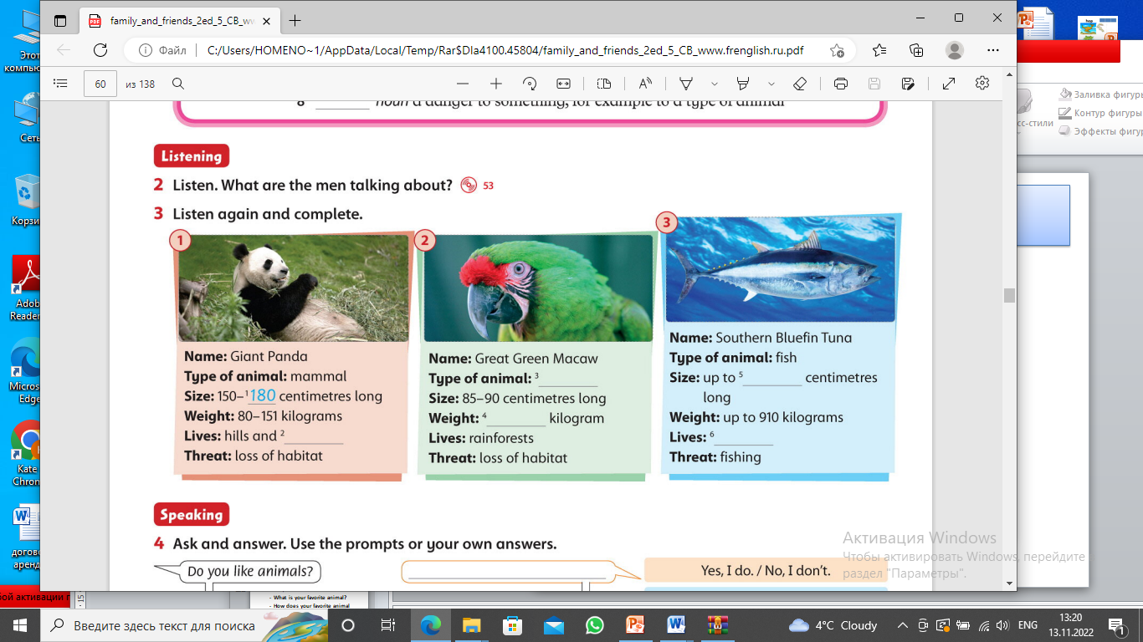  - The teacher asks the questions  - What type of animal is a giant panda?  - How big are the pandas?  - How heavy are the pandas?  - Where do the pandas live?  - What kind of creature is green macaw?  - How big is the green macaw?  - How heavy is the green macaw?  - Where do the live?  - How big is tuna?  - How heavy is tuna  - Where do they live? |  |  | The students answer :  - Living things can move, jump, fly  - Living things need water, food, oxygen and sunlight  The students make up sentences with the given words  Learners repeat the words after the teacher, and then play a game “ Is it…?”  The students play bingo with the given words  The students write quiz on the words and check each other  The learners read about hamsters and fill in the missing words  The students retell about hamsters  The students read the text and answer to the teacher’s questions about the text  The students are given smiles for correct answers  The students identify if the sentences are true or false and raise the cards with letters T and F. the students explain why the sentences are false  The students order the words to make up questions  1.What do the flowers attract  2. Can the plants move?  3. What do the plants give us?  4. Give examples of plants  5. What do the flowers have?  6. What do the plants need?  The students listen to and complete the missing information  The students answer to the questions about the listening text  The students are given smiles for correct answers  - Giant pandas are mammals  - They are from 150-180  - They are about 80-151kg  - They live in hills and mountains  - Green macaw is a bird  - It is 85-90 cm  - It is about 1 kg  - They live in rainforests  - Tuna is 340cm  - It is about 910 kg  - They live in oceans |  | Teacher’s evaluation  Teacher’s evaluation  Mutual evaluation  Self-check  Mutual evaluation  Mutual evaluation  Teacher’s evaluation  Teacher’s evaluation  Teacher’s evaluation  Teacher’s evaluation  Teacher’s evaluation  Teacher’s evaluation  Teacher’s evaluation | PP slide 6  PP slide 7-11  Handout 1  Handout 1  Handout 2
End  5min. | At the end of the lesson, learners reflect on their learning:  Learners count the amount of smiles they have got and put them on the boxes good/better/the best  The students give a feedback  - What was easy  - What was difficult  - What was interesting  The teacher gives homework to describe favorite animal  Saying goodbye |  |  |  |  | Self-assessment

