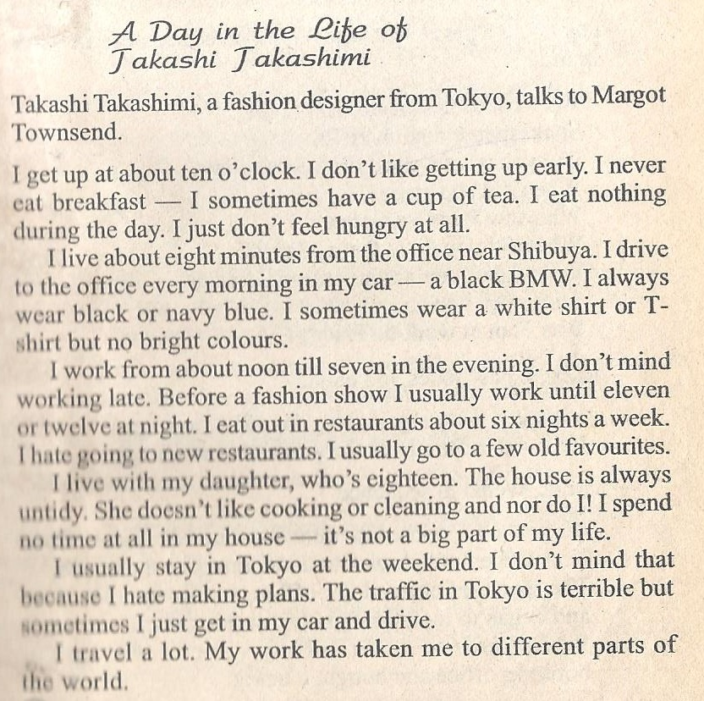

1. Read the text.
2. Write questions as many as you can.
3. Retell the story.
4. Tell about your usual day. Is there any difference between a day of Takashi and yours?