Lesson Plan

Unit 5 |  |  | School: KSU Akkol school #2
Term 3 |  |  | Teacher name: Alimbayeva L.Zh.
Class: 6 |  |  | Number of present: |  | absent:
Lesson title |  | Our health
Learning objectives(s) that this lesson is contributing to (link to the Subject programme) |  | 6.С.9.1- use imagination to express thoughts, ideas, experiences and feelings;  6.R.5.1- deduce meaning from context on a limited range of familiar general and curricular topics, including some extended texts;  6.S.3.1- give an opinion at sentence and discourse level on an increasing range of general and curricular topics;  6.UE.13.1- use modal forms including, mustn’t (prohibition), need (necessity), should (for advice) on a range of familiar general and curricular topics
Lesson objectives |  | By the end of the lesson  All learners will be able to:  Use modal verbs need, must, should;  To read text about healthy lifestyle independently and discuss with others;  Make not fewer 2 questions about health problems;  apply the vocabulary on the theme ‘Health’  Most learners will be able to:  Use modal verbs need, must, should;  To read text about healthy lifestyle independently and discuss with others;  Make not fewer 3 questions about health problems;  apply the vocabulary on the theme ‘Health’  Some of learners will be able to:  Use modal verbs need, must, should;  Make not fewer 5 questions about health problems;  apply the vocabulary on the theme ‘Health’;  tell their personal experience about healthy lifestyle using new words
Assessment Criteria |  | Apply appropriately modal forms including mustn’t (prohibition), need (necessity), should (for advice)  Identify the main idea in short simple text talking about health
Levels of thinking skills |  | Knowledge and comprehension  Application  Higher order thinking skills
PLAN

Plan timings | Teacher actions |  |  | Students’ actions |  | FA | Resources
Start  Beginning  2 min  5 min | - Organizational moment. (T-Cl)  Teacher greets students.  Teacher sets positive atmosphere by asking such ice breaking questions as:  - How are you today?  - What date is it today?  - What day of the week is it today?  - What is the weather like today?  Teacher discusses learning objectives with the students.  Warm –up.  Teacher: Today our lesson is devoted to a very important problem. As you know health is the most important things in people’s life. In order to be healthy, we should follow some special rules. The pictures on the screen will help you to guess what we are going to speak about.  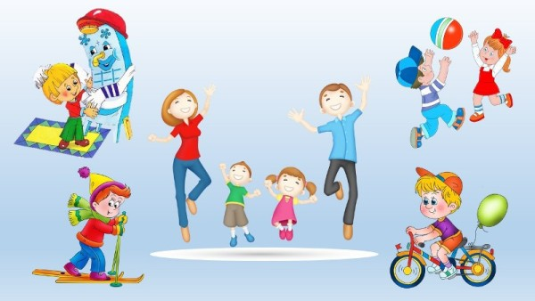  Now look at this picture at once.  Can you guess what we are going to speak about?  S1. A Healthy Way of Life  T. Yes, you are right. Today we are going to speak about our health, about what we should do and what we shouldn’t do to be healthy.  T. But at first we should revise some words on our topic.  Task 1. Running dictation.  Students are divided into 2 teams and complete a relay race–one member RUNS to a specific location to read information, then RUNS back to the team to report it, where a secretary transcribes it. The winner is the team who wrote the biggest number of words and made no spelling mistakes. Each spelling mistake takes away 1 point. |  |  | Students greet the teacher and take their places.  Students answer the questions  Students are divided into 2 teams and do the task. |  | Group assessment  (Students assess their own contribution to the team) | Picture  https://www.google.com/search?rlz=1C1SQJL_ruKZ958KZ958&source=univ&tbm=isch&q=%D0%BA%D0%B0%D1%80%D1%82%D0%B8%D0%BD%D0%BA%D0%B8+%D0%BD%D0%B0+%D1%82%D0%B5%D0%BC%D1%83+%D0%B7%D0%B4%D0%BE%D1%80%D0%BE%D0%B2%D1%8C%D0%B5+%D0%B4%D0%BB%D1%8F+%D0%B4%D0%B5%D1%82%D0%B5%D0%B9&fir=MLMBfpzBMLCcvM%252C0G7_DsRAOAvSKM%252C_%253Birc6xO95XUUDTM%252CeMoNPF90TfpmeM%252C_%253BhAABlqVmHjI_wM%252CeZOJmFCxyFpp4M%252C_%253ByLV_qp8UIR8IFM%252C-  Handout 1
Middle  3 min  10 min  5 min  2 min  7 min  7 min | Task 2.  Reading  Pre-reading. (T-Cl)  ---Teacher shows some pictures and words to match.  Junk food take a shower get up  Healthy lifestyle fat food  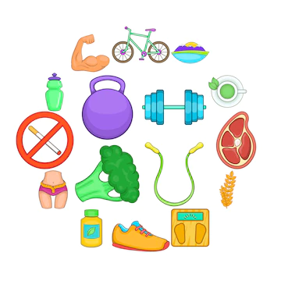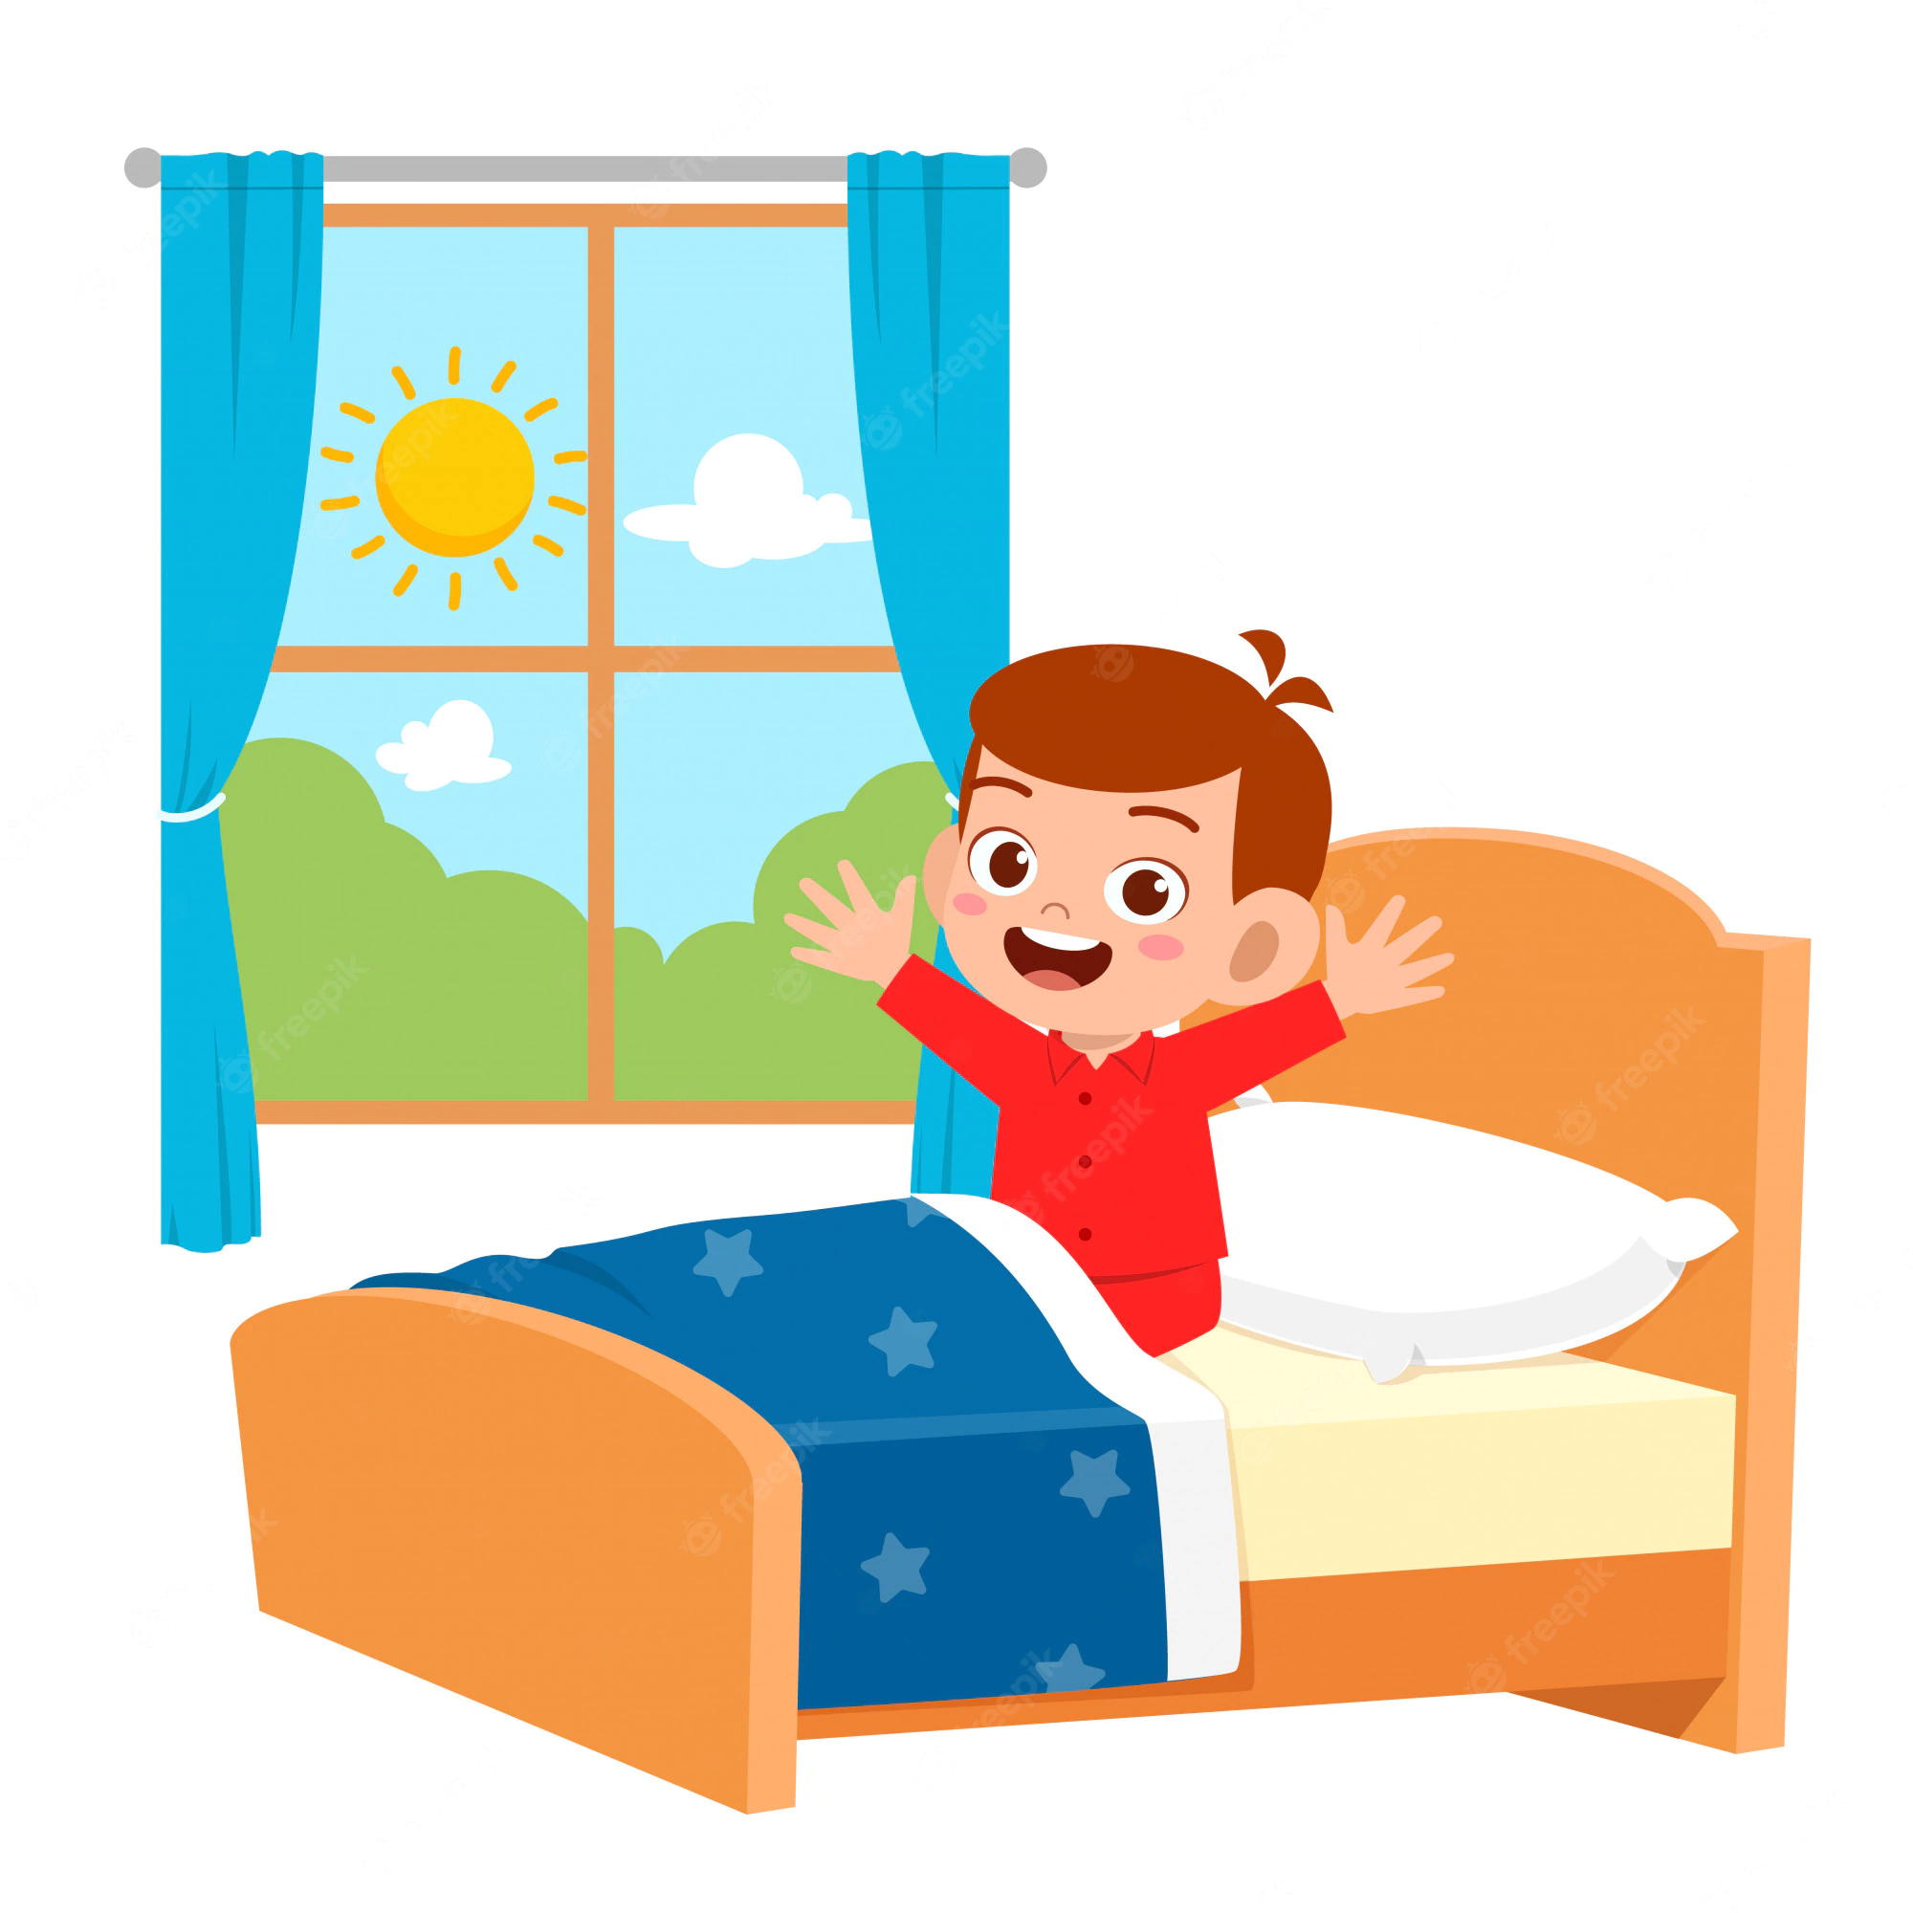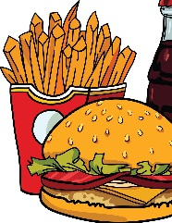  Differentiation by support  ---Teacher drills the pronunciation of these words  (T – Cl).  Teacher asks and makes notes on the number of correct answers  While-reading  Teacher reads the text.  Students listen to the teacher and at the same time follow the text and mark the sentences True or False  Hi. My name is Bob. Sometimes ago I decided to lead healthy life. I want to tell you  something about it. I get up at seven o’clock every morning and begin my day with exercises. I go out  and run near my house ten minutes. Then I take a shower and go to have breakfast. I have a  glass of milk or a cup of tea. At about two I have my lunch. At lunch I eat a lot of vegetables: cabbage, carrots, fresh cucumbers or tomatoes, a piece of bread and a cup of tea without sugar, of course.  I don’t like to eat junk food.  I have dinner in the evening when I have guests at home. I don’t like to receive guests because we usually eat a lot of meat and other fat food which is bad for our health. I want to say: We are what we eat.  Post-reading  Think-Pair-Share S1-S2; S3-S4  Learners work in pairs to make the questions about the text. They are also free to make any changes.  Differentiation by pace of work and support  High level students: make up 5 questions with no support  Middle level students: make up 3 questions with limited support  Low level students: make up 2 questions with considerable support.  Let’s have a rest!  Watch the video, listen, sing and do the same actions.  Task 3. Fill in the gaps with the correct modal verb.  Modal verbs may be used more than once: mustn’t, need, should.  1.They ____________go in for sports.  2.He ____________to go swimming to exercise his leg.  3. Children ____________eat healthy food.  4.You ______________ arrive late to school.  5. I believe, you ____________ go to the doctor.  Differentiation by outcome (Students of different abilities will arrive at outcomes that match their level of understanding and learning)  Task 4. (T –S1, S2, S3…)  Teacher: I will read the sentences. Say, please your opinion- are you agree? Correct the statement where it is  possible.  1) Drink cold water if you have a cough.  2) When you have high temperature do sports exercises.  3) Doctor usually listens to your lungs when you have a backache.  4) Drink cold milk with honey when you have a sore throat.  5) Eat dairy products and vegetables if you want to keep fit.  6) Do sport exercises every day to be healthy. |  |  | Students match pictures and words on the topic “Health”.  Students do the task individually  The students repeat the words in chorus and individually. (3 by 3 drilling)  Students read the text and mark the sentences True/False.  Students make up questions.  Students sing and do exercises  Students fill in the gaps the correct modal verbs  Students listen to the teacher and correct the sentences orally. |  | Individual assessment (Teacher check Students’ answers individually and encourages them with the phrases: Great! You are right! Well done!)  Peer assessment (Students exchange their works and check each other)  Criteria-based assessment (Teacher summarize students’ understanding specific information and assess students according criteria)  Peer assessment (Students exchange their copybooks with classmates and check the task when the teacher says the correct answers.)  Group assessment (Students assess their own contribution to the team) | Handout 2  Handout 3  https://www.youtube.com/watch?v=T37bGn0N8x4  Handout 4
  Assessment criteria | Descriptors | points
  A learner  • marks the sentences True/False | 1.False  2. False  3. True  4. False  5. True | 1  1  1  1  1
  Total 5
  Assessment criteria | Descriptors | points
  A learner  • selects the appropriate modal verb for each sentence;  • writes the words in the sentences. | 1.should  2.need  3.mustn’t  4.mustn’t  5.should | 1  1  1  1  1
  Total 5
End  2 min | Reflexion  At the end of the lesson, Students reflect on their learning:  3 new words they learnt  2 activities they liked  1 challenge (difficulty) they experienced  Home task is:  - to make a cluster “How to be healthy”, draw and write some phrases on this theme (for weaker students).  - to make a cluster “How to be healthy”, draw and write some advices for teenagers (for more motivated students).  - Write an essay on the theme “Healthy lifestyle and me”  Differentiation by home task: the students are given the home task according their level of knowledge. |  |  | Students reflect on their learning |  | Self-assessment (students make judgments about their learning process and products of learning, based on criteria that they have agreed.)
Additional information
Differentiation – how do you plan to give more support? How do you plan to challenge more able learners? | Teacher gives individual support to weaker students during warm-up, while-reading and post-reading activities.
Assessment – how do you plan to check students’ learning? | Teacher observes learners when participating in discussion and during pair work and makes records to provide constructive feedback

Handout 1
- body 1. back
- head 2. health
- junk 3. diet
- foot 4. hand
- knee 5. fat
- ill 6. finger

Handout 2
healthy-lifestyle-icons-set-cartoon-style_96318-4736
happy-cute-little-kid-boy-wake-up-morning_97632-1947
110593011-little-child-girl-character-take-a-shower-daily-routine-isolated-without-background-vector-cartoon-i

cartoon-image-of-junk-food-cola-drink-vector-14242372

Handout 3
Hi. My name is Bob. Sometimes ago I decided to lead healthy life. I want to tell you
something about it. I get up at seven o’clock every morning and begin my day with exercises. I go out
and run near my house ten minutes. Then I take a shower and go to have breakfast. I have a
glass of milk or a cup of tea. At about two I have my lunch. At lunch I
eat a lot of vegetables: cabbage, carrots, fresh cucumbers or tomatoes, a piece of bread and
a cup of tea without sugar, of course.
I don’t like to eat junk food.
I have dinner in the evening when I have guests at home. I don’t like to receive guests because we usually eat a lot of meat and fish and
other heavy things which are bad for your health. I want to say: We are what we eat.
Mark the sentences True or False:
- Bob gets up at six o’clock every morning.
- Bob eats to keep fit a lot of meat and fish.
- Bob doesn’t like to eat junk food.
- Bob has dinner every evening.
- Bob leads healthy life.

Handout 4
Task 2. Fill in the gaps with the correct modal verb.
Modal verbs may be used more than once: mustn’t, need, should
1.They ____________go in for sports. 2.He ____________to go swimming to exercise his leg.
3. Children ____________eat healthy food. 4.You ______________ arrive late to school.
5. I believe, you ____________ go to the doctor.

