Lesson plan
Long-term plan: Module 3. Virtual Reality |  |  |  | School : 5
Date: |  |  |  | Teacher name: Bektassova U.G.
Grade: 10 |  |  |  | Number present: |  | absent:
Lesson title: Mobile Apps
Learning objectives |  | 10.3.7 - use appropriate subject-specific vocabulary and syntax to talk about a range of general and curricular topics;  10.3.5 interact with peers to make hypotheses about a wide range of general and curricular topics  10.4.2 - understand specific information and detail in extended texts on a range of familiar general and curricular topics, and some unfamiliar topics;
Lesson objectives |  | Аll learners will be able to:  - read for specific information and deduce meaning from context in extended texts;  - use appropriate subject-specific vocabulary and syntax to talk;  Some learners will be able to:  - explain & justify your own point of view
Assessment criteria |  | Formative assessment by observation
Value links |  | Respect, Support, Trust, Academic honesty
Cross curricular links |  | Social Studies
ICT skills |  | Projector or Smart board, Power Point Presentation
Previous learning
Plan
Planned timings | Planned activities |  |  |  |  |  | Resources
Start | - Class organization  Learning and lesson objectives are introduced.  Warm up: Riddle about a smartphone. Write the words ‘What am I?’ on the board. Read out the following clues one at a time and tell students to write down what they think the item is that you are describing after each clue (they can guess if they are not sure). At the end, find out which student guessed correctly first.  - Almost everyone has one these days  - I am usually in your pocket or your bag  - I can connect you to other people  - You can use me to do many different things  - I can make phone calls  (answer: mobile phone/smartphone) |  |  |  |  |  | PPP Slide 3  PPP Slide 4  PPP Slide 5
Middle | Pre-reading task. “Brainstorm” strategy  T. Please, brainstorm some ideas that people use their mobile apps for.  Students’ possible answers:  - Get direction  - Upload pictures  - Chat online  - Browse maps  - Play games  - Get breaking news  - Study for exams  - Use dictionary  Descriptor: Learners  - use prior knowledge to think about the topic.  - make predictions about the probable meaning of the text  While reading task.  - Reading strategy “Marking” (W)  Students use little ‘post-it’ labels and try to identify key-words. The process of marking texts can help them to concentrate on reading.  - “5Ws” strategy (approach)  Modelling simple exploratory questions to gather information.  Teacher models the use of  Who, What, Where, When and Why  to set out simple information gathering response based on the information provided  - What do you learn through reading the text?  - Where does the word “app” come from?  - What are examples of mobile applications?  - What are the benefits of mobile apps?  - What are the negative effects of mobile apps?  - What is the writer’s opinion of apps?  - Who do you believe in choosing apps?  - Why do you use your apps?  (P, f) using ―5Ws” strategy students make up conversation in peer  Descriptor: Learners  - preview the text by skimming and scanning to get a sense of the overall meaning.  - monitor understanding by questioning, thinking about, and reflecting on the ideas and information in the text.  After reading task. Formative Assessment tasks  Task 1.  Read the text again and, for questions 1-5, choose the correct answer (A,B,C or D)  Task 2  Match the words in bold to their meanings  Descriptor: Learners  - relate what they have read to their own experiences and knowledge.  - clarify their understanding of the text.  Speaking.  Activity 3 Discussion (Group work/Pair work)  Cut up the discussion questions into strips, and ask students to take it in turns to pick a card and ask the rest of the group their question, or give students Handout 3 and ask them to work through all the questions. Encourage students to give reasons for their answers and opinions. Monitor and make a note of any good language or errors. At the end of the discussion, hold a brief feedback session so that students can share their ideas.  Differentiation: by support (write the names of the students here). Less able students might need language support  Have messaging apps changed the way you communicate with your friends?  Do you think your communication with friends and family would improve or get worse if you didn’t have a mobile phone? Why?  People say that teenagers use their mobiles more than adults. Why do you think this is?  Some people think that writing online is making young people’s spelling and grammar worse. Do you agree? Why / not?  Are there any situations when you turn off your mobile phone? Why (not?)  Why do you think so many people these days are addicted to their phones? Are you addicted to your mobile? What advice would you give to someone who is addicted to their phone?  What are the advantages of sending a message over making a phone call? Are there any disadvantages?  Do you think mobile phones in the future will be smaller or bigger?  Why? Is it always a good idea to take a photo to remember an event or a place? Why (not)?  Descriptor: Learners  - extend their understanding in critical and creative ways.  - give their own ideas related to the theme |  |  |  |  |  | Handout 1  Handout 2  Handout 3
End | Reflection  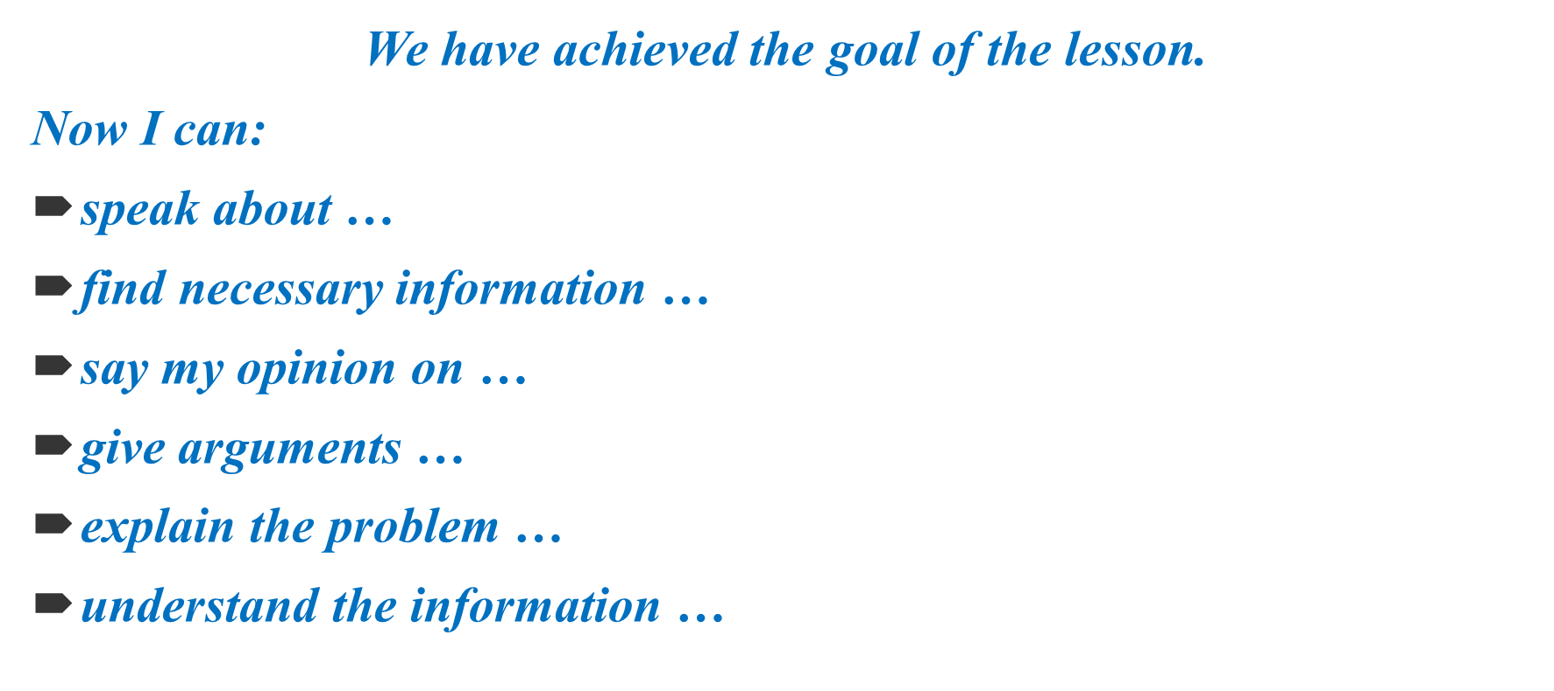 |  |  |  |  |  | PPP Slide 8
ADDITIONAL INFORMATION
Differentiation – how do you plan to give more support? How do you plan to challenge the more able learners? |  |  | Assessment – how are you planning to check learners’ learning? |  | Health and safety check
Differentiation by tasks when do reading activities  Differentiation by support of a partner in a pair work  More support by teacher can be given in speaking activity when some learners give their own ideas or advice |  |  | Teacher’s oral assessment, such as “Good job! Super! You got it! Splendid! You are the best! etc.”  Peer assessment to check up the while reading tasks |  | Everyday classroom precautions will ensure that safety measures are provided to prevent the exposure of electrical power cords

