**How can residents and government of Aktobe deal with the impacts of air pollution?**

Assanali Amandykov

Nazarbayev Intellectual School of Physics and Mathematics in Aktobe

Global Perspectives and Project Work

Tutor: Azat Zhaulbayev

February 28, 2021

# Acknowledgements

During the course of investigation, a few people kindly helped me with the study, showing support and giving numerous pieces of advice. I want to thank all of you for that, it was priceless for me.

Firstly, I would like to express a big thank to my GPPW teacher, Azat Zhaulbayev. Every time I struggled with this study, he gave me a needed piece of advice, and even corrected my work many times.

Then, I want to thank my friend and critical partner Sanzhar Zhagiparov, for staying honorable in criticism of my work, even though he is a good friend of mine.

Last but not least is my family. Every evening I was telling my mother about my problems and lack of motivation to continue this investigation. This was the thing that kept me working for such a long period of time.

**Abstract**

The study investigates the problem of air pollution in Aktobe, and the main aim was to determine ways to reduce air pollution in the region as well as to identify the most suitable renewable energy source. Every second citizen of Aktobe has air pollution related illnesses, most of the population of Aktobe is suffering from a bad smell of rotten eggs. Results of the primary research have shown that plants and fabrics are the main pollutants of air in the town. This paper was made to find the answer for the following question: government of Aktobe was developing economy of the city and wasn’t putting sufficient amount of effort into keeping stable air pollution level in the region.

**Абстракт**

В исследовании исследуется проблема загрязнения воздуха в Актобе, и основная цель заключалась в определении способов снижения загрязнения воздуха в регионе, а также в определении наиболее подходящего возобновляемого источника энергии. Каждый второй житель Актобе страдает заболеваниями, связанными с загрязнением воздуха, большая часть населения Актобе страдает неприятным запахом тухлых яиц. В качестве основного метода сбора данных был выбран опрос. Результаты первичных исследований показали, что растения и ткани являются основными загрязнителями воздуха в городе. В данной статье был найден ответ на следующий вопрос: правительство Актобе развивает экономику города и не прилагает достаточных усилий для поддержания стабильного уровня загрязнения воздуха в регионе.

**Абстракт**

Зерттеу Ақтөбедегі ауаның ластану проблемасын зерттейді және оның негізгі мақсаты аймақтағы ауаның ластануын төмендету жолдарын анықтау, сонымен қатар ең қолайлы жаңартылатын энергия көздерін анықтау болды. Әрбір екінші ақтөбелік ауаның ластануымен байланысты аурулармен ауырады, Ақтөбе тұрғындарының көпшілігі шіріген жұмыртқалардың жағымсыз иісінен зардап шегеді. Сауалнама деректерді жинаудың негізгі әдісі ретінде таңдалды. Алғашқы зерттеулердің нәтижелері өсімдіктер мен маталар қаланың ауасын ластайтын негізгі заттар екенін көрсетті. Бұл мақала келесі сұрақтың жауабын табу үшін жасалған: Ақтөбе үкіметі қала экономикасын дамытып, аймақтағы ауаның ластану деңгейінің сақталуына жеткілікті күш жұмсамады.

# Key Words: Air pollution, renewable energy sources, pollutant, illness, greenhouse gas.

# Ключевые слова: Загрязнение воздуха, возобновляемые источники энергии, загрязнители, болезни, парниковые газы.

# Кілт сөздер: Ауаның ластануы, жаңартылатын энергия көздері, ластаушы зат, аурулар, парниктік газдар.

# Introduction

Greenhouse gases trap heat in the atmosphere, thus, it makes difficult to release heat into the space, which forces climate change on the planet. There are various kinds of gases that were released during manufacturing processes, that can potentially cause global warming, but carbon dioxide, methane, nitrous oxide, and fluorinated gases are the main pollutants of the 21st century.

Air pollution is the most discussible issue of society within residents of Aktobe. It was a government agenda for many years, but so far people have to breathe polluted air. Air pollution is one of the most urgent problems of our time, that we have to find a solution for, in a short period of time. However, the most meaningful impact of air pollution is the health problems that it affects, especially for adolescents. Polluted air is the main factor in the incidence and progress of some diseases such as asthma, lung cancer, Alzheimer’s, and Parkinson’s diseases (WHO, 2018). It is extremely important to investigate this issue for the whole society because everyone has a right to live in an ecologically clean area.

With the development of industrial manufacturing, the number of released carbon dioxide into the atmosphere is increasing every year (Sources of Greenhouse Gas Emissions, n.d.). Aktobe ferroalloys and heat and power plants produces too much greenhouse gases, as a result in many districts of our city air pollution limit is exceeded.

I lived in one of the most polluted areas of our city called Zhilgorodok for 10 years straight. I lived all my childhood there, so most of the time I spent playing on the street with my friends, having a good time, but every evening, starting about 8 in the evening, there was a terrible smell. When I was a kid, I didn’t know what it was, but now I understand that it was hydrogen sulfide, which has a very specific smell. Fortunately, I don’t have any problems with health, like asthma. My life is related to this topic, and I am interested in it too, so I have chosen this topic.

There are many polluted areas in our city, and one of them is district Kirpichniy, where number of greenhouse gas such as formaldehyde is exceeded three times. Moreover, the crossroad of Lomonosova and Mametova streets is the most polluted area in the city, so far. Furthermore, one of the main pollutants of the city atmosphere is the city sewer system. The concentration of the hydrogen sulfide in the sewer system is 2-16%, that is why citizens of Aktobe suffer from bad smell every morning and evening (Alishbayeva, 2014).

# Context

**Context**

Greenhouse gases trap heat in the atmosphere, so it can’t be released; thus, the overall temperature of the earth has increased drastically, which forces climate change all over the world. There are numerous kinds of gases that can potentially cause global warming, but carbon dioxide, methane, nitrous oxide, and fluorinated gases are the main pollutants of the 21st century. According to the United States Environmental Protection Agency, carbon dioxide contributed more than 80% of greenhouse gas emissions in 2018.

Air pollution poses a serious threat to the health of the public. Every day about 90% of the world's children under the age of 15 (1.8 billion children) breathe air that is so polluted it puts their health and development at deliberate risk (World Health Organization, 2018). According to research kept by the Government of the Republic of Kazakhstan, Atyrau, Ust-Kamenogorsk, Balhash, Temirtau, Karaganda, Zhezkazgan, Aktau, Nur-Sultan, and Aktobe cities are the most polluted in the country (Tusupbekova, 2019). Air pollution is considered as the main cause of some illnesses and diseases like asthma, lung cancer, Alzheimer’s, and Parkinson’s diseases, in the urban areas, which are mostly polluted by previously mentioned carbon dioxide.

**Finland**

Finland is in the North of Europe, most of the landscape is covered with forests, making Finland the most densely forested country in Europe. Finland provides many good examples of how to protect the natural environment. Using technological progress products, the government of Finland managed to create effective protection policies, so areas like Lapland, which are very sensitive to any pollutions, and very hard, are protected well before any harm is done. As a result, Lapland is of the most famous places for winter holidays, attracting new tourists by the region's natural settings.

The main activity that the Finland government took for a short-term transition to a green economy and strongly reducing air pollution is an investment in renewable energy sources.

Since 1990 share of coal reduced from an enormous 27000 GWh to 8000 GWh, meanwhile share of renewable sources of energy (Nuclear energy, solar energy, wind energy, Hydro energy, and biofuels) has increased by 20-30% each, and will increase even more, as Finland’s 5th nuclear reactor comes into operation in a few years (International Energy Agency, 2019).

Finland took some very effective methods to reduce the impact of air pollution and limit its emissions. However, there is a disadvantage. Prices for renewable energy sources are very high. For example, the basic construction of nuclear plant costs between 6 billion and 9 billion US dollars (Schlissel & Biewald, 2008, p.2). Another renewable energy source is wind energy. Commercial 2MW wind turbine installation cost is at least 3.5 million US dollars (How much do wind turbines cost, n.d.). That is why Finland has such high taxes. The population of Finland pays about 35 percent of their salary to the government (Налоговая система Финляндии, 2020). Such high taxes result in a low level of entrepreneurship in the country.

**Denmark**

Denmark is a Scandinavian country mostly located on a peninsula called Jutland and an archipelago of four hundred islands. Denmark was one of the explorers of wind energy, and for now, it has big achievements in developing and populating this kind of renewable energy source. Moreover, the Denmark government managed to significantly reduce the emission of greenhouse gas-carbon dioxide.

Denmark is a leader in producing wind energy. According to Denmark's official website, 30% of all consumed energy in Denmark comes from wind energy (Pioneers in clean energy, n.d.). Many wind turbines producing companies are in Denmark. For example, “Vestas” and “Siemens Gamesa” companies have Danish roots and produce a third of global wind installations in twenty eighteen (Pioneers in clean energy, n.d.). There was enormous progress in developing wind energy in Denmark for the last 30 years. According to the diagram shown on the International Energy Agency official website, produced wind energy has increased 100 times for the last 3 decades (International Energy Agency, 2019). The Danish government's current goal is to reach 100% renewable energy, including bio, solar, wind, and geothermal energy. By the end of 2022, the Danish government will end the construction of an island called Mon, which will produce electricity for 600,000 households (Pioneers in clean energy, n.d.).

Denmark made a big step ahead of other European countries, but comparing to others, Denmark started its renewable energy policy in the 1970s. The last 50 years were spent to produce energy for half of the population of Denmark. How much time will be spent to produce energy for another half? Moreover, big investments from the government also occurred. As I mentioned before, the price for a single wind turbine is about three and a half million US dollars, which is expensive even for the Danish government. That is why Denmark has a progressive tax system. Starting tax is 45%, but if you make more than 67000 US dollars a year, then you must pay 7 percent more than you did (Wiking, 2016)

**China**

China is one of the most developed countries globally, with the most powerful and stable economics. Previously, China was a very polluted country with no perspective for clean and renewable energy. However, now, China is one of the leaders in the use of solar and wind energy. According to the International Energy Agency, since 2010 amount of energy produced by solar PV has increased 320 times, which is big progress for China government (International Energy Agency, 2019). However, China is still making big progress in developing solar energy. For example, the last September, China ran the world’s largest solar energy plant located in the desert of Qinghai province (Bellini, 2020)

However, the Chinese government is making good progress in developing solar energy; the share of total consumption is still miserable, only 3.9 % in 2019 (Solar power by Country, 2020). As far as China is the most populated country in the world, with a population of about 2 billion people. It is almost impossible to change the way they produce and consume energy in a short period of time. 

# Methods

Situation related to air pollution in Kazakhstan, and especially in Aktobe is getting worse, so I explored this problem in this research paper. Information collected by secondary research was compared to the data from primary research (a survey). As a result, clearness and credibility of collected data is the best I could get. Moreover, to make results even clearer, a few methods were used.

Before starting a quantitative research, general information about this problem were prepared. Air pollution is one of the most discussed issues of our time along with renewable energy sources, so there was more than enough information on this issue, but most of them were out of date or not credible enough, to use their information. To minimize inaccuracies all of the data was taken from credible information from relevant sources.  For instance, the International Energy Agency website provides current information on the use and production of energy in almost every country around the world, including Finland, Denmark, and China.

Moreover, most parts of the sources were checked according to six steps credibility test, with many questions, and by answering them, it is possible to assume whether the source is credible or not. For instance, to get reliable information on the cost of nuclear plant construction or wind turbine construction, I have used some documents from qualified writers, a couple of them were Biewald and Schlissel both have multiple Master's degrees in different fields like Mathematics, Computer Science, Biochemistry, and Molecular Biology.

 For example, International Energy Agency is an organizational website.

In order to identify the main reasons for pollution in the Aktobe region research required both qualitative and quantitative research methods, but only quantitative research was conducted. The qualitative interview was not chosen due to the following reasons:

·      Most of the experts in this field were not capable of answering questions of interview due to the lack of free time.

·      Due to the situation related to the covid-19 epidemic, probability of getting an appointment with experts, was very low.

A survey was conducted among citizens of Aktobe, Almaty and Moscow. The survey was held on Google Forms. Survey can be used to gather in-depth insights into a problem or generate new ideas for research (Bhandari, 2020).  50 people took part in the survey, most of them are citizens of Aktobe. The target population was local citizens from 16-50 years with a difference in jobs, occupation and living area. My respondents were people who are affected by the problem of air pollution. Since this phenomenon is widespread throughout Kazakhstan, any citizen of our country could be the respondent. Basically, my peers from the city of Aktobe took part in my research.

The survey was chosen due to the vast amount of information that this method provides. Moreover, it took a little time to make it. The survey’s questions were designed to get relevant opinions on this problem. Furthermore, open-ended questions provide an opportunity to get new ways to solve the problem and citizens’ awareness of the main pollutants of our city’s ecology.  The estimated survey time is about 2 minutes long.

The wide age difference between survey participants made it possible to observe the contrast in points of view. Furthermore, the level of awareness also varies from age to age. Due to the fact that none of the participants were forced to take part in my research, surveys were taken in a relaxed atmosphere, which probably has increased the honesty and clearness of collected data.

# Results

The main research was conducted using web-application Google Forms. All the gathered information is relevant, and opinions vary from different areas of city.

Concluding results of the research, air pollution in Aktobe is still a major problem and in some other cities too. Citizens of Aktobe are mostly aware of main pollutants of the air. However, some group of people identify pollutants of air in a wrong way. Furthermore, many different solutions were suggested by respondents. Information from the survey was enough to make a conclusion about this problem.

Data obtained from the survey provided a complete picture of air pollution in Aktobe. Overall, there were 51 responses.  Following list contains identified patterns in the survey results.

1. About 95% of the respondents are living in Aktobe. (Appendix 1.1)
2. Respondents are living in more than 10 different areas (what are they?). (Appendix 1.2)
3. Respondents are mostly (74.5%) mildly of fully satisfied with the ecological situation in Aktobe. (Appendix 1.3)
4. About a half of respondents have health issues related to air pollution. (Appendix 1.9)
5. All respondents have an experience to smell of rotten eggs on the regular basis. (Appendix 1.5)
6. The most common pollutants are sewer system and chromium plants. (Appendix 1.6)
7. 2/3 part of the respondents believe that renewable energy sources are the key to the brighter future. (Appendix 1.4)
8. Solar and wind energies are considered as the most suitable for the region. (Appendix 1.7)

According to the data analysis, main pollutants and ways to reduce pollution were identified. Major contributors to an air pollution are crucial buildings in economy of the city, as a result, government cannot stop the work of plants and fabrics. However, some actions mentioned by respondents can really be taken into an account by the city government. For instance, sewer system accidents are the problem that could be solved by the city government.  The transition to the renewable energy sources, is so far the most effective way for reducing air pollution. As a result, diseases related to the air pollution might occur less frequently.

# 

# Conclusion

Taking in to an account all the information and data given by essential and secondary sources and the results of profound break down of the reviews that were taken from a wide range of population, it is conceivable to make fitting ends and answer the questions that showed up toward the start of the investigation.

To start with, the impact of air pollution in Aktobe on health of citizens. As determined by the results of the survey, citizens of Aktobe are suffering from various illnesses that are closely related to air pollution. Every second citizen of Aktobe is ill with some kind of illness, whether it, chronic asthma or allergy. That actively demonstrates that problem of air pollution in Aktobe is relevant.  It means that people with chronic respiratory system illnesses are endanger of their development to tougher stages. As it might affect quality of life and average lifetime.

 There are many pollutants in Aktobe, it is crucial for research to identify them. According to deep analysis of survey data a few main pollutants of air in the region were determined.  The aim of my research was to reduce effects of air pollution, so it is essential to determine them, and then find out the way to decrease their impact on the ecological situation in the city. Iron-chromium connections plant and other producing facilities were named as the main pollutants of air in Aktobe. However, their production makes up a significant part of the economy of the city.

As mentioned above, the main aim of the research is to reduce impacts of air pollution. According to the survey, many activities that intended to reduce air pollution in the region were mentioned. However, some of them are already in use, but others might decrease level of air pollution significantly. For instance, installing filters on cars and plants is a useful solution. Furthermore, tree planting is already in use of city government.

Last purpose, of the research is to determine the most convenient renewable energy source which is a part of reducing air pollution in Aktobe. Transition to renewable energy sources might be the final stage of reducing air pollution in the region, that is why it is crucial to determine the most suitable renewable energy source. According to the results of the secondary research, wind and solar energy are the convenient for the region.

To sum up everything that has been stated so far, air pollution in Aktobe is relevant problem that desperately needs a solving right now. Many ways are available for the city government, however some of them are not really useful. Transition to renewable energy sources is likely to be the final stage of fighting air pollution in Aktobe, so it will take a long time to get to this stage.

# References

Bhandari, P.  (2020). An Introduction to qualitative research. Retrieved from

 https://www.scribbr.com/methodology/qualitative-       research/#:~:text=Qualitative%20research%20involves%20collecting%20and,generate%20new%20ideas%20for%20research.

Bellini, E. (2020). World’s largest solar plant goes online in China.  Retrieved from

        https://www.pv-magazine.com/2020/10/01/worlds-largest-solar-plant-goes-online-in-china/

Gronholt-Pedersen, J. (2020). Denmark sources record 47% of power from wind in 2019. Retrieved from

        https://www.reuters.com/article/us-climate-change-denmark-windpower-idUSKBN1Z10KE

How much do turbines cost? (n.d.) Retrieved from

         http://www.windustry.org/how_much_do_wind_turbines_cost#:~:text

         =The%20costs%20for%20a%20utility,%243%2D%244%20million%20installed.

International Energy Agency. (2019) Finland – Countries & Regions. Retrieved from

          https://www.iea.org/countries/finland

International Energy Agency. (2019) Denmark – Countries & Regions. Retrieved from

          https://www.iea.org/countries/denmark

International Energy Agency. (2019) China – Countries & Regions. Retrieved from

          https://www.iea.org/countries/china

Pioneers in clean Energy. (n.d.). Retrieved from

          https://denmark.dk/innovation-and-design/clean-energy

Solar power by Country. (2020) Retrieved from

         https://en.wikipedia.org/wiki/Solar_power_by_country#:~:text=By%

         20early%202020%2C%20the%20leading,of%20more%20than%20one%20gigawatt

Schlissel, D. & Biewald, B. (2008).  Nuclear Power Plant construction costs.   p.2. Retrieved from

         http://large.stanford.edu/courses/2016/ph241/long1/docs/nuclear-power-plant.pdf

Wiking, M. (2016). Why Danes Happily Pay High Rates of Taxes. Retrieved from

        https://www.usnews.com/news/best-countries/articles/2016-01-20/why-danes-happily-pay-          high-rates-oftaxes#:~:text=Denmark%20has%20one%

20of%20the,45%20percent%20in%20income%20taxes.

Налоговая система Финляндии. (2020). Retrieved from

         http://worldtaxes.ru/nalogi-v-evrope/nalogovaya-sistema-finlyandii/

**Appendix**

Appendix 1.1

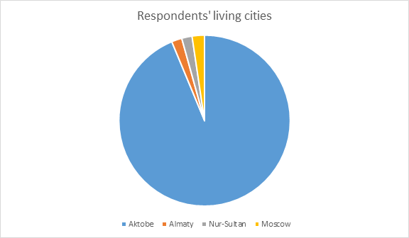

Appendix 1.2

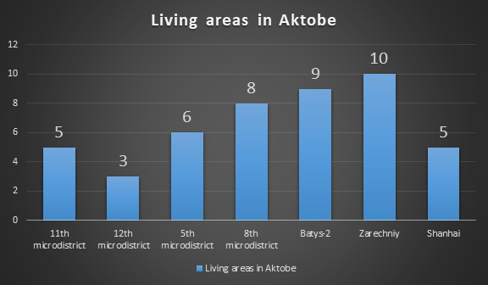

Appendix 1.3

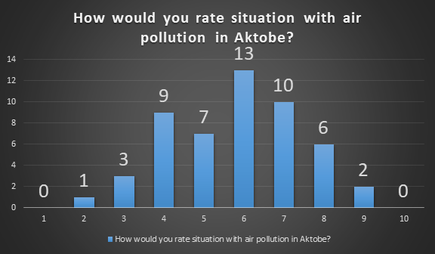

Appendix 1.4

# 

Appendix 1.5

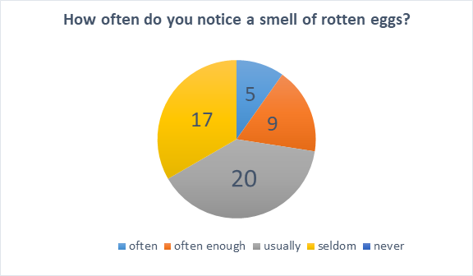

Appendix 1.6 :

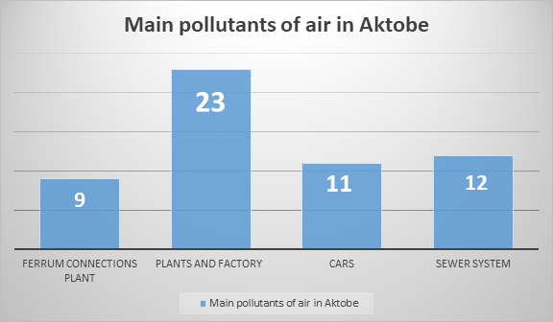

Appendix 1.7 :

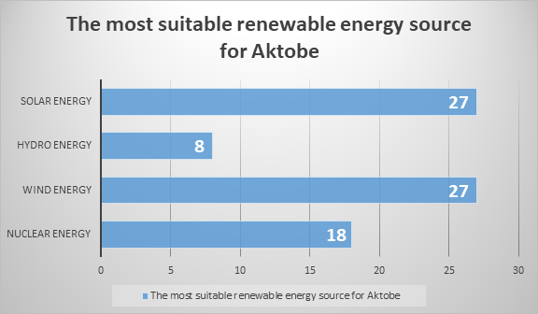

Appendix 1.8:

|  |  |
| --- | --- |
| Way to reduce air pollution | Answers of respondents |
| 1)Landscaping | 1) Landscaping  2) plant greens, listen to ecologists  3) Tree planting  4) follow the recommendations of ecologists  5)trolleybuses return  6) Greening the city |
| 2)Reduce impacts from plants and factories | 1) Install platinum filters in every plant  2) Restrict the work of industrial enterprises / Force filters to be installed.  3) filter air emissions  4) Close factories  5)Installation of filters, air pollution control  6) Protest, fines, standards, consideration of the Aktobe Ferroalloy Plant activities  7)  recycling  8) Greening the city, fine or close factories for exceeding the norm |
| 3)Sewer system actions | 1) reduce formaldehyde emissions into the air  2) elimination of accidents in the sewer system  3) Sewer troubleshooting  4) Wastewater treatment and communication with management  5) improve the sewerage system |
| 4)Volunteering, raising awareness, renewable energy sources, law related actions and etc. | 1) trolleybuses, buses more frequent  2) switch to renewable energy sources  3) Waste sorting centers  4) ride a bike  5) build a nuclear plant  6) Garbage collection, volunteering  7) Tightening the law  8) Use sustainable modes of transport whenever possible  9) Disseminate information  10) take garbage to special places  11) social work  12) Strengthening the law against offenders  13) Alternative methods of obtaining energy, filters  14) volunteer events, factories, recycling |

Appendix 1.9

|  |  |
| --- | --- |
| Type of illness | Answers of respondents |
| 1)Allergy | 1) Allergy  2) Pollen allergy  3) possibly allergy, in other cities there are not such big problems with allergies  4) Summer Allergy  5) allergy torments, doctors advise  get out of town |
| 2)Asthma | 1) Asthma  2) Chronic Asthma |
| 3)Other diseases related to air pollution | 1) Difficult to breath due to smell  2) Headache due to smoke  3) it is difficult to breathe due to dirty air  4) Cough  5) malaise  6) Yes, the pressure rises, it hurts head |