Unit of a long term plan:  Communication and technology |  |  |  |  | School:
Date: |  |  |  |  | Teacher name: Makhazhanova A.K.
CLASS: 7th grade |  |  |  |  | Number present: |  |  | absent:
Lesson title: |  |  | Young people and technology
Learning objectives(s) that this lesson is contributing to (link to the Subject programme) |  |  | 7. L.2 understand with little support most specific information in extended talk on limited range of general and curricular topics.  7.S.7 use appropriate subject-specific vocabulary and syntax to talk about a growing range of general topics and some curricular topics  7.R.2 understand specific information and detail in texts on a range of general and curricular topics.  7.W.2write with minimal support about real and imaginary past events, activities and experiences on a growing range of familiar general and curricular topics
Level of thinking skills |  |  | Knowledge Understanding Application
Lesson objectives |  |  | All learners will be able to:  - read,listen and say information about technology  - make sentences using the phrases  Most learners will be able to:  - read the text about “Greetings from Planet Earth” and find the meaning of the text  Some learners will be able to:  - to make sentences using the phrases and their ideas and share with their minds
Assessment criteria |  |  | Identify the main idea of the text about “Greetings from Planet Earth”
Values links |  |  | Economic growth based on industrialization and innovation
Cross-curricular links |  |  | computer science
Previous learning |  |  | Computer, mobile, internet, etc.
Plan
Planned timings | Planned activities (replace the notes below with your planned activities) |  |  |  |  |  | Resources
Start  3-min  5 min | Greeting  Organization moment  Divide learners into two groups by cut of pictures  Inner and outer circle  Pupils give feedback each other’s and change their thoughts about home work  Video clip about technology  Pupils watch the video clip and discuss it |  |  |  |  |  | Cut of pictures
Middle  3-min  5 min  15-min  7-min  2-min | W.Task-1. Drilling activities. Vocabulary work.  Choral repetition.  Look at the pictures then listen and repeat  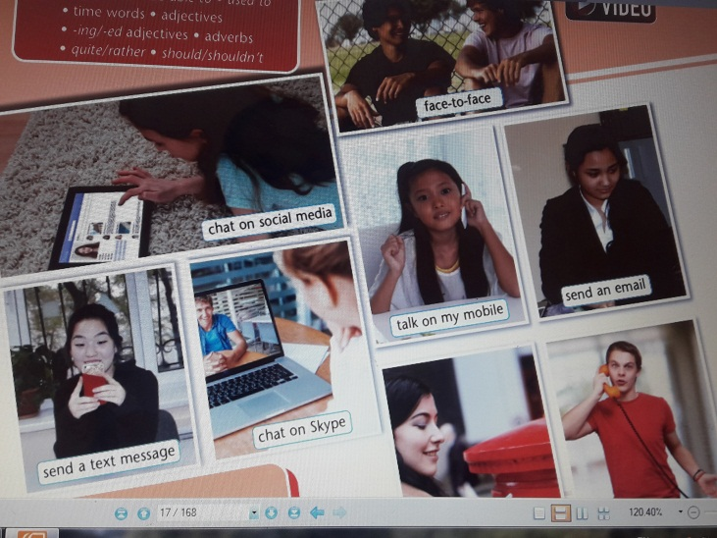  AFL: thumbs up if your pronunciation is good, thumbs down if your pronunciation isn’t good  I.Task-2. Two truth and a lie activity.  Learners make sentences using the phrases with often, sometimes and never ... and pupils find the lie and two truth.  I often chat on social media.  I sometimes chat on skype.  I never use my mobile when I’m at home  AFL: oral feedback  Differentiation by outcome:  More able learners;  -to make negative and question form sentences using the phrases and their ideas  G. Task-3. «Five sentences advertisement» activity  Learners read the text and find out what the text is about and share their minds  Descriptors: A learner  -reads the text  -finds what the text is about  -shares his/her minds  AFL: Fireworks  Differentiation by outcome:  Less able learners;  -find the key words from the text that describes the meaning of the text  I.Task-4. «Numbers speak»  Pupils read the text and answer the questions choosing the multiple answers, when teacher says the number a learner reads the question and answer it.  Descriptors: A learner  -reads the text  -reads the questions  -chooses multiple answers  -reads the answer  AFL: Numbers speak |  |  |  |  |  | Excell-7th grade  pg.17-18  Photos  Sheets of papers  markers  posters , markers  power point
End  5 min | Reflection:  What did you do well in today’s lesson?  What were the most interesting for you?  What did you understand?  What didn’t you understand?  What do you want to know about this lesson?  Successful stairs  Learners looks at the board and puts a tick or a cross for stairs what they have learnt or not  T-4  T-3  T-2  T-1
Additional information
Differentiation – how do you plan to give more support? How do you plan to challenge the more able learners? |  |  |  | Assessment – how are you planning to check learners’ learning? |  | Health and safety check
More able students:  Differentiation by outcome:  - to make sentences using the phrases and their ideas  Less able studentes:  Differentiation by outcome:  - find the key words from the text that describes the meaning of the text |  |  |  | - Oral feedback  - Fireworks  - Numbers speak  - Successful stairs |  | Energizer: physical activity
Reflection  Were the lesson objectives/learning objectives realistic?  Did all the learners achieve the lesson objectives/ learning objectives? If not, why?  Did my planned differentiation work well?  Did I stick to timings?  What changes did I make from my plan and why? |  | Use the space below to reflect on your lesson. Answer the most relevant questions from the box on the left about your lesson.
Summary evaluation

What two things went really well (consider both teaching and learning)?

1:

2:

What two things would have improved the lesson (consider both teaching and learning)?

1:

2:

What have I learned from this lesson about the class or individuals that will inform my next lesson?

