Long-term plan unit: Space and Earth |  |  |  |  | School: Nazarbayev Intellectual School, Taldykorgan
Date: |  |  |  |  | Teacher name:
Grade: 7 |  |  |  |  | Number present: |  |  | Absent:

Professional Development Objective
Theme of the lesson |  |  | Life in the Future. Listening/The moon. Reading
Learning objectives that are achieved at this lesson (Subject Programme reference) |  |  | 7.L4 understand with limited support the main points of extended talk on a range of general and curricular topics;  7.UE8 use future form will to make offers, promises, and predictions on a growing range of familiar general and curricular topics.  7.R1 understand the main points in a growing range of short, simple texts on general and curricular topics  7.R7 recognise typical features at word, sentence and text level in a growing range of written genres  7.S3 give an opinion at sentence and discourse level on an increasing range of general and curricular topics  7.S6 communicate meaning clearly at sentence and discourse level during, pair, group and whole class exchange
Lesson objectives |  |  | - Listen to the article about future life on the Earth;  - Learn new vocabulary connected with the topic “Life in the future”;  - Explain the main points of the article about the moon;  - Share opinions about space travel
Assessment criteria |  |  | - Learners will complete more than 75% of the tasks correctly  - Use ‘will’ to predict the future  - Use at least three new words when exchanging opinions
Type of differentiation |  |  | By task  Vocabulary work: Confident Ss have the task without supported vocabulary.  Less confident Ss have the task with supported words.
Values instilled at the lesson |  |  | Teacher creates a favorable, friendly atmosphere for interaction;  Feedback “Teacher-Student” is carried out throughout the lesson;  Teacher and Students listen to each other and do not interrupt.
Cross-curricular links |  |  | Physics
Global awareness |  |  | Students learn about life on the Earth in future
ICT skills |  |  | Teacher use of PPt
Previous learning |  |  | Knowledge on the topic from grade 6
Course of the lesson
Planned stages of the lesson | Planned activities at the lesson |  |  |  |  |  | Resources
Beginning  5 min. | Teacher and Ss greet each other at the lesson.  Lead in “Guess the picture”:  Ss look at the pictures on the slide of the presentation and try to guess the topic of the lesson.  Teacher asks Ss what topic they will study at the lesson. Then, they discuss lesson objectives and assessment criteria: |  |  |  |  |  | PPT, slide 1  PPT, slide 2-3
Middle  10 min  3 min  3 min.  10 min  3 min  6 min.  5 min.  5 min.  10 min.  3 min.  15 min. | Teacher asks learners to join into random groups of 3-4 to work in three groups.  - Then Teacher presents constructions of the lesson to say about predictions and asks to discuss in groups and predict the way we will live in 2116. Learners have to complete with their partners.  - I suppose …..  - I guess ….  - Probably …  - After 5 minutes, each group shares their ideas and the other group will express their beliefs using prediction constructions:  Pre-listening:  - True/False. Learners guess the answer according to the headline.  Keys:  a F b T c F d T e F f T g T h F  2. Vocabulary practice:  Ss should match synonyms from the article. Then read the words and pronounce them correctly.  Keys:  1. report a. study  2. experts b. specialists  3. totally c. completely  4. revolutionised d. transformed  5. unbelievable e. incredible  6. questioned f. asked  7. advanced g. futuristic  8. design h. plan  9. treatment i. medical care  Assessment criteria:  - Ss correctly match the English words with their synonyms;  - Ss pronounce the words correctly.  While listening  Differentiation by task:  - Confident Ss have to complete gap-filling task without support.  - Less confident learners will complete gap-filling task with support  Learners exchange papers and check the completed words.  Peer assessment criteria:  - Ss spell more than 10 words correctly;  - Ss fill more than 10 words correctly in the gaps.  Post-listening.  Learners read their completed texts and answer comprehension questions in groups.  Keys:  1. Under water  2. Samsung  3. City planners  4. How it would change our lives  5. Unbelievable  6. 2,000  7. Virtual meetings  8. The doctor  9. Space  10. English  Assessment criteria:  - Ss answer 8-10 questions correctly;  BREAK  Teacher presents the learning objectives for the second lesson/  Lead-in task.  Learners refresh their previous knowledge doing the matching task of familiar words with their explanations.  Pre-reading:  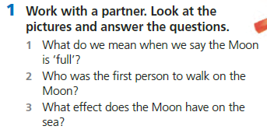  Ss should answer three questions looking at the pictures on the slide.  While reading  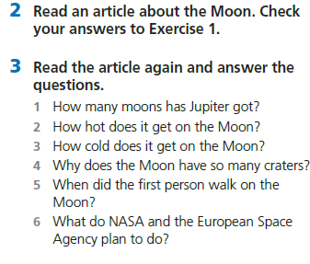  Post reading  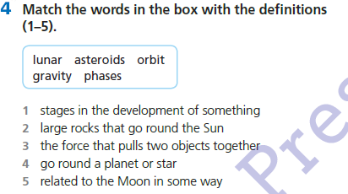  Discussion: Is space travel a good idea?  Teacher asks learners to share opinions on both sides giving at least two arguments for each one.  Scaffolding for speaking: I think it’s a very good idea because …….  I’m not sure. It’s very expensive to travel into space. It might be better to…. |  |  |  |  |  | Only 1 worksheet to cut for three groups  PPt 4-5  PPt 6  Worksheet 2 (1 paper is cut to 4)  PPt 7  https://breakingnewsenglish.com/1602/160218-the-future-2l.html  Worksheet 3 (1 paper is cut to 2)  PPt, 8  Worksheet 4 (1 paper is cut to 3)  PPt 9  PPt 11  PPt 12  PPt 13  PPt 14  Worksheet in Grade 7 resource book, page 44  PPt 15  PPt 16
End  2 min | Reflection:  Ss reflect on the lesson using assessment corners A, B or C  - Interesting. I have known a lot;  - That’s ok. I have to do better next time;  - Boring. Nothing new/…  Home task:  - Ss should learn the vocabulary by heart;  - Write a short essay (90-100 words) on the topic “Is space travel a good idea?” |  |  |  |  |  | PPt 17  PPt 18
Differentiation – how do you plan to give more support? How do you plan to challenge the more able learners? |  |  |  | Assessment – how are you planning to check students’ learning? |  | Health and safety regulations
By task  Vocabulary work: Confident Ss have the task to match the words with their definitions.  Less confident Ss have the task to match English words with Russian equivalents. |  |  |  | Students are assessed formatively |  | Health promoting techniques  Breaks and physical activities used.  Points from Safety rules used at this lesson.
Reflection  Were the lesson objectives/learning objectives realistic? Did all learners achieve the LO?  If not, why?  Did my planned differentiation work well?  Did I stick to timings?  What changes did I make from my plan and why? |  | Use the space below to reflect on your lesson. Answer the most relevant questions from the box on the left about your lesson.
Summary evaluation

What two things went really well (consider both teaching and learning)?
1:

2:

What two things would have improved the lesson (consider both teaching and learning)?
1:

2:

What have I learned from this lesson about the class or achievements/difficulties of individuals that will inform my next lesson?

