АҚТӨБЕ ЖОҒАРЫ ПОЛИТЕХНИКАЛЫҚ КОЛЛЕДЖІ

САБАҚ ЖОСПАРЫ
(онлайн сабақ)

Сабақтың тақырыбы: Three stages in the development of English
Пән атауы: История иностранного языка

Оқытушы: Нурфайзова Гаухар Утягалиевна

Курс  Курс | 2 | Топтар  Группы | 202 ПД
Сабақ номері  Номер занятия | 3 | Сабақтың типі  Тип занятия | комбинированный
Мамандық  Специальность | 0512000 «Переводческое дело» | Біліктілік  Квалификация |  | 0512013 - Переводчик
Оқыту нәтижесі  Результат обучения | Знать основные этапы развития изучаемого языка и объяснять специфические черты современного английского языка
Сабақтың тақырыбы  Тема занятия | Three stages in the development of English
Сабақтың мақсаты, міндеттері  Цели, задачи занятия | to introduce the students with the stages in the development of English
Бағалау критерийі  Критерии оценки | Знает основные этапы развития изучаемого языка
Оқу процесінде білім алушылар меңгеретін кәсіби дағдылар  Профессиональные умения, которыми овладеют обучающиеся в процессе учебного занятия | Умеет объяснять специфические черты современного английского языка
Оқытудың әдіс-тәсілдері, педагогикалық технологиялар  Методы-приемы обучения, педагогические технологии | Модульное обучение
Оқу-әдістемелік жабдықталуы, анықтамалық әдебиеттер  Учебно-методическое оснащение, справочная литература | - Аракин В.Д. Очерки по истории английского языка. М., 2003  - Залеская Л.Д., Матвеева Л.П. Пособие по истории английского языка. М., 2000  - Иванова И.П., Чахоян Л.П. История английского языка. М., 2010  - Ильиш Б. История английского языка. М., 2005  - Расторгуева Т.А. История английского языка. М., 2003
Техникалық жабдықталуы, материалдар  Техническое оснащение, материалы | проектор, экран, ноутбук, Power point, платформа zoom

САБАҚТЫҢ ҚҰРЫЛЫМЫ
Структура занятия

Сабақтың барысы/  Ход занятия | Уақыты  Время  (минут) | Жоспарланған іс-әрекеттер  Запланированные действия |  | Ресурстар  Ресурсы
1 | 2 | 3 |  | 4
1.Ұйымдастырушы, ынталандырушы кезең  Организационный, стимулирующий этап | 10 min | T: Good afternoon, students!  How are you today?  Today we have an open lesson.  Before starting a new theme let’s check your home task. |  | internet, zoom, PC
2. Сабақтың негізгі этапы  Основной этап занятия | 15 min | Introduction of a new theme: Let’s enjoy the video and say what about was it.  Three stages in the development of English  The history of the English language has traditionally been divided into three main periods: Old English (450-1100 AD), Middle English (1100-circa 1500 AD) and Modern English (since 1500). Over the centuries, the English language has been influenced by a number of other languages.  Old English (450-1100 AD)  During the 5th century AD three Germanic tribes (Saxons, Angles, and Jutes) came to the British Isles from various parts of north-west Germany as well as Denmark. These tribes were warlike and pushed out most of the original, Celtic-speaking inhabitants from England into Scotland, Wales, and Cornwall. One group migrated to the Brittany Coast of France where their descendants still speak the Celtic language of Breton today.  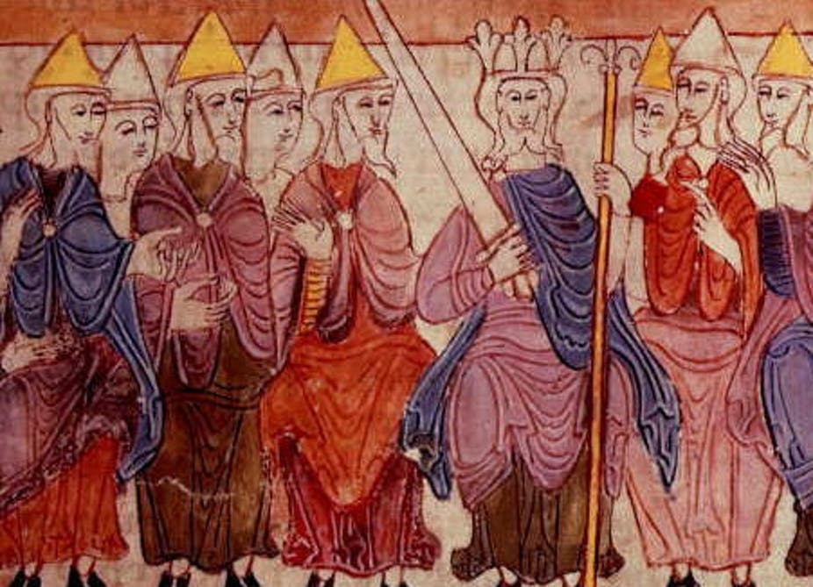  Through the years, the Saxons, Angles and Jutes mixed their different Germanic dialects. This group of dialects forms what linguists refer to as Old English or Anglo-Saxon. The word "English" was in Old English "Englisc", and that came from the name of the Angles.  Before the Saxons the language spoken in what is now England was a mixture of Latin and various Celtic languages which were spoken before the Romans came to Britain (54-55 BC). The Romans brought Latin to Britain, which was part of the Roman Empire for over 400 years. Many of the words passed on from this era are those coined by Roman merchants and soldiers. These include win (wine), candel (candle), weall (wall).  The influence of Celtic upon Old English was unimportant. In fact, very few Celtic words have lived on in the English language. However many of place and river names have Celtic origins: Kent, York, Cumberland, Thames, Avon, Severn.  The arrival of St. Augustine in 597 and the introduction of Christianity into Saxon England brought more Latin words into the English language. They were mostly concerned with the naming of Church dignitaries, ceremonies, etc. Some, such as church, bishop, baptism, monk and presbyter, came indirectly through Latin from Greek.  Around 878 AD Danes and Norsemen, also called Vikings, invaded the country and English got many Norse words into the language, particularly in the north of England. The Vikings, being Scandinavian, spoke a language, Old Norse, which, in origin at least, was just as Germanic as Old English. Words derived from Norse include: sky, egg, cake, skin, leg, window (wind eye), husband, fellow, skill, anger, flat, odd, ugly, get, give, take, raise, call, die, they, their, them.  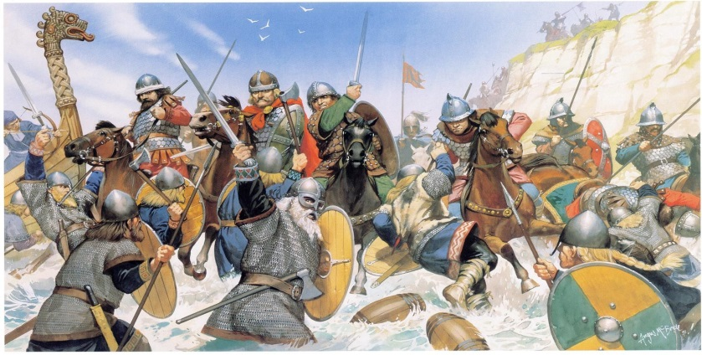  Several written works have survived from the Old English period. The most famous is a heroic epic poem called "Beowulf". It is the oldest known English poem and it is remarkable for its length - 3,183 lines. Experts say it was written in Britain more than one thousand years ago. The name of the person who wrote it is unknown.  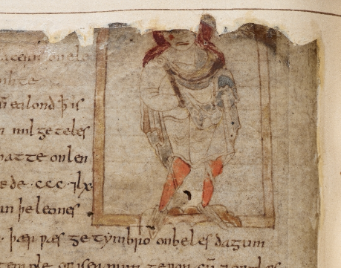  Middle English (1100-1500)  In 1066 William the Conqueror, the Duke of Normandy, invaded and conquered England. The new conquerors, called the Normans, brought with them French, which became the language of the Royal Court, and the ruling and business classes.  During the Middle Ages three languages were spoken in England: the lower classes spoke their native Anglo-Saxon language, the upper classes spoke Norman French, whereas Latin was mainly used by the Church and as the language of learning.  In the 14th century English became dominant in Britain again, but with many French words, such as crown, castle, court, parliament, army, beauty, banquet, art, poet, romance, duke, servant, peasant, traitor and governor.  For the reason that the English underclass cooked for the Norman upper class, the words for most domestic animals are English (ox, cow, calf, sheep, pig, deer), while the words for the meats derived from them are French (beef, veal, mutton, pork, bacon, venison).  This language was called Middle English, but it would be difficult for native English speakers to understand it today.  The most famous example of Middle English is Chaucer's "The Canterbury Tales", a collection of stories about a group of thirty people who travel as pilgrims to Canterbury, England. The portraits that he paints in his tales give us an idea of what life was like in medieval England.  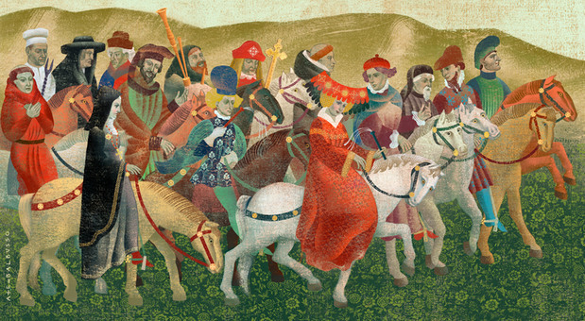  Modern English (since 1500)  Modern English developed after William Caxton established his printing press at Westminster Abbey in 1476. Johann Gutenberg invented the printing press in Germany around 1450, but Caxton set up England's first press. The invention of the printing press made books available to more people. The books became cheaper and more people learned to read. Printing also brought standardization to English. Spelling and grammar became fixed, and the dialect of London, where most publishing houses were, became the standard.  By this time, English was not very different from the English used today. There were three big developments in the world at the beginning of Modern English period: the Renaissance, the Industrial Revolution, and the British colonialism.  It was during the English Renaissance that most of the words from Greek and Latin entered English. This period in English cultural history (early 16th century to the early 17th century) is sometimes referred to as or "the Elizabethan age" or "the age of Shakespeare", taking the name of the English Renaissance's most important monarch and most famous author respectively. During the reign of Queen Elizabeth I there was an explosion of culture in the form of support of the arts, popularization of the printing press, and massive amounts of sea travel.  William Shakespeare (1564-1616) gave the English language many phrases and sayings, which English speakers still use every day. Often, they do not realise these words came from Shakespeare's plays and poems!  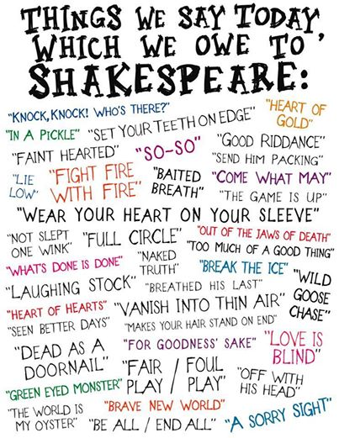  At almost the same time as Shakespeare, came the printing of the "Authorized" or "King James" translation of the Bible in 1611. For almost the first time, anyone who could read had access to the Bible in their own language, and in words which were easily understood.  England began the Industrial Revolution in the 18th century and this had also an effect on the development of the language as new words had to be invented or existing ones modified to cope with the rapid changes in technology.  New technical words were added to the vocabulary as inventors designed various products and machinery. These words were named after the inventor or were given the name of their choice (trains, engine, pulleys, combustion, electricity, telephone, telegraph, camera).  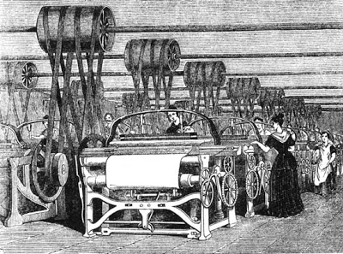  Britain was an Empire for 200 years between the 18th and 20th centuries and English language continued to change as the British Empire moved across the world - to the USA, Australia, New Zealand, India, Asia and Africa. They sent people to settle and live in their conquered places and as settlers interacted with natives, new words were added to the English vocabulary. For example, kangaroo and boomerang are native Australian Aborigine words, juggernaut and turban came from India, coffee and cotton are Arabic words.  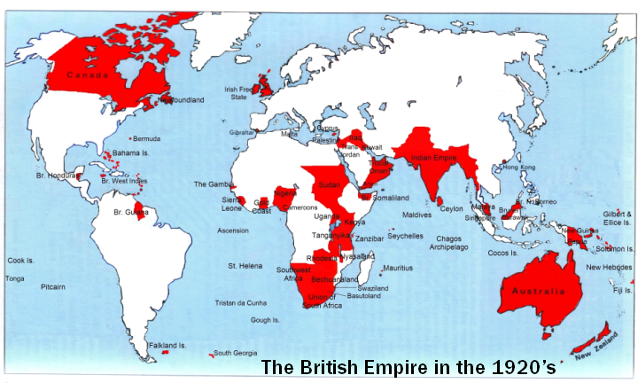  Today, American English is particularly influential, due to the USA's dominance of cinema, television, popular music, trade and technology (including the Internet), but there are many other varieties of English around the world, including for example Australian English, New Zealand English, Canadian English, South African English, Indian English and Caribbean English.  With the increase in communication, travel, radio and television, all these different types of English have mixed. Words from many other languages - French, German, Spanish, Arabic, even Nepali - have been borrowed. So English continues to change and develop, with hundreds of new words arriving every year.  English has without a doubt become the global language. It is used in over 90 countries as an official or semi-official language. It is believed that over one billion people worldwide are currently learning English.  One of the more remarkable aspects of the spread of English around the world has been the extent to which Europeans are adopting it as their internal lingua franca. English is spreading from northern Europe to the south and is now well-established as a second language in countries such as Sweden, Norway, Netherlands and Denmark. Although not an official language in any of these countries, if one visits any of them it would seem that almost everyone there can communicate with ease in English. |  | video material “A Brief History of the English Language”,  Presentation with Power Point: “Three stages in the development of English”
3. Сабақ бойынша рефлексия  Рефлексия по занятию | 3 min | Answer the questions:  - How many stages were there in the development of English? language? - 3  - Can you name Germanic tribes? Saxons, Angles, and Jutes  - The oldest known English poem? Beowulf  Do the test on MOODLE:  1. Are the modern and old English similar?  A)Yes  B)No  C)A bit similar  2.When William the Conqueror invaded and conquered England?  A) in 1600  B)in 1999  C)in 1100  D)there is no correct answer  3.What were the names of the new conquerors?  A) the nomads  B) the mormades  C) the normads  D) the mamonts  4. What language became the language of the Royal Court?  A) French  B) Chinese  C) Japanese  D) Celtic  5.What a sudden and obvious change to the end of the middle English language in pronunciation started?  A)the Great Vowel Shift  B) the Great consonant shift  C) no changes were made  D) there is no correct answer |  | internet, zoom, PC, MOODLE
- Үйге тапсырма  Домашнее занятие | 2 min | Tasks:  - Prepare retelling of the text “Three stages in the development of English”  - Find more information about the old English well known epic poem Beowulf  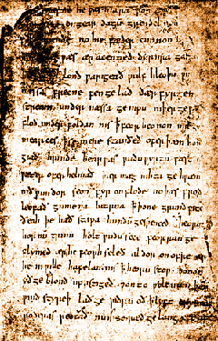 |  | internet, zoom, PC

