Lesson №
The theme of the lesson: New Zealand. Animals and plants.
The aim of the lesson:
Образовательный компонент: формирование социокультурной компетенции через использование страноведческой информации на английском языке и познакомить учащихся с географическими особенностями Новой Зеландии.
Развивающий компонент: совершенствование навыков перевода и чтения незнакомого текста; развитие умений ознакомительного чтения.
Воспитательный компонент: способствовать воспитанию у учащихся уважительного отношения к истории и культуре другого народа.
Задачи урока:
1. Активизировать в речи учащихся лексику по теме.
2. Практиковать в устной речи (монолог, диалоги – расспрос)
3. Расширить знание учащихся о Новой Зеландии, ее географических особенностях, флоре и фауне.
4.Воспитывать интерес к культуре и истории страны изучаемого языка.
The type of the lesson: Combined lesson
Methods of the lesson: showing, explaining, group work, individual work, question-answer.
The visual aids: lecture, table, pictures, interactive board.
Connection of the subjects: History, Russian, Geography, Biology.

Procedure of the lesson
I. Organization moment. Brainstorming:
Good morning? Glad to see you! How are you?
What date is it? Who is absent today? What problem has he (she)?
Are you ready for the lesson? Let’s start!
II. Warming up.
You have learnt much about English speaking countries.
Can you name these countries and show them on the map?
(The UK, USA, Canada, Australia)
Today we will continue to speak about New Zeland.
Open your copybooks and write our theme “New Zealand”

I want to divide you to three groups.
- Cabbage tree (Elmira, Alena, Denis)
- Kiwi (Evgeny, Arina, Alina)
- Maiori ( Zhandos, Kalkaman, Alexandra)

Brainstorming quiz
Each group is given 3 questions.
Group1.
- Who discovered Australia?(James Cook, Christopher Columbus, Rudyard Kipling)
- What is the biggest lake in Australia?(lake Eyre, lake Todd Loch Ness)
- What is the capital of New Zealand? (Melbourne, Wellington, Auckland.
Group2
- Whose statue you can see on the beach of Wellington? (dog’s statue, dolphin’s statue, horse’s statue)
- What is the national game of New Zealand (football, rugby, tennis)
- The national currency of Australia is…( the Australian franc ,Australian dollar, Australian pound)
Gruop3
- What bird you can see in the national emblem of New Zealand? (the parrot, the kiwi ,the raven )
- Australian’s national colours are :( black-red and gold ,white, blue and red , gold, white and bright green )
- The oldest university of Australia is situated (in Sydney, in Canberra, in Brisbane )

Speech drill. Microphone
T: So students it's quite clear that the theme of our lesson is New Zealand. Please, imagine that this is a microphone and try to give answers to my questions. You can answer if you have a microphone, you can’t answer without it.
- Do you know any exotic animal in New Zealand?
- Have you ever been to New Zealand?
- Would you like to go to New Zealand some day?
b) Phonetic drill. T: Pupils, look at the blackboard and repeat the following words after me. We will need these words at our lesson today.
The Geographical names: New Zealand, Australia, the Pacific Ocean, the Tasman Sea, Cook Strait, Wellington, the North Island, the South Island, East Polynesia, Captain James Cook, Abel Tasman, Auckland, Christchurch, Dunedin, Hamilton, Queenstown, Rotorua , Tasmania, Steward Island, volcanoes Egmont and Tongariro , Wellington, Maoris, aborigines, the Commonwealth, the Indian ocean, Waikato , the kiwi.
Today we’ll continue to discuss the main aspects of geographical position, population, animals and plants of New Zealand.
Checking up the hometask. The make esse by internet about animals and plant of New Zeland.
Ученики смотрят презентацию, слушают учителя, задают возникающие вопросы.
True or False
- New Zealand is situated in the Atlantic Ocean. (False)
2. The area of the country is about 270,000 sq km. (True)
3. The two main islands are separated by Tasman Strait. (False)
4. Most of New Zealanders live in the South Island. (False)
5. Europeans first visited New Zealand in 1642. (True)
6. James Cook claimed the land for the British crown. (True)
7. Maori are 80% of the population of the country. (False)
8. Wellington is the largest city of New Zealand. (False)
9. Auckland is the capital of the country. (False)
10. New Zealand is an independent state. (True)
11. The head of state is the governor-general. (False)
Диаграмма Виенна:

3rd group’s task is to find 3 similarities between Kazakhstan and New Zealand
Kazakhstan | Both | New Zeland
President | Parliament | Kiwi bird
steppes | English language | maiori
eagle | Prime minister | Queen

On the blackboard there is a picture of the bird Kiwi.
- What is it? Have you heard about the bird kiwi? Where does it live?
Look at the blackboard and listen to attentively
(listen to information "Amazing facts about kiwis")
VI. Answer the following questions:
- Where is New Zealand situated? (New Zealand is situated in the southern Pacific Ocean.)
2. Is the area of New Zealand 270,000 square km? (Yes, it is. The area of the country is 270,000 square kilometers.)
3. Which country is its nearest western neighbor? (The nearest western neighbor of New Zealand is Australia.)
4. What islands does the country consist of? (It consists of two large islands – the North Island and the South Island, and numerous small islands.)
5. Who are the Native people of New Zealand? (They are Maori.)
- 6. Was James Cook the first European to visit New Zealand? (No, he wasn’t. Abel Tasman was the first European navigator to visit the islands.)
7. What are the official languages in the country? (English and Maori are the official languages in the country.)
8. Wellington is the capital of New Zealand, isn’t it? (Yes, it is. Wellington is the capital of New Zealand.)
9. Is Christchurch the largest city in the country? (No, it isn’t. Christchurch is the largest city in the South Island. New Zealand’s largest city is Auckland.)
10. Who is the head of New Zealand? (The head of state is the British monarch, Queen Elizabeth II, represented by the governor-general.)
The passenger plane touched down at 8 cities in New Zealand.
Can you find the names of those cities by putting together the jumbled word pieces correctly in pairs? Write them please.
WEL RUA QUUENS LINGTON TOWN EDIN ROTO NEL SON LAND CHRIST HAM DUN CHURCH AUCK ILTON
Key: Wellington, Rotorua, Queenstown, Dunedin, Nelson, Auckland, Christchurch, Hamilton.
Solve the puzzle “NEW ZEALAND”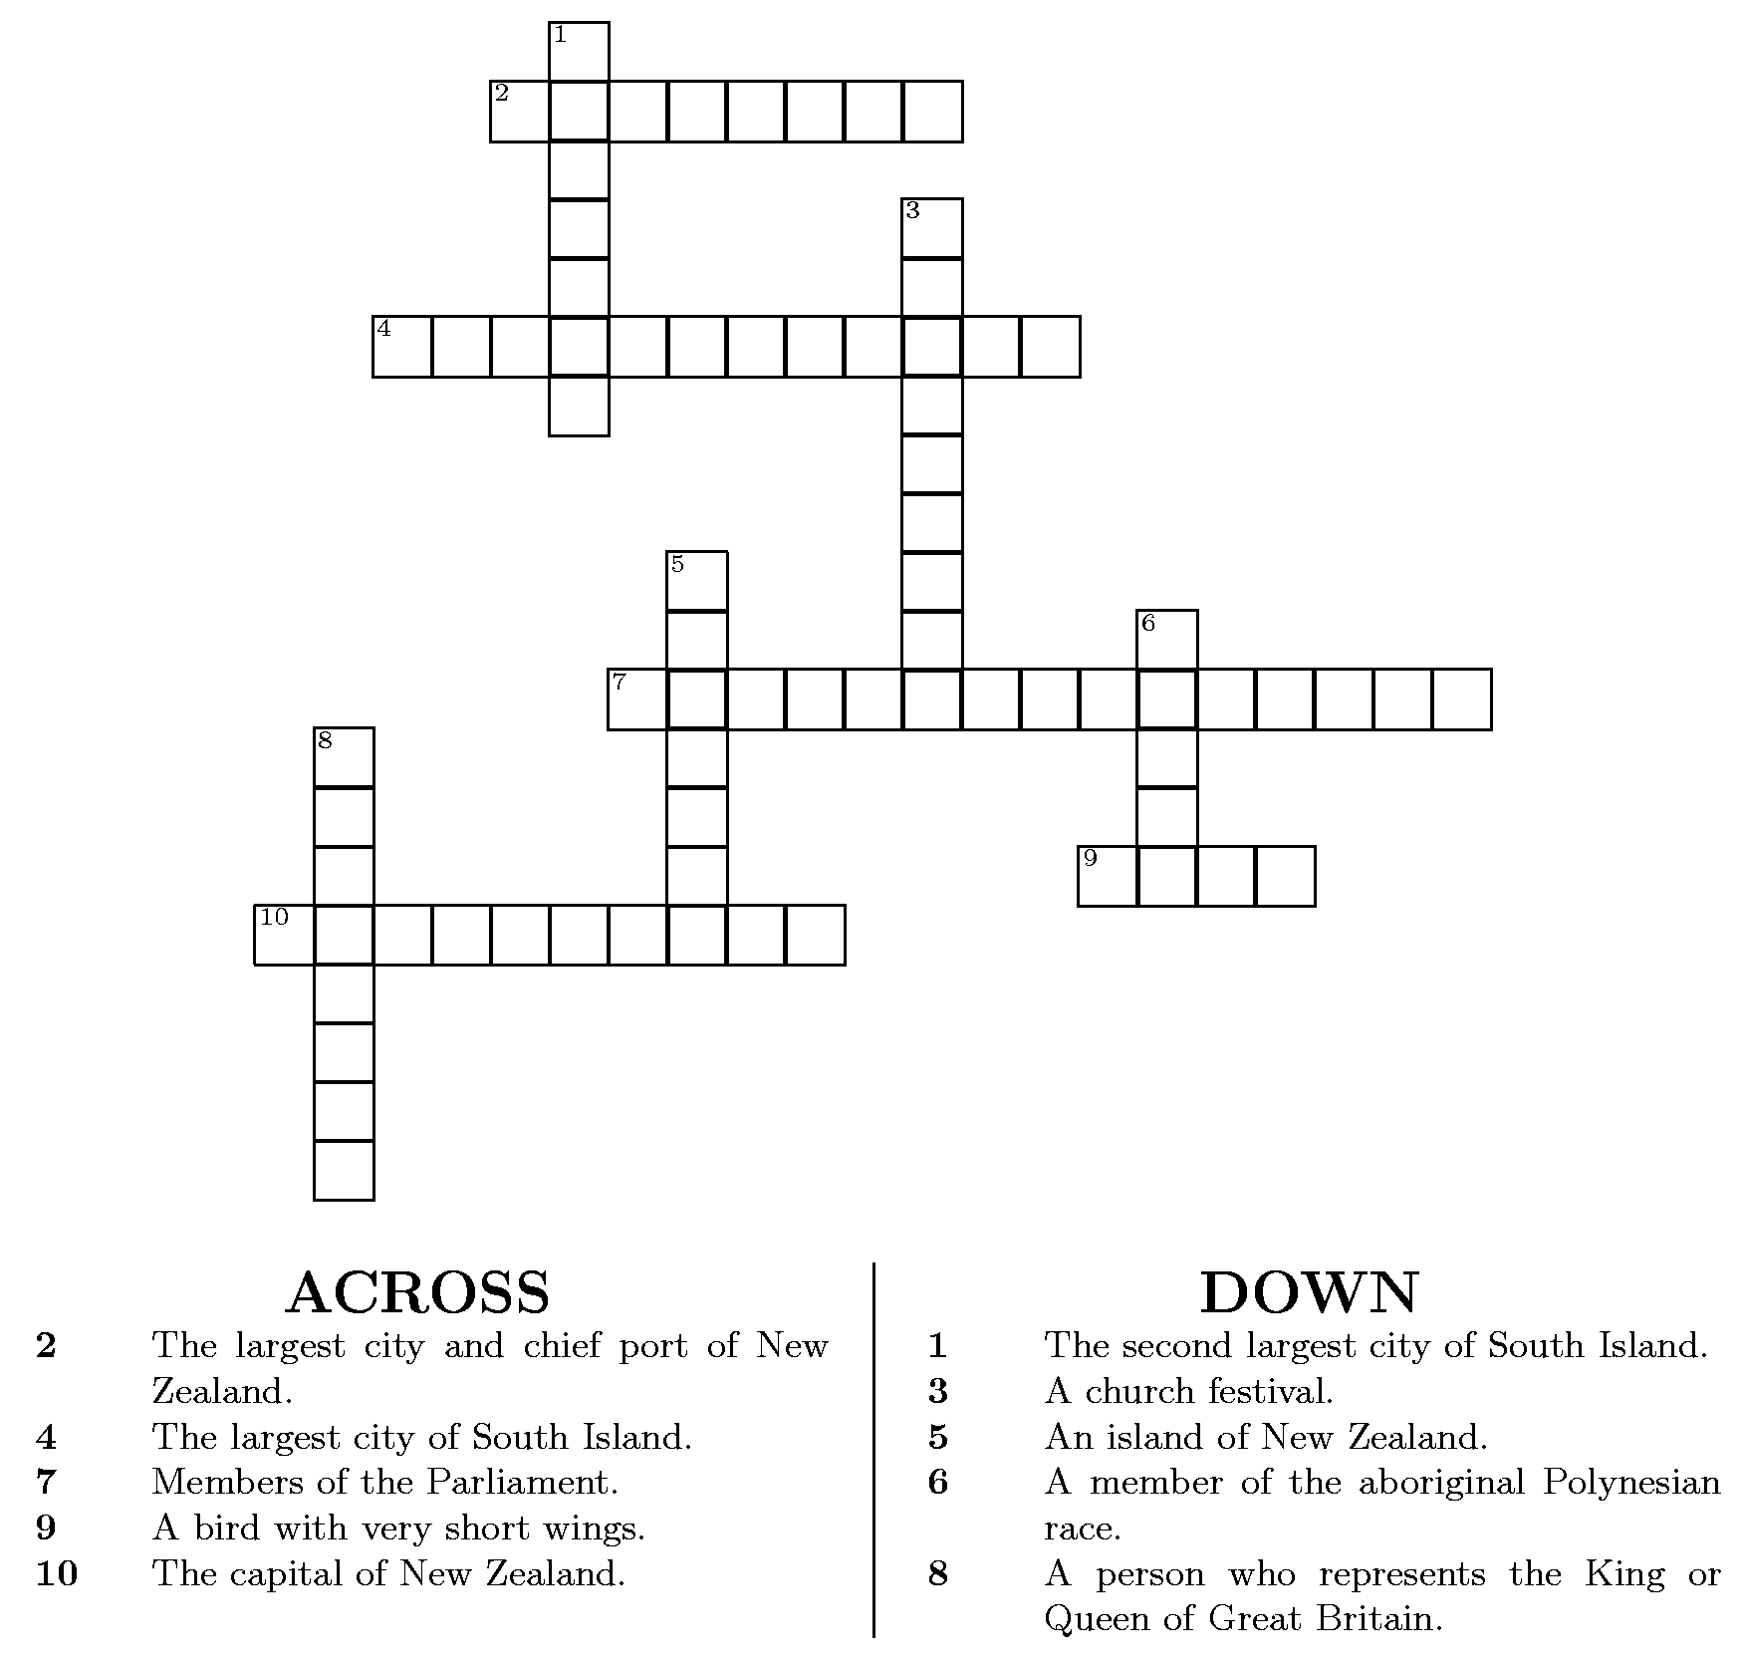

IX. Relaxing
So now I give you 3 sticers. Which are red, green and yellow.
Do you like the lesson?- Choose a pink one.
You don’t understand something – choose a orange one.
You don’t like the lesson – choose a yellow one.
Thanks for your work. I hope our lesson will be useful for you.
X. Conclusion.
At home Learn the new words .
Now our lesson is over. Thank you for your active work.
You are really industrious. It was very pleasant to listen to your answers.

Official name: New Zealand
Consists of: two large islands and numerous small islands
Total area: about 270,000 sq km
Population: about 4 million people
Native people: Maori
Official languages: English and Maori
Capital: Wellington
Largest city: Auckland
Main cities: Christchurch, Queenstown, Hamilton, Dunedin, Rotorua
Government: constitutional monarchy

