Unit 1 |  | Our Class
Teacher |  | Popova L.O
Date |  | 15/09/2022
Grade 6 |  | Number Present: |  |  | absent:
Theme |  | Interrogative pronouns
Learning objectives |  | 6.2.1.1 - understand a longer sequence of supported classroom instructions;  6.3.2.1- ask simple questions to get information about a growing range of general topics
Lesson objectives |  | Learner have to understand how prepositions are used, know the types of interrogative pronouns
Planned activities
Planned timings | Teacher action |  | Student action | Assessment |  | Resources
Beginning of the lesson  Warming-up  10 min. | Emotional mood  I.Greetings. Teacher greets learners.  Hello boys and girls, how are you today?  That’s good  What the weather like today?  Do you like this weather?  You can see three smiles on your desks. Please, choose and show me, what mood do you have at the beginning of our lesson?  II. Organizational moment.  How do you think what the theme of our lesson?  The topic of our lesson is « Interrogative pronouns ».  -Write down the date and the topic of our lesson.  -What will we do in our lesson?  The aim: To learn students to introduce the aim of the lesson, to understand how pronouns are used |  | Children are positive about the lesson  Pupils answer the questions  -Hello teacher  -Fine thanks  -Today is…..  -Yes, I do/No, I don’t  Learners guess the theme of the lesson.  Learners have to understand the aim of the lesson  Write down the date and the topic of the lesson | Oral comments  «The praise» method to evaluate |  | https://elt.oup.com/elt/students/englishplus/english-plus-kazakh-grade-6-students-book.pdf?cc=ua&selLanguage=uk  book  Visual aids
Main part | Beginning the lesson  We have new words. Look at the blackboard and repeat after me.  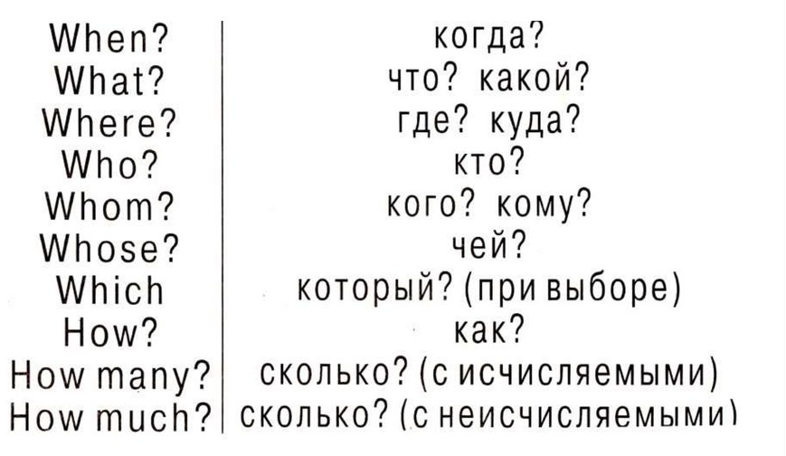  What was your home task?  While you will write them let’s check up your home task  Task 1  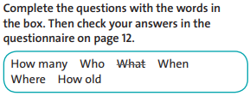  Task 2  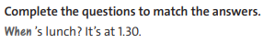  Consolidation of the studied material  Make questions  Can you talk about interrogative pronouns?  Can you express your likes and dislikes? |  | Learners have to listen the teacher  then open the dictionaries and write new words, then spell them together after the teacher.  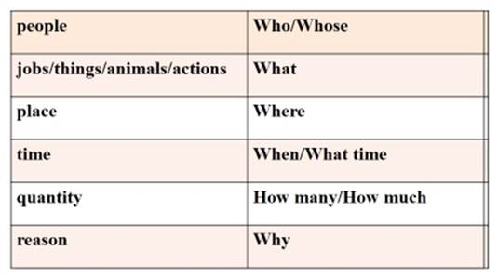  1)Learners have to show their homework.  Learners have to complete the sentences with words into box  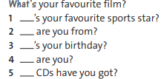  2)Learners have to answer the questions then complete the sentences  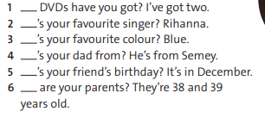  Learners have to answer the question orally | Individually and in written form  «The praise» method to evaluate(похвала)  Oral comments  Mutual check up (Learners exchange their copy-books and check up each other. Keys are on the board)  Oral comments  Mutual check up (Learners exchange their copy-books and check up each other. Keys are on the board)  Individually and in written form |  | Visual aids  Flash cards  Laptop  Dictionaries  handout  blackboard  Pb p13  copybooks  Pb p 13  Handout  Sheet of papers  Board
The end of the lesson | Feedback  I’ll give you a table for every pair “green, yellow, red sheets of paper” complete them with your own thoughts about the lesson.  Giving the marks for the lesson  I hope you’ll be ready for the next lesson and get a good mark.  Home task: words, ex 3,4 p 13 |  | Learners complete the table what they know and want to know, knew.  Aim: define what they have learnt from today’s lesson.  Efficiency:  Helps to analyze about their understanding  - What has been learned  - What remained unclear  - What is necessary to work on | Feedback:  A method of Holly tree. |  | A table for Feedback  