Regional boarding school No. 3 for children with speech disorders

**Open English lesson**

**grade 2«B»**

Theme of lesson: «School days»

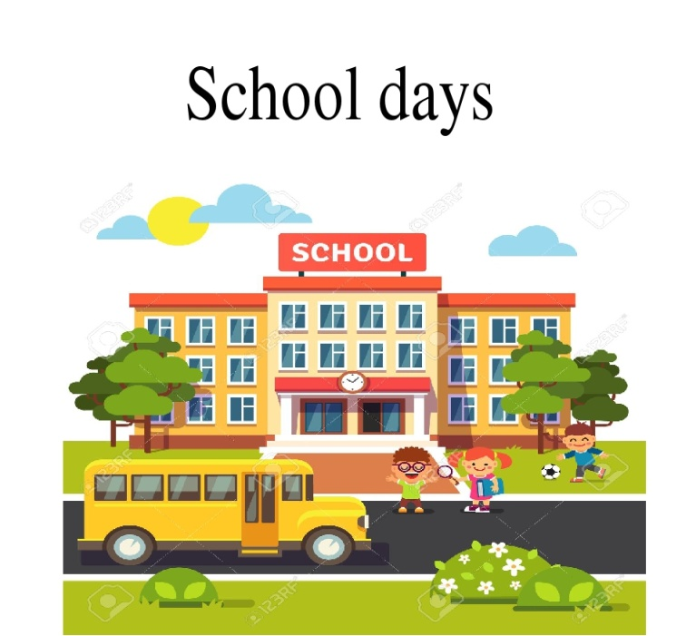

***The teacher of English language mrs. Kabdusheva A.A.***

Atyrau city, 2021-22

|  |  |  |  |  |  |
| --- | --- | --- | --- | --- | --- |
| **Approved:**  **Head teacher Hasanova S.S.**  **Long-term plan unit:**  My school 3 | | | **Regional boarding school №3** | | |
| **Date: 22 November 2021** | | | **Teacher name:**Kabdusheva Ainur Aslanovna | | |
| **Grade:** | | |  | **2B** | |
| **Theme of the lesson:** | | | **School days** | | |
| **Learning objectives(s) that this lesson is contributing to** | | 2.L3recognise with  support common names and names of places and the spoken form of a limited range of everyday and classroom words  2.L2 recognise with support a limited range of basic common personal questions spoken slowly and distinctly | | | |
| **Lesson objectives** | | **Learners will be able to:**  recognise and write days of the week  recognise and name common verbs  listen and describe their days | | | |
| **Value links** | | Respect and cooperation by:   1. Listening to the teacher 2. Listening to each other 3. Take turns 4. Encourage each other | | | |
| **Cross curricular links** | | Home life, transportation, health practices | | | |
| **ICT skills** | | By teacher only, about 15 minutes | | | |
| **Previous learning** | | Practise lesson. Learners practised some words and letters | | | |
| **Plan** | | | | | |
| **Planned timings** | **Planned activities (replace the notes below with your planned activities)** | | | | **Resources** |
| Beginning  Middle  25 minutes | 1. **Warm up activity**   Student come in. choose their own hats, two colors, red and green. Divided into two groups by color.  Divided into two groups by color.  Teacher: Let’s sing a song “Hello”  The teacher greets. Students sing a song “Hello”  https://www.hindipanda.com/wp-content/uploads/2018/09/hello.jpg  Before the lesson, numbers and commands of the teacher, passed in previous lessons.   1. ***Learn the numbers 10-50ty***   **Обратите внимание что эти числительные оканчиваются на T-Y. Repeat again.**  At first let’s practice our tongues! Let play a game “Tongue Twisters”. Listen to me and repeat after me.  Сначала преподаватель повторяет с детьми звуки **[s], [ai], [ei], а затем и скороговорку.**   ***Six slimy snails sailed silently.***   1. **Watch a video on the topic.**   *Disclosure of the topic.*  ***T: What do you think? What is that topic our lesson?***  ***S: Yes, it’s about a school days!***  **Introducing new words**   1. **Learning new words by topic** 2. *Teacher**demonstrates and drills.* 3. *Whole class repeats the words after* 4. *Teacher three times.* 5. *Teacher ask each student to repeat the words.*   **New phrases**  **go to school have lesson have lunch**  **Maths lesson, Science lesson, P.E. Art lesson, Music lesson**   1. **Look at the example**   **I go to school from Monday to Friday**  **I don’t go to school on Saturday and Sunday**   1. **Let’s practice**   **I have Science on Tuesday.**   1. **Remember the rules.** 2. **What is it? \ Who is?**   What is it?  It’s a **school and etc.**  **Working with two groups**  **Working with a group**  **hello_html_5822f98c.png**  **Let’s read!**  **hello_html_m3f0dd4ad.png**  ***Activity book p. 22. exs. 3*** ***Learn new words*** | | | | Оwn hats two colors  Watch a video  PPT |
|  |
| End  5 minutes | 1. **Reflection**   Teacher gives 2 types of smiles and student should to choose one of them  **Good** –if they understand not all  **Sad** –if they don’t understand  Pick up an emotion. Define a lesson using emoticons.    **T:** *We have good worked today. And it’s great!*   1. **Teacher says goodbye to children** | | | |  |

