Short-term plan  Entertainment and media  Term 2 Unit 3 |  | School: School lyceum № 27 Nur - Sultan
Date: 15.10.2021 |  | Teacher name: Shomanova D.M
Grade: 9 |  | Number present: | Number absent:
Theme of the lesson: |  | My news
Learning objectives that this lesson is contributing to |  | 8.2.1.1(L1) understand with little or no support the main points in extended talk on a wide range of general and curricular topics;  8.3.7.1(S7) use appropriate subject-specific vocabulary and syntax to talk about a range of general topics, and some curricular topics  8.4.2.1(R2) understand specific information and detail in texts on a growing range of familiar general and curricular topics, including some extended texts;  8.5.1.1(W1) plan, write, edit and proofread work at text level with little support on a growing range of general and curricular topics;
Lesson objectives |  | All learners will be able to:  - Express own ideas on some topics clearly;  - Recognize specific details in a text;  - Write a letter on given topic with support (8-10 sentences)  Most learners will be able to:  - Express and ask for ideas to each other;  - Recognize specific details in a text;  - Write a letter on given topic with little or no support (8-10 sentences)  Some learners will be able to:  - Assist with expressing and asking for ideas to others;  - Recognize specific details in a text;  - Write a letter on given topic without support (8-10 sentences)
Language objectives |  | Past tense forms  Practice of applying personal questions
Cross curricular links |  | ICT, Social studies, Media
Value links |  | Cross cultural respect, functional literacy, internet awareness
Previous learning |  | Students have studied news related vocabulary and peculiarities of using past tenses
Plan
Planned timings | Planned activities |  |  | Resources
Start  5 min  (W)  5 min  (I, P) | Leading-in  - Greetings  - Organizational moments  Teacher tells students about the lesson objectives  - express own ideas on some topics clearly;  - recognize specific details in a text;  - write a letter on given topic with support (8-10 sentences)  Teacher demonstrates the video ‘5 Ways To Spot Fake News’ to introduce the lesson theme and brings out some thoughts about news.  Warming-up  Task 1. Strategy “Think-pair-share” (P)  Teacher stimulate students to generate more ideas proportion to the topic.  According to this activity, teacher asks learners to think or write answers to questions below for 1-2 minutes, after finishing individual answers they pair up and discuss their responses.  Then one pair are asked to share their answers for each question and the rest pairs are asked to add to or/and question what the pair said to multiply the thinking.  Did you learn anything new to yourself?  What other ways of spotting fakes do you know?  Would you use the tips from now on?  Differentiation: Teacher helps weaker students to fully understand the content by supportive questions.  Assessment: pair assessment by support  Physical training: “Let’s play” song  Teacher sings a song and shows moves by its text. Students catch it up and repeat the activity. |  |  | https://youtu.be/g2AdkNH-kWA
Middle  15 min  (G, I, P) | The main part of the lesson  Task 2. Pre-reading  Strategy “Quick Write” (G)  Teacher distributes index cards introducing the word ‘A blog’ and students in groups of 4 are given 1-2 minutes to write everything relative to the concept. After time is called, each group share their thoughts on the subject.  Differentiation: Stronger learners help weaker ones in groups to understand and complete the task.  While-reading  Strategy “Inferring” (I)  Learners decipher the meaning of unknown words using the context while reading the blog ‘Theme park trip’.  Post-reading  Strategy “Creative discussions” (P)  Teacher starts the activity by giving each pair prepared questions they should talk about for 1-2 minutes. After that, the pairs change members and discuss questions one more time.  1. Do you like sharing with your news?  2. Do you share news in internet? How?  3. Do you read any blogs or bloggers?  4. Do you think it is important to have a place where you can share with news or thoughts? Why/Why not?  Assessment: Each student assess two members of his pair. |  |  | Handout 1  https://learnenglishteens.britishcouncil.org/sites/teens/files/a_blog_-_blog_2.pdf
10 min  (I) | Task 3. Writing  Formative assessment (I)  Write a letter to your friend/sibling to share with your latest news using appropriate letter structure.  Assessment: Students self-assess their draft writings and proofreads final versions. |  |  | Handout 2  FA
End  5 min  (I) | Reflection “Shaping up review” (I)  Teacher passes out ‘Shaping up review’ worksheet.  In ‘the Heart’, students write one thing they loved learning about in the lesson.  In ‘the Square’, they write four important concepts in their opinion from the lesson.  In ‘the Triangle’, they write three facts they learn in the lesson.  In ‘the Circle’, learners write one global statement to summarize the lesson. |  |  | Handout 3

Handout 1

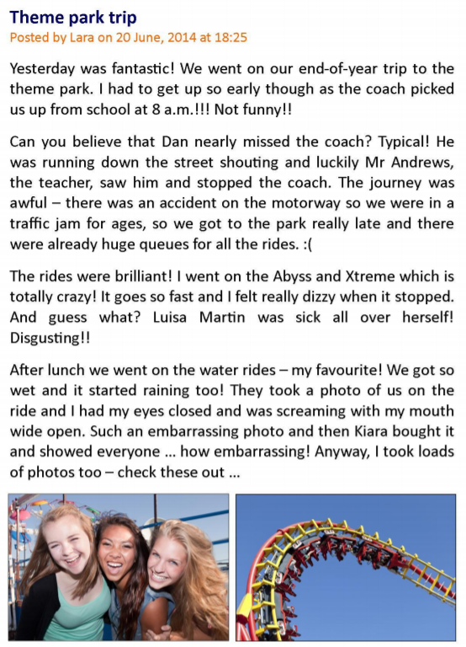

Answer the questions:
- Do you like sharing with your news?
- Do you share news in internet? How?
- Do you read any blogs or bloggers?
- Do you think it is important to have a place where you can share with news or thoughts? Why/Why not?

Text link: https://learnenglishteens.britishcouncil.org/sites/teens/files/a_blog_-_blog_2.pdf

Handout 2
Formative assessment
Writing
Learning objectives | 8.5.1.1(W1) plan, write, edit and proofread work at text level with little support on a growing range of general and curricular topics;
Level of thinking skills | Application  Higher order thinking skills
Assessment criteria | Create a writing plan, write a draft text, revise for mistakes
Task
Write a letter to your friend/sibling to share with your latest news using appropriate letter structure. Present at least 8-10 sentences.
In your letter:
- Use greeting and closing structures;
- Share with your latest news;
- Describe one of the news in more detail.

To:
From:
____________________________________________________________________________________________________________________________________________________________________________________________________________________________________________________________________________________________________________________________________________________________________________________________________________________________________________________________________________________________________________________________________________________

Descriptors
Assessment criteria | Descriptor | Mark
 | A learner
Create a writing plan, write a draft text, revise for mistakes | makes a plan of writing | 1
 | performs at least 8-10 sentences | 1
 | uses greeting and closing constructions | 1
 | describes one news in detail | 1
 | proofreads the writing | 1
Total marks |  | 5

Handout 3
