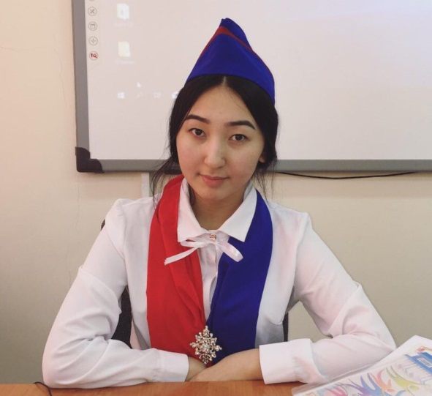
Алатау ауданы, Алматы қаласы
№ 26 жалпы білім беретін мектеп
Ағылшын тілі пәні мұғалімі
Серікова Диляра
Lesson plan
School: № 26 school |  | Long-term plan unit: Traditions and folklore
Date: |  | Teacher name: Serikova Dilyara
Grade: 1 «n» |  | Number present: 15 |  |  | Absent: 15
Theme of the lesson: Happy Birthday

Learning objectives that this lesson is contributing to |  | 1.R3 recognise some very high frequency words from local environment  1.L1 recognise short basic instructions for a limited range of classroom routines spoken slowly and distinctly  1.S3 pronounce basic words and expressions intelligibly  1.W2 form some lower case letters of regular size and shape
Lesson objectives |  | Learners will be able to:  Understand and follow teacher’s instructions  Recognize familiar words  Pronounce words on the topic intelligibly
Success criteria |  | Student achieved the LO (L1) if he:  do 4 or more correct actions;  recognise spoken language slowly and distinctly;  recognise short basic instructions
Value links |  | Education throughout life
Cross curricular links |  | The world around us, culture
ICT skills |  | Using SMART board, pictures and videos, working with URLs
Previous learning |  | This unit recycles and revisits a lot of vocabulary seen in previous units, e.g. words for colours and simple objects and animals. Learners further practice giving short answers in response to direct questions.
Plan
Planned timings | Planned activities |  |  |  |  | Resources
Beginning  10 min | Organizational moment  Teacher greets students; students respond to greeting and take their places.  Warming up  - Teacher revises the days of the week and asks sts “What day is it today? What day was yesterday? What day will be tomorrow?”  - Teacher asks sts about the weather.  - Teacher nominates sts to answer “How are you?” question. Each student describes his/her mood saying “I am...”  "One, two, three...”  It is a competition on the blackboard the teacher draws a large circle and enters the number in it in a scattered order, calls two students to the board. Other students name different numbers, the students at the board must find those numbers and pull out. The student who finishes the task first and quickly will be the winner.  1. Round -Numbers  2. Round- Matching letters with pictures |  |  |  |  | Posters on the walls  cards
Middle  10 min  5 min  5 min  5 min | Happy Birthday  . Introducing new words  • Teacher demonstrates and drills birthday words: cake, balloons, candles, cards, presents, party using the activity "Surprise Box"  a. Teacher brings the box with the hole to the class with objects  b. Students come to the board one by one and gets one object from the box and Teacher names this object in English  c. Whole class repeats the words after Teacher three times.  d. Teacher can ask each student to repeat the words  CAKE!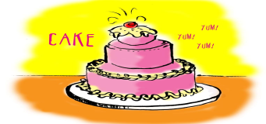  CANDLES!  BALLOONS!  PRESENTS!  CARDS! 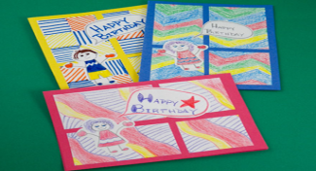  BIRTHDAY HAT!  PAIR WORK  Pupils respond to some information questions about their birthday correctly.  Teacher:Look at the pictures and ask each other a new question.  Children: How old are you? – I am 5.  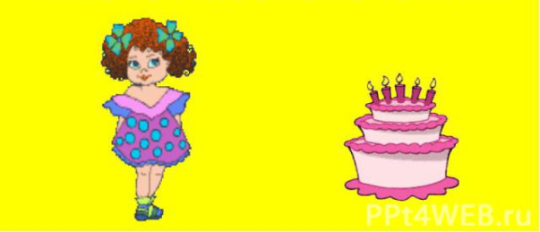  Children: How old are you? – I am 8.  Children: How old are you? – I am 7.  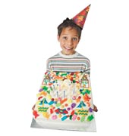  Children: How old are you? – I am 1.  Physical training  Sing a song “Happy Birthday to you”.  Teacher plays the video , pause for showing deferent words to read and repeat, if a learner can pronounce and give the translation he/she takes points. Then they should repeat them in groups with translations.  Teacher introduced students English speaking countries topic with  Teacher gives learners worksheets to write the country for each nationality with help of previous worksheets.  Ph. training learners dance a little  Learners work with countries word search worksheet 1,2 |  |  |  |  | Flash cards  Cards (PPP)  PPT  worksheet 3
End  5 min | Reflection / home task  Ask sts to look at the ladder of success and identify their position at the end of the lesson (with great teacher support)  Give home task: to learn the words on the topic “Birthday” |  |  |  |  | A picture of a ladder of success
Additional information
Differentiation – how do you plan to give more support? How do you plan to challenge the more able learners? |  |  | Assessment – how are you planning to check learners’ learning? | Health and safety check  ICT links
Less able students – greater support by means of visuals or writing difficult words on the blackboard  More able students – independent work on definite tasks with little/no support |  |  | - Monitor individual / group work, listen to discussions, check sts’ understanding of classroom instructions  - Consider results of self-assessment and peer assessment | - Use water based markers  - Work with the SMART board not more than 10 minutes. Make short breaks.  - Ensure proper ventilation  - Monitor classroom space when sts start moving around  - Check sockets’ safety
Reflection
Were the lesson objectives/learning objectives realistic? Did all learners achieve the LO? If not, why?
Did my planned differentiation work well?
Did I stick to timings?
What changes did I make from my plan and why?
Summary evaluation
What two things went really well (consider both teaching and learning)?
1:

2:

What two things would have improved the lesson (consider both teaching and learning)?
1:

2:

What have I learned from this lesson about the class or achievements/difficulties of individuals that will inform my next lesson?

