LESSON |  |  | Unit 3: Creativity
Teacher’s name: Semikhvostova Ye.V |  |  | School: KIS “ Bayterek”
Date: 15.01.2024
Grade: 5 V\G |  |  | Number present: |  | Number absent:
Theme of the lesson: |  | The world of music
Learning objectives |  | 5.R2 understand with little support specific information and detail in short, simple texts on a limited range of general and curricular topics  5.S7 Use appropriate subject-specific vocabulary and syntax to  talk about a limited range of general topics  5.L8 understand supported narratives, including some extended talk, on an increasing range of general and curricular topics
Lesson objectives |  | All students will be able to understand with support information in a reading text, communicate meanings clearly with support, understand the listening tasks with support  Most students will be able to understand with some support information in a reading text, communicate meanings clearly with some support, understand the listening tasks with some support  Some students will be able to understand without support information in a reading text, communicate meanings clearly without support, understand the listening tasks without support
Plan
Planned timings | Planned activities |  |  | Learners’ activities |  | Evaluation | Resources
Beginning  5-min | Class organisation  Warm-up and lesson objectives presentation |  |  |  |  |  | Slide 1
Middle  35 min | Lead-in  The teacher asks the students to look at the screen and answer the questions?  - What has 88 keys but can’t open a single door?  - On the screen you see the pictures of Mozart, Chopin and Beethoven what is common in them.  - Who are composers?  The teacher asks the students to guess what are they going to talk about  The teacher asks who is a musician.  What is an orchestra?  What is a band?  How do we call the words of a song?  Pre-speaking  The teacher asks the students to look at the screen and repeat the topic music  Music is a combination of pleasant sounds  We can hear music everywhere  People all over the world are fond of music.  They listen to music, sing to music, dance to music and learn to play musical instruments.  Speaking  - The teacher asks the students to ask each other questions about music  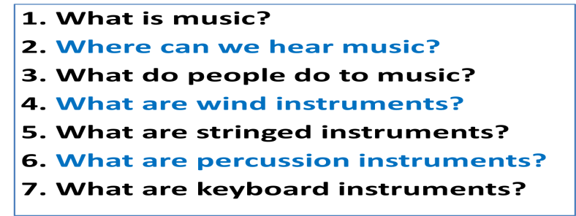  - The teacher shows the pictures of musical instruments and asks the students to name them  - The teacher asks the students to look at the screen and ask each other the questions about maracas and a bagpipe  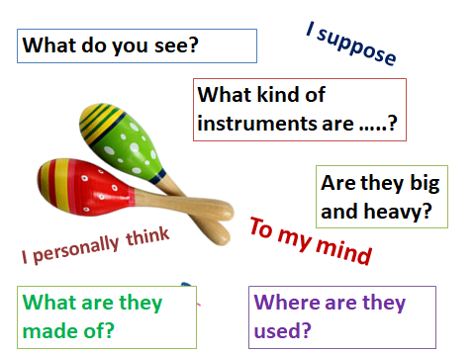  Listening  The teacher asks the students to listen to the text and fill in the table  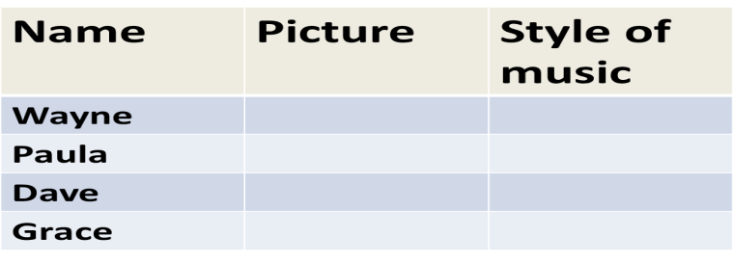  Differentiation  Less able students are given the words with translation.  Reading  The teacher asks the students to read the text about music  The teacher asks the students to answer the questions for the text  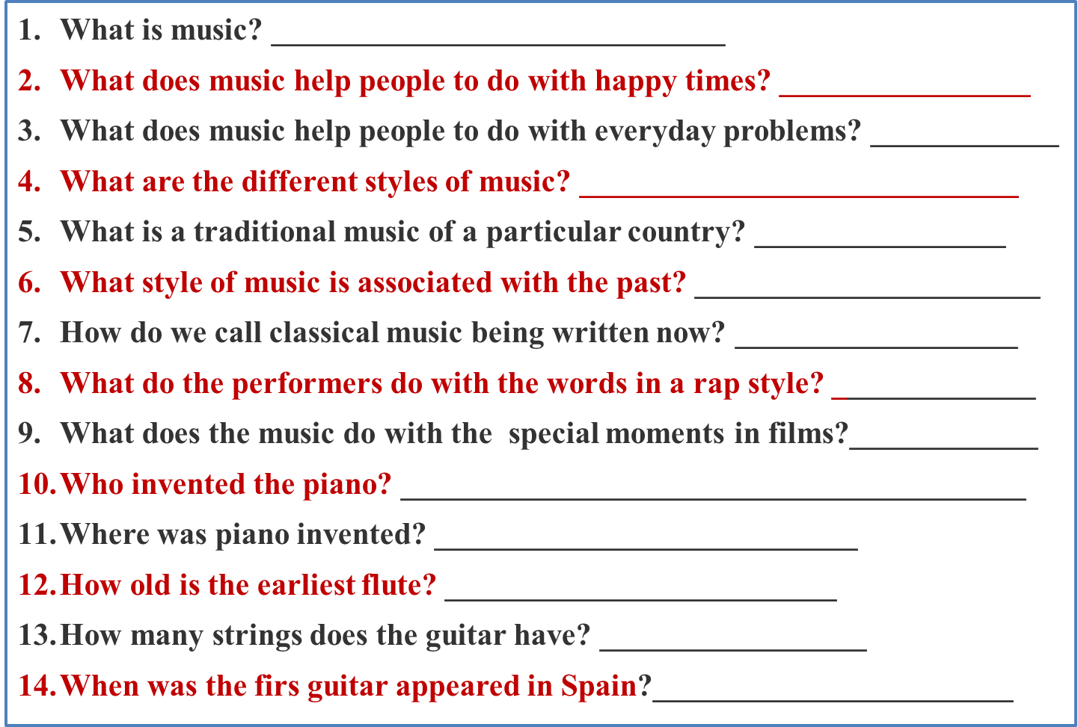  The teacher asks the students to read their answers and check  The teacher asks the students to prepare cards true/false and look at the sentences on the screen to identify if the sentences are true or false  1. The piano is a stringed, percussion and keyboard instrument.  2. The piano was invented in 1800  3. The old flutes have been found in caves in Italy and Slovenia.  4. The guitar is played in rock and classical styles of music.  5. Films would be interesting without music.  6. Pop, rap and techno are styles of music.  7. Neo-classical music is associated with the past.  Differentiation  Less able students are provided with the text |  |  | The students answer the teacher’s questions  - Piano  - They are composers  - A composer is a person who writes music  The students guess that they are going to talk about music  A musician is a person who plays the musical instrument  An orchestra is a large group of people who play together  A band is a small group of people who play together  Lyrics is the words of a song  The students repeat after the teacher  The students ask each other questions about music  The students work in the worksheets and the same task is shown on the screen  The students look at the pictures of musical instruments and name them  The students look at the slides and ask each other the questions about the instruments  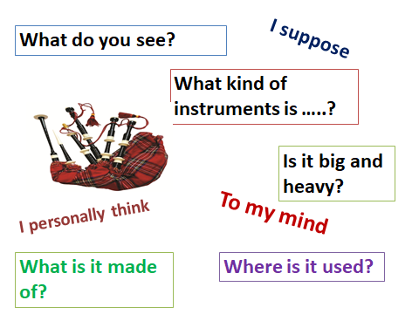  The students listen to and fill in the table  One student read the text about music  The students answer the questions  The students read the answers and check  The students read the sentences and raise true/false cards |  | Mutual evaluation  Teacher’s evaluation  Teacher’s evaluation  Teacher’s evaluation  Teacher’s evaluation  The teacher’s evaluation  Mutual evaluation  Teacher’s evaluation  Teacher’s evaluation  Teacher’s evaluation  Mutual evaluation | Slide 2-3  Slide 4  Slide 5  Slide 6  Pictures  Slide 7-8  Worksheet 2  Slide 9  Audio Script 5  Worksheet 1  Worksheet 2  Slide 11  Slide 12-18
End  5 min | Reflection  The teacher asks the students  What was easy?  What was difficult?  What was interesting?  What was boring?  Saying goodbye |  |  | Learners answer |  | Self-assessment | Slide 20

