"The pros and cons of Teaching English through Distance Learning"
Kadyrgaliyeva Yelizaveta Mukanovna
Teacher of English
School-lyceum # 28, Uralsk
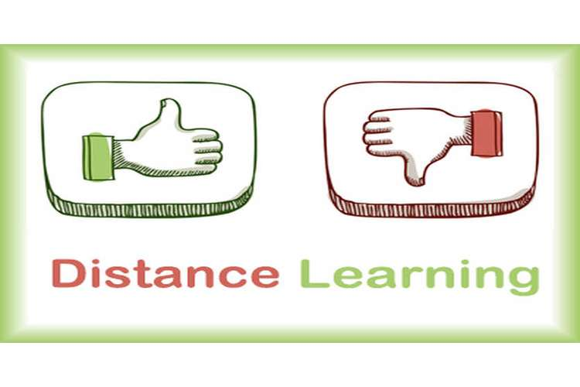
Story at a glance
This spring, students were sent home because of the pandemic.
Teachers and parents have had to adjust to remote learning.
For the upcoming school year, we are considering hybrid models with both remote and in-person learning.
The COVID-19 pandemic is having a significant impact on people’s lives. Perhaps the most significant impact has been on education. Teachers have had to adapt quickly as the spread of coronavirus prompted more stringent social distancing measures for the safety of all.
The remote learning experience has its advantages and disadvantages. Positives can be seen with the increased independence of students, the growth shown with Information Technology (IT) skills of all members of the community and increased time students have spent with their families. Conversely the remote learning experience is not without challenges. Students and teachers have lost face-to-face connection(s), difficulties for dependent learners are strengthened, and life for working families has been shifted on a foundational level.
Undoubtedly, the greatest positive of remote learning is the development of all students’ Information and Communication Technology (ICT) skills. The growth and development of these skills in such a short period of time is awful. Students have displayed great courage embracing the challenge (and frustrations) that this can bring.
The remote learning experience also requires a greater level of independence from students when compared with traditional classroom learning. Teachers have noticed a growth in the students independence during this period. This is a valuable life skill for empowering our young children and definitely a positive overall outcome.
Adapting pedagogy to an online environment in a short space of time—whilst ensuring that learning experiences remained engaging and catered to the diverse learning needs of our children —proved challenging. The fast transition of all staff to use online platforms effectively was crucial to curriculum delivery and is testament to the professionalism of teachers` staff.
The spread of COVID-19 meant that many families had to juggle busy work commitments from home, whilst assisting their children with classwork. Online delivery of education can be an effective alternative medium for the self-disciplined student but it is certainly a challenging prospect for more dependent learners.
The most significant disadvantage of remote learning is, unsurprisingly, that students miss the connection of face-to-face contact with their peers and teachers.
While nothing can replace face-to-face teaching, this experience has sustained our students’ approach to resilience, independence and creativity when it comes to making connections. Some of these adapted teaching methods are balanced to find a permanent place in the classroom when students return to school.
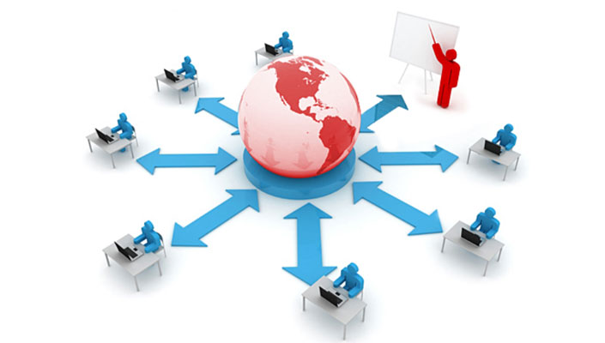

The Pros & Cons of How COVID Affected Children's Education
The pandemic has thrown a lot of things for a loop and virtual learning has been interesting, not all good, but not all bad either.

Pros for Children
Our children's technology-based world has them well prepared for self-navigating learning. The independent learning who consumes first than ask later was a positive aftereffect of all that screen time. A benefit for years to come, according to the World Economic Forum, which reports 65 percent of children today will be working jobs that require these future skills.
Formal education through virtual learning was not the only pro. Many parents saw potential during COVID to combine education and life skills. Cooking and Science, Budgeting and Math, Schedules and Time management. Social interactions and effective communication increased, during this time.
The crysis enlarged, peer-to-peer connections, mentoring, and tutoring. Children had more time to connect with their friends and communicate with their families.

Pros for Parents
Parents not only taught their children life skills but to have positive interactions. With traditional homework removed for some, children learned to manage and succeed in the home. If not for a pandemic, our children would have entered into the workforce and adulthood ill-prepared.
They have the power to collaborate and solve the most significant problems, all while sitting behind a screen. Our children are citizens of the world. They can interconnect and search engine "everything" in a few clicks.
Students and families also benefited from studying at their leisure or when it best fits their schedule. Distance learning allowed children not to move in unison, allowing them the freedom to grow and develop at their own pace.

Cons for Children
Unfortunately, COVID arrived with some negative reflection, too. The researcher project that at the being of the next school, roughly 66 percent of students will lag in their reading skills and 44 percent in math. It suggested the reading gap may widen more; as the top third, readers are likely to continue to build their skills.
Mental wellbeing has magnified in children and teenagers since school closing began. Schools provide up to 57 percent of mental health services for adolescents. A study found that school closing are particularly destructive for children in lower-income families, as the families are less likely to have access to alternative health care services.
Research shows academic achievement and mental health significantly affect one another. Those who live in chronic stress, experience change to the structure of the brain. Impaired cognitive skills and deficits can result in poor educational performance for our students.

Cons for Parents
Another con is the functionalities of everyone at home. Logistically, devices, and internet services may limit our child's ability to participate in online schooling. Not all houses have internet access or several electronic devices lying around to support distance learning.
Parents became the ultimate multitaskers as they learned to manage several class schedules, multiple children, and limited devices. All the while still attending to their regular household duties and continuing their work schedules.
The majority of today's students have only known a world with technology. The world of texting, acronyms, and instant everything are all they know. Snap chat, Tik Tok, and YouTube trained our children to be remote and proved to be an influence in distant learning. However, it did not demonstrate itself flawlessly. Our education systems, and we as parents, realized we had a lot to learn too.
Nevertheless, it just proved as parents, we are flexible and we are teaching our children to be, too.
Creating a lesson plan and conducting a class is more challenging when the teacher is not with his students every day. But adapting the teaching style to reach our students remotely has introduced us to new methods of communicating with the class. They could even be used once the pandemic is over. “The silver lining is we’re all going to be better teachers. Remote lessons or video chats could be used to connect with students on extended vacations or students who can’t make it to class,” Davis said. “We’re constantly learning new things about technology, new things about our students, who might not have Wi-Fi access. These things are coming to light you wouldn’t normally see.”

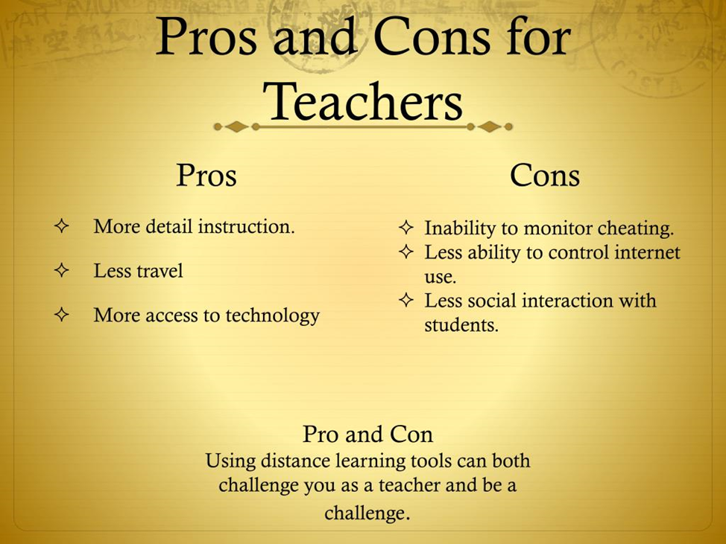
One of the most important omissions was the fact that during the distance learning at the Summative Assessment Lessons we couldn`t evaluate all students skills, only Reading and Writing. It was an imperfect assessment. Listening and Speaking remained underestimated. Сan we rate this time? We should indeed.

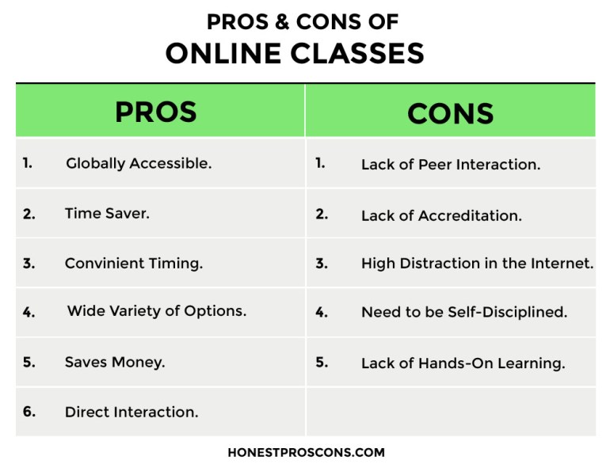

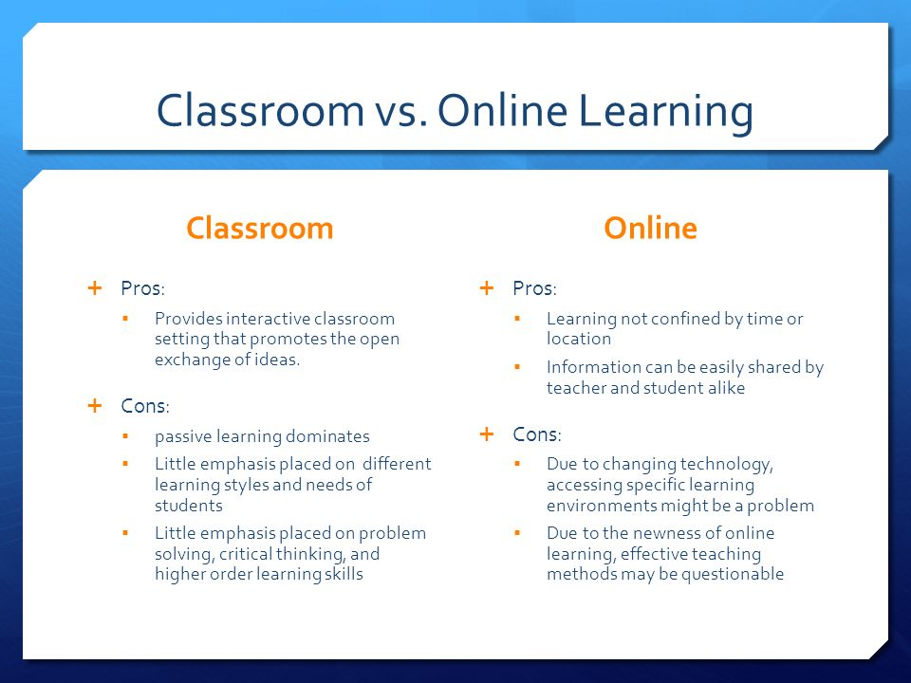

Some students were asked questions about the study during the pandemic. And here are their replies.
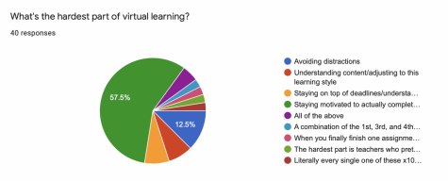

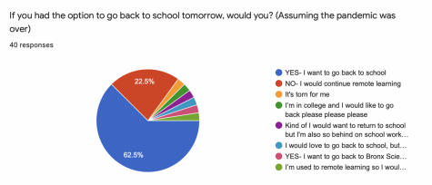

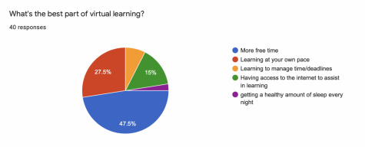

The SWOC Analysis of Online Learning during the Crises.
SWOC = Strengths, Weaknesses, Opportunities, & Challenges.

Strengths
E-learning methods and processes are really strong. These strengths of the online learning modes can rescue us from these hard times. It is student-centered and offers a great deal of flexibility in terms of time and location. The e-learning methods enable us to customize our procedures and processes based on the needs of the learners. There are plenty of online tools available which is important for an effective and efficient learning environment. Educators can use a combo of audio, videos, and text to reach out to their students in this time of crisis to maintain a human touch to their lectures. This can help in creating a collaborative and interactive learning environment where students can give their immediate feedback, ask queries, and learn interestingly. The Anywhere-Anytime feature of e-learning is beneficial in the times of crisis-like situation, for instance, man-made disasters, natural disasters, or pandemics such as Covid-19. The closure of places and unsafe traveling by roads can create a lot of troubles but e-learning will at least not keep us deprived of getting an education at our homes or workplaces.
Technology provides innovative and resilient solutions at times of crisis to combat disruption and helps people to communicate and even work virtually without the need of face-to-face interaction. This leads to many system changes in organizations as they adopt new technology for interacting and working (Mark & Semaan, 2008).

Weaknesses
E-learning has certain weaknesses in the form that it can hamper the communication between the learner and the educator, that is, direct communication and human touch are lost. Users can face many technical difficulties that hinder and slow-down the teaching–learning process (Favale et al., 2020). Time and location flexibility, though it is the strength of online learning these aspects are fragile and create problems. Student’s nonserious behavior in terms of time and flexibility can cause a lot of problems. All students and learners are not the same, they vary in degrees of their capabilities and confidence level. Some do not feel comfortable while learning online, leading to increased frustration and confusion. Inadequate compatibility between the design of the technology and component of psychology required by the learning process; and inadequate customization of learning processes can obstruct the teaching process and creates an imbalance.

Opportunities
Online learning generally has a lot of opportunities available but this time of crisis will allow online learning to boom as most academic institutions have switched to this model. Online Learning, Remote Working, and e-collaborations exploded during the outbreak of Corona Virus crisis (Favale et al., 2020). Now, academic institutions can grab this opportunity by making their teachers teach and students learn via online methodology. The people have always been complacent and never tried some new modes of learning. This crisis will be a new phase for online learning and will allow people to look at the fruitful side of e-learning technologies. This is the time when there is a lot of scope in bringing out surprising innovations and digital developments. Already, EdTech companies are doing their bit by helping us fighting the pandemic and not letting learning to be put at a halt. Teachers can practice technology and can design various flexible programs for students’ better understanding. The usage of online learning will test both the educator and learners. It will enhance problem-solving skills, critical thinking abilities, and adaptability among the students. In this critical situation, users of any age can access the online tools and reap the benefits of time and location flexibility associated with online learning. Teachers can develop innovative pedagogical approaches in this panicky situation, now also termed as Panicgogy. EdTech Start-ups have plenty of opportunities to bring about radical transformations in nearly all the aspects associated with education ranging from, teaching, learning, evaluation, assessment, results, certification, degrees, and so on. Also, increasing market demand for e-learning is an amazing opportunity for EdTech start-ups to bring technological disruption in the education sector.

Challenges
Online learning faces many challenges ranging from learners’ issues, educators’ issues, and content issues. It is a challenge for institutions to engage students and make them participate in the teaching–learning process. It is a challenge for teachers to move from offline mode to online mode, changing their teaching methodologies, and managing their time. It is challenging to develop content which not only covers the curriculum but also engage the students (Kebritchi et al., 2017). The quality of e-learning programs is a real challenge. There is no clear stipulation by the government in their educational policies about e-learning programs. There is a lack of standards for quality, quality control, development of e-resources, and e-content delivery. This problem needs to be tackled immediately so that everyone can enjoy the benefits of quality education via e-learning (Cojocariu et al., 2014). One should not merely focus on the pros attached to the adoption of online learning during the crises but should also take account of developing and enhancing the quality of virtual courses delivered in such emergencies (Affouneh et al., 2020). A lot of time and cost is involved in e-learning. It is not as easy as it seems, a considerable amount of investment is needed for getting the devices and equipment, maintaining the equipment, training the human resources, and developing the online content. Therefore, an effective and efficient educational system needs to be developed to impart education via online mode.
Ensuring digital equity is crucial in this tough time. Not all the teachers and students have access to all digital devices, internet, and Wi-Fi. Unavailability of proper digital tools, no internet connections, or iffy Wi-Fi connections can cause a lot of trouble due to which many students might lose out learning opportunities. Efforts should be taken by institutions to ensure that every student and faculty is having access to the required resources. They must also ensure that all the educational apps work on mobile phones as well, in case students do not have laptops. Therefore, steps must be taken to reduce the digital divide.
Practice makes a man perfect is a famous and very true proverb. Students and teachers across various universities have never really practiced e-learning. Most of them are complacent and are stuck with traditional modes of teaching. The Corona Virus outbreak is the chance to make out the best from the current situation. We can learn a lot in this challenging situation. A lot of tools are available, teachers are required to choose the best tool and implement it to impart education to their students. A step-by-step guide can be prepared by academic institutions that can guide the teachers and students on how to access and use various e-learning tools and how to cover major curriculum content via these technologies thereby reducing the digital illiteracy. Teachers can present the curriculum in various formats, that is, they can use videos, audios, and texts. It is beneficial if educators complement their lectures with video chats, virtual meetings, and so on to get immediate feedback and maintain a personal connection with the students.

