Unit5 Reading Questionnaire Card Name__________________
Task 1. What school subjects can you see on the picture?
Write the words : (_______/ 5 points)
words | Points
1 | 1  2  3  4  5
2

3

4

5

Task 2. Find out: How many computers are there in the room? (_____/2 points)
Answer: There are ______ _____________ _______ _________ _________.
Task 3. Underline the words in the text. Count the words in the text and circle the number of words.
(______/13 points) 1 2 3 4 5 6 7 8 9 10 11 12 13
Task 4. Read the text and choose the number of smiles to conduct self -assessment (________/5 points)
OK  2 | Good  3 | Very good  4 | Excellent  5
Task 5 Class book p 40 ex 3 (_____/4 points)
1 2 3 4
Task 6 Answer the questions. Complete the sentences with missing words. (_______/11 points)
1.The children are ______________________________. (1)
- There are _________ pupils. (1)
- The computers have got _________________. (1)
- They can ______________ and ___________. (1)
- They can a) __________________ (1)
b) __________________ (1)
c) _____________ (1)
d) ________________ (1)
6. The computers help the pupils to _____________and____________. (1)
7. The children come to the computer room every ____________ and ____________ (1)
8. Yes, they do./ No, they don`t. (1)
________/ 40
Unit 5 We`ve got English |  |  | School: KIS Bayterek
Date: 23.02.2022 |  |  | Teacher`s name: Kitalenko Y. K.
Grade: 2G |  |  | Number present: 11 |  | Number absent:
Theme of the lesson: |  | At our school
Learning objectives |  | 2.S3 use a limited range of basic words, phrases and short sentences to describe objects, activities and classroom routines  2.R3 read and follow with considerable support simple, words, phrases and sentences on familiar topics
Lesson objectives |  | All learners will be able to:  Read and understand a webpage  Study and review vocabulary  Most learners will be able to:  Find specific details in a text  Pronounce the words correctly  Answer the questions on the text  Some learners will be able to:  Construct sentences about their school  Retell the text
Assessment criteria |  | Learners have met this learning objective if they can:  - read and understand vocabulary and structures studied previously
Previous learning |  | Vocabulary Revision
Plan
Planned timings | Planned activities |  |  | Learners’ activities |  | Evaluation | Resources
Beginning  5 min | ORGANIZATIONAL MOMENT  The objectives of the lesson.  This lesson learners will read and understand a text about school. Learners are informed about the grades they get at the end of the lesson.  Warm -up : Student talk about computers. Answer the questions:  Do you like computers?  Do you have computer lessons?  When have you got computer lessons? |  |  | Greeting  Students answer the questions about themselves |  | Verbal evaluation | PPP
Middle  30 min | Focus on the picture. (5 points)  1.What school subjects can you see on the picture? Write them down.(5)  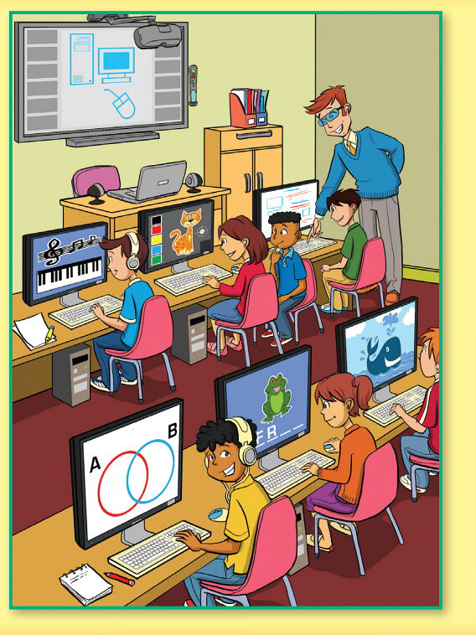  1)Pre- Reading Task:  They are going to read and listen to the webpage about the computer room in a school.  - Read the words from the text (vocabulary review)  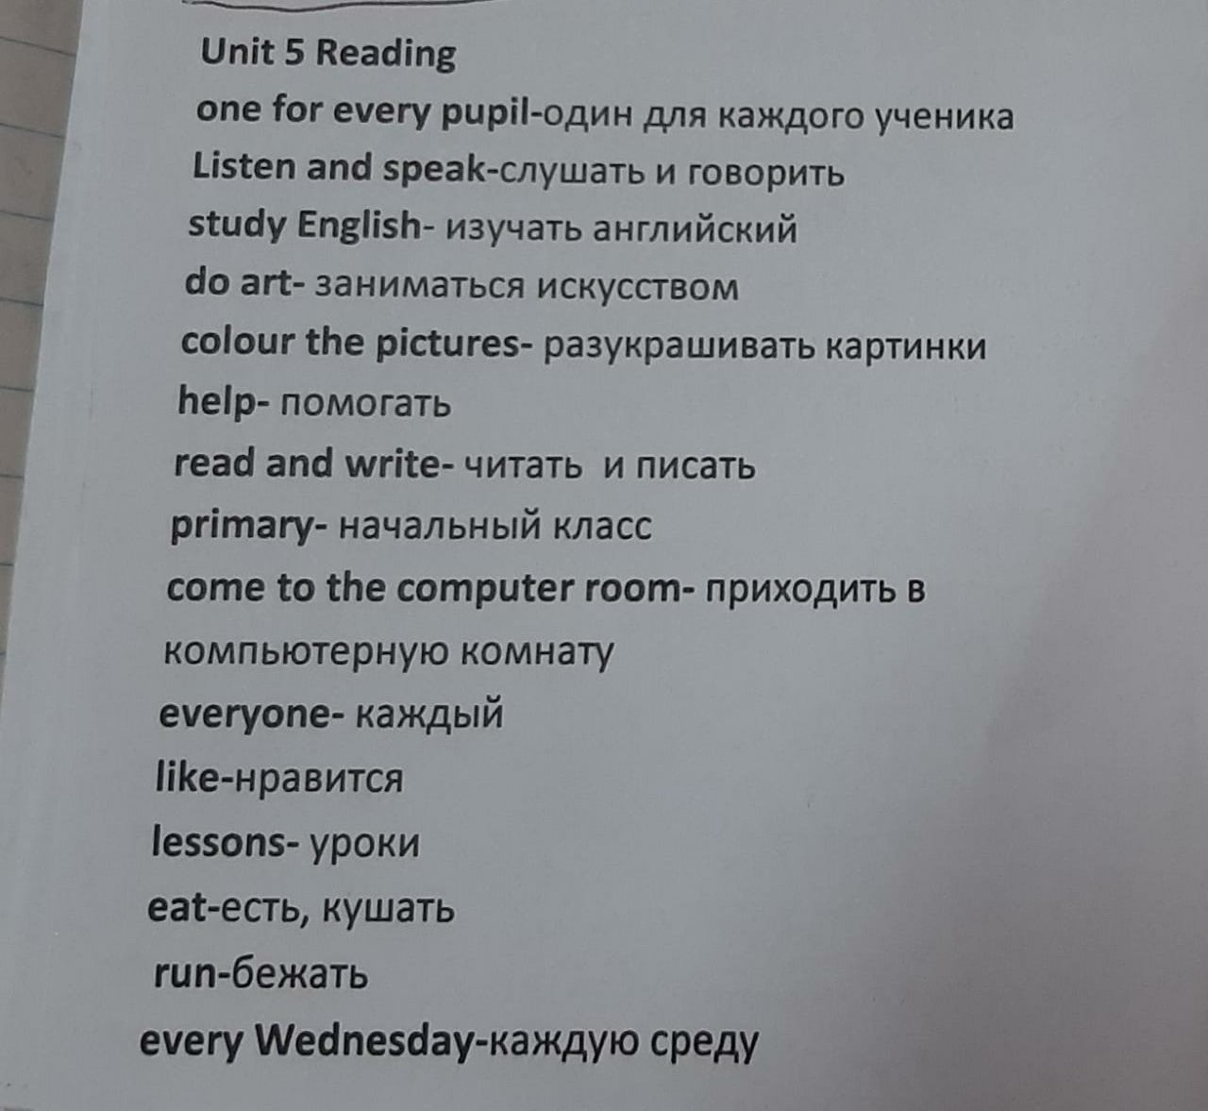  2) While-Reading/Listening Task (2 points)  Read the question  Listen and read the text to find out the answer. Write it down  Find out :  How many computers are there in the room?  Answer: There are………..  Task 3. Read and listen again. (13 points)  - Underline as many words as you can in the text in 3 minutes  Task 4 (5 points)  Task 5 (4 points)  Read again. Circle the false word and write the correct word.  Copy the first sentence on the board. Ask learners : Is the sentence correct? (No)  What word is wrong?  Invite a child to come up and circle the incorrect word in the sentence.  Invite another child to write the correct word next to the sentence.  Students work on their own.  Task 6 Comprehension  (11 points)  - Where are the children?  - How many pupils are there?  - What have computers got?  - What can the pupils do with headphones?  - What can pupils do in the computer room?  - What do computers help the pupils do?  - When do the children come to the computer room?  - Do they like the lessons? |  |  | Learners predict about what they are going to read.  Learners study the picture and write down the school subjects Check their words from the PPP slide  1. music  2. art  3. maths  4. English  5. science  Learners circle the point in the questionnaire they have.  Learners read and listen to the text and find the answer to the question. They write the answer in the card  Learners listen and read again. Afterwards they have 3 minutes to find as many words as they can in the text.  Learners check the words from the vocabulary list with the teacher`s help/  Learners circle the number of words they have found in their cards.  Learners read the text and circle smiles in their card to conduct self-evaluation  Learners need to find the wrong word in each sentence. They should then put the correct word at the end of the line  Learners answer the questions in their questionnaire .  Learners check their answers from PPP slide  And count their points on the card  1.The children are in the computer room. (1)  - There are 12 pupils. (1)  - The computers have got headphones. (1)  - They can listen and speak. (1)  - They can  a) study school subjects (1)  b) do art (1)  c) draw (1) d) colour the pictures (1)  6. The computers help the pupils to read and write. (1) 7. The children come to the computer room every Tuesday and Thursday (1)  8. Yes, they do. (1) |  | Individual evaluation  Verbal evaluation  Frontal evaluation  Self-assessment  Self-assessment  Self-check  Self-check | card worksheet  Task 1  PPP  Class book  card worksheet  Class book
End  6 min | FEEDBACK  Represent the grade system to students  .  Home task: Retell the text  Saying goodbye |  |  | At the end of the lesson learner are presented the  grade system and count their points . |  | 40-39 =10  38-35=9  34-31=8  30-27=7  26-23=6  22-19=5  18-15=4  14-11= 3

