Mission | Vision | Global citizenship
Contribute to the development and well-being of intellectual and competitive people with high moral values, ready for life-long learning and changes in global and digital world. | School community is open for changes, ready to lead and responsible for themselves, the country and the world. | Live in peace and for peace  This is respect for the diversity of cultures, religions of people, support for inclusion, equality and anti-racism in the world, a humane attitude towards nature, openness of consciousness as an understanding of what is happening in the big world, readiness for change, the ability to adopt someone else's experience and learn from others.
Lesson Plan
Short-term plan  Term 4 Unit Different Ways of Living |  |  | School: Nazarbayev Intellectual school of Physics and Mathematics in Taldykorgan
Date: |  | Teacher’s name: Yengay N.V.
Professional Development Aim |  | Development of essay writing skills through the study of visuals.  Развитие навыков написания эссе через исследование несплошного текста.
Grade: 10 |  | Number present: |  | Absent:
Theme of the Lesson: |  | Story 2
Learning objective(s) that this lesson is contributing to |  | 10.W1 plan, write, edit and proofread work at text level independently on a range of general and curricular topics  10.W4 use style and register to achieve appropriate degree of formality in a growing variety of written genres on a range of general and curricular topics
Lesson objectives |  | Learners will be better able to:  - Consider the style of story writing  - Plan the relevant context of the story
Assessment criteria |  | Context – the ideas are relevant to the task  The style and language tools are appropriate for an ‘academic’ story
Differentiation |  | Learners have enough time for planning and writing their own stories.
Mission, Vision, Global Citizenship |  | CEA preparation, respect for the diversity of cultures, religions of people, support for inclusion
Value links  Respect, transparency, cooperation, patriotism and responsibility, diligence and creativity, honesty, family values and traditions, health and well-being, global citizenship |  | Respect, diligence and creativity
Cross curricular links |  | Literature, Social study
ICT Skills |  | N/n
Previous learning |  | Exam practice
Health and safety for effective learning |  | Keeping safety rules working with Active board, digital sources. Short physical exercises in between the activities.
Plan
Planned timings | Planned activities |  |  |  | Resources
Beginning  5 mins | Ask learners to look at the picture and name the details of the story structure: W-T  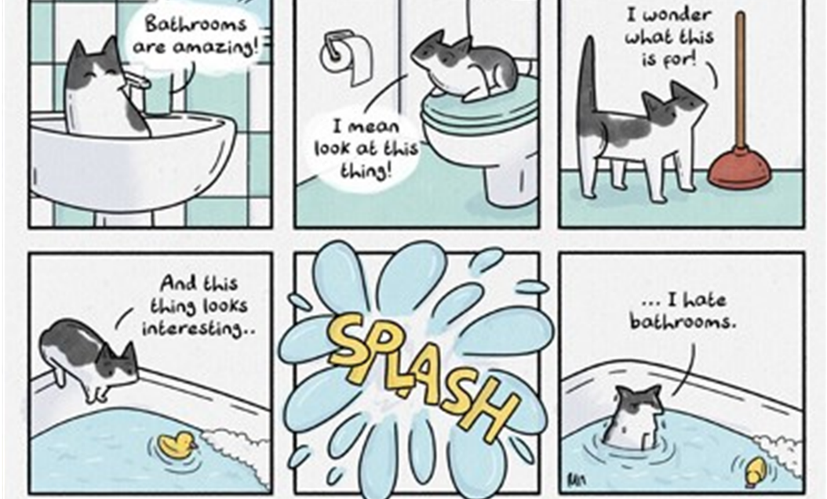  - What is exposition? (a new inhabitant – a cat in a bathroom)  - What makes a rising action? (interests to unknown items)  - What is a climax of this story? (splash)  - What is resolution?  - What is missing? (a falling action)  Introduce the theme and lesson objectives. |  |  |  | PPT slides 1-2
Middle  13 mins  20 mins | Ask learners about the topics from Grades 9-10 which could be included into the task. Learners’ answers. W  Suggest that learners read the example of the story.  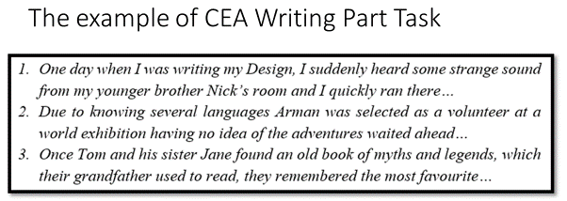  They should assess the story using the CEA Criteria and explain their marks. Learners could be divided into the groups in accordance with the marks. Anyway they should make comments on the basis of the mark scheme.  The main idea is to consider the rubric Communication which includes register (the level of academic language) and style.  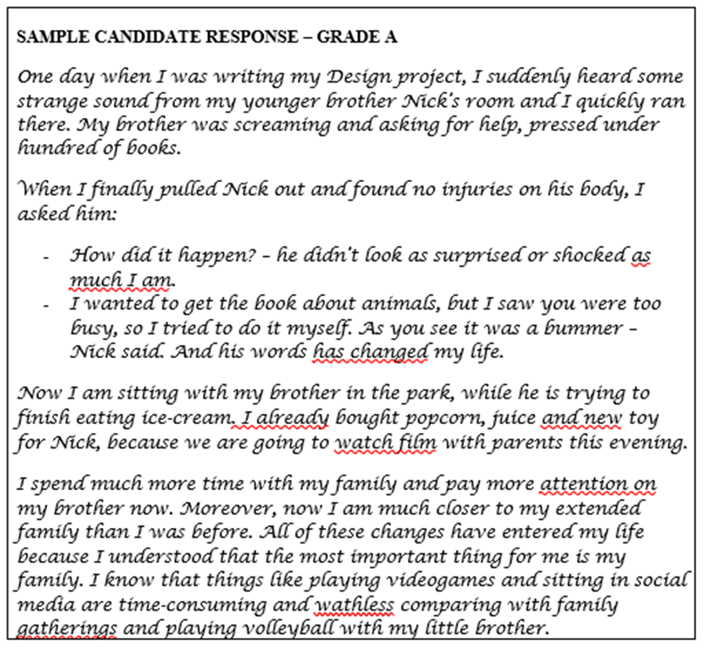  Making a plot  Learners are suggested a list of story ideas. They choose one of them and make a plot. I  Learners work in pairs and share the plots assessing the ideas in accordance with their relevancy. P  - Write a story about a birthday wish that comes true, much to the wisher’s surprise.  - Write a story about a book that has a different ending every time, depending upon who’s reading it.  - Write a story about an AI device with a mind of its own.  - Write a story about a fishing trip that goes wrong when someone catches something very unexpected.  - Write a story about a teacher who can read minds.  - Write a story about a town where everyone shares one unique mystical ability.  - Write a story about a strange Chinese restaurant where everyone’s fortune cookie messages always seem to come true.  - Write a story about a group of aliens who are worried about the prospect of a human invasion.  - Write a story about a young girl who wakes up one day with incredible athletic abilities. |  |  |  | Slide 3  Slide 4  Slide 5
End  2 mins | Learners make corrections in the plot if it is needed.  Ask learners to use a technique of creative writing (1 minute) to reflect on lesson’s objectives and their outlook.
REFLECTION
Were the lesson objectives/learning objectives realistic?
What did the learners learn today?
What was the learning atmosphere like?
Did my planned differentiation work well?
Did I stick to timings?
What changes did I make from my plan and why?
Summary evaluation
What two things went well (consider both teaching and learning)?
1:

2:

What two things would have improved the lesson (consider both teaching and learning)?
1:

2:

What have I learned from this lesson about the class or achievements/difficulties of individuals that will inform my next lesson?

