Unit 7: Journey into Space |  | Lesson 53
Teacher name:

Date:
Grade: 4 |  | Number present: | absent:
Lesson title | Into Space 1
Learning objectives | 4.1.5.1 identify initial, middle and final phonemes and blends  4.5.5.1 use interrogative pronouns including: who, what, which, where, whose, how many, how much, how often, how big, what kind of … to ask questions on growing range of familiar topics  4.4.7.1 spell most familiar high-frequency words accurately when writing independently;
Lesson objectives | Learners will be able to:  - talk about space.
Value links | Family – Family values are moral and ethical principles of typical family life, including sacrificing for loved ones, putting your loved ones first, and keeping your loved ones at the centre of your thoughts and actions.
Plan

Stages / Time | Teachers actions | Students actions | Assessment criteria | Resources
Beginning of the lesson  Warming-up    3 min.  Pre-learning  «Brainstorming» method  7 min. | Organization moment :  1.Greeting.  Ask about the weather.  The teacher sets the lesson objectives, letting students know what to anticipate from the lesson.  Warming up  Where are you from?  How old are you?  What color is it?  How many students are there in class?  What day of the week today?  Lead – In  Hand out the completed Progress Report Cards for the previous module and ask the pupils to file them in their Language Portfolios.  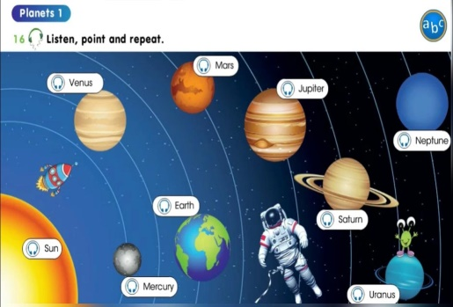 | The aim: To develop pupils speaking skills and create friendly atmosphere  Efficiency: By wishing each other they feel better and feel the support of others  Students of the class are listed.  Students' attention is drawn to the lesson.  Students say different words from the picture  •Learners remember previous lesson vocabulary  •Learners answer the questions | The teacher to assess learners for their ability.  “Good job!  Well done!”  Formative Assessment    Good job!  Descriptor:  - remembers the lesson passed  Point 1  Assessment criteria  make basic statements related to personal information, people and objects | Pictures  worksheet  Picture
Middle of the lesson  Presentation part.  30 min | Ex:1 P:101  • Put the Journey into space poster up on the board. Point to the pictures, one at a time, and say the corresponding words.  Elicit answers from individual pupils. Then say and write on the board: Earth. Explain to the pupils that Earth is.  The pupils repeat, chorally and/or individually. Point to each picture in random order. Ask individual pupils to name them.  Ex: 2 P: 101  • Explain the activity. Allow the pupils some time to match the pictures with the correct words. Play the CD. The pupils listen and check their answers.  Ex: 3 P: 101  Look at the task. Read the statement and find correct answer.  Teacher gives this task to check students general comprehension.  Ex: 4 P: 101  Refer the pupils to the picture and have a picture discussion. Read the example aloud and explain the activity. Allow the pupils some time to look at the picture and complete the activity. Ask individual pupils to answer. Ask the rest of the class for verification.  Conclusion during the lesson some tasks differentiated by outcomes of the students and by their abilities. | • learners look at the picture. Would you like to travel into space? Why?/Why not? Do you know any planets bigger than Earth?  ANSWERS  I would like to travel onto space to visit other planets. Jupiter, Saturn, Uranus and Neptune are bigger than Eaarth.  • learners can you find these in the picture on page 100? Match. Then listen and check  ANSWERS  2 I 3 h 4 f 5 d 6 b 7 g 8 e 9 c  • learners read and write  ANSWERS  2 space ship  3 spacesuit  4 telescope  5 space station  6 alien  • learners look and read. Write yes or no.  ANSWERS  2 no  3 no  4 yes  5 no | Descriptor:  - look at the picture  - answer the question  Total: 3 point  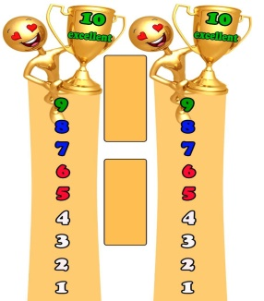  Self assessment  Descriptor:  - find these in the picture on page  - match the pictures with the correct words  Total: 2 point  Descriptor:  - read and match  Total: 3 point  -Make CCQ questions Yes / No |   Card  Worksheet  Students book
End of the lesson  5 min | FEEDBACK  Traffic light method is used to find out was the lesson clear or not. Use the stickers. | 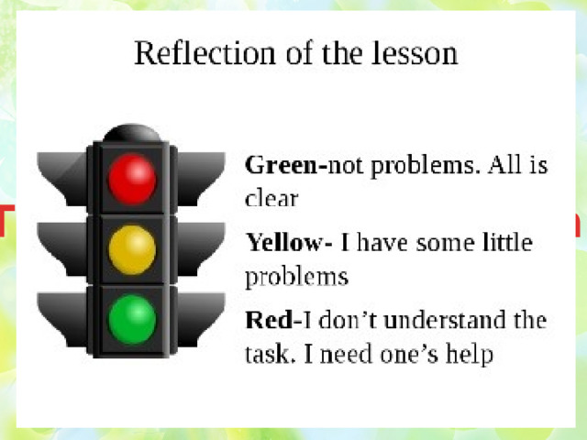 |  | Poster Success  

\

Unit 7: Journey into Space |  | Lesson 54
Teacher name:

Date:
Grade: 4 |  | Number present: | absent:
Lesson title | Into Space 2
Learning objectives | 4.​2.​6.​1 take turns when speaking with others in a growing range of short, basic exchanges;  4.​4.​4.​1 write with support a sequence of short sentences in a paragraph to give basic personal information  4.3.6.1 understand with some support, some specific information and detail in short, simple texts on a growing range of general and some curricular topics
Lesson objectives | Learners will be able to:  - to talk about holidays.
Value links | Family – Family values are moral and ethical principles of typical family life, including sacrificing for loved ones, putting your loved ones first, and keeping your loved ones at the centre of your thoughts and actions.
Plan

Stages / Time | Teachers actions | Students actions | Assessment criteria | Resources
Beginning of the lesson  Warming-up  3 min.  Pre-learning  «Brainstorming» method  7 min. | Organization moment :  1.Greeting.  Ask about the weather.  The teacher sets the lesson objectives, letting students know what to anticipate from the lesson.  Warming up  Where are you from?  How old are you?  What color is it?  How many students are there in class?  What day of the week today?  Lead – In  Hand out the completed Progress Report Cards for the previous module and ask the pupils to file them in their Language Portfolios. | The aim: To develop pupils speaking skills and create friendly atmosphere  Efficiency: By wishing each other they feel better and feel the support of others  Students of the class are listed.  Students' attention is drawn to the lesson.  Students say different words from the picture  •Learners remember previous lesson vocabulary  •Learners answer the questions | The teacher to assess learners for their ability.  “Good job!  Well done!”  Formative Assessment  Good job!  Descriptor:  - remembers the lesson passed  Point 1  Assessment criteria  make basic statements related to personal information, people and objects | Pictures  worksheet  Picture
Middle of the lesson  Presentation part.  30 min | Ex:5 P:102  • Put the picture flashcards up on the board. Point to them, one at a time, and name them. The pupils repeat, chorally and/or individually. Then point to the picture flashcards in random order. Ask individual pupils to name them.  Ex: 6 P: 102  • Refer the pupils to the pictures and elicit the new vocabulary. Read the example aloud and explain the activity. Allow the pupils some time to complete it. Check their answers.  Ex: 7 P: 103  Say, then write on the board: Who is he? Underline the word in bold. The pupils repeat, chorally and/or individually. Then point to a pupil and ask: Who is he? Elicit the name of the pupil, (e.g. Berik). Say, then write on the board: He's Berik. Underline the word in bold. Explain that we use the interrogative pronoun who to ask about people. Repeat to present the rest of the interrogative pronouns. Explain that we use how old to ask about age, why to ask for reason, what to ask about objects/actions, where to ask about position/ location, and when to ask about time.  Conclusion during the lesson some tasks differentiated by outcomes of the students and by their abilities. | • learners listen, point and repeat.  ANSWERS  Student’s own answer.  • learners the Zorby family is visiting Earth on holiday. What do they want to do? Read and complete. Then match the pictures to the aliens.  ANSWERS  2 souvenirs - f  3 sightseeing – e  4 goggles – c  5 hiking – d  6 sunscreen, swimsuit, sunbathe - a  • learners Flop is getting ready for holiday. Read and complete the dialogue.  ANSWERS  Where are you going?  Who are you going with?  How many days are you staying?  What are you doing there?  When are you leaving? | Descriptor:  - point to them  - repeat, chorally and/or individually  Total: 3 point  Self assessment  Descriptor:  - read the example aloud  - match the pictures to the aliens.  Total: 2 point  Descriptor:  - Read and complete the dialogue.  - answer the question  Total: 3 point  -Make CCQ questions Yes / No | Card  Worksheet  Students book
End of the lesson  5 min | FEEDBACK  Traffic light method is used to find out was the lesson clear or not. Use the stickers. |  |  | Poster Success

Unit 7: Journey into Space |  | Lesson 55
Teacher name:

Date:
Grade: 4 |  | Number present: | absent:
Lesson title | Planets 1
Learning objectives | 4.1.6.1 understand some specific information and detail of short, supported talk on an increasing range of general and some curricular topics  4.​3.​4.​1 find with support books, worksheets and other print materials in a class or school library according to classification;
Lesson objectives | Learners will be able to:  - develop listening skills to point correct answers  - learn the spelling of the words intelligibly
Value links | Family – Family values are moral and ethical principles of typical family life, including sacrificing for loved ones, putting your loved ones first, and keeping your loved ones at the centre of your thoughts and actions.
Plan

Stages / Time | Teachers actions | Students actions | Assessment criteria | Resources
Beginning of the lesson  Warming-up  3 min.  Pre-learning  «Brainstorming» method  7 min. | Organization moment :  1.Greeting.  Ask about the weather.  The teacher sets the lesson objectives, letting students know what to anticipate from the lesson.  Warming up  Where are you from?  How old are you?  What color is it?  How many students are there in class?  What day of the week today?  Lead – In  Say where you are going on summer holidays and ask individual pupils to say what they are doing there. e.g. Teacher: We are going to Greece this summer. Pupil 1: I am going swimming.  Pupil 2: I am going sightseeing, etc | The aim: To develop pupils speaking skills and create friendly atmosphere  Efficiency: By wishing each other they feel better and feel the support of others  Students of the class are listed.  Students' attention is drawn to the lesson.  Students say different words from the picture  •Learners remember previous lesson vocabulary  •Learners answer the questions | The teacher to assess learners for their ability.  “Good job!  Well done!”  Formative Assessment  Good job!  Descriptor:  - remembers the lesson passed  Point 1  Assessment criteria  make basic statements related to personal information, people and objects | Pictures  worksheet  Picture
Middle of the lesson  Presentation part.  30 min | Ex:9 P:104  • Go through the pictures of the story and set the scene by asking the pupils questions about what they can see in the pictures. e.g. Teacher: (pointing to picture 1) What are they doing?  Class: They're packing their suitcases.  Teacher: Yes. They're getting ready for their summer holidays, etc  Play the CD. The pupils listen and follow the story in their books.  Ex:10 P: 105  • Allow the Ss some time to read the story silently and complete the activity. Check their answers.  Ex: 11 P: 105  Allow the pupils some time to read the story again. Then they choose a title. Allow them time to complete the activity. Check their answers.  Ex: 13 P: 105  The pupils, in pairs, act out similar dialogues about themselves. Go around the classroom providing any necessary help. Ask some pairs to come to the front of the classroom and act out their dialogue. If you wish, write the following on the board so the pupils can refer to it while they are completing the activity.  Ex: 14 P: 105  Refer the pupils to the pictures. Point to sheriff and say:/J/ sheriff. The pupils repeat, chorally and/or individually. Check their pronunciation. Repeat the procedure for cash. Point to cheque and say:/tf/- cheque.  Conclusion during the lesson some tasks differentiated by outcomes of the students and by their abilities. | • learners listen and read  ANSWERS  Student’s own answer.  • learners read the story and correct the mistakes.  ANSWERS  Daisy wants to swim all day.  Daisy's dad wants to go fishing every day.  Daisy's sister wants to play on the beach all day. Bella is having  • learners choose the best title for the story.  ANSWERS  C Holiday For All!  • learners talking point. Listen and read. Make a new dialogue with your friend.  ANSWERS  Let's pack our suitcases.  Berik: Hurray! I can't wait! I want to fish all day!  Dana: Don't forget to take your fishing rod!  Berik: I want to go sightseeing, tool  Dana: Don't forget your camera!  Berik: Thanks! Well, that's everything. We're ready for our holiday.  Dana: Let's go  • learners listen and repeat  ANSWERS  [ʃ] shoe, shell, wash  [tʃ] chocolate, cheap | Descriptor:  - listen and read  - answer the question  Total: 3 point  Self assessment  Descriptor:  - read the story  - correct the mistakes.  Total: 2 point  Descriptor:  - read the story again  - choose a title  Total: 2 point  Descriptor:  - listen and read  - make a new dialogue  Total: 2 point  Descriptor:  - pronounce words correctly  - repeat, chorally and/or individually  Total: 2 point  -Make CCQ questions Yes / No | Card  Worksheet  Students book
End of the lesson  5 min | FEEDBACK  Traffic light method is used to find out was the lesson clear or not. Use the stickers. |  |  | Poster Success

Unit 7: Journey into Space |  | Lesson 56
Teacher name:

Date:
Grade: 4 |  | Number present: | absent:
Lesson title | Planets 2
Learning objectives | 4.3.5.1 understand the main points of short simple texts on a limited range of familiar general and some curricular topics by using contextual clues  4.4.2.1 begin to use joined-up handwriting in a limited range of written work  4.​5.​1.​1 use singular nouns, plural nouns – including some common irregular plural – and uncountable nouns, possessive ‘s/s’ to name, describe and label things
Lesson objectives | Learners will be able to:  - to talk about planets
Value links | Family – Family values are moral and ethical principles of typical family life, including sacrificing for loved ones, putting your loved ones first, and keeping your loved ones at the centre of your thoughts and actions.
Plan

Stages / Time | Teachers actions | Students actions | Assessment criteria | Resources
Beginning of the lesson  Warming-up  3 min.  Pre-learning  «Brainstorming» method  7 min. | Organization moment :  1.Greeting.  Ask about the weather.  The teacher sets the lesson objectives, letting students know what to anticipate from the lesson.  Warming up  Where are you from?  How old are you?  What color is it?  How many students are there in class?  What day of the week today?  Lead – In  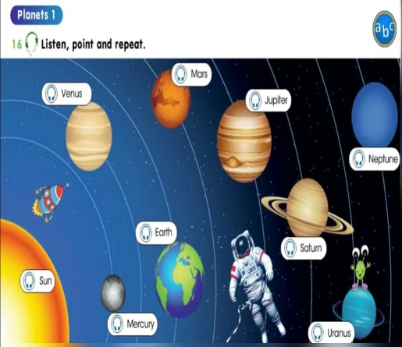 | The aim: To develop pupils speaking skills and create friendly atmosphere  Efficiency: By wishing each other they feel better and feel the support of others  Students of the class are listed.  Students' attention is drawn to the lesson.  Students say different words from the picture  •Learners remember previous lesson vocabulary  •Learners answer the questions | The teacher to assess learners for their ability.  “Good job!  Well done!”  Formative Assessment  Good job!  Descriptor:  - remembers the lesson passed  Point 1  Assessment criteria  make basic statements related to personal information, people and objects | Pictures  worksheet  Picture
Middle of the lesson  Presentation part.  30 min | Ex:16 P:106  • Put the Planets poster up on the board. Point to the planets, one at a time, and say the corresponding words. The pupils repeat, chorally and/or individually. Point to each planet in random order. Ask individual pupils to name them  Ex:17 P: 106  • Explain to the pupils that they will do a quiz about planets. Go through the questions and the prompts and elicit/explain any unknown vocabulary. Allow the pupils some time to do the quiz. Check their answers. Ask the pupils to count how many planets they collected, write the number in their books and check their results.  Ex: 18 P: 106  Underline the words in bold. The pupils repeat, chorally and/or individually. Explain the difference between the present simple (for repeated actions) and the present continuous (for temporary actions or future plans). Point out the use of key words (always, usually, today, every day, etc) to determine which tense is to be used. Revise/Elicit the interrogative, negative and the short answers. Ask the pupils to make sentences about what they usually do and what they are doing today  Conclusion during the lesson some tasks differentiated by outcomes of the students and by their abilities. | • learners listen, point and repeat  ANSWERS  Student’s own answer.  • learners do the quiz and collect planets. Check your answers with your teacher or online.  ANSWERS  1 a  2 b  3b  4a  5a  6a  • learners read and complete  ANSWERS  1 called  2 are coming  3 are exploring  4 discovered  5 are leaving  6 travels  7 walked  8 used | Descriptor:  - point to each planet  - listen and repeat  Total: 2 point  Self assessment  Descriptor:  - do the quiz  - collect planets  Total: 2 point  Descriptor:  - read and complete  - make sentences  Total: 2 point  -Make CCQ questions Yes / No | Card  Worksheet  Students book
End of the lesson  5 min | FEEDBACK  Traffic light method is used to find out was the lesson clear or not. Use the stickers. |  |  | Poster Success

