Plan of the student’s independent work
Good morning dear students! How are you? Hope that everything is OK!
Today is the 23rd of September.
Module 1. Culture Corner.

The Theme of the lesson: The man who invented the net.
Student’s Book: Action for Kazakhstan p.16

Get acknowledge with your new vocabulary
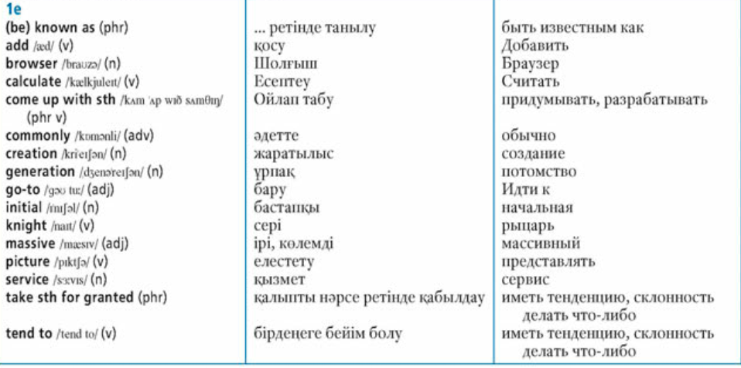
Ex.1.p.16. What do you know about the invention of the Internet? Read to find out.
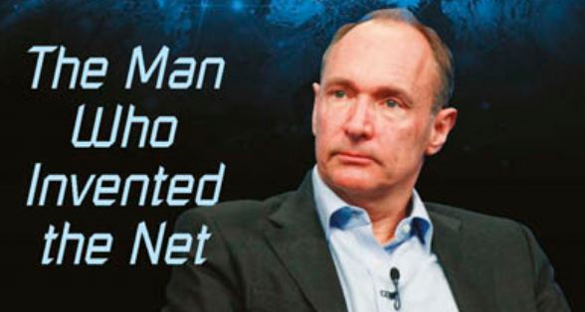
Ex.2 p.16. Read again and fill in gaps 1-10 with an appropriate word.
Ex.3 p.16. Fill in: history, important, do, famous, source, study, media, known.
Ex 4 p 16. Answer for the questions.
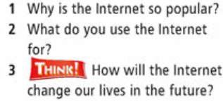
Send your work by Bilimland.

