Long-term plan unit:  4 The world around us |  |  | School: ШСО «BASTAU»
Date: 21.12 |  |  | Teacher name: Rakhmatulina R. V.
Grade: 1 А, Б, В, Г |  |  | Number present: |  | absent:
Theme of the lesson: Colors and size

Learning objectives(s) that this lesson is contributing to |  | 1.L1 recognise short instructions for basic classroom routines spoken slowly and distinctly  1.L4 recognise with support short basic questions about what something is  1.UE3 use basic adjectives to describe people and things
Lesson objectives |  | All learners will be able to:  - Recognize colors and size  Most learners will be able to:  - Describe objects using colors and size with teacher’s support  Some learners will be able to:  - Describe objects using colors and size without any help
ICT skills |  | Using videos/PPT
Previous learning |  | Students learned colors, classroom objects, numbers 1-20, family members, animals
Plan
Time | Planned activities |  |  |  |  | Resources
Beginning  5 min  (W) | Teacher greets students; students respond to greeting and take their places.  - Good morning, good morning, good morning to you!  - Good morning, good morning, I’m glad to see you!  Warming up  Teacher asks students “How are you?” to find out their mood at the beginning of the lesson; students choose one of the smiles they see on the slide, saying “I am happy/sad….etc.”  Teacher introduces lesson objectives to students.  Then they play a game “You cannot fool me!”.  The teacher names the words big, small, long, short and accompanies the words with gestures. Further, the teacher begins to deceive the children, then says a word, but shows the wrong gestures. The task of children is to listen carefully and show the gesture that the teacher said, and not the one that showed.
Middle  10 min  (I/W) | Animals revision:  - give students a couple of minutes to revise the vocabulary on the topic “Animals”  - nominate students and elicit target vocabulary by means of showing pictures of various animals  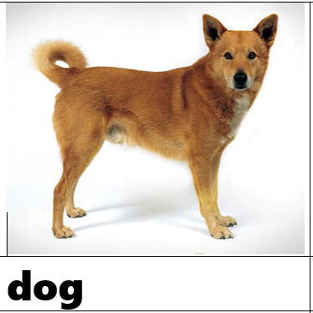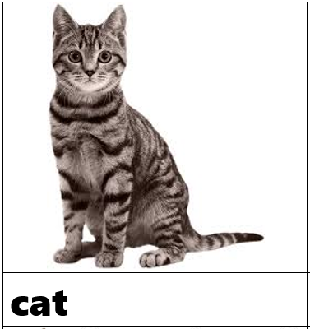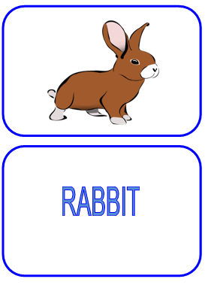  - demonstrate a video about animals and sounds they produce in order to revise and consolidate the vocabulary  (a dog, a cat, etc.) |  |  |  |  | flashcards
20 min  (I/W) | Now open your Pupil’s book on page 48.  Ex. 5 Read and color. Play the guessing game.  - There is a big black dog.  - There is a small brown cat.  - There is a big brown rabbit.  - There is a small black mouse.  - There is a small pink fish.  Do a physical minute with musical video.  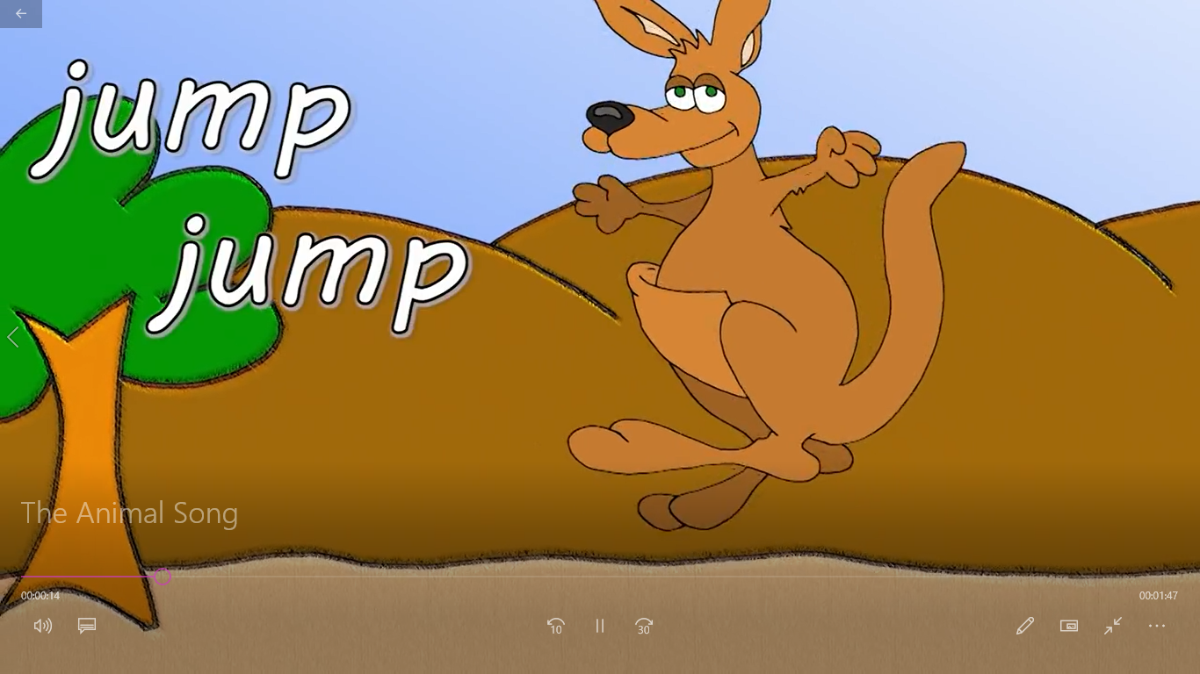  Open your Pupil’s book on page 51.  Ex.11 Listen and circle. Point and say. |  |  |  |  | PB  Video material  https://www.youtube.com/watch?v=wCfWmlnJl-A
End  5 min  (W) | Reflection  - What did we do today on the lesson?  -What new did you know?  Repeat sizes with children.  Give them a positive assessment.
Additional information
Differentiation – how do you plan to give more support? How do you plan to challenge the more able learners? |  | Assessment – how are you planning to check learners’ learning? |  | Health and safety check  ICT links
- more support can be given during elicitation, instruction and questioning phases of the lesson by nominating learners to answer items relating to more high frequency vocabulary to build confidence through participation. |  | - through questioning and the redirecting of questioning in feedback activities  - through observation |  | - Art  - World around us
Reflection
Were the lesson objectives/learning objectives realistic? Did all learners achieve the LO?
If not, why?
Did my planned differentiation work well?
Did I stick to timings?
What changes did I make from my plan and why?
Summary evaluation
What two things went really well (consider both teaching and learning)?
1:

2:

What two things would have improved the lesson (consider both teaching and learning)?
1:

2:

What have I learned from this lesson about the class orachievements/difficulties of individuals that will inform my next lesson?

