Short term plan

Checked up:________________

Long-term plan unit: Unit 6  Entertainment and media |  | School: I.Rybalko
Date: 14.02.18 |  | Teacher name:Kasenova A
CLASS: 7 |  | Number present: | absent:

Theme of the lesson : Structure and criteria for a good film review
Learning objectives(s) that this lesson is contributing to | * 7.C 7 develop and sustain a consistent argument when speaking or writing  *7 .L 2 Understand with little support most specific information in extended talk on a limited range of general and curricular topics  *7. S3 give an opinion at discourse level on growing range of general and curricular topics  *7 .S 6 begin to link comments with some flexibility to  what others say at sentence and discourse level in pair,  group and whole class exchange
Lesson objectives | All learners will be able to:
- Pronounce and understand the key words and phrases : I like /don’t like …because ;
describe photos of actors and actresses
 | Most learners will be able to:
 | - Make basic personal statements about films:
Some learners will be able to:

Think up in groups which films are worth to be seeing.

Criteria | * express opinion about films when speaking and writing  * understanding with little support most specific information about films and film genres in extended talk  * giving an opinion at discourse level on growing range of general and curricular topics  * Discuss in pair or groups films and make criteria for a good film
Level of thinking skills | Knowledge, understanding, application, analysis, synthesis, assessment.
Value links | National unity, peace and harmony in our society. Respect and cooperation by:  1.Listening to the teacher  2.Listening to each other  3.Help each other  4.Encourage each other
Cross curricular links | - Self –Knowledge
ICT skills | - By teacher only
Health and safety | To compliance security in the classroom
Previous learning | TV- programmes
Plan

Planned timings |  |  | Planned activities |  | Resourses
Beginning | GREETING  Teacher greets students; students respond to greeting and take their places.  Hello, children! How are you?  Previous learning Favorite heroes  Teacher sticks cards with a picture of film stars on the back of some pupils so they can`t see them and they ask questions to guess “Who is the hero?”.  Lead-up: Look at the blackboard . You can see different pictures , different quotations by famous people.  Can you guess what the subject of our today’s lesson is. What are we going to speak about?  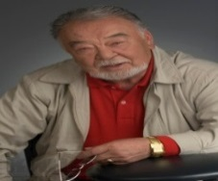  1.Do you watch films?  2.How often do you watch films?  3.What film genres do you like to watch?  4.What film genres do you know?  Descriptor: a learner  a) answers the questions
Middle  End | Task1 . Students listen to the words and identify what topic they belong to? According to these words can you guess what is our theme?  documentary, soap opera, drama show  the news, weather, quiz show, cartoon  fashion show, chat show, sport game  comedy show, play, film, children’s programme  music programme, police drama, nature programme  Vocabulary work.(English-English)  1. Plot --the story of a book, film, play  2. Scenario—a written outline of a film, novel, or stage work giving details of the plot and individual scenes  3. Budget –to show how to spend or to earn money  4.Special effects --special effects are illusions on visual tricks used in the film, TV, theatre, video, game  5. Genre --a style of category of art, music or literature  6. Director --The person who decides how it will appear on stage or screen and who tells the actors and technical staff what to do in a play, film or TV programme  .  Task 2.Pair work: Discuss with your partners films like or don`t like.  Ex; My favorite film is… because….  I like the film….. because…  I don’t like the film…. because…  Descriptor:  Gives an information about films he/she likes.  Gives an information about films he/she doesn`t like.  Task 2. Watch the extract of Kazakh film “Zhauzhurek min bala ”.  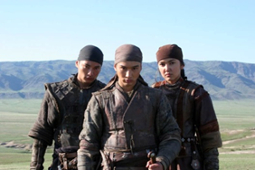  Define the genre of the film.  Name and describe the main heroes. Say some words about the plot of the film. Why is this film considered as the National Property?  - What is the title of the film?  - What type of film is it?  - Is the film based on a book?  - Who is the director of the film?  - Who plays the main parts in the film?  - Who are the main characters?  - Where does the action take place?  - Do you recommend to see it?  Descriptors:  Define the genre of the filmName and describe the main heroes  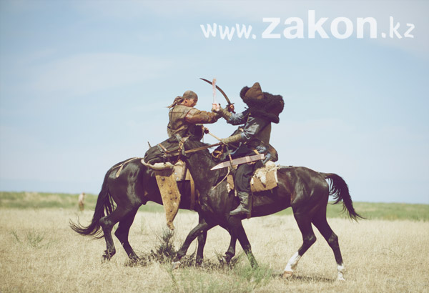  Says some words about the plot of the film.  Task 3. Discuss in groups which films are worth to be seeing. Make your own criteria for the good film.(Presentation)  Descriptors:  - Discuss or groups  - characteristics of a good film.  - .Make their own criteria for the good film.(Presentation)  - Creativity  Homework: Assess on the base of your criteria “ Taxi ”  Feedback : “Star alley”  Leaners should show their mood with Estimate “STAR ALLEY”  Excellent- Clap your hands up  Good- Clap your hands in front of you  Satisfactory- Clap your hands down |  |  |  | Cards,  Pictures,  Photos.  http//kino24.kz
Additional information
Differentiation – how do you plan to give more support? How do you plan to challenge the more able learners? |  |  |  | Assessment – how are you planning to check learners’ learning? | Health and safety check  ICT links
More able learners will be Think up in groups which films are worth to be seeing.  - More support will be given to weaker learners Pronounce and understand the key words and phrases : I like /don’t like …because ;  - describe photos of actors and actresses. |  |  |  | - through questioning and the redirecting of questioning in feedback activities  - through observation in speaking skills  - through formative task | - White board is used no more than 10 minutes  - Use water based pens  - Health promoting techniques  - Breaks and physical activities used.  - Points from Safety rules used at this lesson.  - Use video 5 minutes
Reflection  Were the lesson objectives/learning objectives realistic?  What did the learners learn today?  What was the learning atmosphere like?  Did my planned differentiation work well?  Did I stick to timings? What changes did I make from my plan and why? |  | Use the space below to reflect on your lesson. Answer the most relevant questions from the box on the left about your lesson.  STAR ALLEY  Leaners should show their mood with Estimate “STAR ALLEY”  Excellent- Clap your hands up  Good- Clap your hands in front of you  Satisfactory- Clap your hands down
Summary evaluation
What two things went really well (consider both teaching and learning)?
1:
2:
What two things would have improved the lesson (consider both teaching and learning)?
1:
2:
What have I learned from this lesson about the class or individuals that will inform my next lesson?

