Summative Assessment for Term 4

Name ________________
Task 1. Look and complete.

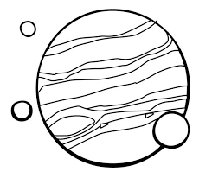 | 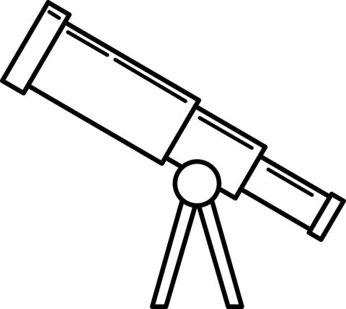 | 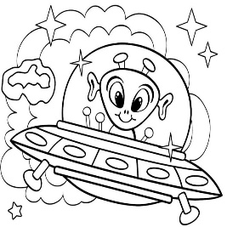 | 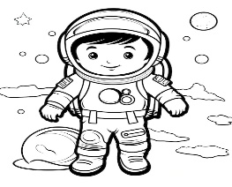 | 
p - - - - - | t - - - - - - - - | a - - - - | a - - - - - - - - | r - - - - -

Marks 5
Task 2. Complete the dialogue using the expressions in the box.

-Where is he? - Why is he tired? -Who is he? -What does he wear?

1.________________________________________________
- He is an astronaut.

2. _________________________________________________

- He is in space.
3.__________________________________________________
- He wears spacesuit.

4. __________________________________________________
- Because he is visiting Mars now.
Marks 4

Task 3. Read and complete. (bike, coffee maker, washing machine, sewing machine)

People put water in me. Then they put coffee in me to make a drink. | ________________________________
People sit on me. They use my pedals to move and get where they want to go. | ________________________________
People use me to make clothes. | __________________________________
People use me to wash their clothes | ________________________________________

Marks 4
Task 4. Fill in made or used. Then match.

0 C It’s made of metal. It’s used for telling the time. | A) belt
1__. It’s_________ of wax. It’s _______ for lighting a room. | B) scarf
2.__It’s _______ of wool. It’s _________ for keeping you warm. | C) watch
3.__ It’s___________ of leather. It’s ________for keeping trousers up. | D) candle
Marks 3Total 16

