Akhmetbekova D. Zh.
English teacher
School-gymnasium №4
Nur-Sultan city
The Methodology of Projects
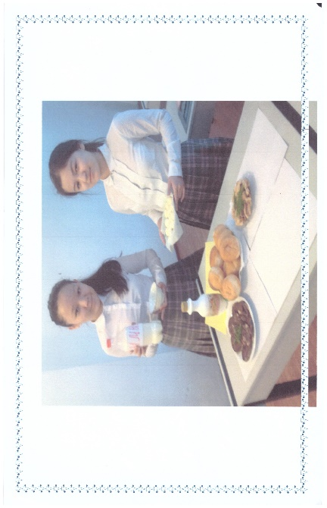
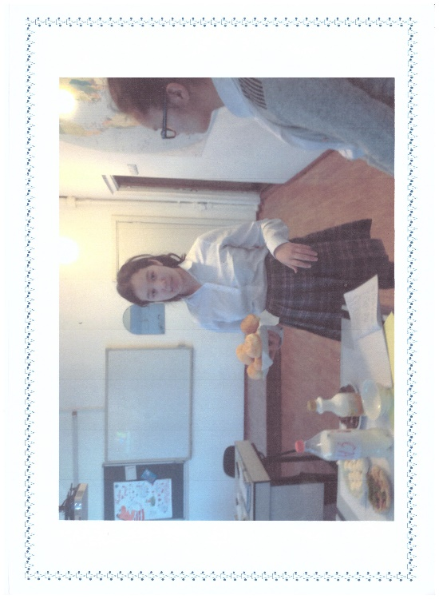
Time is going on… and what should we do? The life is passing, everything is changing in a second, minute, hour. Of course, nothing is stopped. The 21 century requires new methodologies, approaches, methods, devices in teaching and learning. For my being a teacher I have used in my practice many of them, because it is demanded by new time and epoch. In this case, mostly the teachers need to change. Why? We need to change because it is our mission, because we understand intuitively the value of steady learning, we are interested in imparting our knowledge to the growing generation, because we understand that learning is grown dynamically and we are used to work hard and long hours, because our world is changed and we love our pupils and teaching. We know they need us and we should direct them forward in this changeable world. So, in my practice I chose the methodology of projects. It is one of the 21st century’s progressive and developing technology. Nowadays, it is noticed the decreasing of interest to the learning of English language, though the knowledge of it is necessary in the world. So I’ve chosen this method, because I consider it is one the effective way in teaching of speaking. The project of learning helps children to rise their motivation to subject and to be interested in learning of English language. But before using this kind of work the teacher should think over it thoroughly, plan and elaborate it. During the practice the teacher becomes children’s consultant and supporter, warm and confident relations are set between teacher and pupil. Pupils present their work to mates than, to teacher and it is oriented to the practical result. The project work usually has many aims, which are overwhelmed during the preparation. They are: it is promoted to be self- confident, to be competent and capable. It is developed positive image of a person, critical thinking, the spirit of team and friendship, communicative and collaborative features, the ability of finding the way of solution of some problems, and research work, analytical thinking. Of course, this technology should be realized in our practice work. The project work has usually two forms: individual, when every student prepares the work from the beginning up to the end by himself (seeks, finds, researches, compares, thinks over, analyses, evaluates) and at the end present it before class, and there is the other form of PW (project work): in team or a group. Team work has also some advantages: no leaders, everybody are equal, kindly relations, self-confidence, support each other, active contribution to work. I usually use the projects methodology in more profiled class where pupils can speak English well, in order to sum up the knowledge of the last unit or material. Of course, these children should have creative and communicative dexterities, know how to use speaking cliché, and flair for expressing own opinion. I’d like to write about one of the lesson of project work in the 8th form, Unit 8 “Food and Drink”, ‘Eyes Open 4’. First of all, the pupils studied all appropriate vocabulary and grammar then did some exercises in order to practice. In order to formulate problem, they prepared the answers to the next questions first of all: “What do we eat every day? “, “What do you know about dangerous food?”, “Can you classify healthy and unhealthy food?” At the end, they elicited the problem: “How can we feed the growing population of the planet in future?” To solve this global issue, they proposed different ways, they suggested many possible variants. The most effective and realistic was: “Vertical and Traditional farming”. At the lesson pupils presented so many interesting and rational projects and posters, tables and charts that I was endless surprised. Of course, the presentation of project can’t be limited by one form, and after it students expressed their own opinion, agreement and disagreement, evaluated, analyzed, discussed, debated using arguments and following the ethics. In conclusion, pupils chose the most interesting project, according to their points of view. At the end I accessed the pupil’s activity, project and presentation. It goes without saying, that in this kind of work there were some challenges: the low level of language and no involvement of some children in discussion, the lack of time, non- ordinary form of the activity, low motivation. But in spite of all difficulties we continue using this technology because it’s ending result- to speak English.

