LESSON: Module 5 lesson 1 Musical instruments |  | School: P. Vikhrev
Date: 21.02.2020 |  | Teacher name: Yakup S.I. Rahmanova SH
CLASS: 3 “A” |  | Number present: | absent:
Learning objectives(s) that this lesson is contributing to |  | 3.2.1.1- make basic statements which provide personal information on a limited range of general topics  3.1.3.1- understand the main points of short, slow, carefully articulated talk on a limited range of general and some curricular topics  3.1.1.1- understand short supported classroom instructions in an increasing range of classroom routines
Aims |  | To talk about musical instruments.
Previous learning |  | Learners will need to be familiar with/reminded of the formation and use of present simple questions, has got and there is structures, the use of demonstrative pronouns and short answers (me too, I don’t).
Cross-curricular links |  | Music Art
ICT skills |  | Using videos& pictures, working with URLs
Plan

Planned timing | Planned activities (replace the notes below with your planned activities) |  |  | Resources
Start  5 min  30 Middle  minutes | Organizational moment  - Good morning Children  - Nice to see you  - Are you fine? Are you ok?  Children, do you like music? Jazz, rock, pop, classical?  Today we`ll speak about musical instruments  - So , the aims are:  - To name M.I  - To write the names of M.I  - To speak about M.I…  Are you ready?  Psychological mood  Children let`s to each other good luck.  Phonetic drill.  Piano  Drum  Guitar  Violin  Kobyz  Zhetygen  Saxophone  Tambourine  Accordion  Recorder  Dombra  Descriptor:  - Students listen to music sound and write the name of the musical instrument on a puzzle part.  Task № 1  So, listen to me. You have 6 parts of a big puzzle. Every puzzle has a number. So, listen to music and write the name of the M.I on it.  For example, music №1, part №1  Are you ready!  Let`s start  Music №1 and part №1.  Music №2 and part №2  Music №3 and part №3.  Music №4 and part №4.  Music №5 and part №5.  Music №6 and part №6  Descriptor:  - Students listen to music sound and write the name of the musical instrument on a puzzle part.  Assessment: self-assessment  Now, check yourself.  - It is piano,  - a guitar,  - a violin,  - a drum,  - a saxophone,  - an accordion.  Task 2  - Now put all parts together.  - What instrument do you have?  - It is a national Kazakh instrument.  Descriptor : students put all parts together and get a musical instrument  Assessment: self- assessment  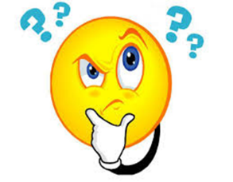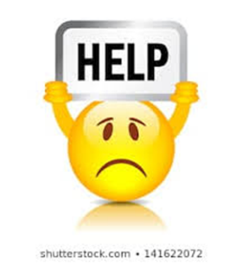  Task № 3  Read the text  The history of dombra  The dombra is a musical instrument and a national symbol of Kazakhstan. It has got a wooden body, a long neck and two strings. People use it to play traditional Kazakh music. The dombra is thousands of years old, but no one is sure exactly where it comes from.  Task №4  True or False  - 1 The dombra is a musical instruments T  - 2 The national symbol of Russia F  - 3 There are four strings F  - 4 People use it to play traditional Kazakh music T  - 5 It`s made of wood T  - 6 It`s neck is short F  Descriptor: students remember questions and try to give full answers  Assessment : self- assessment  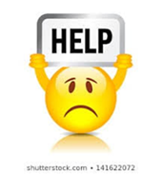  Физкультминутка  Task 5  Time for clil  Crossword the Musical instruments :  - Kobyz  - Violin  - Zhetygen  - Guitar  - Drums  - Recorder  - Dombra  Descriptor: students remember questions and try to give full answers  Assessment : self- assessment  Task 6  Now use the letter from the shaded squares to complete the sentence below.  Descriptor: students remember questions and try to give full answers  Assessment : self- assessment |  |  | Presentation  Video  Presentation  Puzzle  Crossword
End  5 minute | Now, let`s remember our aims  - I know M.I  - I can write them M.I  - I can speak about them M.I  «Weighing scale»  I can I can’t  Take your note. Come here and if you can put here, if you can`t put here.  Ok, great …  Thank you 1

