Lesson plan
Journey into Space
Module: | Journey into Space
Teacher: | Raspayeva Ainur Zhumashevna
Date:

Class: 4 | Number of students present: | Number of students absent:
Theme: | Journey into Space. Unit Revision
Learning objectives: | 4.4.7.1 spell most familiar high-frequency words accurately when writing independently;  4.3.5.1 understand the main points of short simple texts on a growing range general and some curricular topics by using contextual clues;  4.4.1.1 plan, write and check sentences with support on a range of basic personal, general and some curricular topics;
Lesson objectives: | Students will be able to:  - revise the active vocabulary of the Unit;  - work in groups;  - make a Dream Planet Booklet and speak about it.

Plan
Этапу рока/ Время  Stages | Действия педагога  Teacher’s actions | Действия ученика  Student’s actions | Оценивание  Assessment | Ресурсы  Resources
Beginning | T / М  - Good afternoon, children!  The teacher organizes the speech drill at the beginning of the lesson  - Answer my questions:  What day is it today?  What date is it today?  What is the weather like today?  What season is it now?  What season do you like?  I think we can start our lesson.  - And now, let's remember our tongue twister.  The teacher presents the topic of the lesson and the lesson objectives; asks them to read.  The topic of our lesson: Unit Revision (Journey into Space)  The lesson objectives are:  - revise the active vocabulary  - work in groups  - make a Dream Planet Booklet and speak about it | Ss / О  - Good afternoon, teacher!  -answer the questions of the teacher; tells the day, date, speak about the weather and their favourite season.  - tell a tongue twister  - discuss the topic of the lesson and the lesson objectives | Teacher’s assessment  PPT | Blackboard  PPT
Middle | Division into groups. Method “Puzzles”  The teacher divides Ss into groups by giving them pieces of a picture; asks them to find other pieces and make a whole picture; explains that according to the picture they should name their group.  The Sun  The Earth  The Moon  The teacher asks the Ss to perform movements and pronounce phrases - So, we are going on our journey into space. Fasten your seat belts! Start the engines! There is a contact! 5-4-3-2-1! Let's go!  The teacher asks the Ss to revise the names of planets, gives them different tasks on the revision of planets.  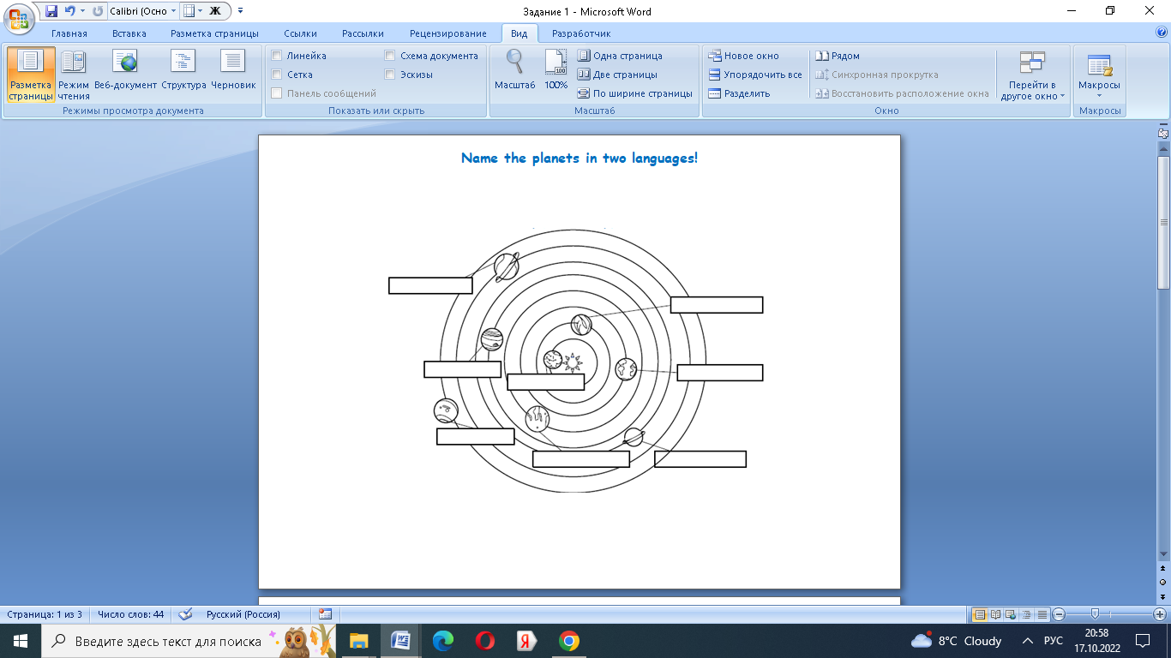  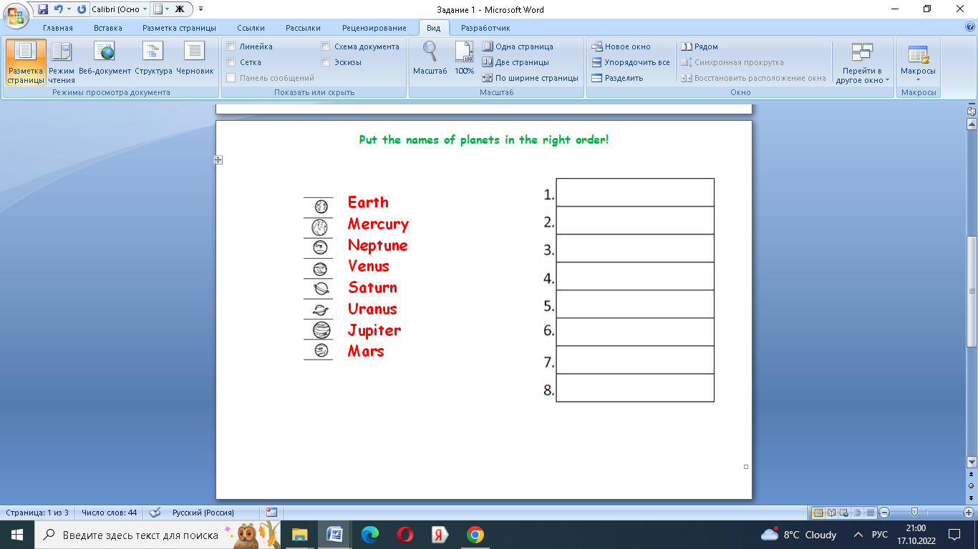  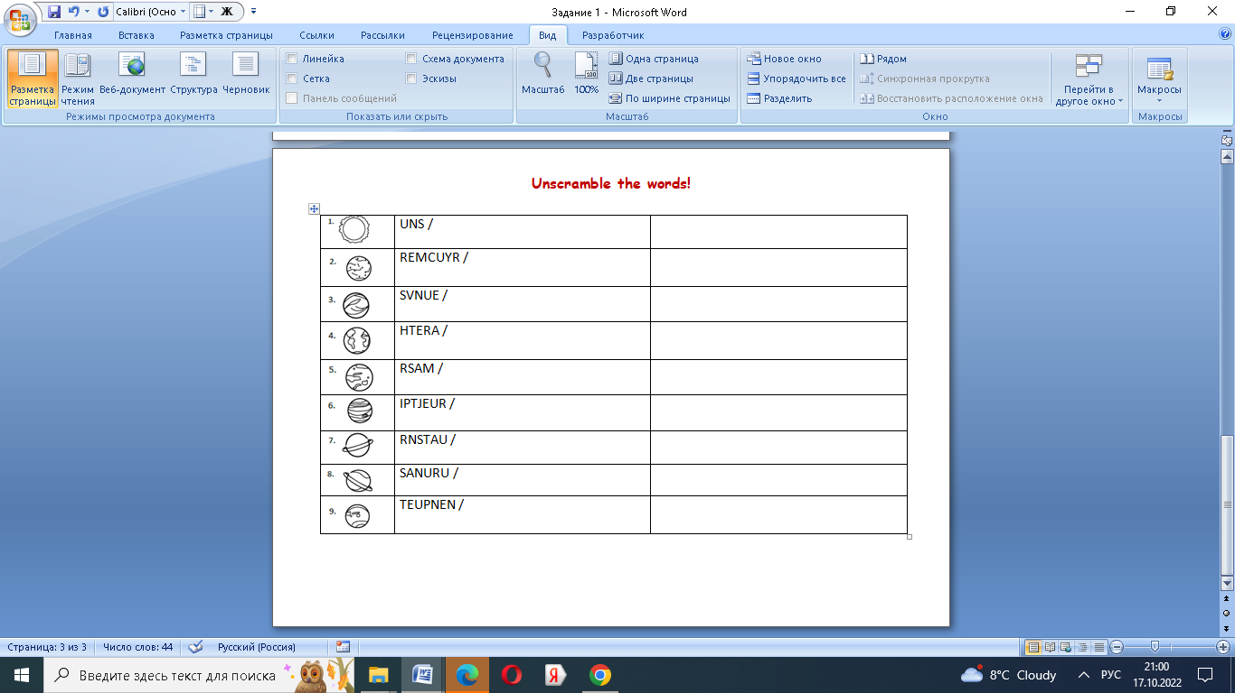Method “Game goal”  - And now please I want you to revise the names of planets! Please these tasks are for you. You have one minute to do the tasks.  The teacher prepares students for the project work, introduces students the information about three significant planets, gives a task to fill in the gaps in the text, then checks the correctness of the tasks. The teacher explains that according to the structure of these texts, children will create their own booklets.  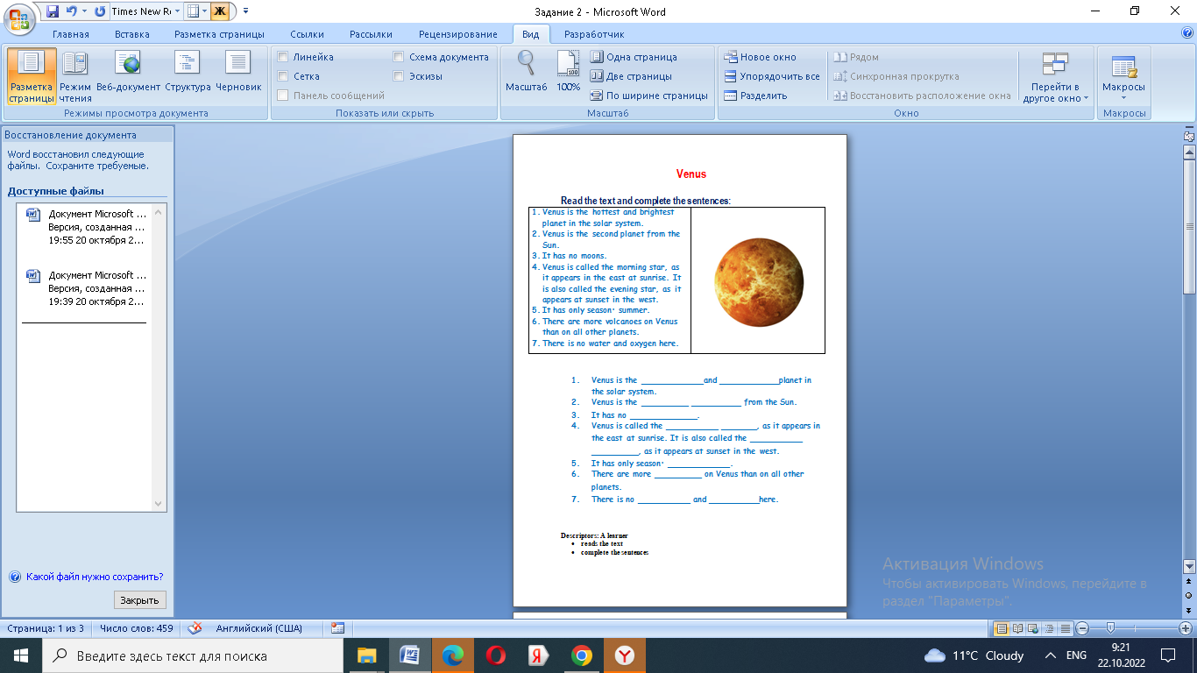  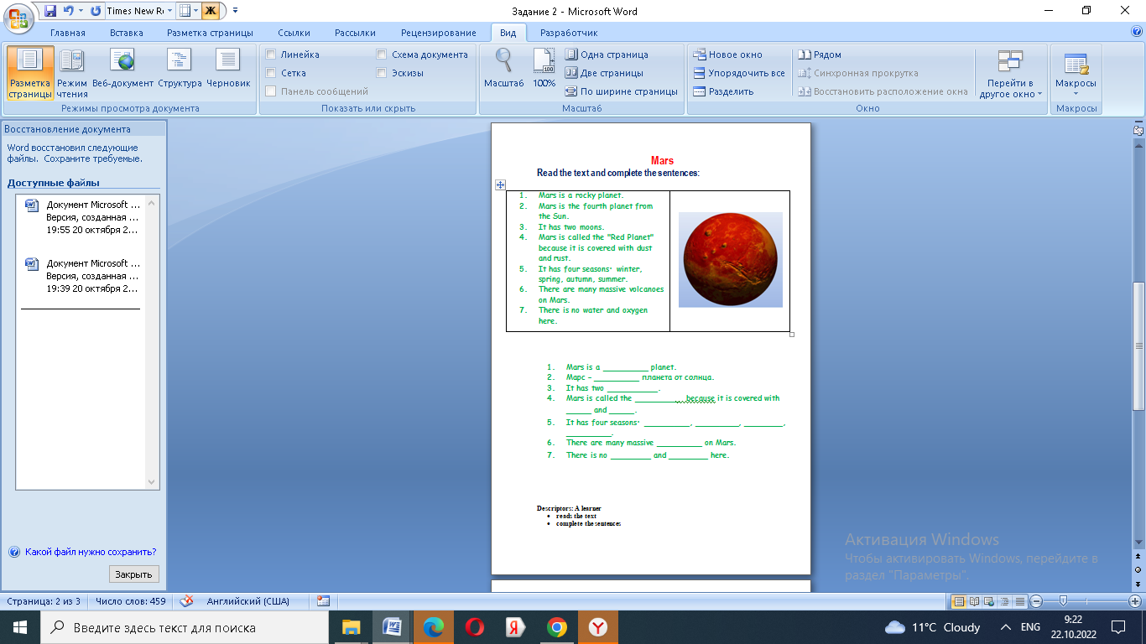  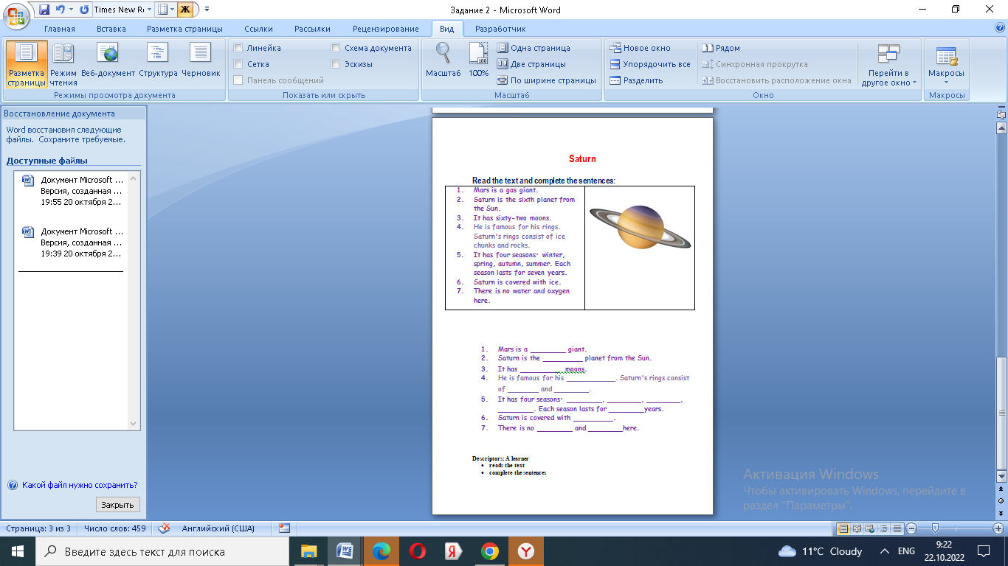  The teacher explains the task; asks the Ss to make a Dream Planet Booklet; explains that they should draw a Dream Planet and speak about it according to the model text from the previous task.  The teacher asks the rest to evaluate each other.  The teacher uses the method “Fantastic supplement”  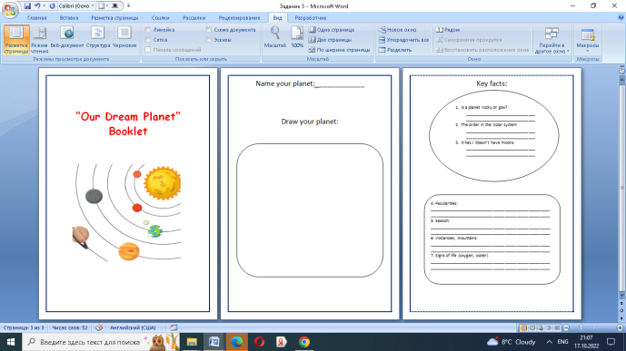 | - find pieces of the picture; according to the picture name their group.  - perform movements following the teacher and pronouncing words after her  - get different tasks on the names of planets; revise the planets.  - Mercury  Venus  Earth  Mars  Jupiter  Saturn  Uranus  Neptune  - prepare for project work, read texts about the three planets, insert missing words and phrases into the sentences.  Listen to the task; make a Dream Planet Booklet; draw a Dream Planet and speak about it according to the model text from the previous task. Present their booklets to the rest of the class | Teacher’s assessment  TA  Peer-assessment  Texts about planets, tasks on the cards
End | The teacher asks Ss to analyze the work done by telling whether the lesson objectives were fulfilled  The teacher asks students to analyze whether all the objectives of the lesson have been achieved  The teacher asks Ss to reflect their work at the lesson by drawing the pictures of the Sun.  Method “Color chart”  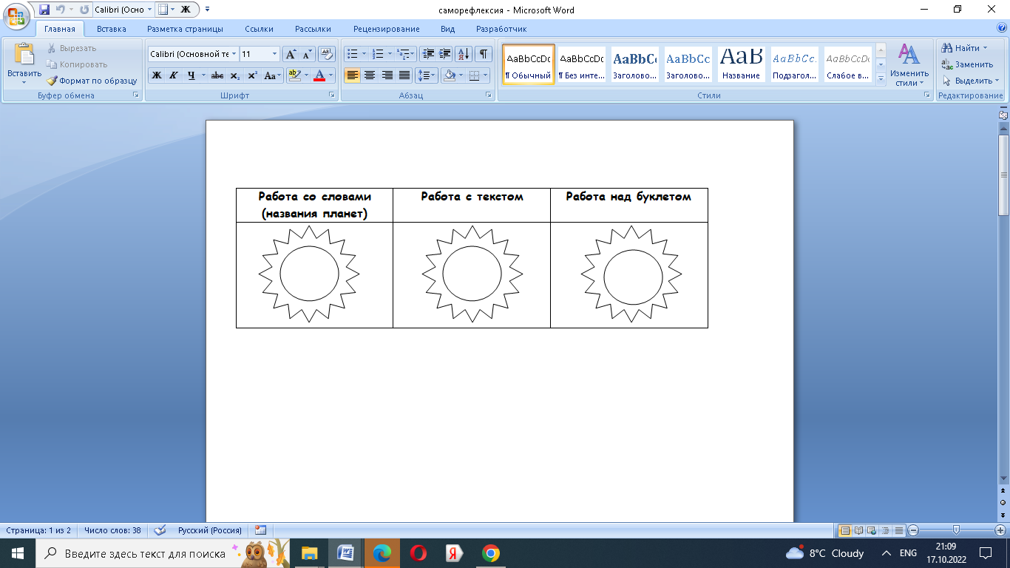 | tell whether the lesson objectives were fulfilled  Students analyze the objectives of the lesson  Ss reflect their work at the lesson by drawing the pictures of the Sun. |  | Interactive whiteboard

