Teacher: | Aslanova Chinara Kanan | Date:
Unit: Reading for pleasure
Lesson:
Grade: | 8 A, B, V

Theme: | Books and films: features
Learn objectives | 8.C7 develop and sustain a consistent argument when speaking or writing  8.L2 understand with little or no support most specific information in extended talk on a wide range of general and curricular topics  8.S7 use appropriate subject-specific vocabulary and syntax to talk about a range of general topics, and some curricular topics
Lesson objectives: | All learners will be able to:  -ask and answer the question  -can say about genres  Most learners will be able to:  -use most of new vocabulary in the speech without support  Some students will be able to:  - use most of new vocabulary in the speech without support  -complete most of tasks correctly with no support
Value links | A secular society with high spirituality
Cross curricular links | Literature
Previous learning | Cinema
Plan  Beginning the lesson | The lesson greeting.  The teacher sets the lesson objectives, letting students know what to anticipate from the lesson.  Teacher uses method: Brainstorm  Teacher ask questions and students answer:  1 What is the title of the last book you read?  2 Who is your favourite book character?  3 Why is reading a book better than watching moving?  4 What kind of film or book genres do you know?  Teacher gives students pictures about films, books, cartoons and magazine; then students choose one of them. If the student takes picture of the book he/she is in the group of “Books”. If the student takes picture of film he/she is in the group “Films’.
Middle  Writing and reading | Read text and find specific information  (T-S) Presentation of the new words  Teacher presents new words that they need in whole lesson, then ask them by choral and individual drill  Teacher uses method: “Jigsaw reading”  Magazines  Cartoons  Books  Films  Task. 1 Reading task . “Books and films: genres”  Teacher gives worksheets with the text and students read and share their knowledge to other group through Jigsaw strategy  AFL “with fingers”  Students change their groups  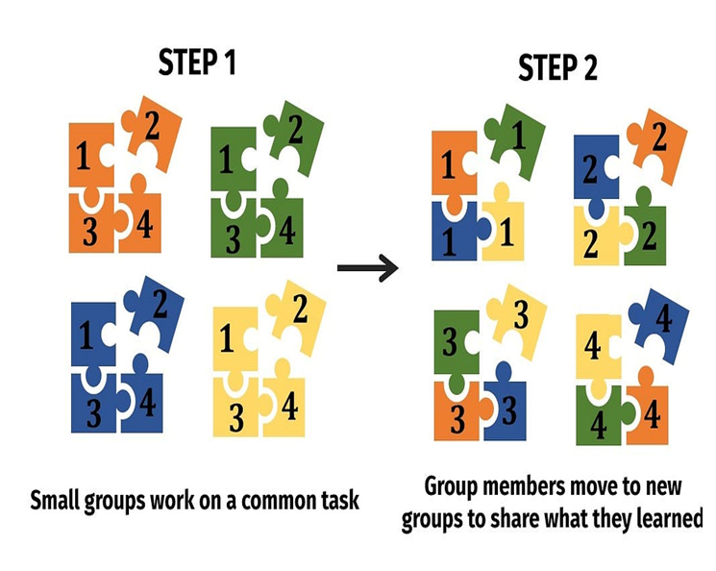  Task 2 . Writing and Speaking task  Teacher uses method : Venn Diagram . Teacher gives paper with Venn Diagram, students write what are the different between book and film genres  AFL “with smiles”  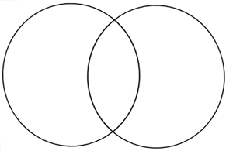  Assessment criteria Descriptor  Skim the text and identify the general information A learner: -Students read the text -Make a Venn Diagram from given text -Protect poster  Task 3. Writing task  Teacher uses method: Bloom’s daisy  Teacher gives each groups of daises in which answer are written. Every student is taking only one leaf and write question. Example: What is your favourite genre of books? My favourite genre is science fiction.
Reflection | Reflection and feedback:  Traffic light  Red – I don’t understand  Yellow – I have some questions  Green – I understand
Home work | Learn new information

