Short plan
Module | Unit 2: Communication and Technology
Teacher’s name: | Temirova T
Date:
Grade: | 7th
The theme of the lesson | Writing a formal letter about mobile phones being dangerous
Learning objective | 7.W5 develop with some support coherent arguments supported when necessary by examples and reasons for a limited range of written genres in familiar general and curricular topics
Lesson objective | develop with some support coherent arguments supported when necessary by examples and reasons for a limited range of written genres in familiar general and curricular topics
Assesment criteria | Learners can develop with some support coherent arguments supported when necessary by examples and reasons for a limited range of written genres in familiar general and curricular topics
Plan of the lesson
Planing | Teacher’s action | Pupil’s action | Evalution | Resource
Organization moment | Greating.Todays our lesson about writing a formal letter about mobile phones being dangerous.  Present Simple question | Greating with teacher  Ready to the lesson
Main part | New lesson  Exercise 2. Students book, p:19 . Find the hidden words  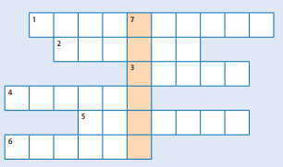  Exercise 3. Students book, p:19  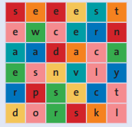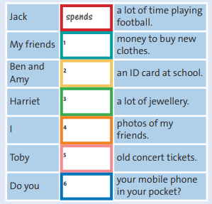 | Students read the text and write true or false  Students can understand meaning and many,much.  Do exercise to their copybook | Descriptor  Students can write an article and answer the questions. | Work book p:17
Reflection and conclusion | At the lesson  - know about holding a debate about technology.  - Can describe another earthquake for the school magazine.

