Lesson 31 Unit 3: Fantasy world |  | School: №9
Date: 17.11.2021 |  | Teacher`s name: Канатова Салтанат
Grade: 5 |  | Present: | Absent:
Lesson title: |  | There is, There are: questions and short answers
Learning objectives:  (оқу мақсаты) |  | 5.W1 plan, write, edit and proofread work at text level with support on a limited range of general and curricular topics  5.UE6 use basic personal and demonstrative pronouns and quantitative pronouns some, any, something, nothing anything on a limited range of familiar general and curricular topics
Lesson objectives:  (сабақ мақсаты) |  | All learners will be able to:  - understand and use a sequence of supported classroom instructions with teacher’s prompting  - communicate at sentence level during, pair, group and whole class supporting by peers  Most learners will be able to:  - communicate at sentence level during, pair, group and whole class exchanges with teacher’s some gestures  Some learners will be able to:  - use appropriate countable and uncountable nouns, including common noun phrases describing times and location, on a limited range of familiar general and curricular topics without any supports
 |  | Lesson plan
Stages/timing | Teacher’s  activity | Student’s  activity |  | Assessment | Resource
Beginning  5min  The new theme: 10 min  Do Ex: 5 min  Do ex: 8 min  Do ex: 7 min  Do ex: 5 min | Hello, students!  Write the date and theme of this lesson into your copybook.  Warm-up (2–3 minutes)  • Books closed. Remind students about the shopping  Centre and discuss whether they would prefer to go  shopping in a big shopping centre or in small shops in a  town.  Explain to the pupils how to use There is and there are in questions forms:  Open your book at page 31  Ex 1  Complete the questions in the table with words forms exercise 5 on page 26  Ex 2 p 31  Choose the correct words. Then write short answers.  Answers:  ANSWAnswers:ERS  1 Is 2 Is 3 Are 4 are 5 Is 6 Is 7 Is 8 are  New word:  Under – астында next to- келесі  Opposite- қарама-қарсы on- үстінде  Near – жанында in- ішінде  Ex 4 p 31  Study the prepositions. Then look after the pictures and complete the sentences.  Answers:  ANSWERS  1 in 2 on 3 under 4 next to 5 opposite 6 near  1 people / balls, sports shop 2 boys, door 3 shoes  4 balls, bags 5 t-shirts 6 bag | Students write the date, day and lesson objectives into their copybooks  Understand to pupils how to use there is and there are in question forms and answer with short answers.  For example:  - Is there a boy? Yes, there is or No, there is not  - Are there teachers in the class? Yes, there are or No there are not  Ex 1 p 31 Complete the questions in the table with words forms exercise 5 on page 26  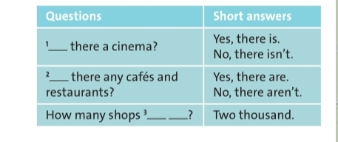  Ex 2 p 31  Choose the correct words. Then write short answers.  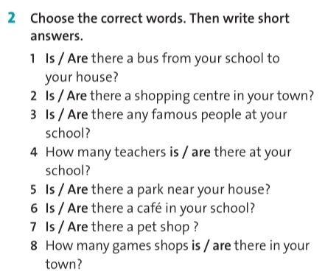  Ex 4 p 31 Study the prepositions. Then look after the pictures and complete the sentences.  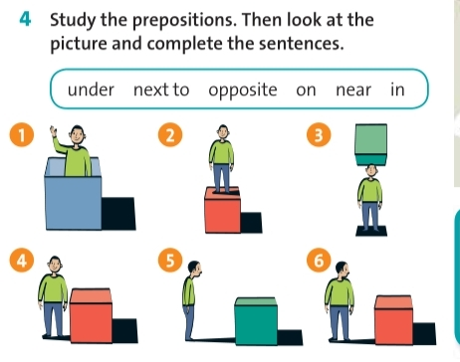  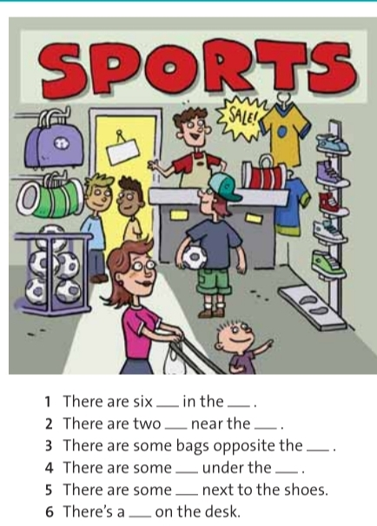 |  | Descriptor  Complete the table:  2 points  Descriptor  Choose correct words:  4- points  Descriptor  Put the prepositions:  4-pionts | English Plus , Grade 5, Student`s book p 31  English Plus , Grade 5, Student`s book p 31
End 5min | Reflection  Teacher asks learners  1) What was difficult to do at the lesson?  2) What do you need to work on?  . | Feedback  Learners complete an evaluation sheet of what they did during  the lesson writing a number in each statement or circling one word:  What activities are popular? |  | Descriptor:  If pupils do three exersicses correctly Total 10 points
Home task | Ex 6 p 31 Activate Draw your favourite shop then describe your own ideas

