|  |  |  |  |
| --- | --- | --- | --- |
| **Unit of a long term plan Helping and heroes** | | **School:** M.Kurmanova | |
| **Date:11.10.2022** | | **Teacher name:** Zeinalova D. | |
| **Grade: 6В** | | **Number present: 12** | **absent:0** |
| **Lesson title** | **Community Helpers in our life.** | | |
| **Learning objectives** | 6.4.1.1. Understand the main points in a growing range of general and  curricular topics  6.5.1.1. - Plan, write, edit and proofread work at text level with  some support on a growing range of general and curricular topics | | |
| **Lesson objectives** | **All students will be able to :**   * Explain and open the means of Community Helpers in our life. * Make a plan * Write according to the plan * Edit and proofread writing draft   **For students with special and individual need:**   * Find the definitions of means «Community Helpers in our life» * Make a plan, write according to the plan, edit and proofread writing draft with support and different resources | | |
| **Levels of thinking skills** | Knowledge and comprehension  High order thinking skills | | |

|  |  |  |  |  |
| --- | --- | --- | --- | --- |
| Stages / Time | Teachers actions | Students actions | Assessment | Resources |
| *Beginning*  *1 min*  *2 min*  *4 min*  *3 min* | ***Greetings***  Teacher greets learners, introduces the lesson objectives.  ***Lead – in***  *Ask students questions.*  Who are the Community Helpers in our life?  What these helpers do*?*    **Method of Associations**  the Community Helpers in our life.  Community Helpers in our life  Doctor  Teacher  Firefighter  ***Prediction:*** Students speak their ideas and associations on the topic.  ***Differentiation:***  ***Students with special needs*** *can answer by using given pictures.*  ***High achieving students*** *can answer to the questions, making own sentences without support.*  **Odd and one cut**  Teacher show 6 pictures of different helpers for students, and they should explain which one doesn’t belong with the rest and give a reason why? And ask students what these helpers do?  **Teacher gives extra support to student with special needs** by waiting time and given pictures.  Teacher encourages students to take pictures of «The Moon», «The Sun» and «The Earth» and divides into three groups. | *Students answer the questions*  *Students predict the topic of the lesson .try to raise students interest by visualizing and expand the topic by questioning*  *Whole class name their associations*  Students should find and say an extra picture and say why exactly it is extra.  Students should find and say an extra picture and say why exactly it is extra  Students divides into three groups | Assessment by questioning | **Handout 1**  <https://i.pinimg.com/originals/87/5b/d1/875bd18fa4cd8b00fb23928ff95955ad.jpg>  **Handout 2**  <http://profchoice.ru/atlas-professij/pozharnyj> <https://medcentr.biz/patients/articles/vrach-khirurg-chto-on-lechit/>  **Handout 3**  <https://ru.freepik.com/premium-vector/alphabet-flashcard-with-letter-m-for-the-moon_24967247.htm> <https://ru.freepik.com/premium-vector/vocabulary-flash-card-for-kids-sun-to-with-picture-sun_17847437.htm> <https://kids-flashcards.com/ru/free-printable/solnechnaya-sistema-razvivayushchie-kartochki-na-anglijskom> |
| 5 min  Middle  6 min  8 min  3 min  9 min  End  4 min | **Pre-reading task**  **Match the community helpers and definitions for them.**   |  |  | | --- | --- | | 1. Teacher | 1. A person who help sick animals | | 1. Doctor | 1. A person who protect us from fire. | | 1. Firefight | 1. a person who teaches, especially in a school. | | 1. Police-officer | 1. A person who catches thieves. | | 1. Vet | 1. A person who help sick people |  |  | | --- | |  | |  | |  | |  | |  |   Keys  1 C  2E  3B  4 D  5 A  **Differentiation by grouping**  (After completing the tasks , the groups exchange cards and check each other using the answer keys)  **Differentiation by resources.**  **Students with Special needs** will do this task using pictures with professions.  **While reading task**  Read the text.  Find out most important parts in the text and take notes.  **Differentiation by resources.**  Students with **Special needs** while reading can watch the video.  **Post-reading**  **Draw, explain, it is important and action.**  **Strategy «Gallery walk»**  **Descriptors:**   * work in a group * read the text * find out important parts * visit the gallery   **Students with Individual needs** can be a speaker when he defends the work from the group.  **Pre-writing**  Use the word box below to fill in the community helper sentences.  Hose/ hard hat/safe/ teeth/  medicine /letters/ books/ learn  A doctor gives us _________ when we are sick  A teacher helps you to ______ new things in school  A police officer helps to keep us _____.  A firefighter uses a ________ to put out fires  A builder wears a _________ on the job to stay safe  A librarian helps us check out ______from the public library.  A mail carrier delivers______ to your mailbox  A dentist helps to keep your ______ clean  **Differentiation by pace**  **When Ss with IN** completed his task he can help to check the assignment for a Ss with SN.  **Student with special need** will do another task  Task for Ss with SN  Ss with SN should cut and paste the correct tools for each helper.    **Writing**  **Write a short essay about**  **«Should we have community helps in our life?»**  **Descriptors**  work individually  **Differentiation by resources.**  Students with **Special needs** can use some information from the table  **Reflection**  **Ticket to exit the class**  Give Students a piece of paper with questions about their learning which they should answer and hand over to the teacher before they are allowed to leave the classroom  - what did you learn?  - what was unclear for you?  - what did you need to continue working on?  **Home task:** Find out some information about “Our Countryside” | Group work  **Individual work**  (Students will individually read the text and find important parts from the text and take notes.)  **Group work**  Students will work in groups, they need to work on together and present their ideas on a sheet. Once they have completed their poster, have them display it on the wall, much like at a scientific poster session. One of their group will stay with the poster and help to explain it as the class circulates to look at all of the posters. Students take turns standing by their poster so that each of them have the chance to visit the other groups’ posters.  **Criteria:**   * draw most important part   in the text  explain its importance  **Pair work**  Students should use the word box below to fill in the community helper sentences.    **Individual work**  Students will work individually, they need to write an essay on the topic  «Should we have community helps in our life?» using some criteria .  **Criteria:**   * choose one Community helper * write 5 sentences for providing idea   **Individual work**  Students should answer the questions and hand over to the teacher before they are allowed to leave the classroom | Peer assessment  **Pair discussion**  **Add ideas**    (Students in pairs will discuss important parts from the text and exchange ideas complementing each other)  **Peer assessment**  2 stickers  (1st red sticker What you liked)  (2st blue sticker Recommendations)  **Peer assessment**  using keys  **Peer assessment** | **Handout 4**  (worksheet)  **Handout 5**  (worksheet for Ss with special needs)  **Handout 6**  (Note sheet and text with pictures.)  **Handout 7**  (For Ss with SN)  https://youtu.be/GwcvYv_Tu3o  **Handout 8**  sheet of paper to complete the task in a group.  **Handout 9**  Worksheet for all Ss and Ss with SN  **Handout 10**  For Ss with SN (table) |

**Handout 1**

**For students with special needs**

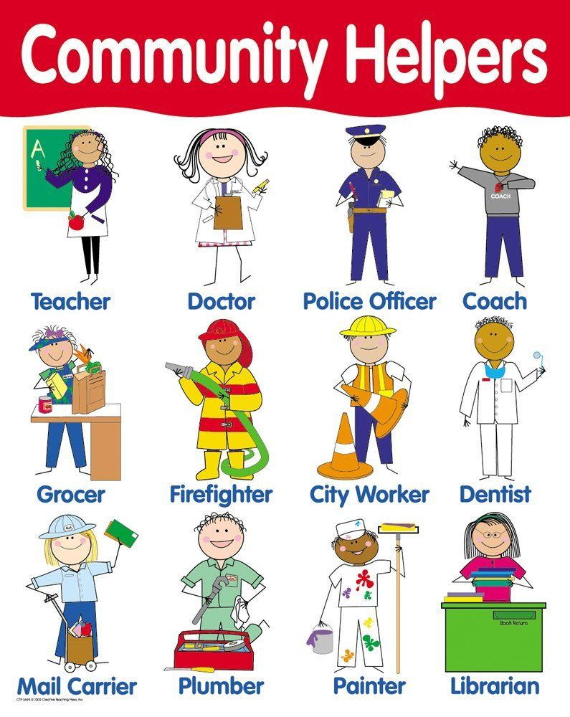

<https://yandex.kz/images/search?text=community%20helpers%20craft%20for%20kids&lr=29450&from=tabbar&p=17&pos=516&rpt=simage&img_url=https%3A%2F%2Fi.dlpng.com%2Fstatic%2Fpng%2F4233516-community-helpers-png-4-png-image-png-community-helpers-1055_793_preview.webp&rlt_url=https%3A%2F%2Fi.pinimg.com%2Foriginals%2F87%2F5b%2Fd1%2F875bd18fa4cd8b00fb23928ff95955ad.jpg&ogl_url=https%3A%2F%2Fi.dlpng.com%2Fstatic%2Fpng%2F4233516-community-helpers-png-4-png-image-png-community-helpers-1055_793_preview.webp>

**Handout 2 For all students**

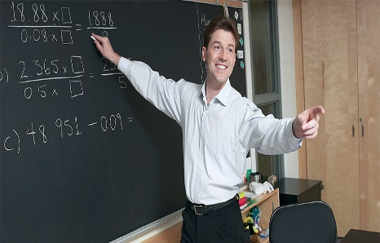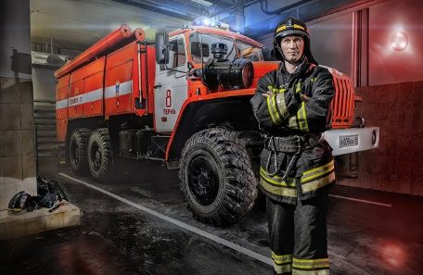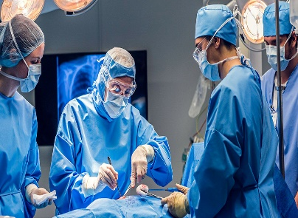

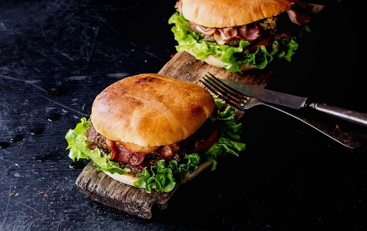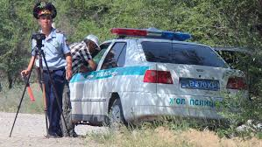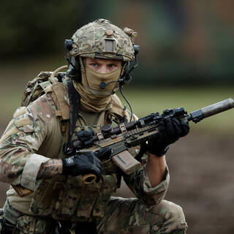

<http://profchoice.ru/atlas-professij/pozharnyj>

<https://medcentr.biz/patients/articles/vrach-khirurg-chto-on-lechit/>

<https://proforientator.ru/publications/articles/professiya-uchitel.html>

<https://www.delfi.lt/ru/misc/sex/eda-dlya-instagrama-kak-socialnye-seti-izmenili-nashi-privychki.d?id=76829355>

<https://kolesa.kz/content/articles/avtopark-politsii-v-kazahstane-vchera-i-segodnya/>

<https://lenta.ru/news/2021/05/10/france/>

**Handout 3 For all students**

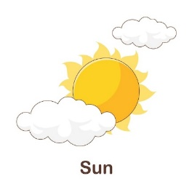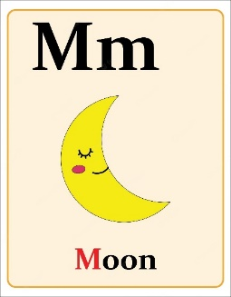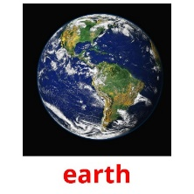

<https://ru.freepik.com/premium-vector/alphabet-flashcard-with-letter-m-for-the-moon_24967247.htm>

<https://ru.freepik.com/premium-vector/vocabulary-flash-card-for-kids-sun-to-with-picture-sun_17847437.htm>

<https://kids-flashcards.com/ru/free-printable/solnechnaya-sistema-razvivayushchie-kartochki-na-anglijskom>

**Handout 4 (For all students)**

|  |  |
| --- | --- |
| 1. Teacher | 1. A person who help sick animals |
| 1. Doctor | 1. A person who protect us from fire. |
| 1. Firefight | 1. a person who teaches, especially in a school. |
| 1. Police-officer | 1. A person who catches thieves. |
| 1. Vet | 1. A person who help sick people |

|  |
| --- |
|  |
|  |
|  |
|  |
|  |

**Handout 5 (For students with special needs)**

|  |  |  |
| --- | --- | --- |
| 1. Teacher | Профессия учитель - описание, где учиться и работать, плюсы и минусы  профессии, онлайн тесты | 1. A person who help sick animals |
| 1. Doctor | Врач-хирург: что он лечит и с какими симптомами к нему обращаться?. Сеть  медицинских центров и МЦ «Здоровье» в Москве. | 1. A person who protect us from fire. |
| 1. Firefight | Пожарный-2 | 1. a person who teaches, especially in a school. |
| 1. Police-officer | Автопарк полиции в Казахстане: вчера и сегодня — Kolesa.kz || Почитать | 1. A person who catches thieves. |
| 1. Vet |  | 1. A person who help sick people |

<http://profchoice.ru/atlas-professij/pozharnyj>

<https://medcentr.biz/patients/articles/vrach-khirurg-chto-on-lechit/>

<https://proforientator.ru/publications/articles/professiya-uchitel.html>

<https://kolesa.kz/content/articles/avtopark-politsii-v-kazahstane-vchera-i-segodnya/>

<https://lenta.ru/news/2021/05/10/france/>

<https://jivago55.ru/news/chto-dolzhen-znat-kazhdyy-veterinar-o-zhivotnyh.html>

**Handout 6 Reading For all students**

|  |  |
| --- | --- |
| **Community helpers are important people whose job it is to help others. Some examples of community helpers are teachers, firefighters, doctors, police officers, and veterinarians. There are many more community helpers than this, but these are just a few examples. . A teacher is an educator who works with people to help them learn. The teacher works at the school. They can teach in preschool, elementary school, middle school, high school, or even college. They use books to help them understand what to teach. A firefighter is a person who drives a large truck and puts out fires. They work in the fire department and wear yellow jackets. They use a fire hose to put out the fire. A doctor is a person who helps you when you are sick.The traditional dress of doctors is a white coat. Doctors work in doctor's offlmes and hospitals.** |  |

**Handout 7 For students with Special needs**

<https://youtu.be/GwcvYv_Tu3o>

**Handout 9** Use the word box below to fill in the community helper sentences.

Hose/ hard hat/safe/ teeth/

medicine /letters/ books/ learn

A doctor gives us _________ when we are sick

A teacher helps you to ______ new things in school

A police officer helps to keep us _____.

A firefighter uses a ________ to put out fires

A builder wears a _________ on the job to stay safe

A librarian helps us check out ______from the public library.

A mail carrier delivers______ to your mailbox

A dentist helps to keep your ______ clean

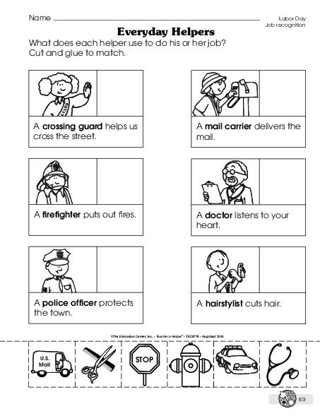

**Handout 10 Writing**

**For Ss with SN**

|  |  |  |  |  |
| --- | --- | --- | --- | --- |
| *Community helpers* | *Function* | *Location* | *Tools* | *Uniform* |
| *Teacher* | Help kids learn Teach children | *School* | pencil whiteboard projector Books | *Nice clothes* |
| *Doctor* | Help sick people | Hospital | bandages gurney medicine  cast | White  coat |
| Police Officer | Keep us Safe | Police Station | Radio Police Car Handcuffs Gun Flashlights | Hat Badge Blue Pant Boots |
| Fire Fighter | Put out fires | Fire Station | ladder Fire Truck Hose | Helmet Boots Yellow Jacket Yellow Pants |