|  |  |  |  |  |  |  |
| --- | --- | --- | --- | --- | --- | --- |
| **Short-term plan :**  **Unit 5 Hot and Cold** | | **School**: Secondary School № 3 of Tayinsha | | | | |
| **Date**: | | **Teacher:** Tastemir Zhanna Sanatovna | | | | |
| **Grade**: 4 | | Number present: | | absent: | | |
| **Theme of the lesson:** **Weather 1** | | | | | | |
| **Learning objective(s)** | | **4.L3** understand the main points of short supported talk on an increasing range of general and some curricular topics  **4.S5** respond to questions on a limited range of general and some curricular topics  **4.UE10** use common present continuous forms, including short answers and contractions to talk about what is happening now on a limited range of personal and familiar topics | | | | |
| **Lesson objectives** | | * Identify the main points of short dialogue with some support * Answer the questions on the given topic * Use present continuous forms and topical vocabulary to describe pictures | | | | |
| **Assessment criteria** | | * Recognize the meaning of short dialogue with some support * Give full correct answers to questions about weather * Describe pictures using present continuous forms and new words | | | | |
| **Value links** | | Labour and creativity, cooperation, lifelong learning | | | | |
| **Cross-Curricular links** | | Knowledge of the world | | | | |
| **Previous learning** | | Present continuous forms, special questions | | | | |
| Plan | | | | | | |
| Planned timings | Planned activities | | | | | Resources |
| Beginning  1-3 min | **GREETING** (Whole Class)  **WARM UP:**   * Learners watch a video “Rain, rain go away”   **BRAINSTORMING:**   * After watching a video learners should guess the theme of the lesson with helping of questions * What season do you like? * Do you like rain? * What is the weather like today?   **Teacher presents the theme of the lesson**   * Draws learners’ attention to the lesson objectives and makes sure they all understand them. | | | | | https://www.youtube.com/watch?v=HRJUGl1a1t8  PPT  Slide 1  Slide 2  Slide 3 |
| Middle  4-7 min  8-9 min  10- 14min  15-20 min | **Teacher gives constructions and examples of Present continuous tense to refresh learner`s knowledge** (Whole Class)   * Present continuous tense   **Learners listen and repeat after the teacher in chorus.**   * Drilling activity: new words of the lesson     **Exercise 1 Listening. Learners listen to the dialogue and do activity while listening.**(Whole Class)  **Listen to the conversation between Ann and Tony.**  — What is your favorite season, Ann?  — I like autumn. When it’s not too hot but not too cold. I also like when it’s raining. I think it’s the most beautiful season of all. And what about you, Tony?  — I prefer summer. I like to spend time outside, camping or just lying on the beach. I like when it’s hot and sunny.  — What about winter?  — I don’t like winter very much. It’s beautiful when it’s snowing but I don`t like cold weather.  **While listening activity.**(Individual Work)  **Choose True (T) or False (F)**  **Example: Ann likes summer.(F)**   1. Ann likes autumn, because it is not too hot and not too cold. 2. She thinks it`s the most beautiful season of all. 3. Tony prefers winter. 4. He likes skating and playing hockey. 5. Tony likes hot and sunny weather. 6. Tony doesn`t like winter. 7. He thinks it`s beautiful when it`s snowing. 8. Tony likes cold weather.   *Descriptors:* - Listen to the dialogue between Ann аnd Tony   * Read the statements * Сhoose True (T) or False (F)   *Pair assessment:* learners swap their works and check them using right answers on the slide.  **Exercise 2. Speaking. Work in pairs. Ask your partner and answer his/her questions orally** (Pair Work)   * What is your favorite season? * Why do you like it? * What do you like to do in (your favorite season)?   Descriptors: - Read the questions   * Ask your partner and answer his/her questions orally   *Assessment:* teacher assess by giving the sun – full right answers, the cloud – for partly completed answers, the snowflake – for not full answers  **Warm – up activity.**  Yes – stand up!  No – sit down! | | | | | Slide 4  Slide 5  Audio 1  https://vk.com/audios398400612  Worksheet 1  Slide 6  Slide 7  Slide 8 |
| 21-36 min | **Exercise 3. Use of English. Differentiated Task**(Individual Work)  **Teacher gives worksheets with differentiated tasks for all learners.**  **A level.** **Look at the picture and complete the sentences. Use verbs from the box in Present Continuous Tense.**   |  | | --- | | skating making feeding sitting looking flying  throwing hiding standing playing wondering snowing | | | | | | Worksheet 2 |
| End  37-40 min | C:\Users\admin\Desktop\81cfb6c98d97787a1f6892d4a1c55d5b.jpg  1. It is………today. 2. Children are ……. outside. 3. John is………..a snowman. 4. The dog is………..at the children. 5. Daisy is…………the birds. 6. The cat is………..on the snow. 7. Robert is…………snowballs. 8. The bear is……… behind the tree. 9. Tom is ……… how Sally can skate well. 10. The butterfly is ………over the snowman. 11. Sally is………  *Descriptors:*  1.Look at picture  2. Complete the sentences  3. Use verbs from the box in Present Continuous Tense.  **B level. Look at the picture and write answers to questions**  C:\Users\admin\Desktop\f9dd74d5127acf40006d6f9cd2025152.jpg  *Questions:*  1. Is Emily skating?  2. Is Andy sledding?  3. Are Elza and Anna making a snowman?  4. Is Sally lying on the snow?  5. Is James throwing snowballs?  6. Are John and Daisy making a snowman?  *Descriptors:*  1. Look at the picture and read the questions  2. Write answers to the questions  3. Use Present Continuous Tense.  **C – level. Describe the picture using present continuous form.**  C:\Users\admin\Desktop\e649cd32b4a8840b336f4ed772f7bbf6--hidden-words-in-pictures-word-pictures.jpg  *Descriptor:*  1.Look at the picture  2. Make up sentences to describe the picture  3. Use present continuous tense  *Assessment:* teacher assess learners by giving them cards with pictures:  The sun – great job!  The cloud – good work!  The snowflake – try better!  **Reflection**  Learners choose card with picture to show their mood:  SUN – It was clear!  CLOUD – I had some problems!  SNOWFLAKE – It was very difficult!  **Home task:**  Tell learners they must learn weather words – they will have a mini quiz on the words next lesson. | | | | | Worksheet 3  Worksheet 4  Slide 9  Cards with pictures  Slide 10 |
| Additional information | | | | | | |
| Differentiation – how do you plan to give more support? How do you plan to challenge the more able learners? | | | Assessment – how are you planning to check learners’ learning? | | Health and safety check | |
| Less able learners were given a support with constructions of Present Continuous Forms and words, questions. More able learners were challenged by describing picture with full sentences without any support. | | | Pair assessment: learners wrap up their works and check them using right answers on the slide.  Teacher assess by giving the sun – full right answers, the cloud – for partly completed answers, the snowflake – for not full answers  Monitoring their knowledge during whole lesson | | Using white board not more than 10 min  Physical activity | |
| Summary evaluation  What two things went really well (consider both teaching and learning)?  1:  2:  What two things would have improved the lesson (consider both teaching and learning)?  1:  2:  What have I learned from this lesson about the class or achievements/difficulties of individuals that will inform my next lesson? | | | | | | |

Worksheet 1

|  |  |
| --- | --- |
| **While listening activity.**(Individual Work)  **Choose True (T) or False (F)**  **Example: Ann likes summer.(F)**   1. Ann likes autumn, because it is not too hot and not too cold. 2. She thinks it`s the most beautiful season of all. 3. Tony prefers winter. 4. He likes skating and playing hockey. 5. Tony likes hot and sunny weather. 6. Tony doesn`t like winter. 7. He thinks it`s beautiful when it`s snowing. 8. Tony likes cold weather.   *Descriptors:* - Listen to the dialogue between Ann And Tony   * Recognize the words that are connected to the theme * Read the statements and choose True (T) or False (F) | **While listening activity.**(Individual Work)  **Choose True (T) or False (F)**  **Example: Ann likes summer.(F)**   1. Ann likes autumn, because it is not too hot and not too cold. 2. She thinks it`s the most beautiful season of all. 3. Tony prefers winter. 4. He likes skating and playing hockey. 5. Tony likes hot and sunny weather. 6. Tony doesn`t like winter. 7. He thinks it`s beautiful when it`s snowing. 8. Tony likes cold weather.   *Descriptors:* - Listen to the dialogue between Ann And Tony   * Recognize the words that are connected to the theme * Read the statements and choose True (T) or False (F) |
| **While listening activity.**(Individual Work)  **Choose True (T) or False (F)**  **Example: Ann likes summer.(F)**   1. Ann likes autumn, because it is not too hot and not too cold. 2. She thinks it`s the most beautiful season of all. 3. Tony prefers winter. 4. He likes skating and playing hockey. 5. Tony likes hot and sunny weather. 6. Tony doesn`t like winter. 7. He thinks it`s beautiful when it`s snowing. 8. Tony likes cold weather.   *Descriptors:* - Listen to the dialogue between Ann And Tony   * Recognize the words that are connected to the theme * Read the statements and choose True (T) or False (F) | **While listening activity.**(Individual Work)  **Choose True (T) or False (F)**  **Example: Ann likes summer.(F)**   1. Ann likes autumn, because it is not too hot and not too cold. 2. She thinks it`s the most beautiful season of all. 3. Tony prefers winter. 4. He likes skating and playing hockey. 5. Tony likes hot and sunny weather. 6. Tony doesn`t like winter. 7. He thinks it`s beautiful when it`s snowing. 8. Tony likes cold weather.   *Descriptors:* - Listen to the dialogue between Ann And Tony   * Recognize the words that are connected to the theme * Read the statements and choose True (T) or False (F) |

Worksheet 2

**Look at the picture and complete the sentences. Use verbs from the box in Present Continuous Tense.**

|  |
| --- |
| skating making feeding sitting looking flying  throwing standing playing wondering snowing |

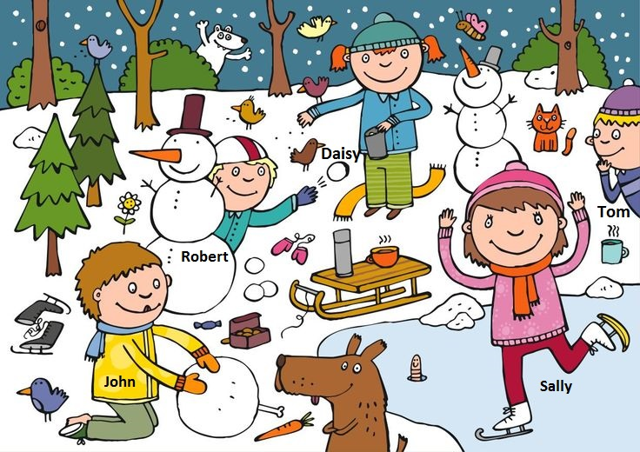

1. It is………today. 2. Children are ……. outside. 3. John is………..a snowman. 4. The dog is………..at the children. 5. Daisy is…………the birds. 6. The cat is………..on the snow. 7. Robert is…………snowballs. 8. Sally is………9. Tom is ……… how Sally can skate well. 10. The butterfly is ………over the snowman.

*Descriptors:*

1.Look at picture

2. Complete the sentences

3. Use verbs from the box in Present Continuous Tense.

Worksheet 3

**Look at the picture and write answers to questions**

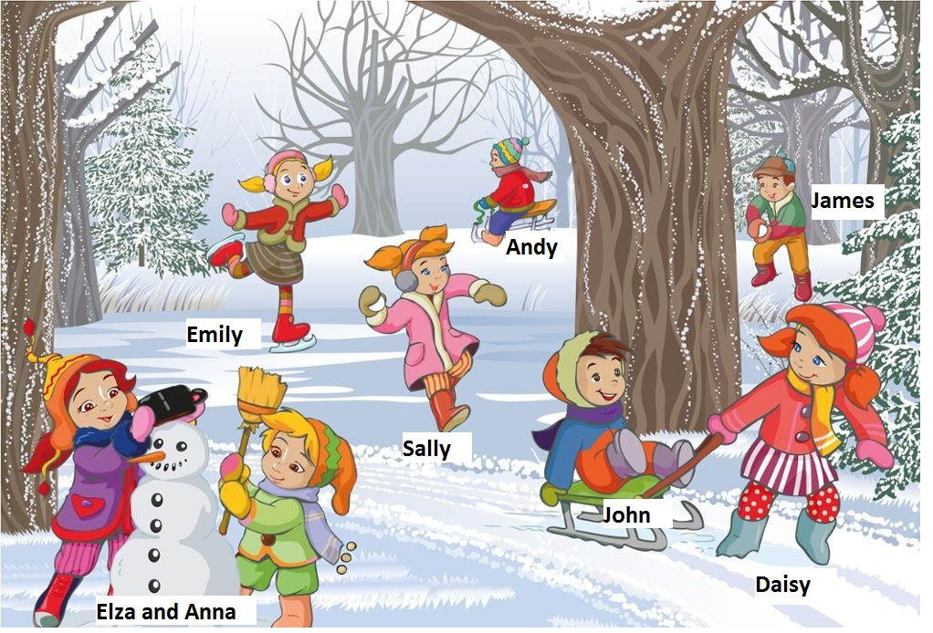

Example: Is Emily skating? Yes, she is.

*Questions:*

1. Are John and Daisy making a snowman?

2. Is Andy sledding?

3. Are Elza and Anna making a snowman?

4. Is Sally lying on the snow?

5. Is James throwing snowballs?

___________________________________________________________________________________________________________________________________________________________________________________________________________________________________________________________________________________________________________________________

*Descriptors:*

1. Look at the picture and read the questions

2. Write answers to the questions

3. Use Present Continuous Tense

Worksheet 4

**C – level. Describe the picture using present continuous form.**

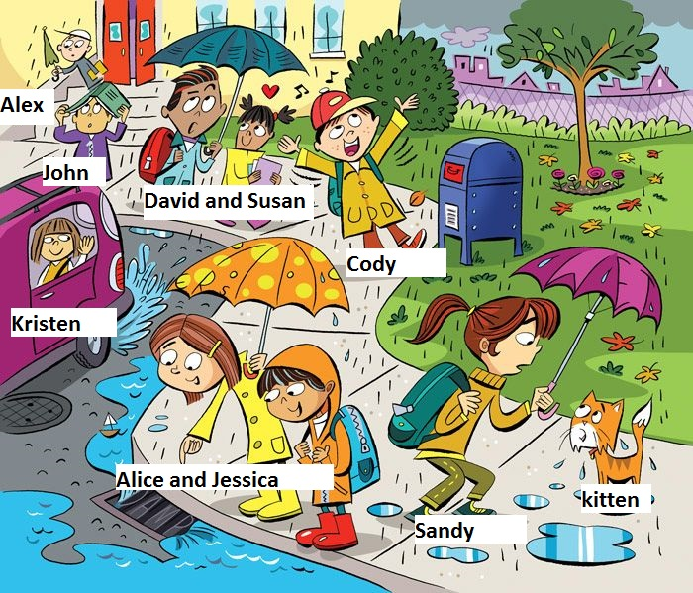

*_____________________________________________________________________________________________________________________________________________________________________________________________________________________________________________________________________________________________________________________________________________________________________________________________________________________________________________________________________________________________________________________________________________________________________________________________________________________________________________________________________________________________________________________*

*Descriptor:*

1.Look at the picture

2. Make up sentences to describe the picture

3. Use present continuous tense