Lesson plan

Unit of a long term plan:  Music and Film (Language with Content) |  |  |  | School:
Date: |  |  |  | Teacher’s name:
CLASS: 9 |  |  |  | Number present: |  |  | absent:
PDG |  | Developing reading literacy via interactive activities
Lesson title |  |  |  |  | Live Music
Learning objective |  |  |  |  | 9.L2 understand most specific information in unsupported extended talk on a wide range of general and curricular topics;  9.R6 recognise the attitude or opinion of the writer in extended texts on a range of familiar general and curricular topics;  9.R7 recognise typical features at word, sentence and text level in a wide range of written genres;  9.S3 explain and justify their own point of view on a range of general and curricular topics;
Lesson objectives |  |  |  |  | Revise previously taught vocabulary on the topic “Music”;  Practice in listening matching the speakers to the options;  Develop speaking skills explaining and justifying personal point of view while describing the favourite song;
Assessment criteria |  |  |  |  | Peer assessment
Values links |  |  |  |  | Respect peers’ opinions and ideas
Cross-curricular links |  |  |  |  | Art, other linguistic disciplines
Previous learning |  |  |  |  | Live Music
Plan
Planned timings | Planned activities (replace the notes below with your planned activities) |  |  |  |  |  | Resources
Lesson 1  Beginning  4 min  1 min | Warm-Up  (W) 1) T pays Ss’ attention to the pronunciation of some words from the quote;  2) Ss read the quote and the name of a person who said it;  3) Ss agree or disagree with it explaining their point of view;  T presents the lesson objectives. |  |  |  |  |  | Slide 1;  Slide 2;
Middle  35 min  35 min | Discussion Corner  (P) Ss work in pairs and answer the questions, giving as much information as possible:  On a typical day, do you listen to music? When? Where? How?  Do you listen to different kinds of music at different times of day?  What makes you choose one kind of music over another?  Get some feedback for each question from various Ss;  Pre-Listening Activity 1  (G) Ss work in small groups, answer the question “Why do we listen to music?” and make a list of reasons;  (W) Ss share their ideas;  While-Listening Activity 1  1) (I) (Ex. 1b) Ss will listen to Part 1 of a talk by John Sloboda, a music psychologist, about why we listen to music;  Point out that he is the author of the book in the photo;  You could pause after each reason and example is given;  2) (I) (Ex. 1b) Ss complete the reasons 1 – 3 by writing key words or phrases;  3) Ss listen to the recording for the second time and complete examples;  4) (P) Ss compare notes with their partners;  5) Check as a whole class;  Keys:  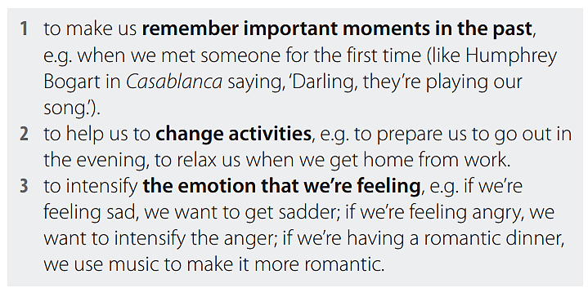  Differentiation: more able students help less able learners;  Post-Listening Activity 1  (W) Ss compare their reasons which they suggested at the beginning of the lesson with the ideas of the psychologist and define if they are similar or different;  Pre-Listening Activity 2  (P) (Ex. 1e) Ss share their ideas with their partners answering the question and using the adjectives from the slide:  How can music make you feel?  While-Listening Activity 2  1) (I) (Ex. 1e) Play the audio, pausing after each piece of music;  (P) Assessment: Ss tell their partners how these pieces of music make them feel;  Differentiation: more able students help less able learners;  While-Listening Activity 3  2) (I) (Ex. 1f) Ss look at the incomplete notes;  In the third section (Emotions related to pieces of music), they should be looking for the emotion word / how you feel (sad, etc.);  Play the audio, pausing between each section to give Ss time to complete their notes;  (G) Assessment: Ss work in small groups and compare their answers;  Differentiation: more able students help less able learners;  (W) Check as a class;  Answer Keys:  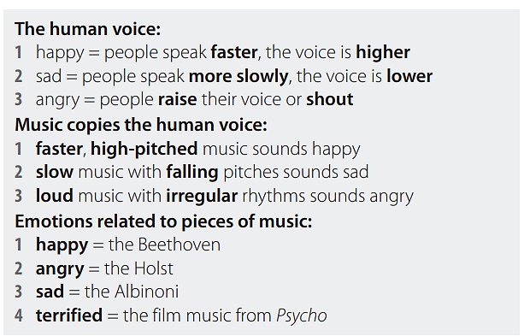  Post-Listening Activity 3  (P) (Ex. 1g) Ss work in pairs answering the questions and giving reasons;  Pre-Reading Activity  (G) Ss work in small groups and discuss the question:  Do you normally listen to music when you are working or studying?  What kinds of music?  While-Reading Activity  1) (I) (Ex. 4b) Ss read an article about some research into music and work habits (they should not worry about the gaps);  Ss choose the best summary of the research findings;  (G) Ss compare their answers;  (W) Check as a whole class;  Key: 2;  2) (I) (Ex. 4c) Ss read the article again and complete the gaps with phrases from A – F;  (P/W) Get Ss to compare with a partner, and then check answers;  Keys:  3) (I) (Ex. 4e) Ss read what four doctors say about playing music while they work;  (P) Ss look at the photo and answer the questions with a partner;  Get some feedback from various pairs;  For question 1, you could get a show of hands for Ss’ opinions. For question 2, you could elicit all the advantages and disadvantages onto the board to help Ss with f;  4) (W) Focus on the four different surgeons and check Ss know what kind of surgery they do;  Give Ss time to read the article to check their answers to e;  Focus on the second part of the task. Elicit / Explain the meaning of general consensus /ˈdʒenrəl kənˈsensəs/ (= the opinion that most or all members of a group agree with);  5) (I) Ss the article and write RT, SA, SN or GW  (P) Ss compare their answers in pairs;  Check as a whole class;  Key:  Post-Reading Activity  (P) Ss work in pairs and create a playlist of five songs that would help them to do a creative group task;  Video Corner  1) (I) Ss watch an interview with a famous pianist called Isata Kanneh-Mason;  Give Ss time to read the two questions (Ex. 6a);  Play the video once the whole way through for Ss to watch and answer the questions;  Key:  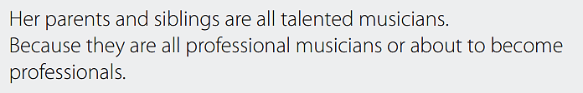  2) (I) Ss watch the video again and answer the questions;  (P) Ss compare the answers with their partners;  Check as a class;  Key:  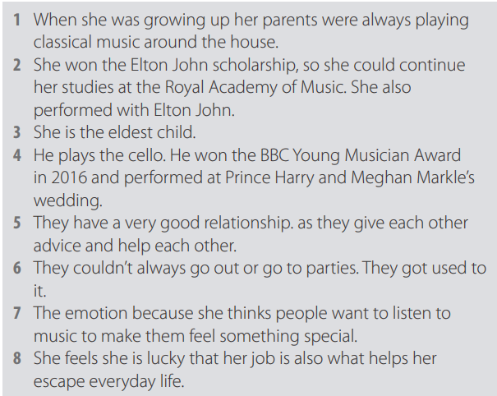 |  |  |  |  |  | Slide 3;  Slide 4;  Slide 5;  Handout; Audio 6.10;  Slide 6;  Handout;  Slide 7;  Handout;  Slide 8;  Handout;  Audio 6.11;  Slide 9;  Handout;  Audio 6.12;  Slide 10;  Handout;  Slide 11;  Handout;  Slide 12;  Handout;  Slide 13;  Handout;  Slide 14;  Handout;  Slide 15;  Handout;  Slide 16;  Handout;  Slide 17;  Handout;  Slide 18;  Handout;  Video;  Slide 19;  Handout;  Video;
End  5 min | Plenary  Ss role a dice and carry out the task according to the number on the dice:  1 – name 1 thing you learnt today;  2 – name 2 things you would like to know more about;  3 – say 3 points to this lesson;  4 – point at another pupil and ask a question about today’s lesson;  5 – summarise the lesson in 5 words;  6 – name a skill you used in this lesson; |  |  |  |  |  | Slide 20;
Additional information
Differentiation – how do you plan to give more support? How do you plan to challenge the more able learners? |  |  |  |  | Assessment – how are you planning to check learners’ learning? | Health and safety check
Differentiation is achieved through the selection of activities, identification of learning outcomes for a certain student, provision of individual support to learners |  |  |  |  | Self and peer assessment | Health saving technologies.  Using active activities.  Rules from the Safety Rules book which can be applied in this lesson.
Reflection  Were the lesson objectives/learning objectives realistic?  Did all the learners achieve the lesson objectives/ learning objectives? If not, why?  Did my planned differentiation work well?  Did I stick to timings?  What changes did I make from my plan and why? |  |  | Use the space below to reflect on your lesson. Answer the most relevant questions from the box on the left about your lesson.

