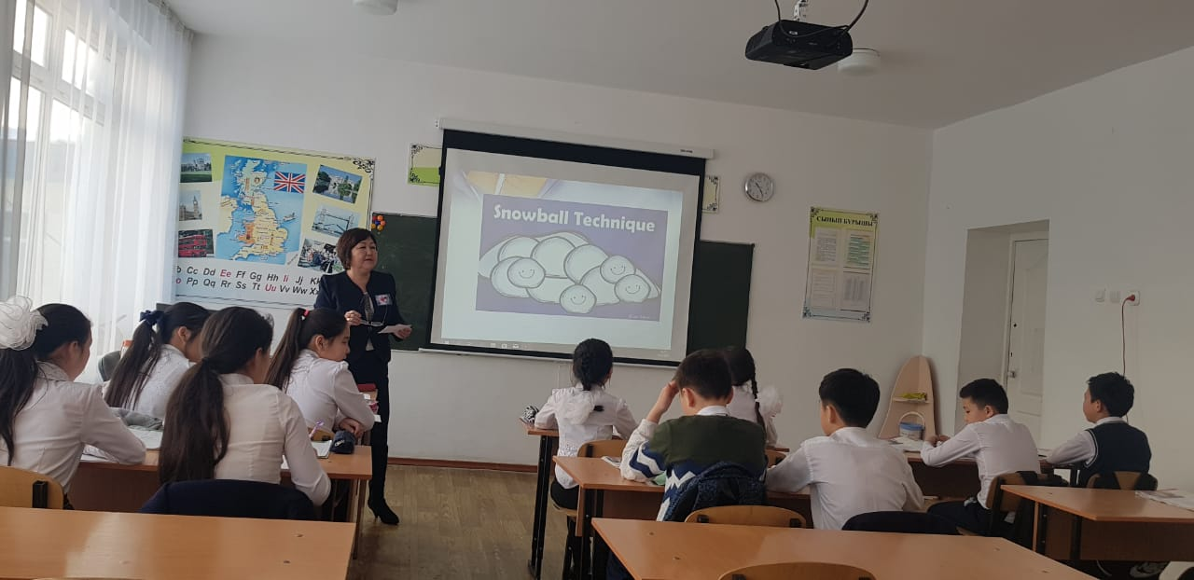

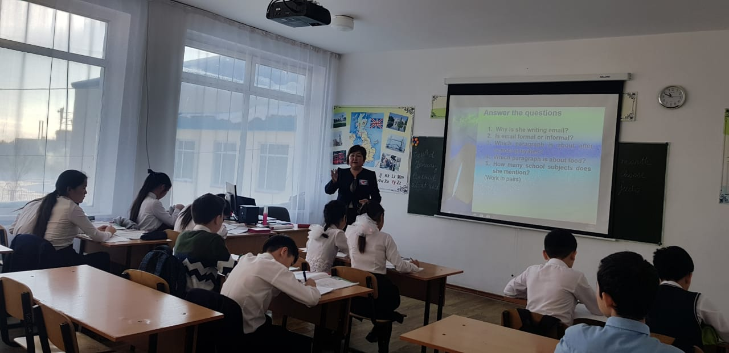

Short term lesson plan
Unit of a long term plan: Unit 5 Our Health. Lesson plan 50 | School: №6
Date: | Teacher's name:Kumis Omarova
CLASS: 6 | Number present: | absent:
Lesson title | School life.
Learning objectives(s) | 6.S1 provide basic information about themselves and others at sentence level on an increasing range of general topics 6.S2 ask simple questions to get information about a limited range of general topics 6.S3 give an opinion at sentence level on a limited range of general and curricular topics  6.L4 understand the main points of supported extended talk on a range of general and curricular topics 6.R5 deduce meaning from context in short texts on a limited range of familiar general and curricular topics 6.W1 plan, write, edit and proofread work at text level with support on a limited range of general and curricular topics 6.W5 link without support sentences using basic coordinating connectors
Lesson objectives | All learners will be able to:  • Identify the theme, new words and use them as the basis for discussion. • Demonstrate knowledge for usage of the Present Simple and Past Simple, making stories about a school in the Present Simple and Past Simple. • Transfer information from the given information into a graphic organizer.  Most learners will be able to:  • Select, compile, and synthesize information for an oral presentation • Provide a point of view in conversations and discussions; describe school using active vocabulary.  Some learners will be able to:  • Respond to and discuss the reading passage using interpretive, evaluative and creative thinking skills. • Make a presentation about your school.
Assessment criteria | • Read the given text of description and identify the general information. • Demonstrate skills of organizing and expressing ideas accurately. • Illustrate a viewpoint in a discussion
Target language | English, Music, Art, Kazakh, Russian, Maths, Science and PE, Handicraft and History.ICT…
Values links | Responsibility, Global Citizenship, Respect and Love to people and school, Care to modern technology, Love to nearest and dearest.
Cross-curricular links | Information Technology, Kazakh, Russian
Previous learning | Vocabulary relating to students' activity, school and school subjects.
Plan
Planned timings

Planned timings | Planned activities (replace the notes below with your planned activities) | Resources
 | I. Greetings
 | II. Wаrm up  That’s great and cool  We study at school  English, Music, Art,  Kazakh, Russian, Maths,  Science and PE,  Handicraft and History. | Student Book p63  Pictures PPT  White board
 | III.Checking up of the home task  Revising of vocabulary and making sentences  Proverbs | Snowball technique
 | IV. An e-mail about school (new topic)  Reading, doing tasks | Pairwork
V. Writing an e-mail about school
p.59 can for ability аnd permission
 | VI. Conclusion  Cinquain  Line 1: one word (subject or noun)  Line 2: two words (adjectives) that describe line 1  Line 3: three words (action verbs) that relate to line 1  Line 4: four words (feelings or a complete sentence) that relates to line 1  Line 5: one word (synonym of line 1 or a word that sums it up)  Marks | Cinquain

