LESSON 1 |  |  | Unit 1: Homes and away
Teacher name: Rogova V.V. |  |  | School: Stavropolka Secondary School

Date:
Grade: 5 |  |  | Number present: |  |  |  | Number absent:
Theme of the lesson: |  | Homes 1
Learning objectives |  | L1. Understanding sequence of supported classroom instructions  S7. Use appropriate subject- specific vocabulary and syntax to talk about a limited range of general topics  UE3. Use a growing variety of adjectives and regular and irregular comparative and superlative adjectives an a limited range of familiar general and curricular topics  W3 write with support factual descriptions at text level which describe people, places and objects
Lesson objectives |  | Name parts of yurt, understand vocabulary, describe places  Understand specific vocabulary
Plan
Planned timings | Planned activities |  |  | Learners’ activities |  | Evaluation |  |  | Resources
Beginning 5 min | GREETINGS  Good morning pupils!  Who is on duty today?  Who is absent?  Teacher divides pupils in 2 groups with cards: “ Yurts’, “ Homes” |  |  | Greeting
Middle  35 min | Task 1 Listen to and repeat attentively after teacher : a bedroom, a dining room, bathroom, a living room, a toilet, a study, a round-shaped , a shanyrak , a kerege ,a uwyk  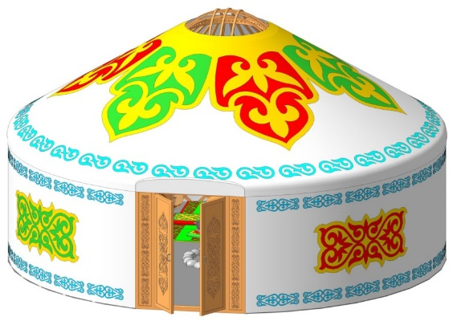  Task 2 Match the pictures with the words  Yurt is a round-shaped, it consists of three main parts and many other smaller parts. Three main  parts include Shanyrak – top of the Yurt, Kerege – walls carcass and Uwyk – a carcass  part from Kerege to the Shanyrak.  Yurt usually does not have rooms in it, and it was a common practice to have a separate  YuYrt as a bedroom, separate one as a kitchen, guesthouse, etc as long as people could  afford that.  Task 3 Find out which of these adjectives in positive degree, in comparative degree, in superlative degree  1 A building is bigger than yurt.  2. Yurt is smaller than a building.  3. A house is modern.  4. A living room is the most comfortable room in the house.  5.Yurt is the oldest house.  Task 4 Write things you remember from the texts  Yurt, kerege ,house ,shanurak .small ,beautiful ,modern  Bedroom, living-room ,comfortable  Descriptor: |  |  | Learners listen to and repeat  Learners match the pictures with the words  Learners find degrees of adjectives  Learners write names of rooms ,describe of house |  | Verbal evaluation  Individual avaluation  Mutual avaluation
End  5min. | Answer the question “ How can be a modern house?”  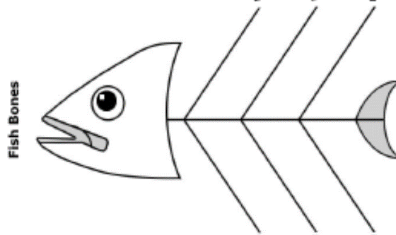  Draw your room and furniture’s in the paper. Make a dialogue with your partner about your room.  Home task: learn the new vocabulary  Saying goodbye |  |  |  | Self-assessment

LESSON 2 |  |  | Unit 1: Homes and away
Teacher name: Rogova V.V. |  |  | School: Stavropolka Secondary School
Date:
Grade: 5 |  |  | Number present: |  |  | Number absent :
Theme of the lesson: |  | Homes 1  Entering Test
Learning objectives |  | S4. Respond with limited flexibility at sentence level to unexpected comments on an increasing range of general and curricular topics.  W1. Plan, write, edit and proofread work at text level with support on a limited range of general and curricular topics.  UE14. Use prepositions to talk about and location: use prepositions like to describe things and about to denote topics: use prepositions of direction to, into, out of, from, towards on a limited range of familiar general and curriculum topics.
Lesson objectives |  | Understand specific information related to the target.  Pronounce and name some words, according to the topic.  Recognize the theme and grammar material;  To write short sentences in a paragraph.
Plan
Planned timings | Planned activities |  |  | Learners’ activities | Evaluation |  |  | Resources
Beginning 5 min | Greeting. Teacher greets learners; learners respond to greeting and take their places.  Happiness circle.  Teacher greets and invites to stand in a circle and to greet each other. The teacher divided the class with the method of mosaic.  S1 Brainstorming.  Revision the previous lesson. Scrambled letters. You must make up some words and translate them into Kazakh. |  |  | Greeting  Learners do the task | Verbal evaluation |  |  | Flashcards  PPT (slide – 1-2)  Pictures
Middle  15 min | Working with new vocabulary.  Prepositions: In, On, Next to, Above, Under, Opposite,  In front of, Behind, Between.  Task 1. Practice  The bed’s on the left and there’s small wardrobe on the right. There are some posters …… the wall …… the bed. There is a table …… the bed, and there is a lamp and clock …… the table. There is a chest of drawers …… the table, and there are some shelves …… the chest of drawers. There is a desk …… the door, …… the window. There is a chair in the corner and another chair ….. the desk. You can see Sadie’s tennis racket …… the desk.  Task 2. Group work  I - group  1. We have breakfast, lunch, dinner, supper there.  We eat in it. What room is it?  2. We cook dinner, wash up dishes there. There is cooker a fridge, a dishwasher there. There are plates, cups, cupboards there.  What room is it?  3. There is a bed, a picture, a window, a curtain, a toilet table in it.  What room is it?  II - group  4. There is a towel, a bath, a soap, a mirror, a sink, a shelf in it.  What room is it?  5. There is VCR, a sofa, a fire, a carpet, an armchair, a picture, a television in it. What room is it?  6. There is a computer, a desk, a bookshelf, a chair, a lamp, a flower, a plant, a clock in it. What room is it? |  |  | Learners use prepositions.  Complete the description of Sadie’s room.  Learners read the puzzles and guess what rooms they are.  PPT | Individual avaluation  Mutual avaluation |  |  | PPT
Entering Test  20 min | Teacher explain the tasks and criterias. |  |  | Learners do the tasks | Individual avaluation |  |  | Workseets
End  5 min | Assessment. Traffic light.  Feedback. The teacher gives comments about learners work and awards learner. Students will choose one and put on the board their stickers.  Home task: Draw your room and furniture’s in the paper.  Saying goodbye |  |  |  | Self-assessment |  | Stickers  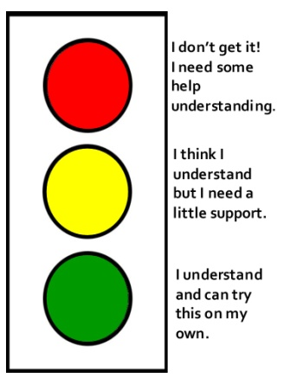

LESSON 3 |  |  | Unit 1: Homes and away
Teacher name: Rogova V.V. |  |  | School: Stavropolka Secondary School
Date:
Grade: 5 |  |  | Number present: |  |  |  |  | Number absent :
Theme of the lesson: |  | Homes 2
Learning objectives |  | 5.S6 communicate meaning clearly at sentence level during, pair, group and whole class exchanges  5.W3 write with support factual descriptions at text level which describe people, places and objects  5. UE6 use basic personal and demonstrative pronouns and quantitative pronouns some, any, something, nothing anything on a limited range of familiar general and curricular topics
Lesson objectives |  | ask simple questions to get information and answer it use appropriate subject-specific vocabulary syntax to talk about  communicate meaning clearly at sentence level during, pair, group and whole class exchanges organise and present information
Plan
Planned timings | Planned activities |  |  | Learners’ activities |  |  | Evaluation |  | Resources
Start  10min | GREETINGS: Good afternoon dear children  How are you?  What is the weather like today?  Is it hot or warm?  Is it rainy or sunny?  What is the weekday today?  What is the season now?  Teacher will put some questions according to the theme. Why should we need a home? Do we need rooms? What would we do if we have no rooms? |  |  | Learners will answer to the given questions. |  |  | Verbal evaluatio |  | Cards flashcards of rooms
Middle  30 min | Task1.  Describe your house with the given vocabulary  Bedroom, living room, bathroom, kitchen, dining room, upstairs and downstairs, sofa, bed, TV, armchair, table, chair, carpet, curtain.  In three minutes write a few sentences about it. Compare your room with your partner’s. What is similar/different? Tell the class  My ideal bedroom has got ... . There’s a ... in my bedroom. ...There is a ………. My bedroom is cool!  Task 2  Complete the grapes with the given vocabulary and talk about it.  Bedroom, living room, bathroom, kitchen, dining room  For the conclusion of the lesson teacher takes the activity “branches of grapes” there will be drawn branch of grapes and learners should put the names of rooms on the grapes and pronouns which relates to a house on branches learners will show and discuss about rooms and describe one room of their house using pronouns. |  |  | Learners describe your house with the given vocabulary  Learners draw your ideal bedroom.  Learners complete the grapes with the given vocabulary and talk about it. |  | Individual avaluation  Mutual avaluation |  |  | A cheet of paper pencil  Flipchart marker cards
End  5min | For the feedback we will talk about “Traffic lights”    -Green The lesson is clear for me  -Yellow I have got some question  -Red I don’t understand anything  Home work: Writing and speaking “My room” Use what you know  Saying goodbye |  |  | Figures of traffic lights | Self-assessment

LESSON 4 |  |  | Unit 1: Homes and away
Teacher name: Rogova V.V. |  |  | School: Stavropolka Secondary School
Date:
Grade: 5 |  |  | Number present: |  | Number absent :
Theme of the lesson: |  | Homes 2
Learning objectives |  | 5.S6 communicate meaning clearly at sentence level during, pair, group and whole class exchanges  5.S7 and use appropriate subject-specific vocabulary syntax to talk about a limited range of general topics  5.W3 write with support factual descriptions at text level which describe people, places and objects  5. UE6 use basic personal and demonstrative pronouns and quantitative pronouns some, any, something, nothing anything on a limited range of familiar general and curricular topics
Lesson objectives |  | They introduced with the construction there is / there are
Plan
Planned timings | Planned activities |  |  | Learners’ activities |  | Evaluation | Resources
Start  10min | T-S.Greetings: Good afternoon dear children  Org moment: T-S. Dividing learners into three groups by the names of rooms  Livingroom bathroom kitchen  T-S .After dividing each groups should tell about the rooms and describe it what they can do in that room.  Today we are going to talk about our homes and objects in it and will describe and talk about it. |  |  | Greeting  Learners do the task |  | Mutual avaluation | Cards flashcards of rooms
Middle  30min | Task 1.  In general we use some in positive sentences and any in questions and negative sentences .We also use any with the meaning ‘it doesn’t matter which’:  • You can catch any bus. They all go to the centre.  Task 2. Complete the sentences with some or any.  1 .We didn’t buy ...any... flowers.  2 .This evening I’m going out with............................. friends of mine.  3.‘Have you seen........ good films recently?’ ‘No, I haven’t been to the cinema  for ages.’  4. I didn’t have money, so I had to borrow.............................  5 .Can I have......................milk in my coffee, please?  6 .I was too tired to d o .........................work.  Make up your own sentences with the some ,any There is a nothing between two beds  Describe your room with the some , any There is some flowers in the kitchen.  Task 3 Say the suitable sentences in pair work two learners in pair should say three sentences two sentences must be according to the theme one sentence must be the odd one and neighbours should recognize which is the odd one out.  Living room is the place where we can sit and watch TV.  Kitchen is the place where we can cook meals.  Gym is the place where we can play volleyball with our friends |  |  | Learners follow the instructions  Learners complete the sentences with some or any.  Learners make up your own sentences with the and  describe room with the some ,any  Learners give two clear sentences and one odd sentence during pair work |  | Verbal evaluation  Individual avaluation | cards  Flipchart marker cards  A list of descriptor  Flipchart
End  5min | All learners put stickers into three groups according their understanding of  the lesson  Home work: Make up a story about your house using prepositions  Saying goodbye |  |  | Figures of traffic lights |  | Self-assessment
  I know and understand   | I can speak   | I need a help

LESSON 5 |  |  |  | Unit 1: Homes and away
Teacher name: Rogova V.V. |  |  |  | School: Stavropolka Secondary School
Date:
Grade: 5 |  |  |  | Number present: |  |  |  |  |  |  |  | Number absent :
Theme of the lesson: |  |  | Cities and countries 1
Learning objectives |  |  | 5.L1understand a sequence of supported classroom instructions  5.S1 provide basic information about themselves and others at sentence level on an increasing range of general topics  5.S2 ask simple questions to get information about a limited range of general topics  5. UE3 use a growing variety of adjectives and regular and irregular comparative and superlative adjectives on a limited range of familiar general and curricular topics
Lesson objectives |  |  | understand a sequence of supported classroom instructions ask simple questions to get information  use adjectives and regular and irregular comparative and superlative adjectives with support  provide basic information about themselves and others at sentence level on an increasing range of general topics
Plan
Planned timings | Planned activities |  |  |  |  | Learners’ activities |  |  |  | Evaluation |  |  |  |  |  |  | Resources
Start  5min | Greeting: Good day, dear learners! Nice to meet you  How are you? Thank you, sit down.  Are you ready for today’s lesson?  Who is absent today?  Who is on duty today?  What is the weather like today?  “Brainstorming”  everyone takes a piece of paper and writes as many words as you remember from the theme homes. Share ideas asking each student to read out a word from their list. They must not repeat a word that has already been said. |  |  |  |  | Greeting  Learners do the task |  |  |  |  |  |  |  |  |  |  | Sweets, box, board, video  The pictures of cities and the names of countries
Middle  35 min | Task 1. Listen to the recorder and complete the table with the capitals of countries and nationalities. |  |  |  |  | Learners listen to the recorder and complete the table |  |  |  | Individual avaluation |  |  |  |  |  |  | CD
 | Presentation of the grammatical materials through “Bus stop”.  The teacher presents materials as a guide in the bus. Each bus stop presents one city of the Kazakhstan.  Bus stop 1 “Astana” Bus stop 2 “Almaty”  Adjectives  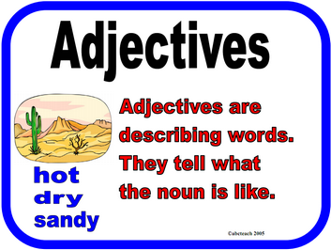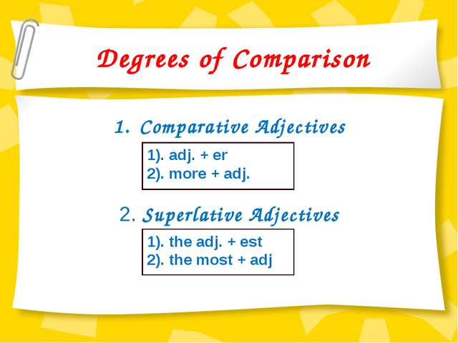  Bus stop 3 “Shymkent”  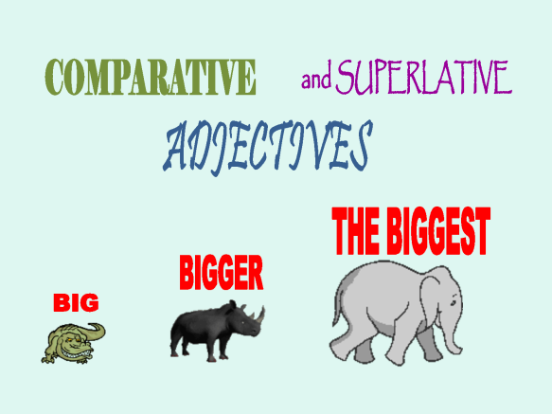 |  |  |  |  | Learners follow the instructions |  |  |  | Mutual avaluation |  |  |  |  |  |  | Map of the world
  Country | Capital | Nationality
  the UK , | London | English
  the USA
  Kazakhstan
  Turkey
  France
  Russia
  Uzbekistan
  Kirgizia
  Turkmenia
  Mexico
  Japan
  Spain
End  5 min | Reflection  Learners have to write their answers on the stickers and stick it on a tree:  What have you learnt today?  What would you like to learn?  What would you like to work on?  Home work: Look for from internet and find information about language population capital the weather and best places of your favourite country.  Saying goodbye |  |  |  |  |  |  |  |  | Self-assessment
LESSON 6 |  |  |  | Unit 1: Homes and away
Teacher name: Rogova V.V. |  |  |  | School: Stavropolka Secondary School
Date:
Grade: 5 |  |  |  | Number present: |  |  |  |  |  |  | Number absent :
Theme of the lesson: |  | Cities and countries 1
Learning objectives |  | 5.L1understand a sequence of supported classroom instructions  5.S1 provide basic information about themselves and others at sentence level on an increasing range of general topics  5. UE3 use a growing variety of adjectives and regular and irregular comparative and superlative adjectives on a limited range of familiar general and curricular topics
Lesson objectives |  | understand a sequence of supported classroom instructions ask simple questions to get information  use adjectives and regular and irregular comparative and superlative adjectives with support  provide basic information about themselves and others at sentence level on an increasing range of general topics
Plan
Planned timings | Planned activities |  |  |  | Learners’ activities |  |  |  | Evaluation |  |  |  |  |  | Resources
Start  10 min | GREETING  Dividing learners into two groups by “magic box” there will be some sweets choose one of them. Who choose red sweets sit to red group and who choose green sit to green group.  Teacher plays a video a conversation between boy and a girl they talk about cities and countries and then learners recognize by this video the name of the new theme.  Introducing the lesson objectives. Now boys and girls the theme of our new lesson is Cities and countries Today we are going to speak about the best places for living  Teacher will put some questions according to the theme. Do you live in a city? What is the difference between city or a country? Where do we live? How do you think is the city better place to live? |  |  |  | Greeting  Learners follow the instructions |  |  |  | Verbal evaluation |  |  |  |  |  | Sweets, box, board, video  The pictures of cities and the names of countries
Middle  30 min | Task 1.  Irregular Forms of Comparison  Task 2.  Clean –cleaner – cleanest  Easy - ______ - easiest  Fat - ______ - fattest  Hot - ______ - hottest  --------- – simplier - _______  Thin – thinner - _________  Task 3. “Ten question on stickers”  One learner comes to the board and puts a sticker on forehead and learners will put question according the city and the country of a city  Example: What is the capital city of England?  What is the country of Moscow city?  “Creative work” Make your own story about your city with the given vocabulary  Bank, airport, museum, hospital, theatre, chemist’s ,library, bus stop, police station, police station  I live in Astana city. There are a lot of banks……. |  |  |  | Learners change the words into the right form of adjectives  Learners change the words into the right form of adjectives.  Learners answer the questions  Learners create a story using given vocabulary. |  |  | Individual avaluation  Mutual avaluation |  |  |  |  |  | Stickers  posters markers
  Good | Better
   | Worse
  Hot |  | The hottest
   | Bigger
End  5 min | Reflection “Five fingers”  What was easy for you?  What was difficult for you?  Show on your fingers your opinion about the lesson  1-the lesson was difficult  2-you liked the most  3- your mood glad, sad, bad  4- Activities you have done  5- I learnt today  Home task: Make your own story about your city with the given vocabulary  Saying goodbye |  |  |  | Learners draw the shape of their hands and write on each finger. |  | Self-assessment

LESSON 7 |  |  | Unit 1: Homes and away
Teacher name: Rogova V.V. |  |  | School: Stavropolka Secondary School
Date:
Grade: 5 |  |  | Number present: |  |  | Number absent:
Theme of the lesson: |  | Cities and countries 2
Learning objectives |  | 5.S2 ask simple questions to get information about a limited range of general topics  5.S7 use appropriate subject-specific vocabulary and syntax to talk about a limited range of general topics  5.W1 plan, write, edit and proofread work at text level with support on a limited range of general and curricular topics  5.UE1 use appropriate countable and uncountable nouns, including common noun phrases describing times and location, on a limited range of familiar general and curricular topics
Lesson objectives |  | Say some words and understand the meaning of new words  Ask simple questions  Use some short form answers correctly  Differentiate countable and uncountable nouns  Correct and find mistakes  Write short text according to the theme
Plan
Planned timings | Planned activities |  |  | Learners’ activities | Evaluation |  | Resources
Begining  5 min | Greetings: Good afternoon, dear students!  The game “Bingo”. Teacher gives nine pictures of souvenirs around the cities of Kazakhstan. On the words they should write the names of cities, who finish first tells “Bingo”. After they will correct, if they have mistakes. |  |  | Greeting  Learners answer the questions
Middle  35 min | Task 1. Check the meaning of the words. Then match the words with 1-6  Mountain forest desert lake river steppe  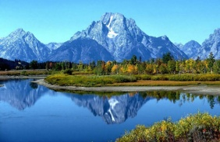  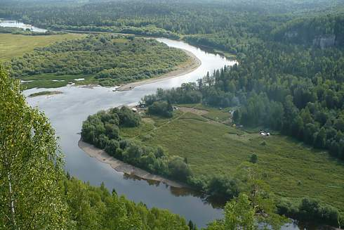  Task 2. Method insert. Reading text with tags. Look at the map of Kazakhstan and choose the correct words in the text. Say and check.  There are forests/lakes in the north and west. In the centre of the country there is a steppe/lake called Saryarka and a desert/mountain called Aral Karakum. Kyzylkum and Moyunkum are in the south. There are three long rivers/deserts in the south Syrdarya, Shu and Ile. In the south-east, there is a big lake/river called Balkhash. The mountains/forests in the east are called the Altay and in the north-west there are the Urals and the Tien Shan.  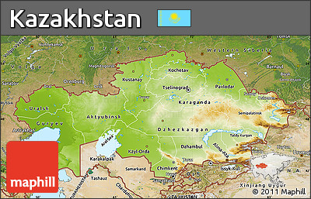 |  |  | Learners match the words  Learners reads the text and chooses correct words | Individual avaluation  Mutual avaluation
End  5 min | Feedback  Method “Free letter” in 2 minutes learners express thoughts according to the theme, it may be an essay.  Home task: Choose a country and write 3 sentences about it.  Saying goodbye |  |  |  | Self-assessment

LESSON 8 |  |  | Unit 1: Homes and away
Teacher name: Rogova V.V. |  |  | School: Stavropolka Secondary School
Date:
Grade: 5 |  |  | Number present: |  |  | Number absent:
Theme of the lesson: |  | Cities and countries 2
Learning objectives |  | 5.S2 ask simple questions to get information about a limited range of general topics  5.S7 use appropriate subject-specific vocabulary and syntax to talk about a limited range of general topics  5.W1 plan, write, edit and proofread work at text level with support on a limited range of general and curricular topics  5.UE1 use appropriate countable and uncountable nouns, including common noun phrases describing times and location, on a limited range of familiar general and curricular topics
Lesson objectives |  | Say some words and understand the meaning of new words  Ask simple questions  Use some short form answers correctly  Differentiate countable and uncountable nouns  Correct and find mistakes  Write short text according to the theme
Plan
Planned timings | Planned activities |  |  | Learners’ activities | Evaluation |  | Resources
Begining  5 min | Greeting.  Good morning, children !  How are you?  I am fine, thank you.  Who is on duty today?  Who is absent today?  What month is it now?  What date is it today? |  |  | Greeting  Learners answer the questions
Middle  35 min | Children, we know that the Kazakh, the Russian languages have plural forms.  Task 1.Complete the sentences with the plural forms of the nouns.  1.In winter, there is a lot of snow in the …When the weather is good, people go there to ski.  2. There is a lot of fish in the …People go there to catch the fish.  3 .There is more water in the …after heavy rain. People go there to swim.  4. There are a lot of trees in the … and the air is very clean. People go there to hike.  5.There is a lot of sand in the …Sometimes people go there to ride a camel.  6.. There are no trees in the … but there is grass. People go there to see interesting plants and animals.  Children, how do you think why I write these words in blue, what kind of words are they and give translation of these words. You are right, can you give me plural forms of these words in your language? Yes, they don’t have plural forms, in English it’s called uncountable nouns.  Task 2. Answer the questions according to the task 1.  Can we count these nouns using numbers?  Do uncountable nouns have plural forms?  Do we use a/an in front of uncountable nouns? |  |  | Learners complete the sentences with the plural forms of the nouns  Learners translates the given words,  completes the sentences  and answers the questions | Individual avaluation  Verbal evaluation  Mutual avaluation
End  5 min | Feedback. The teacher gives comments about learners work and awards learner. Students will choose one and put on the board their stickers.  Home task: Choose a country and write a short text about it. Include the following information:  What is the name of the country?  Are there any mountains, deserts, lakes, etc.?Where are they in the west, east, north?  Why are people go there?  Saying goodbye |  |  |  | Self-assessment

LESSON 9 |  |  | Unit 1: Homes and away
Teacher name: Rogova V.V. |  |  | School: Stavropolka Secondary School
Date:
Grade: 5 |  |  | Number present: |  |  | Number absent:
Theme of the lesson: |  | Weather and climate 1
Learning objectives |  | 5.L1understand a sequence of supported classroom instructions  5.S6 communicate meaning clearly at sentence level during, pair, group and whole class exchanges  5.R1 understand the main points in a limited range of short simple texts on general and curricular topics  5.W1 plan, write, edit and proofread work at text level with support on a limited range of general and curricular topics
Lesson objectives |  | Hold a communication clearly at sentence level during pair, group and the whole class exchanges  Write a sentence correctly keeping the correct word order  Interpret the whole content of the video using phrases and topical vocabulary
Plan
Planned timings | Planned activities |  |  | Learners’ activities | Evaluation |  |  | Resources
Begining  5 min | Greetings: Good afternoon, dear students!  The game “Bingo”.  Teacher gives nine pictures of souvenirs around the cities of Kazakhstan. On the words they should write the names of cities, who finish first tells “Bingo”. After they will correct, if they have mistakes. |  |  | Greeting  Learners play a game | Verbal evaluation
Middle  35 min | Listening/Watching  Divide your learners into 3-4 groups with 4 students. Make sure each group has at least one the most able student to assist others while they are doing listening activities. In a group, there will be definitely one-two less able students who should be supported with the transcript of the listening track.  Video segment teaching method  Pre-listening- Words on the board method  Ask one student to come to the board and circle two words, and make a good sentence using both. Repeat the same with others until the words are picked.  While listening activity  They start watching a video and try to pause when they meet those revised new words and again repeat their meanings. If it is important, translate into Kazakh language for better understanding.  Post listening. Discussion through noting method.  When they finish listening to video the following questions to the video are given on PPT. Leader of the group divides them into the number of the pupils. BUT, according to the levels of pupils, the most able student may have not 1, but 2 questions to answer. Here interpretation method will be useful in which students write on their own words using new words above  What is climate change?  How do understand CO2?  What happens if all people use cars?  Is it harmful to the air if we watch TV and use electricity so often?  If the climate change what does it cause?  What is coral reef?  What must we do to stop climate change? |  |  | Learners do the task  Learners follow the instructions  Learners answer the questions | Individual avaluation  Mutual avaluation |  |  | https://www.youtube.com/watch?v=ko6GNA58YOA  PPT with new words  Handout with these words and expressions  PPT with questions
End  5 mins | Concluding the lesson  Assessment  Three things I’ve learnt.  Home task: To read the text “Saving the planet” They will work on new words and retell to the whole class.  Saying goodbye |  |  |  | Self-assessment |  | Handout  KWL chart

LESSON 10 |  |  | Unit 1: Homes and away
Teacher name: Rogova V.V. |  |  | School: Stavropolka Secondary School
Date:
Grade: 5 |  |  | Number present: |  | Number absent:
Theme of the lesson: |  | Weather and climate 2
Learning objectives |  | 5.L3 understand an increasing range of unsupported basic questions on general and curricular topics  5.S2 ask simple questions to get information about a limited range of general topics  5.S6 communicate meaning clearly at sentence level during, pair, group and whole class exchanges
Lesson objectives |  | Identify the parts of speech of words (noun, adjectives)  Write the weather words correctly (spelling);  To write a short weather report
Plan
Planned timings | Planned activities |  |  | Learners’ activities |  | Evaluation | Resources
Begining  5 min | Greetings  Warm –up  Learners identify weather sounds of rain, thunder and wind. Ask learners to guess what the topic is. (weather)  Teacher introduces lesson objectives. |  |  | Learners identify weather sounds |  |  | https://www.youtube.com/watch?v=bqix15pI8rM
Middle  35 min | Teacher distributes cards with the words: cloud, rain, snow, ice, sun, fog, wind, and storm.  The class is to guess what the word is.  e.g. This is water when it’s very, very cold. We can see it on in rivers and ponds in winter. We can skate on it. (ice)  Suggest learners to divide their copybook into three columns, according to the spelling.  (Differentiation) The task can be differentiated. Allow more able learners to think and write the words in the correct columns.  Teacher supports less able learners with the following division.  Only ‘y’ (snowy, rainy, cloudy, windy, stormy)  Double consonant before ‘y’ (sunny, foggy)  Drop ‘e’ and add ‘y’ (icy).  Teacher monitors learners’ works.  (Self-assessment) Learners check the answers as a whole class and tick the correct words in the columns. In case there are mistakes more able learners or teacher comment and explain the mistake.  Teacher asks learners to identify the difference between weather and climate?  What is weather?  What is climate?  (Weather is what is happening today in a town, city or in the countryside. Climate is used to talk about what the weather is like generally in a country.)  Teacher reminds learners the question to ask about weather: ‘What’s the weather like today?’  Teacher hands out copies with tasks on weather.  Learners brainstorm words related to the previous day’s weather: morning; midday; afternoon. They write a simple weather report using was and were and compare with a partner. |  |  | Learners read the words and explain them.  Learners in pairs write adjectives to describe weather.  Learners answer the questions  Learners do matching task then underline the correct weather words in sentences. |  | Verbal evaluation  Individual avaluation  Mutual avaluation | Worksheet 1
End  5 min | Feedback.  At the end of the lesson learners reflect on:  What they learned;  What remained unclear for them;  What they need to continue working on;  Teacher gives comments about learners work and awards learners. Students will choose one and put on the board their stickers.  Home task: worksheet 1  Saying goodbye |  |  |  |  | Self-assessment

LESSON 11 |  |  | Unit 1: Homes and away
Teacher name: Rogova V.V. |  |  | School: Stavropolka Secondary School
Date:
Grade: 5 |  |  | Number present: |  |  | Number absent:
Theme of the lesson: |  | Weather and climate 2
Learning objectives |  | 5.L3 Understand an increasing range of unsupported basic questions on general and curricular topics  5.S2 Ask simple questions to get information about a limited range of general topics  5.UE1 use appropriate countable and uncountable nouns, including common noun phrases describing times and location, on a limited range of familiar general and curricular topics
Lesson objectives |  | Recognize basic general questions without support  Make up basic interrogative, affirmative and negative sentences and get information about the topic
Plan
Planned timings | Planned activities |  |  | Learners’ activities | Evaluation |  | Resources
Begining  5 min | GREETINGS: Good afternoon dear children  How are you?  What is the weather like today?  Is it hot or warm?  Is it rainy or sunny?  What is the weekday today?  What is the season now? |  |  | Greeting  Learners answer the questions | Mutual avaluation
Middle  15 min | Group work.  Writing skill. Persuasive style method  Pre-writing activity. Support your learners with vocabulary to write a letter in the group. The question they need to discuss and write within the group |  |  | Learners discuss | Verbal evaluation |  | Handout with these words and expressions
SA  20 min | LISTENING AND SPEAKING  Task 1. Listen to the text and answer the questions.  1. Where is the house?  2. What shape is it?  3. How many rooms has it got?  4. What is there outside the house?  5. What is the house made of?  USE OF ENGLISH  Task 2. Look at the picture. Complete the gaps in the sentences with the correct form of there is/there are.  Example: Is there a bookcase in the living room?  - No, there is not.  1. ________________ any cushions on the sofa?  _______________________________________  2. ________________ a picture on the wall?  _______________________________________  3. ________________ any books in the kitchen?  _______________________________________  4. ________________a carpet on the floor?  _______________________________________  5. ________________ a lamp on the table? |  |  | Learners listen to the text and answer the questions.  Learners complete the gaps in the sentences with the correct form of there is/there are. | Individual avaluation |  | Copy books, pens and PPT with useful words
End  5 min | Concluding the lesson  Assessment  Self-assessment chart  Three things I’ve learnt.  Home task: learn the new grammar theme and adjectives Saying goodbye |  |  |  | Self-assessment |  | Handout  KWL chart

LESSON 12 |  |  | Unit 1: Homes and away
Teacher name: Rogova V.V. |  |  | School: Stavropolka Secondary School
Date:
Grade: 5 |  |  | Number present: |  |  | Number absent:
Theme of the lesson: |  | Unit revision
Learning objectives |  | 5.L7 recognise the opinion of the speaker(s) in basic, supported talk on an increasing range of general and curricular topics  5.R2 understand with little support specific information and detail in short, simple texts on a limited range of general and curricular topics  5.W1 plan, write, edit and proofread work at text level with support on a limited range of general and curricular topics  5.S2 ask simple questions to get information about a limited range of general topics
Lesson objectives |  | read the text, learn new words, make a simple sentences according to the theme,  make a dialogue according to the theme with correct pronunciation.  compeer our climate with other countries and answer the questions.
Plan
Planned timings | Planned activities |  |  | Learners’ activities | Evaluation |  |  | Resources
Start  10 min | Organizational moment  Warm up  “Listen and remember ”  To learners will be given 8 simple words twice.  Lion, baby, sweet, balloon, friend, umbrella, house, bike |  |  | Greeting  Learners do the task |  |  |  | 
Middle  30 min | Task 1. Listen and read the dialogue in pair, underline adjectives from the dialogue and answer the questions |  |  | Learners underline adjectives from the dialogue and answer the questions | Verbal evaluation
  - Hello, Charles.
  - Hello, Dick, lovely day, isn't it?
  - Yes, it says it will be bright and sunny.
  - How nice. Nice weather for outing.
  - You are right.
 | Task 2. Answer the following questions  1 Who are the names of these two friends?  What about they are talking?  What says the weather forecast for tomorrow?  What is the weather like today?  Task 3. Group work.  Differentiate among weather, season and climate according to the pictures, describing;  Rain, stormy, hot, shining, wind, freeze, umbrella, coat...etc  Play a game “Freeze in a circle” when teacher will say freeze pupils will stop walking and freeze by showing a nature phenomenon.  Complete the sentences about yourself  My favorite season is….  The weather is ….  I usually go …. |  |  | Learners answer the questions  Learners do the task  Learners play a game  Learners complete the sentences | Mutual avaluation  Individual avaluation |  | 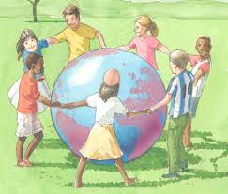  Posters, markers
End  5min | Planning, crafting and speaking on the  “Hand print Sun” and write about:  - what they learned about weather and climate  - what remained unclear for them  - what they need to continue working on  Home task: Write short story about your favorite season  Saying goodbye |  |  |  | Self-assessment |  | 

LESSON 13 |  |  | Unit 2: Living things
Teacher name: Rogova V.V. |  |  | School: Stavropolka Secondary School
Date:
Grade: 5 |  |  | Number present: |  | Number absent:
Theme of the lesson: |  | Plants 1
Learning objectives |  | 5.L3 understand an increasing range of unsupported basic questions on general and curricular topics;  5.R2 understand with little support specific information and detail in short, simple texts on a limited range of general and curricular topics;  5.W3 write with support factual descriptions at text level which describe people, places and objects
Lesson objectives |  | read, understand and reorder most of the events in the story;  write, about a plant that grows in Kazakhstan with minimum support.  understand most of the language on the story video;  use the Present Simple Tense accurately in writing without support
Plan
Planned timings | Planned activities |  |  | Learners’ activities |  | Evaluation | Resources
Beginning 5 min. | Warm-up Game  Pair work.  Learners are divided into pairs. (Differentiation by support, more able learners with learners who need support, more able learners can help with translation or meaning of the words.)Teachers distributes the handouts..(seed, plant, shoot, tree, leaf, rain, roots, sunlight)  Learners guess the topic of the lesson. |  |  | Learners are suggested to work in pairs and match the words with the pictures |  |  | http://learnenglishkids.britishcouncil.org/sites/kids/files/attachment/stories-the-lucky-seed-worksheet-final-2012-11-01.pdf
Middle  35 min | Listening  Pre-listening task  Teacher asks learners to read the sentences, underline the unfamiliar words in the task 2. They walk around the classroom and ask the group mates about the unfamiliar words. (Peer’s support).  If learners cannot find the meanings/translations of the words teacher provides the meaning of the words. (Teacher’s support).  Pair work. Learners are divided into pairs. They compare their answers with the partner. Teacher checks answers as an open-class activity.  Reading task.  To check the ability of students to use vocabulary in context, learners are asked to read the same story and write the correct word into the missing space. Teacher monitors and supports some students who need help.  Production  Ask learners in their L1 language what they know about plants and what they need to grow. Then suggest learners work in pairs by forming pairs according to teacher’s decision and to tick things that plants need to grow. (Peer’s support). Open - class activity checking.  Practice  Learners have to choose one card and are divided into 3 groups with the help of these cards: tree, sunlight, leaf.  What kinds of plants do you know?  What plants grow in Kazakhstan?  Teacher demonstrates some plants which grow in Kazakhstan. (Roses, tulips, poppies).  Teacher shows the clue that learners should use in the next task-writing.  e.g. This is a camomile. It grows in fields, mountains and gardens. It has a white flower, thin leaves. It is very useful. If you are ill you can drink camomile tea. |  |  | Learners listen and watch the story, put the sentences in correct order.  Learners follow the instructions  Learners draw the plants that grow in Kazakhstan. |  | Individual avaluation  Mutual avaluation  Verbal evaluation | Worksheet 1. Task 2
End  5min. | FEEDBACK  The most activities in class for me are…….  In class I don’t like……….  Today I couldn’t say because………  I have some difficulties with speaking……  Home task: read the text once more  Saying goodbye |  |  |  |  | Self-assessment

LESSON 14 |  |  | Unit 2: Living things
Teacher name: Abdraemova A |  |  | School: 9
Date:
Grade: 5 |  |  | Number present: |  | Number absent:
Theme of the lesson: |  | Flags of the world
Learning objectives |  | 5.L3 Understand an increasing range of unsupported basic questions on general and curricular topics  5.S2 Ask simple questions to get information about a limited range of general topics  5.UE1 use appropriate countable and uncountable nouns, including common noun phrases describing times and location, on a limited range of familiar general and curricular topics
Lesson objectives |  | • Recognize basic general questions without support  • Make up basic interrogative, affirmative and negative sentences and get information about the topic
Plan
Planned timings | Planned activities |  |  | Learners’ activities | Evaluation | Resources
Beginning 5 min. | Greeting.  Teacher shows the video.  Warm up  Sing a song of flowers.  Sing a song of flowers,  Flowers all around  Flowers that are growing,  Growing in the ground  Flowers of every color  They look so pretty too? |  |  | Greeting  Learners sing a song |  | Video
Middle  35 min | The method ‘’Think,integrate,share’’  Listen to the teacher.  Answer the question.  1.Do you plant flowers?  2. When do you usually plant flowers?  3. Where do you usually plant flowers?  4. What’s your favorite flower?  5. Do you water it?  6. How often do you water it?  7. What kind of flowers do you plant?  8. What do living plants need?  9. What do plants provide us?  10 What type of plants do you know? |  |  | Learners look at the pictures and name the words. Then answer the questions | Verbal evaluation | ICT board  poster
 | Read the text and choose the best title  Strange Animals – Logums.  Plants of planet Dentol.  A Logum has a very big tail.  Match the halves of the sentences.  Logums are animals A) three big toes  There are four B) from the planet Dentol  Each foot has C) sharp teeth in the mouth.  WRITING  Task 2. Write a short paragraph of 4 sentences to complete a story using the pictures below and words from the box. Check your sentences.  Happy family  Once upon a time there lived animals and people in one house. They were very friendly and happy. They helped each other in different situations.  For example: This is a doctor. He has a blue tie.  This is a_____. She has a _______.  This is a _______. It has a _______.  This is a ______. It has a ________.  This is a ________. It has _______.  This is a ____. It has a _______.  People call this family “Happy family” because they lived happily. |  |  | Learners read the text and choose the best title  Then match the halves of the sentences  Learners write a short paragraph of 4 sentences to complete a story using the pictures below and words from the box. | Mutual avaluation  Individual avaluation
End  5min. | At the end of the lesson, learners reflect on their learning:  Learners have to write their answers on the stickers and stick it on a tree:  - What have you learnt today?  What would you like to learn?  What would you like to work on?  Home task: repeat grammar themes  Saying goodbye |  |  |  | Self-assessment

LESSON 15 |  |  | Unit 2: Living things
Teacher name: Rogova V.V. |  |  | School: Stavropolka Secondary School
Date:
Grade: 5 |  |  | Number present: |  |  | Number absent:
Theme of the lesson: |  | Plants 2
Learning objectives |  | R.2 Understand with little support specific information and detail in short simple texts on a limited range of general and curricular topic  W.7 Use with support appropriate layout a text level for a limited range of written genres on familiar on general to general topics and some curricular topics  U.E3 Use a grouping variety of adjectives and regular and irregular comparative and superlative on limited range of familiar general and curricular topics
Lesson objectives |  | All learners will be able  to understand with support specific information detail short simple texts  Most learners will be  to use a grouping variety of adjectives  Some learners will be  to read and write some of the words from the topic.
Previous learning |  | Plants 1
Plan
Planned timings | Planned activities |  |  | Learners’ activities | Evaluation |  |  | Resources
Start  10 min | Warming up  Teacher asks learners «How are you?» to find out their mood at the beginning of the lesson: students choose one of the smiles they see on the slide, saying «I am happy/sad....etc.»  Planned activities: Dividing into two groups by method “Flowers” Steppe flowers- Room flowers. ( with picture)  “Brainstorming”  1. What colour do you like? (green or red)  2. What plant do you like? (Trees or flowers)  3. Why do you like tree ?  4. Why do you like flower ? |  |  | Learners look pictures and answer the questions | Mutual avaluation |  |  | Slide
Middle  25 min | Read the short text about «The little plant»  A little plant lived inside a dark damp room.One day she heard a soft tapping on her door, «Who is there?» she asked «I am little raindrop.Please let me in,» cried the visitor. «No way!» said the Plant angrily. Little Raindrop was very sad for being turned away.After sometime the Plant heard a soft rustle near the door. « Who is there now?» she asked « I am Sunny Sunshine,» said the new visitor. «I don’t have time for sunshine,» said the Plant haughtily. A few days later, the leaves of the Plant turned brown in colour, and her young stem began drooping. Then one day, she heard the chirping of birds, and opened her door to see outside.It was spring and there were colourful flowers and greenery all around.  Read the sentences and write True or False.  1. Leaves take in sunlight, water and soil to make food.  2. Roots absorb water from the air.  3. Fruit protect the seeds.  4. Plants need soil, air, sunlight and milk to grow.  5. Flowers attract mammals.  6.We use plants to make cosmetics such as perfumes, shampoos and cream  Fill in the correct from of the adjectives.Regular and irregular Comparative Superlative forms.  1 bad-worse-the worst.  2 This is the..... picture on the wall  3 My test was.... yours  4 Ben and Jake were the....t actor in the school play  5 .Good - better – the best  6. This plant ..... than this  7. Football is .... than hockey  8. I am ..... now than yesterday |  |  | Learners reads text and finds adjectives  Then compare the plant with flower using these adjectives  Learners write the sentences and choose True or False.  Learners fill in the correct from of the adjectives. | Verbal evaluation  Individual avaluation
End  5min. | REFLECTION  What have you learnt today?  What would you like to learn?  What would you like to work on?  Home task: read the text and finds adjectives  Saying goodbye |  |  | Learners have to write their answers on the stickers and stick it on a tree: | Self-assessment

LESSON 16 |  |  | Unit 2: Living things
Teacher name: Rogova V.V. |  |  | School: Stavropolka Secondary School
Date:
Grade: 5 |  |  | Number present: |  |  | Number absent:
Theme of the lesson: |  | Plant 2
Learning objectives |  | 5.R2 understand with little support specific information and detail in short, simple texts on a limited range of general and curricular topics  5.W3 write with support factual descriptions at text level which describe people, places and objects  5.UE3 use a growing variety of adjectives and regular and irregular comparative and superlative adjectives on a limited range of familiar general and curricular topics  5.C5use feedback to set personal learning objectives
Lesson objectives |  | to understand with support specific information detail short simple texts  to read and write some of the words from the topic.
Plan
Planned timings | Planned activities |  |  | Learners’ activities | Evaluation |  | Resources
Start  10 min | Organization moment.  Greeting. Dividing in two groups by lion and mouse.  Warm up.  Presenting a criteria – based assessment on the table on sheets of paper for each group .Self assessment of their own group. |  |  | Learners answer in written form within 5minutes
Middle  30 min | Summarizing all the lesson  1.Number these sentences in order 1-5  … Next, the small plant grows flowers.  ….First, a seed falls into the ground.  ….Finally, the adult plant grows fruits and seeds.  ….Then, the seeding grows a stem and leaves.  …Roots start to grow from the seed.  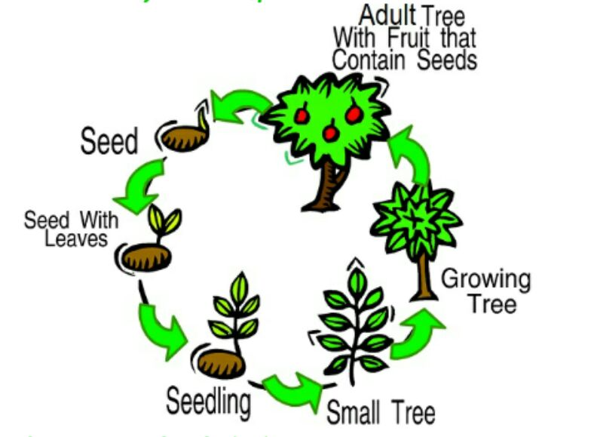  2. Answer the questions. Use full answers.  Why are plants important? ……………….  What do plants need to grow? Plants needs w….., s……t, and … grow.  What do we use plants for? We use plants to make f…, d…., c…., m….. and c….. .  Where do seeds grow? …………..  In summary section use method “Success ladder”(Feedback)  The first stairs: I know information about plants.  The second stairs: I know read and understand text about plants.  The third stairs: I know what grow plants and use forms adjectives in the sentences. |  |  | Learners number these sentences in order  Learners answer the questions. Use full answers.  Learners do the task | Individual avaluation  Mutual avaluation  Verbal evaluation
End  5 min | All learners put stickers into three groups according their understanding of the lesson  Home task: find the information about plants in Red Book  Saying goodbye |  |  |  | Self-assessment |  | stickers
  I know and understand | I can speak | I need a help

LESSON 17 |  |  | Unit 2: Living things
Teacher name: Rogova V.V. |  |  | School: Stavropolka Secondary School
Date:
Grade: 5 |  |  | Number present: |  |  | Number absent:
Theme of the lesson: |  | Animals 1
Learning objectives |  | 5L3 Understand an increasing range of unsupported basic questions on general and curricular topics.  5C4 Evaluate and respond constructively to feedback from others.  5R1 Understand the main points in a limited range of short simple texts on general and curricular topics.  5W2 Write with support a sequence of short sentences in a paragraph on a limited range of familiar general topics.
Lesson objectives |  | participate in discussions;  give and respond the questions;  answer the questions; talk about the plants ;  uses appropriate layout; improve communication skills;  Make their own sentences learners speak out their opinions about the topic covered; gives constructive feedback;
Plan
Planned timings | Planned activities |  |  | Learners’ activities | Evaluation
Start  10 min | GREETING  Write a few words/phrases from the previous lesson on the board but with jumbled letters. Ask the pupils to unscramble the letters and write the words in their notebooks. Check their answers. |  |  | Learners unscramble the letters and write the words in their notebooks
Middle  25 min | Read the text and answer the questions.  Plants are very important kind of life. Plants are living organisms such as flowers, trees, herbs, bushes, grasses, vines, ferns, mosses and green algae. They provide us with food materials, wood and also the live giving oxygen. Plants cover most land and can be big or small and come in many colors, but they are not animals. Plants usually can’t move. They breathe a different kind of air than people and animals do. Plants make their own food from water, sunlight and the soil. Plants usually make more plants, or reproduce, with seeds.  Questions:  1.Why plants are very important kind of life?  2.What do living plants need?  3.How do plants grow?  4.What do plants provide us?  Write a short topic using the picture from task 2.  Follow the instructions.  1.Give the title to the topic.  2.Make up a short plan.  3.Write the main idea.  4.Give three details.  5.Write summary sentence.  6.Use your draft organizer.  7.Follow the layout structure.  8.Write a short story (about 10 sentences).  Group work. In their groups learners write 3-4 sentences about this plant using the Present Simple forms.  Teacher nominates a group of learners to present the plant. Learners give peer feedback such as: Your English / / pronunciation is good. We can understand all of / most of the presentation. We like the ____. Teacher praises learners’ and suggests an improvement.  Learners peer assess each other following the suggested criteria. |  |  | Learners read the text and answer the questions  Learners follow the instructions  Learners share their ideas about the exact plant in groups, choose the best sentences and present them. | Verbal evaluation  Individual avaluation  Mutual avaluation
End  5 min | Method “Free letter” in 2 minutes learners express thoughts according to the theme, it may be an essay.  Home task: learn the new vocabulary  Saying goodbye |  |  |  | Self-assessment

LESSON 18 |  |  | Unit 2: Living things
Teacher name: Rogova V.V. |  |  | School: Stavropolka Secondary School
Date:
Grade: 5 |  |  | Number present: |  | Number absent :
Theme of the lesson: |  | Animals 1
Learning objectives |  | 5.S4 respond with limited flexibility at sentence level to unexpected comments on an increasing range of general and curricular topics  5.W3 write with support factual descriptions at text level which describe people, places and objects  5.UE9 use simple present and simple past regular and irregular forms to describe routines, habits and states on a limited range of familiar general and curricular topics
Lesson objectives |  | - write with support factual descriptions at text level which describe animals, places and objects with support;  - get information about a limited range of the topic «Animals» with support;  - use simple present to describe routines, habits and states on topic “Animals” with support
Plan
Time | Planned activities |  |  | Learners’ activities |  | Evaluation | Resources
Beginning  10 min | 1. Greeting: duty’s report  2. Psychological atmosphere  Phonetic drill  3. Checking up the home task talk about sea animals  New words: teacher will pronounce every word, students will repeat after teacher  domestic animal, wild animal, woods, jungles, fields, fox, tiger, wolf, elephant, hare, horse, bull, sheep |  |  | Learners guess the name of animals |  | Verbal evaluation | pictures
Middle  20 min | Speaking  Method: 5W Questions  Ex: 2 Answer the questions  Teacher will ask questions then children will answer  Teacher makes discussion around this question:  1. What kind of animals do you know?  2. Where do wild animals live?  3. Where do domestic animals live?  4. When do people use animals?  5. Which animals are very clever?  Method: Imagine  Guessing game. Ex: 3. Learners look at the picture and guess, parts of what animals are there on the picture  Teacher asks learners: “What animal is it?’’  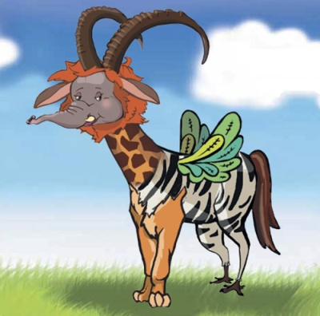  Reading  Ex:2  Group 1: underline new words and explain their meanings  Group 2: ask 10 questions about the specific details of the text.  Group 3: summarize the text.  Animals  There are two types of animals.  We know wild animals. They are those that live in the woods, jungles and in the fields. They are: foxes, tigers, wolves, elephants, hares and so on.  And there are animals that live near the people. They are called domestic animals. And some of them even help people. Horses, bulls, dogs help people a lot. Domestic animals are cows, cats, sheep and so on.  Many years ago when there were no cars and trucks people used horses and bulls working in the fields. Dogs are our great friends but they also guard our houses and they are used in the army and by the police. Cats catch mice and rats. As for other domestic animals they are also very useful. Hens, ducks, geese, turkeys give meat and eggs. Cows and goats give milk.  It should be said that both wild and domestic animals can be good actors and we can see them in the circus. There are animal-trainers that train a certain kind of animals. For example, Kucklachov has the theatre where cats play main parts. Such shows are really funny and interesting. |  |  | Learners answer the questions  Learners try to share their opinions  Learners choose one card and answer.  Learners read and translate the text. |  | Mutual avaluation  Individual avaluation
End  10 min | Feedback. The teacher gives comments about learners work and awards learner. Students will choose one and put on the board their stickers.  Home task for the next lesson.  Read the text once more and translate it  Saying goodbye |  |  |  |  | Self-assessment | Smiles  Stickers

LESSON 19 |  | Unit 2: Living things
Teacher name: Rogova V.V. |  | School: Stavropolka Secondary School
Date:
Grade: 5 |  | Number present: | Number absent :
Theme of the lesson: | Animals 2
Learning objectives: |  | 5.S7 Use appropriate subject-specific vocabulary and syntax to talk about a limited range of general topics.  5.R4 Read with some support a limited range of short fiction and non-fiction texts.  5.UE1 Use appropriate countable and uncountable nouns, including common noun phrases describing times and location, on a limited range of familiar general and curricular topics.  5.W3 Write with support factual descriptions at text level which describe people, places and objects.
Lesson objectives |  | Listen, repeat the new word follow the instruction according the new words;  Read and answer the true or false questions of a given topic.  Make sentences, using of countable and uncountable nouns.
Plan
Planned timings | Planned activities |  | Learners’ activities | Evaluation |  | Resources
Start  10 min | Greeting. Warm up  Now, it’s time to play now. One pupil say sea animals name one word. Another pupil will name one word. Another repeat it and add his word for example: a sea horse. A sea horse and a shark. A sea horse, a shark and a fish. A sea horse, a shark, a fish and a whale.  So, Today we are going to talk about sea animals. I will divide you into two group. I give you dolphin’s pictures. And you are take them.  Method: ‘Mosaic’  1st group: blue dolphin  2nd group: grey dolphin. |  | Learners follow the instructions |  |  | Cards of animals
Middle  25 min | Task 1  Children catch at the picture and find the new words.  The method: “ Catch a fish”  S_a dolphin_ _hale jellyfi_h mam_ al s_ark b_at oc_an  The method: Brainstorming  Do you know about this animal?  Have you ever seen a dolphin?  Where? Do you like this animal?  Task 2  Reading  Read the text “Dolphins – The dogs of the Sea  Dolphins are sometimes thought of as the dogs of the sea because they are usually playful and friendly. They’re also among the smartest animals on Earth. Dolphins are water mammals. Scientists believe they’re as smart as chimpanzees or dogs. Dolphins live in rivers and oceans, but the fun thing all about dolphins is that they must come up to breathe air.  Are the sentences True or False? Circle the correct answer.  1. Dolphins are smart animals.  2. Dolphins live in Lakes  3. Dolphins are related to whales.  4. Dolphins can live without air.  Task 3  Write two forms of nouns. Make sentences with nouns.  For example: I have got a dog. Dolphins live in the rivers and oceans. Chimpanzee is smart animal. I drink water. Cats like milk. |  | Learners find the missing letter and connect with pictures.  Learners reads the text and statements. Then circle the correct answer according to the text.  Learners compare two forms of noun | Individual avaluation  Verbal evaluation  Mutual avaluation
End  10 min | In summary section use method:  “ Sailor”  Sea – I can read new words;  Ship – I can read and say new words;  Sail – I know countable and uncountable nouns;  Flag – I can make up short sentences.  They build ship because clarify their level  Home task for the next lesson.  Read the text once more  Saying goodbye |  |  | Self-assessment

LESSON 20 |  |  | Unit 2: Living things
Teacher name: Rogova V.V. |  |  | School: Stavropolka Secondary School
Date:
Grade: 5 |  |  | Number present: |  |  |  | Number absent:
Theme of the lesson: |  | Animals 2
Learning objectives |  | L6 deduce meaning from context in short supported talk on an increasing range of general and curricular topics.  S6 communicate meaning clearly at sentence level during pair, group and whole class exchanges.  R9 recognise the difference between fact and opinion in short, simple texts on an increasing range of general and curricular topics.  W7 use with some support appropriate layout at text level for a limited range of written genres of familiar general topics and some curricular topics.
Lesson objectives |  | understand some specific information and detail with some support questions  use adjectives to describe things  take turns when speaking with others  recognize the difference between fact and opinion  compare  spell most familiar high – frequency words accurately when writing independently analyze
Plan
Planned timings | Planned activities |  |  | Learners’ activities |  | Evaluation |  |  | Resources
Beginning  5min. | Greeting: Teacher greets learner learners respond to greeting  Dividing into subgroups: Teacher divides learners into subgroups using pieces of animals’ pictures.  Revising the previous lesson:  What are the differences between the domestic animals and wild animals?  Brainstorming  Teacher shows photo of animal on the screen and asks questions:  Do you know this animal? Have you ever seen it? |  |  | Learners listen and answer questions. |  | Verbal evaluation |  |  | Pieces of animals’ pictures
Middle  35 min. | Task 1 Read the text, decide which statement is a fact and which is an opinion  Snow leopard  The snow leopard is an official Symbol of Kazakhstan. In Kazakhstan people always respected this leopard as the strongest and proudest animal. The snow leopard is a big cat. It lives high up in the Tien Shan mountains. It usually comes out at night. It has thick fur, which protects it from the freezing cold.  It eats wild sheep and goats. It also eats smaller animals and birds. But it isn’t dangerous for people. It is strong and can kill animals that are three times biggest than it. Unfortunately, they are an endangered species. In Kazakhstan there are less than 200, so we need to protect them in order to survive.  Task2 Write 3 forms of underlined adjectives from the text and make sentences:  Example, strong-stronger-strongest  A lion is stronger than a wolf.  Task 4 Pair work. Talking about animals. The learners ask questions each other such as:  1Do you have pet?  2What is your favourite pet?  3What does it like?  4 What other domestic animals do you have?  5How do you care of them?  6 How do you protect them?  Descriptor  answer guestion correctly |  |  | Learners read the text, decide which statement is a fact and which is an opinion  Learners rite comparative and superlative of regular adjectives  Learners put question correctly |  | Individual avaluation  Mutual avaluation
End  5min. | Reflection: Self-assessment: At the end of the lesson, learners reflect on their learning:  The learners will be assessed by the active work at the lesson with stickers  Home task for the next lesson.  Repeat the words and prepare to the writing essay  Saying goodbye |  |  |  | Self-assessment |  |  | Stickers

LESSON 21 |  |  | Unit 2: Living things
Teacher name: Rogova V.V. |  |  | School: Stavropolka Secondary School
Date:
Grade: 5 |  |  | Number present: |  |  |  | Number absent:
Theme of the lesson: |  | Human Beings 1
Learning objectives |  | L6 deduce meaning from context in short supported talk on an increasing range of general and curricular topics.  S6 communicate meaning clearly at sentence level during pair, group and whole class exchanges.  R9 recognise the difference between fact and opinion in short, simple texts on an increasing range of general and curricular topics.  U.E3 use a growing variety of adjectives and regular and irregular comparative and superlative adjectives on a limited range of familiar general and curricular topics.
Lesson objectives |  | understand some specific information and detail with some support questions  use adjectives to describe things  spell most familiar high – frequency words accurately when writing independently analyze
Plan
Planned timings | Planned activities |  |  | Learners’ activities |  | Evaluation |  |  | Resources
Beginning  5min. | Greeting: Teacher greets learner learners respond to greeting  Revising the previous lesson:  What are the differences between the domestic animals and wild animals? |  |  |  |  |  |  |  | Pieces of animals’ pictures
Middle  35 min | Write a short essay about animal. Follow the instructions:  give a title to the essay  make up a short plan  write the main idea  give three details  write a summary sentence  Summary graphic organizer  Title _______________________  Main idea:_ _________________  Circle the 3 most important words in the main idea and then write them  here:______________________  Three important details:  1)  2)  3)  Summary of the passage in one sentence:___________  PRESENT SIMPLE TENSE  The Past Tense is used to talk about something that started and finished at a definite time in the past.  Affirmative form  Question form  Negative form  Inductive methods  Ex: 1 Make sentences  You should make sentences from present and past simple using these verbs  Live, help, use, work, play  For example:  In present: I live in Shymkent. In past: I lived in Moscow |  |  | Learners write a short essay about animal. Follow the instructions  Learners  writes a short story  uses appropriate layout  keeps the format of a given genre  Learners make sentences |  | Individual avaluation  Verbal evaluation  Mutual avaluation
  I played | We played
  You played | You played
  He / she / it played | They played
  Did I play? | Did we play?
  Did you play? | Did you play?
  Did he / she / it play? | Did they play?
  I did not play | We did not play
  You did not play | You did not play
  He / she / it did not play | They did not play
End  5min. | Reflection: Self-assessment: At the end of the lesson, learners reflect on their learning:  The learners will be assessed by the active work at the lesson with stickers  Home task: make 5 sentences in PRESENT SIMPLE TENSE  Saying goodbye |  |  |  | Self-assessment |  |  | Stickers

LESSON 22 |  |  | Unit 2: Living things
Teacher name: Rogova V.V. |  |  | School: Stavropolka Secondary School
Date:
Grade: 5 |  |  | Number present: |  |  | Number absent:
Theme of the lesson: |  | Human Beings 1  SA 2
Learning objectives |  | 5.R1 Understand the main points in a limited range of short  simple texts on general and curricular topics  5.R4 Read with some support a limited range of short fiction and non-fiction texts  5.W2 Write with support a sequence of short sentences in a  paragraph on a limited range of familiar general topics
Assessment criteria |  | - Identify main idea of simple texts on familiar topics  - Identify the general information of the text with some support  - Write short sentences on familiar topics with support  - Connect sentences into a paragraph
Plan
Planned timings | Planned activities |  |  | Learners’ activities | Evaluation |  |  | Resources
Beginning  5min. | Organization moment:  Good morning pupils! How are you today?  Are you ready for the lesson?  Who is on duty to today?  Warm up “Listen and remember ”  To learners will be given 8 simple words twice. |  |  | Greeting  Learners do the task | Verbal evaluation
Middle  15 min | Choose the correct answer.  1. In his den the lion  a) is jumping. b) is sleeping. c) is eating.  2. The lion is going  a) to kill the mouse. b) to eat the mouse. c) to play with the mouse.  3. The mouse  a) is laughing. b) is running away. c) is crying.  4. When the mouse sees the lion in the net she  is running away. b) is laughing. c) is chewing the net. |  |  | Learners choose the correct answer | Individual avaluation
SA  20 min | LISTENING AND SPEAKING  Task 1. Watch the video and answer the questions.  Transcript for the teacher:  - What did naughty young giant do?  - Where did naughty young giant move the Pyramids?  - Where did naughty young giant move the Leaning Tower of Pisa?  - What did naughty young giant swap?  - What did he do after mom scolded him?  USE OF ENGLISH  Task 2. Look at the picture. Complete the gaps in the sentences with the correct form of there is/there are.  Example: Is there a bookcase in the living room?  - No, there is not.  1. ________________ any cushions on the sofa?  2. ________________ a picture on the wall?  3. ________________ any books in the kitchen?  4. ________________a carpet on the floor?  5. ________________ a lamp on the table? |  |  | Learners watch the video and answer the questions  Learners complete the gaps in the sentences with the correct form of there is/there are.
End  5min. | Reflection: Self-assessment: At the end of the lesson, learners reflect on their learning:  The learners will be assessed by the active work at the lesson with stickers  Home task: to repeat the theme There is…/ there are…  Saying goodbye |  |  |  | Self-assessment |  | Stickers

LESSON 23 | Unit 2: Living things
Teacher name: Rogova V.V. | School: Stavropolka Secondary School
Date:
Grade: 5 | Number present: | Number absent:

Theme of the lesson: |  | Human Beings2
Learning objectives |  | 5.L3 understand an increasing range of unsupported basic questions on general and curricular topics  5.S6 communicate meaning clearly at sentence level during, pair, group and whole class exchanges 5.W7 use with some support appropriate layout at text level for a limited range of written genres on familiar general topics and some curricular topics
Lesson objectives |  | Use present and past simple to describe routines, habits and states on a limited range of familiar general and curricular topics
Plan
Planned timings | Planned activities |  | Learners’ activities | Evaluation |  | Resources
Start  5 min | GREETING  Teacher greets and invites to make a circle, greet each other and wish their best wishes to each other.
Middle  35 min | BRAINSTORMING  Teacher shows video. Stop in the middle of the video, and ask gist questions to open the theme of the lesson.  What did you watch from this video?  What about is this video?  How do you think what is theme of our lesson?  What parts of body do you know?  TASK 1.  Listen to the teacher. Use new vocabulary.  Which parts of body work together when one is watching TV?  Which set parts of body are found in the head?  What parts of body we use when we write?  Are the parts of body help us perform our daily activities?  Which set parts of body is found in the upper limbs?  TASK 2.  Write and speak about your favourite cartoon character. Use new words.  TASK 3. “Think and find”  There some hidden words at the board. Leaners should come and read the hidden word and explain it to other learners.  TASK 4.  Change the tense in each of the following sentences. Use the tense given in brackets.  1. My father likes seafood. (change to past simple) My father _____ seafood.  2. Do you watch the film? (change to past simple)  ______ the film?  3. My sister doesn’t have a job. (change to past simple) My sister ____a job a year ago.  4. He speaks four languages. (change to past simple) He ________ four languages last year.  5. I saw a great film. (change to present simple)  I _______a great film yesterday.  6. He reads a lot of books in his spare time. (change to past simple) He ______ a lot of books in his spare time last summer.  7. He liked his job. (change to present simple)  He _____ his job. 8. Elizabeth isn’t at home. (change to past simple) Elizabeth ______ at home yesterday.  9. Are they here? (change to past simple)  _________ here a year ago?  10. He liked the job. (change to present simple)  He _______ the job. |  | Learners do the task  Learners answer the questions correctly.  Learners write short story  Learners explain hidden words to others  Learners change the tense in each of the sentences | Verbal evaluation  Individual avaluation  Mutual avaluation  Individual avaluation |  | http://www.youtube.com /watch?v=uTDJiPdz3L0  Flipchart  Pictures  Flipchart  PPT
End  5 min | Feedback.  What they learned;  What remained unclear for them;  What they need to continue working on;  Teacher gives comments about learners work and awards learners.  Home task: to learn the new words  Saying goodbye |  | Learners will choose one and put on the board their stickers. |  | Self-assessment |  | Stickers, traffic lights

LESSON 24 | Unit 2: Living things
Teacher name: Rogova V.V. | School: Stavropolka Secondary School
Date:
Grade: 5 | Number present: | Number absent:

Theme of the lesson: | Human Beings2

Learning objectives |  | 5.S1 provide basic information about themselves and others at sentence level on an increasing range of general topics  5.W8 Spell most high-frequency words accurately for a limited range of general topics  5.UE1 use appropriate countable and uncountable nouns, including common noun phrases describing times and location, on a limited range of familiar general and curricular topics  5.C6 organize and present information clearly to others
Lesson objectives |  | Match the pictures with sentences,  distinguish the countable and uncountable  will write parts of the body (singular and plural form)
Plan
Planned timings | Planned activities |  | Learners’ activities |  | Evaluation |  | Resources
Beginning  5 min | GREETING .  T: Good morning, students! I am glad to see you. How are you today? I hope you are well.  Task:1 Match the pictures with their names and say. 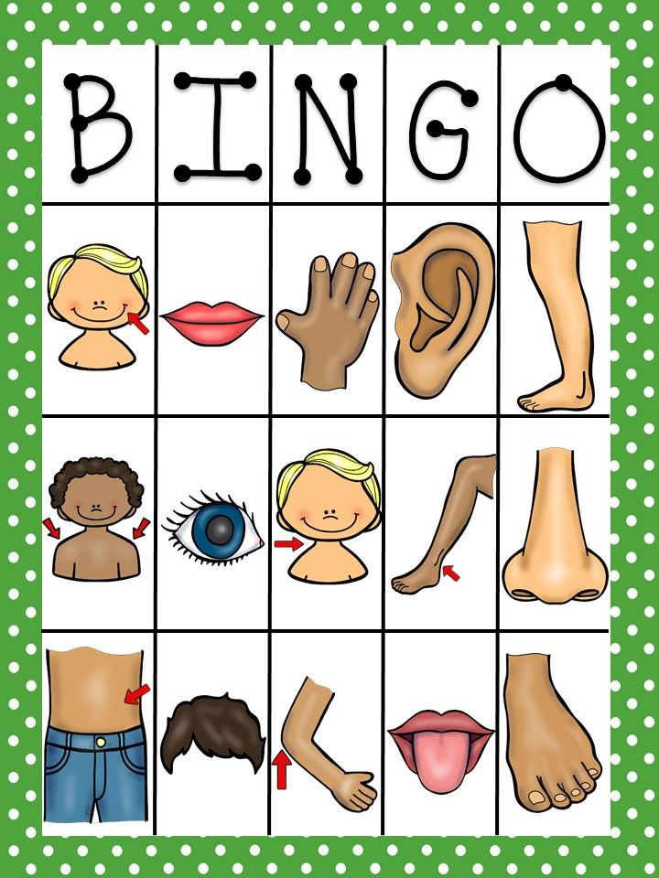 |  | Learners match the pictures with their names and say |  | Individual avaluation |  | Pictures  
Middle  35 min | Task:2. Fill in the gap, put necessary verbs with group  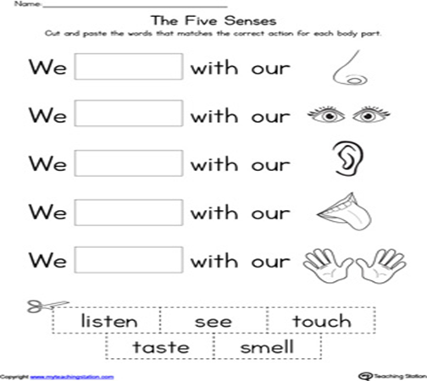  Task 3. Write parts of the body (singular and plural form)  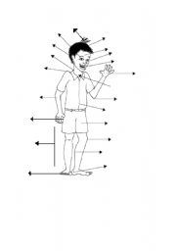  Read the sentences and write T for True or F for False sentences.  The lion and the mouse are good friends.  The lion kills the mouse.  The lion is sleeping in the den.  The mouse helps the lion.  The lion is free. |  | Learners  fill in the gap, put necessary verbs with group  Write names of parts of the body (singular and plural)  Learners read the sentences and write T for True or F for False sentences | Verbal evaluation  Mutual avaluation  Self-assessment |  |  | Flashcards, active board  Flashcards, active board  blackboard
End  5 min | REFLECTION  All learners put stickers into three groups according their understanding of the lesson  Home task: to repeat the words and grammar theme.  Saying goodbye |  | stickers

LESSON 25 |  |  | Unit 2: Living things
Teacher name: Rogova V.V. |  |  | School: Stavropolka Secondary School
Date:
Grade: 5 |  |  | Number present: |  |  |  | Number absent:
Theme of the lesson: |  | Summative control work for the 1st term
Learning objectives |  | 5.L6 Deduce meaning from context in short, supported talk on an increasing range of general and curricular topics.  5.R1 Understand the main points in a limited range of short simple texts on general and curricular topics.  5.W1 Plan, write, edit and proofread work at text level with support on a limited range of general and curricular topics.  5.W2 Write with support a sequence of short sentences in  a paragraph on a limited range of familiar general topics.  5.S1 Provide basic information about themselves and others at sentence level on an increasing range of general topics.  5.S3 Give an opinion at sentence level on a limited range of general and curricular topics.
Lesson objective |  | Each learner works individually.  Learners listen to the recording twice and write numbers to the pictures in an order they appear in the recording.  Learners read the text related to the topic “Home and away” and write the names or first letters of the children next to the activities given in the task. They write the postcard.  Learners make a plan of writing.  Learners are expected to answer Alex’s questions.  Learners should write their personal feelings and opinions on a given topic using topical vocabulary with appropriate spelling. Learners individually describe the picture using questions as a support. Teacher can ask supporting questions if necessary to help learners.
Plan

Planned  timings | Planned activities |  |  | Learners’ activities | Evaluation |  |  | Resources
Begining  2min | ORGANIZATION MOMENT  1.Greeting  2. Lesson objective
Middle  35 min | LISTENING  Task  Part 1. Listen to the recording twice and underline an odd word.  Part 2. Listen to the recording twice and number the pictures.  READING  Task. Read the text about four learners’ daily routine.  Read the text again and identify who does each activity. Write the learners’ names or first letters next to the phrases. The first task is done for you as an example.  M = Max, J = Julia, L = Luke, S = Sara.  Example: go to the park - M  - enjoy Art _____  - do sport activities  - like music  - keen on reading  - spend time with friends _____  - do house work _____  WRITING  Task. Your pen- friend has sent you a postcard of his/her hometown.  Write your answer to Alex. Make a plan of your writing and answer the questions  SPEAKING  Task. Choose one of the pictures below and describe it. Answer the questions:  - What can you see in the picture?  - Where are people or cartoon characters?  - What are they doing?  - Do you like the picture and why? |  |  | Learners do the task  Learners read the text and identify who does each activity.  Learners make a plan of your writing and answer the questions  Learners answer the questions | Individual avaluation |  |  | CD3.  Tapescript 1.
End  3min | FEEDBACK  The most activities in class for me are…….  In class I don’t like……….  Today I couldn’t say because………  I have some difficulties with speaking……  Home task: to repeat the words and grammar theme.  Saying goodbye |  |  |  |  | Self-assessment |  |  | A sheet of paper

LESSON 26 |  |  | Unit 2: Living things
Teacher name: Rogova V.V. |  |  | School: Stavropolka Secondary School
Date:
Grade: 5 |  |  | Number present: |  |  | Number absent:
Theme of the lesson: |  | Unit revision
Learning objectives |  | 5.L3 understand an increasing range of unsupported basic questions on general and curricular topics 5.S6 communicate meaning clearly at sentence level during, pair, group and whole class exchanges 5.S7 use appropriate subject-specific vocabulary and syntax to talk about a limited range of general topics 5.UE15 use common verbs followed by infinitive verb / verb + ing patterns on a limited range of familiar general and curricular topics
Lesson objectives |  | All learners will be able to:  read and understand main facts about plants in our life Most learners will be able to:  can use common verbs followed by infinitive Some learners will be able to:  tell about the role of plants and animals in human being’s life
Plan
Planned timings | Planned activities |  |  | Learners’ activities | Evaluation |  |  | Resources
Beginning  5 min | GREETING  Teacher shows a short video about the Human beings and plants and asks: So can you guess what the theme of our lesson is? We’ll speak about plants and animals because plants and animals are the part of nature. Teacher introduces lesson objectives to the learners |  |  | Greeting | Verbal evaluation |  |  | https://www.youtube.com/watch?v=QVig7_D-VFc
Middle  35 min | Pre-reading: “ Brainstorming” Have students brainstorm answers to the following questions: Ask each group to record as many plants and animals as possible How do you understand the word “ living things and none-living things”? And what about a human being? What plants do you know? Do you have any plants at home? What do plants give us? Why are plants important to people?”  1.Work with text . Teacher asks learners to read the text , complete the chart with the main ideas  2. Read the text again and mark the statements right (v) or wrong (x).  1. Without plants , people could live 2 . Animals , plants and human beings aren’t parts of nature. 3. Plants provide habitats for animals and human beings. 4. Plants help moderate the temperature |  |  | Learners answer the questions  Learners should complete KWL chart about “plants in our life”  Learners complete the chart  Learners read the text and mark the statements right or wrong. | Mutual avaluation  Individual avaluation
  What I know | What I want to know
  The role of plants
  (1 group) Animals | (2 group)  Human beings
End  5 min | REFLECTION  Ask students to look at lesson objectives they set at the beginning of the lesson and think and say what they did well in the lesson and what needs improvement. At the end of the lesson, students reflect on:  - what they learned  - what remained unclear for them  - what they need to continue working on  Leaners should show their mood with Estimate “Firework”  Excellent- Clap your hands up  Good- Clap your hands in front of you  Satisfactory- Clap your hands down  Saying goodbye |  |  | Learners make comments about the lesson orally. | Self-assessment

