Lesson plan

LESSON: Module 2 |  | School: gymnasium 8
Theme:Past Simple.Pronunciation-/t/,/d/,/id/.Regular/Irregular verbs
Date: 13.10.20 |  | Teacher name: Nyu E.E
CLASS:6a b v |  | Number present: | absent:
Learning objectives(s) that this lesson is contributing to | 6.3.6.1- communicate meaning clearly at sentence and discourse level during, pair, group and whole class exchanges;  6.6.5.1 - use questions including questions with whose, how often, how long and a growing range of tag questions on a growing range of familiar general and curricular topics;  6.1.1.1- use speaking and listening skills to solve problems creatively and cooperatively in groups;  6.4.2.1 - understand independently specific information and detail in short, simple texts on a limited range of general and curricular topics;  6.3.7.1- use appropriate subject-specific vocabulary and syntax to talk about a limited range of general topics, and some curricular topics;  6.5.3.1 -write with some support about personal feelings and opinion on a limited range of familiar general and curricular topics;  6.2.1.1- understand a longer sequence of supported classroom instructions; 6.5.8.1- spell most high-frequency vocabulary accurately for a limited range of familiar general topics and some curricular topics  6.5.2.1 - write with some support about real and imaginary past events, activities and experiences on a limited range of familiar general topics and some curricular topics;
Lesson objectives | All learners will be able to:  use and pronounce some target language accurately in response to prompts and in controlled tasks with support
Most learners will be able to:
use and pronounce most target structures accurately in response to prompts and in controlled tasks with support
Some learners will be able to:
use and pronounce most target structures accurately in response to prompts and in controlled tasks with little support
Previous  learning | vocabulary for appearance / describing character
Plan
Planned  timings | Planned activities |  | Excel  Resources | Teacher  Notes

Beginning the lesson  6.3.6.1  6.1.1.1 | To present grammar for appearance  Ss close their books. Present the Past Simple. Say, then write  on the board: I worked hard yesterday. Underline worked and explain that this verb is in the past simple. Point to a S and say: You worked hard yesterday. Then write it on the board. Point to a male S and say: He worked hard yesterday. Then write it on the board.  Present the other persons in the same way. Elicit that the verb is the same in all
Main Activities  6.6.5.1  6.2.1.1 | To present the Past Simple  persons. Explain/Elicit the spelling rules of the past simple for  regular verbs by writing the verbs work, love, play, study, travel and their past simple forms on the board: work – worked (most verbs take -ed to form their past simple form), love – loved (verbs ending in -e add -d), study – studied (verbs ending in consonant +y lose y and take -ied), play – played (verbs ending in a vowel  +y add -ed), travel – travelled (verbs ending in vowel + l, p, k, b, etc double the consonant and add -ed).
 | To practise the Past Simple
6.4.2.1 | Explain the task and allow Ss some time to complete it
 | in their notebooks.
 | Check Ss’ answers by playing the recording. Check
 | correct spelling on the board.
 | To pronounce /t/, /d/, /Id/ (Past Simple verb endings)
 | Play the recording with pauses for Ss to repeat chorally
6.5.8.1 | or individually.
 | Ss copy the table into their notebooks.
 | Play the recording again. Ss listen and tick the correct
 | sounds. Check Ss’ answers, then elicit more words with
 | the same sounds
6.5.2.1 | To practise using the Past Simple affirmative
 | Allow Ss some time to complete the task and then check
 | Ss’ answers. Elicit which verbs are regular/irregular.
 | To practise using the Past Simple negative
6.5.2.1 | Explain the task and read out the example.
 | Ss do the task. Check Ss’ answers.
Ending the lesson  6.1.1.1 | Monitor the activity around the class and check Ss answers.

monitor less able groups  in controlled tasks and  provide support through  further modelling and  drilling | monitor pair sentence completion tasks and encourage learners to give feedback to each other on answers | Being a hero
provide extra challenge by getting more able learners to use short answers ‘yes I did/no I didn’t’ by asking them to confirm answers given  by others. | check pronunciation in whole class feedback and remodel/drill use of endings -d/-ed and contractions where necessary
Additional information | 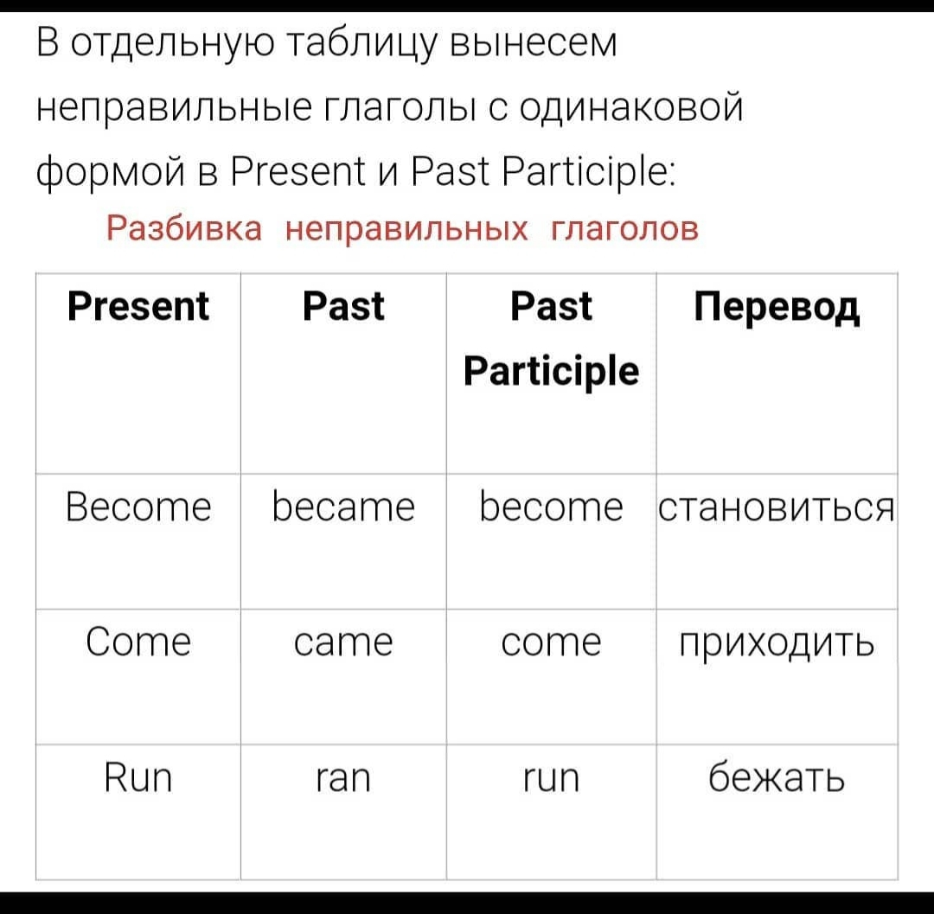  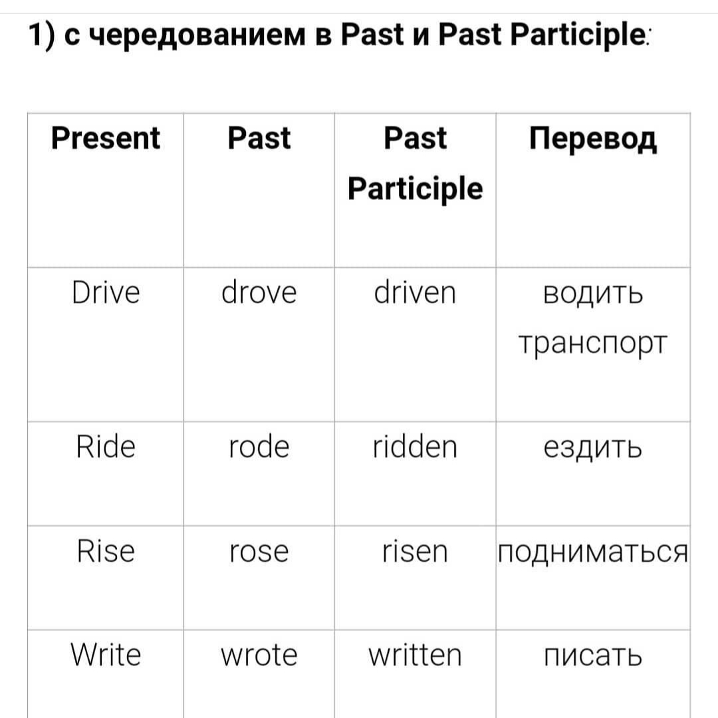  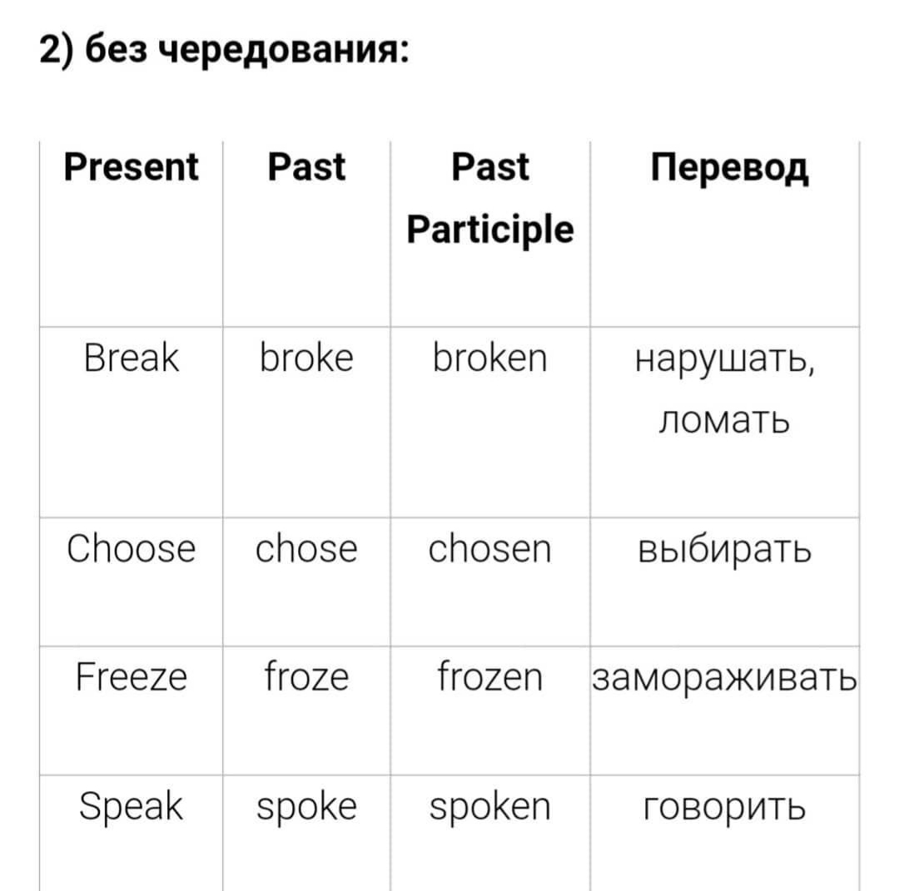  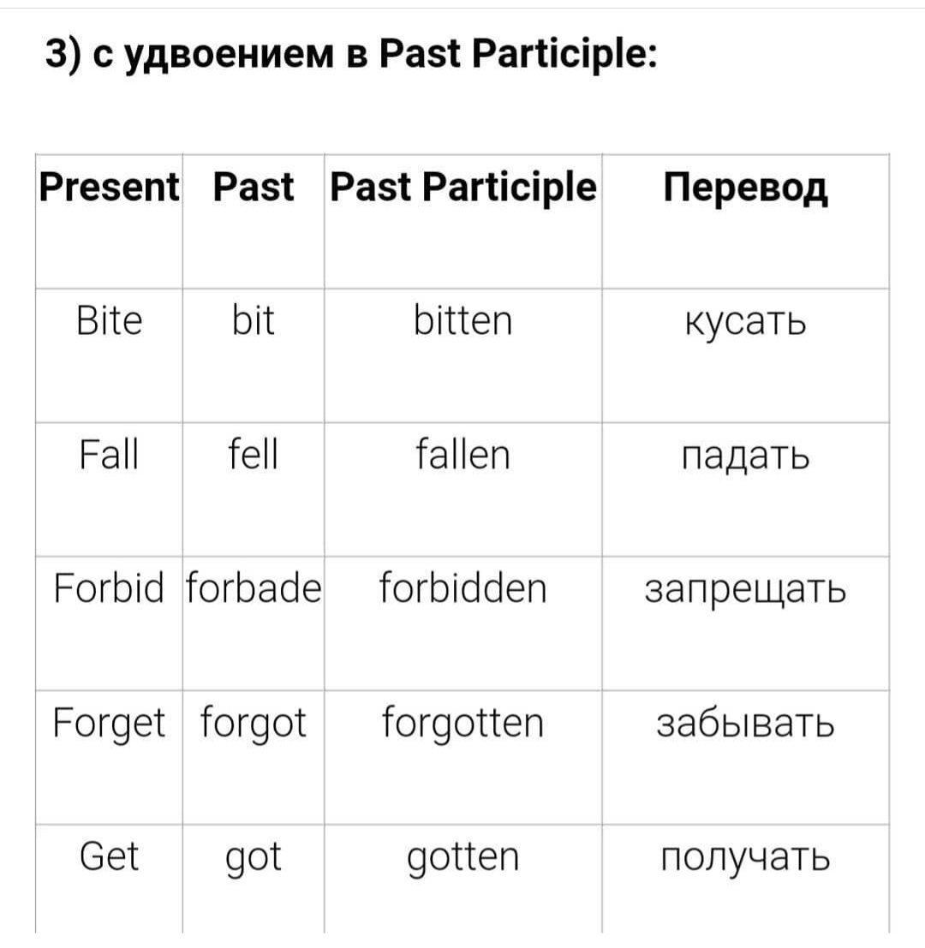  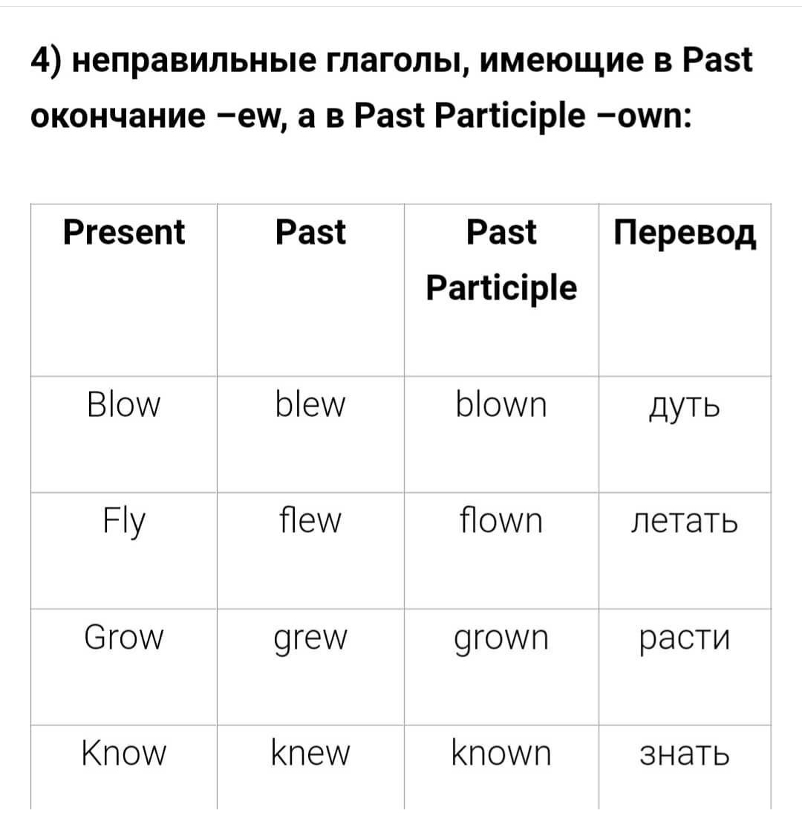  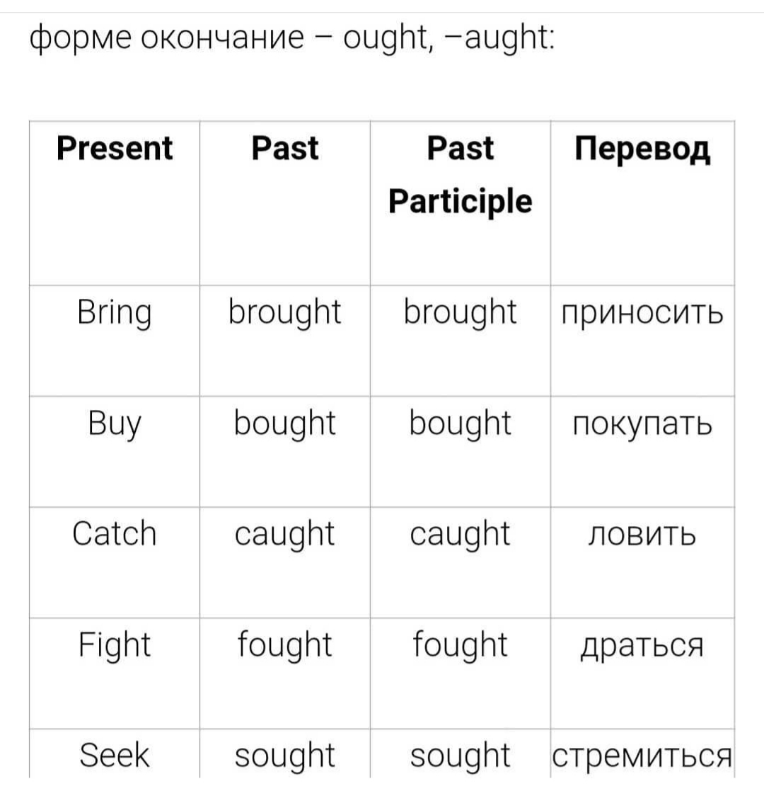  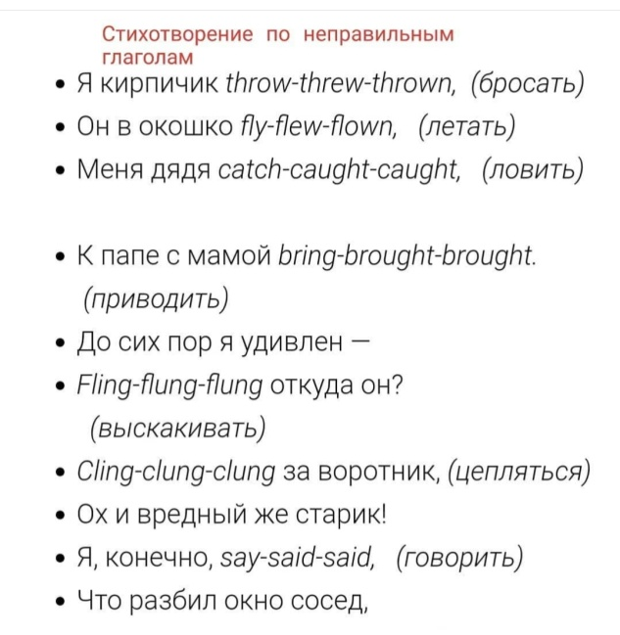

Reflection | Answer the most relevant questions from the box on  the left about your lesson.
Were the lesson objectives/learning objectives realistic?
Did I stick to timings?
What changes did I make from my plan and why?

