**Benefits of using Drama Techniques in ELT**

Жақсылыкова Жазира Әскербайқызы

Дарынды қыз балаларға арналған

“Білім-Инновация” лицей-интернаты КММ

Ағылшын тілі мұғалімі

е-mail: [zhaksylykova.zhazira@gmail.com](mailto:zhaksylykova.zhazira@gmail.com)

**Absract:** This study aims to explore the use of drama and dramatic activities in Intermediate English Language Teaching online. It looks at some of the theories behind the definition of drama, approaches to teaching drama and finds the answer of benefits of using dramatic games and activities, forms of dramatic activities. Then take a look at some practical procedural strategies of dramatic activities such as simulation and exploiting a scripted play and how they can be employed in the online language classroom.

***Key words:*** *Drama, drama techniques, simulation, exploiting a scripted play.*

Drama is not a new approach in foreign language teaching. Its origins can be traced back to the nineteenth century. As Via asserts, this method has become an integral part of language teaching with the increasing prevalence of the Communicative approach. [1]. Drama is not a new approach to foreign language teaching. It was used in the nineteenth century. Dramatic techniques such as role-playing games and simulations help teachers use live language from real life. Drama is one way of using literature in teaching English.

Drama is generally an umbrella term. One of the definitions of term drama is: drama is a window that not only permits its audience to look into the cultural values of the people but also allows for reflecting a social life in which the reader can deduce and determine the culture and the way of living in any society [2].

Definition drama as text. Drama as text is essentially an authentic play written with the purpose of being performed on the stage. The dramatic text is “the literary genre which is most like naturally occurring conversation” because it consists largely of character-to-character interaction [3].

Definition drama as performance. According to Wessels drama in a very concise, but powerful way: “Drama is doing. Drama is being,” remarkably implying that the essence of a literary dramatic text lies in its performative act [4].

English-Canadian writer Peter Robinson suggests two approaches to the teaching of drama. First is “the ‘a’ type analytical” approach to drama/theater texts in which the language is the matter. A literary text illustrating structures is chosen, the teacher helps learners become aware of and practice them. This is an analytical approach to the use of drama in the classroom where drama is the object of instruction. There is also “the ‘b’ type experiential approach to drama theater texts” as a second approach. This approach is inductive, language is regarded as a tool rather than an object. Learning through the students’ experiences is the major concern, and this is acquired via their comments, responses, and expressions based on the text itself or its theme/topic [5]. A stimulation was used as “the ‘b’ type experiential” and exploiting a scripted play was used as “the ‘a’ type analytical”.

There are numerous reasons that make drama suitable for language teaching. It is considered an ideal way of encouraging students to use real, everyday language and of helping them to make the linguistic step beyond the limitations of the language classroom [6]. Marini-Maio stresses that drama in language learning has an intrinsic value as a creative and liberating impetus because it helps to “lower the students’ affective filter, liberating their potential, increasing their spontaneous communication and fluency” and consequently, learners’ positive attitudes and motivation towards learning a foreign language [7].

Drama approaches give an opportunity to teach students to acquire language in a fully contextualized manner. It helps to pay special attention to both verbal and non-verbal communication. Drama provides authentic texts, such as plays or script sketches. There are authentic grammar structures and vocabulary. In role play you can teach students how to be polite or how to ask directions, time. This will be beneficial for their future. When students learn the real life language it develops their motivation and language skills to learn language. It also provides cultural context. While reading plays or scripts there can be holidays, traditions. Moreover, when students play out the play performance creates an interaction between students, generates a friendly classroom environment, and trains emotional memory.

Wessels distinguishes between structure games which reinforce a particular area of grammar and drama games where the emphasis is put on production rather than reception. In games, students are challenged to take part and respond in a meaningful way [4].

Improvisation without a script.Improvisation is activity without a script. In the lesson students can choose one theme and imprivise about it. They can be divided into roles.

In this research two types of drama activities were chosen.

A simulation activity is one where the students choose one problem and talk about it. In this activity, the students can play themselves or someone else. It is an interaction activity with different dialogues.

Exploiting a scripted play. In this activity the teacher should choose one script according to the level of the students. Briefly, it should be relevant and accessible to students needs and the topic arouses the students interest. Before dividing the roles, students read the script on their own. Then the teacher discusses the text and characters in detail. While rehearsing the script the teacher draws attention to emotions and attitudes. The teacher divides the students into two groups and in groups students divide the roles.The final stage is the performance of the play or a scene from it. The performance could be recorded for the students to listen to later.

Teachers have one task is preparing students to be successful in a rapidly changing world. There is an increasing need to work together with people from all over the world, to think creatively and solve problems, to analyze sources more critically, to exchange opinions effectively and to maintain positive thinking in an increasingly complex world. Today the emphasis is on formation of students’ communicative competence through the implementation based on a student-centered approach fitted to students’ wishes and abilities.

Through the activities done with my students online, I have come to see that role-play simulation provides an interesting way for students to learn and appreciate language in meaningful, communicative contexts.

Methodology

The first drama activity is exploiting a scripted play.

Roles - 6

Run time – Around 6 minutes, depending on production.

Set – A shop.

Props - Table(s) for counter

Style - А sketch with minimal stage requirements, and а single set

Synopsis - Ап entertaining short рlау that shows that being impolite doesn't рау.

Language level - lntermediate - В1

Language areas - Going shopping; expressing politeness.

Stage tips - То help students to fully identify with the mood swings of the customers (from being аbrupt and impolite to showing states of growing politeness), it may be а idea to do with the students а variation of the game described оn p.43 in the Stage Tips section.

Draw the following graph оn the board:



Explain to them that 0 оn the scale is neutral, 3 is vеrу polite, and -З is very impolite, Get them to mime facial expressions mime for 0, 3 and -3. Then ask them to О,1,2, З, and finally -1, -2 and -З.

Dictate the following sentences, reading them to express the following degrees of politeness (as indicated in brackets), and ask the students to write down the number they think the sentence would take оп the scale. Could you possibly get me а hаmmеr, please. (very polite: З) Get me а hammer right now. (very imроlitе, -З) I'd like а hаmmеr. (neutral: 0) Good mоrning. I’d like а hammer, please. (mоrе polite: 2) Get me а hаmmеr. (mоrе impolite: -2) Would you mind getting mе а hammеr? (polite: 1) Where аrе yоur hammers? (impolite: -1) Finally, write а different sentence оп the board, expressing а neutral tone, е.g. l wаnt а screwdriver. Get students to make this sentence more polite and mоrе impolite, show them how not опlу the words we use, but also body language, оur facial expression and the stress and intonation influence whether а sentence we say comes across as polite or impolite [8].

Second drama activity is simulation.

Level: intermediate and above.

Aim: to use interactional language in a role-play situation.

The task: going shopping along a typical British high street. Half the class have shopping lists and the other half own a shop.

There are five shops: a computer shop, a newsagent's, a fruit shop, a small supermarket, and a language bookshop. The cards are structured so that some discussion and negotiation is necessary to find most of the things on the learners' shopping lists. In addition, each list also has a short task typical of normal interaction in the street, for example asking the time or directions to a bank.   
 Before the class, copy and cut the cards on worksheets A and B. The ideal number is five of each, you can duplicate the cards if your class is larger than 10.

In class.

* If you are practicing language, review useful structures with the class first, e.g. *'I'm looking for a…', 'I wonder if you can help me, I…', 'How much is that?'*, etc.
* Divide cards to the students making sure there is an equal number of shopping lists and shops.
* Give the learners time to read their cards and ask you about any problem language. Remind the shop owners that they may need to decide how much their products cost before starting.
* Set up your classroom to represent a street, with each table being a shop if possible. Ask the learners who own a shop to prepare a card (folded piece of paper) saying what shop they own.
* Start the role-play. The shoppers need to find everything on their lists and complete their short task also.
* Monitor the activity for interesting language or for problems, which you can feedback afterwards. Try not to intervene too much at this stage.
* Keep the role-play going until enough shoppers have completed their tasks.
* Put the class into groups and ask them to explain how the shopping (and selling) went, and what problems they had.
* Feedback open class on any interesting language points [9].

These activities were conducted online with 8 D and 8 F grades. There were a total 25 students, 4 students were absent. While reading and acting the script it was fun and students participated well. Their intonation and voice were appropriate. But while doing simulation activity students faced challenges. Firstly, it was difficult to divide the roles, so the roles were divided by the teacher. Also, the problem was bad internet connection, some students disappeared during reading and it took time. It was all virtual, there were separate rooms for the shopkeepers on zoom, customers went there to buy and ask about time, and so on.

Based on the answers received from the survey, we can see students’ attitudes towards using drama activities in teaching online. In question 1 - I liked the drama activity we did during the lesson 10% disagreed, 10% partially agreed, 80% agreed, so most of the students enjoyed the activity. But in simulation role-play 70% agreed, 30% partially agreed, nobody disagreed. In question 2 - I think that after reading and doing the task I improved my communication skill in the first activity 10% disagreed, 20% partially agreed, 70% agreed. This question in the second activity 30% partially agreed, 70% agreed, nobody disagreed. In question 3 - I think that after this task the classroom relations have been enriched; we were free to express ourselves and there was a friendly, trustful and relaxed environment in the first activity. I 100% agree. Third question in second activity 10% disagreed, 50% partially agreed, 40% agreed. In question 4 - I learnt how to be polite and its importance in the first activity. 10% disagreed, 10% partially disagreed, 80% agreed. In question 4 - I learnt how to ask and answer about directions, time and how to behave in the shop in the first activity. 20% partially agreed, 80% agreed. In question 5 - I think that this activity will be useful for my future. In the first activity 10% disagreed, 20% partially agreed, 80% agreed. This question in the second activity 10% partially agreed, 90% agreed, nobody disagreed.

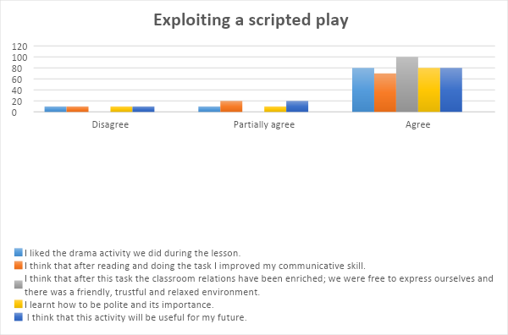

Graph 1. Analysis of the results about exploiting a scripted play

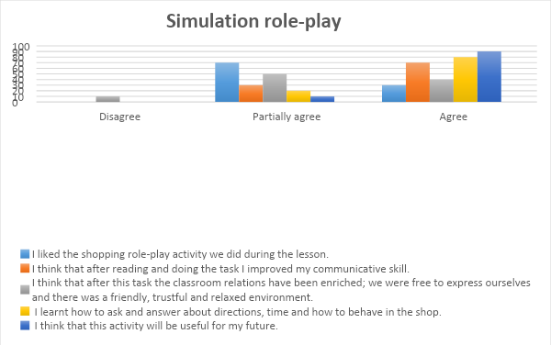

Graph 2. Analysis of the results about simulation role-play

**References**

1. Via, R. (1976), English in Three Acts, Honolulu: University Press of Hawaii.
2. Keshta, A. S. (2000). Alternative Approaches for Teaching English Literature to Undergraduate Students in Gaza.
3. Short, M. H. (1996), “Drama: the conversational genre”, in Short, M. H. (1996), Exploring the Language of Poems, Plays and Prose, London: Longman, pp. 168-194.
4. Wessels, C. (1987), Drama (Resource books for teachers), Oxford: Oxford University Press.
5. Robinson, P. (1997). Generalizability and automaticity of second language learning under implicit, incidental, enhanced, and instructed conditions. Cambridge: Cambridge University Press.
6. Maley, A., & Duff, A. (1984), (4th Edition), Drama techniques in language learning: A resource book of communication activities for language teachers, Cambridge: Cambridge University Press.
7. Marini-Maio, N. (2010), “Full-Scale Play Production: Filling the “Empty Space” between Language and Literature with Fo and Pirandello”, in Marini-Maio, N. & Ryan-Scheutz, C., Set the Stage! Teaching Italian through Theatre: Theories, Methods and Practices, New Haven-Yale, pp.239-266.
8. Herbert Рuсhtа, Glinter Gerngross, Matthew Devitt (2012), Get on stage: Helbling Languages. p 56-61.
9. British Council <https://www.teachingenglish.org.uk/article/a-shopping-role-play>