Short Term Plan

Unit: 4. Organic and Non-Organic Worlds (Fuels) |  | School: Kyxylzhar Secondary General School
Date: |  | Teacher's name: Albina Mukusheva
Grade: 10th |  | Number present: |  | absent:
The topic of the lesson: |  | Organic and Non-Organic food
Learning objectivess |  | 10. 1. 10 use talk or writing as a means of reflecting on and exploring a range of perspectives on the world  10.2. 1 understand the main points in unsupported extended talk on a wide range of general and curricular topics, including talk on a limited range of unfamiliar topics  10. 2. 6 deduce meaning from context in unsupported extended talk on a wide range of general and curricular topics, including talk on a limited range of unfamiliar topics  10. 4. 2 understand specific information and detail in extended texts on a range of familiar general and curricular topics, and some unfamiliar topics  10.4. 5 deduce meaning from context in extended texts on a wide range of familiar general and curricular topics, and some unfamiliar topics  10. 6. 11 use a variety of reported statements and question forms on a wide range of familiar general and curricular topics
Lesson objectives |  | All learners will be able to:  - make up 1 sentence on the topic  - listen to identify 70-79% of detailed information  - read to identify 70-79% of detailed information  Most learners will be able to:  - make up 2-3 sentences on the topic  - listen to identify 80-89% of detailed information  - read to identify 80-89% of detailed information  Some learners will be able to:  - make up 4 sentences on the topic  - listen to identify 90-100% of detailed information  - read to identify 90-100% of detailed information
Assessment criteria |  | Informal Assessment  -identify the relevant opinion of the speaker in a talk  -use the following structure to create arguments: Statement, Explanation  -speak fluently and grammatically true at the time of explaining own point of view range of general topic  -use new vocabulary while writing and speaking  Formal Assessment  -to provide answer in full sentences following the simple sentence structure.
Value links |  | The students work in collaboration in groups and respect each other’s opinions and views.  Cooperation  Digital Learning/21st Century Skills  Think Pair Share
Cross curricular links |  | Biology  Health  Science
ICT skills |  | Smart board, Cards
Previous learning |  | The students have already some knowledge on the topics from the previous lessons.
Plan
Planned lesson stages | Planned activities |  |  |  | Resources
Beginning  10 min  Middle  15 min  10min | Hello dear students! How are you doing?  Today we are going to speak about interisting Organic and Non organic foods.  Let’s start from the  Warm Up  Brainstorming.  Task 1  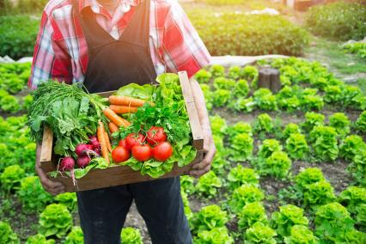  I show the students 2 images, one image of a large, modern, intensive monoculture farm and the other image of a mixed organic farm.  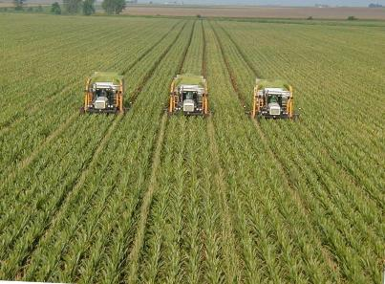  Ask the students to spot differences between the two. E.g. the organic farm has lots of trees and hedgerows. It has an orchard and woodland area etc.  Explain that since the industrial revolution we have seen most of our small farms close down to make way for larger, intensive farms.  Key Questions  What differences can you see between these two farms?  Which one has more varieties of plants?  Which one is has bigger fields?  What do you think are the advantages of intensive monoculture farming?  What are the advantages of organic farms?  Did You Know? (Ag Facts)  - While organic-label foods are offered in each section of the grocery store, fresh fruits and vegetables are the top selling category of organically grown food.  - Consumer demand for organically produced goods has shown double digit growth during most years since the 1990s.  - Organic foods do not have a nutritional advantage over their conventional counterparts.  Listening and Writing practice  Now we are going to watch a little video about organic and non-organic foods. Then we will try to answer a guestion by using the following steps. We will divide into the 3 groups. I will give you new words and you should use them in your answesr.  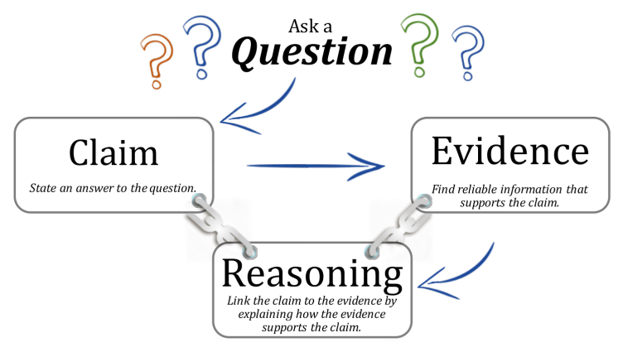  One question for one group  - Are organic foods safer or more nutritious than conventionally-grown foods?  - Is there a measurable difference between a conventionally grown food and an organically grown food?  - Does organic/conventional food taste better?  List of new words:  Word Meaning  Agricultural adj. related to farming  Bacteria noun tiny organisms that can live in our bodies  Consumer noun a person who buys something  Debate noun a discussion in which opposing ideas or arguments are expressed  Ingredients noun the different foods, spices, etc used to make a meal or a dish  Nutritious adj good for your health (of food and drinks only)  Pesticide noun a chemical that stops insects from destroying crops  Reading Practice  This is a way to get prepared for the little Test and revise the vocabulary and grammar learned during the term unit.  Students are to read the text. After reading, in pairs, they look for answers.  Test:  1. What is the main difference between organic and non-organic food?  - use of pesticides  - size of the company  - location of the farm  2. Which is usually more expensive?  - pet food  - organic food  - non-organic food  3. Many small organic food companies found it difficult to _______ .  - waste money  - stay in business  - find cheap pesticides  4. Recent studies show that eating organic produce can _______ your chances of having heart disease.  - Develop  - Increase  - reduce  5. Dangerous bacteria can contaminate  - organic food only  - non-organic food only  - organic and non-organic food  Key:  1. use of pesticides  2. organic food  3. stay in business  4. reduce  5. organic and non-organic food |  |  |  | Pictures  Smart board  https://www.youtube.com/watch?v=_g6TMZZfbUE  https://www.englishclub.com/reading/health/organic.htm#vocab
The end of the lesson  5 min | Okay, students let’s review and summarize the following key concepts:  Tell me your ideas about it.  -The nutrition and overall food safety of organic and conventionally produced food is the same. The difference lies in the production methods used on the farm.  -A variety of farming methods can be used to produce a safe and nutritious food supply  Thanks for the lesson! Goodbye and have a good day! |  |  |  | Smart board
Differentiation – how do you plan to give more support? How do you plan to challenge the more able learners? |  |  | Assessment – how are you planning to check learners’ learning? |  | Health and safety check  ICT links
Differentiation  By support - Teacher can support less-abled classes with the list of unknown words from the text with their definitions.  Before starting of reading process teacher can organize the discussion on this kind of tasks pointing some tips and strategy of effectiveness.  More able students can come up with outstanding ideas with argumentation and creativity. They can use the Internet dictionaries to search for additional information and the meanings of the new words they come across. |  |  | Teacher circulates about the room helping students with vocabulary and expressions, monitors learners as they make up sentences.  - Observation  - Peer Assessment  - Reflection |  | Health and safety check links. Teacher controls the students to keep safety instructions while working with laptops and running dictation.
Reflection
What did you learn in this lesson?
Which part did you find most useful?
How confident do you feel in using what you learned?
Summary evaluation
What two things went really well (consider both teaching and learning)?
What two things would have improved the lesson (consider both teaching and learning)?
What have I learned from this lesson about the class or individuals that will inform my next lesson?

