Long-term plan Unit 3 Holidays and Travel |  |  | School: Secondary school of M.Gorky
Date: |  |  | Teacher’s name: Teacher: Sadiyarova M.A.
Grade: 7 |  |  | Number present: | absent:
Theme Learning map about reading

Learning objectives |  |  | 7.S4 respond with some flexibility at both sentence and discourse level to unexpected comments on a growing range of general and curricular topics  7.C2 use speaking and listening skills to provide sensitive feedback to peers  7.R9 recognise inconsistencies in argument in short, simple texts on a limited range of general and curricular subjects  7.L1 understand with little support the main points in extended talk on a limited range of general and curricular topics
Level of thinking skills |  |  | Understanding  Knowing  Application
Lesson objectives |  |  | All learners will be able to:  Use speaking and listening skills to provide sensitive feedback to peers with support;  Determine and sort information with some flexibility at both sentence and discourse level of topic “Learning map about reading”;  Understand with support the main points in extended talk on a topic “Learning map about reading”  Most learners will be able to:  Use speaking and listening skills to provide sensitive feedback to peers with some support, identify verbs in 1 and 3 forms of Past Participle.  Some learners will be able to :  Discuss and prove opinion using special vocabulary without support, solve a problem how to be a responsible traveler, shows abilities for creating the poster by the given them
Assessment criteria |  |  | Understand and apply given information, demonstrate knowledge about the theme “Learning map about reading” and makes up his own description, using special vocabulary, practice of using Past Participle structure.  Discuss partners’ opinion working in group and whole class.
Value links |  |  | National unity. peace and harmony in our society
Cross curricular links |  |  | Geography, history
ICT skills |  |  | Using internet
Previous learning |  |  | Discussing unusual and interesting journeys across Kazakhstan and around the world
Plan
Planned timing | Planned activities |  |  |  | Resources
Beginning  3 min | The teacher greets students; students respond to greeting and take their places.  Lead-up:  Now we’ll watch а сartoon “Magic map”. You should guess what is the title of our lesson. Listen to the poem and read together  Our wonderful world!  We’ve travelled to so many lands  And trekked across the desert sands  We’ve visited some famous sights  And marvelled at the night lights  This world’s a wonderful place  So many joys for you and me  This world’s a wonderful place  So many places we can see  Our world’s a brilliant place to be  There are so many things to see  Let’s take a trip just you and me  And sail across the deep blue sea. |  |  |  | Video material
Middle (30 min)  2 min  8 min.  7 min  7 min  5 min.  8 min | (Students guessed about the theme).  .  Students are divided into four groups with the help of the directions- the North, the South, the West, the East of Kazakhstan  Put attention the pictures and determine the direction.Every students takes the piece of paper beginnig the letter N,W,E,S.  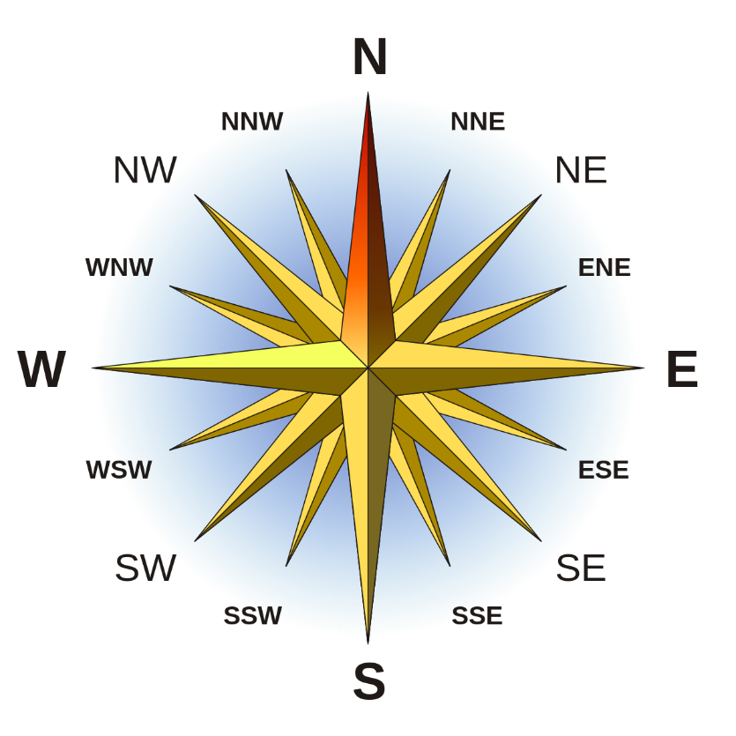  Task 1. Definites the direction according the pictures each group describes their direction (with some or no support). Discuss in groups, find the right answers using knowledge by geography, history.  .Questions for groups -the first group – (The North)  1. What is famous for every part of Kazakhstan?  2. What cities are there?  3. Describe the weather in each part  The second group(The South)  1. What is the capital of our republic?  2. What is the population of our republic?  3. Name the famous people of Kazakhstan  The third group(The West)  1. What is the area of Kazakhstan?  2. What does mean the silhouette of eagle on the national flag?  3. Complete the story about national holidays  The fourth group(The East)  1. How many nationalities are there in Kazakhstan?  2. What countries has borders with Kazakhstan?  3. Complete the story about EXPO-2017  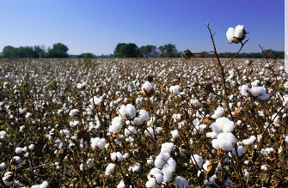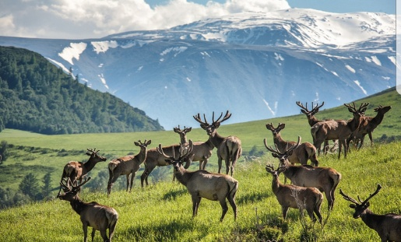  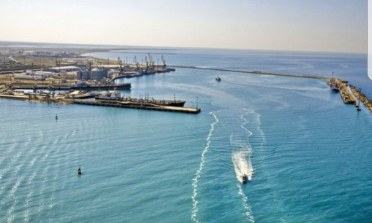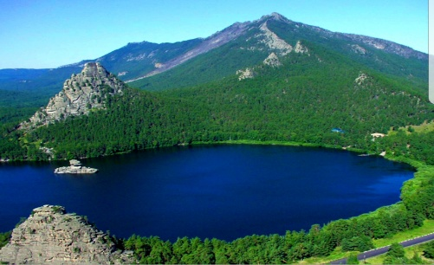  South, East, West, North  Less able students- take part in discussion, describe the direction, answer the questions.  More able students – find answers.  The most able students- complete the story using knowledge by geography, history.  Descriptor:  - Definites the direction  - Describes the direction  - Finds the answers  - Completes the story using knowledge by geography, history.  Task 2. Now each group presents his story to three groups.  Descriptor:  - Demonstrates knowledge about the direction of our Republic using internet and activities, facts from geography.  Тask 3. Prepare a 2-minute video about being a responsible traveler. Use the ideas in the exercise as well as your own. Be able to prove your opinion  1 I ask for permission before I take photos of locals. .......  2 I respect the locals’ way of living. .......  3 I try to learn a few sentences of the local language. .......  4 I meet local people. .......  5 I try local food. .......  6 I buy locally produced goods. .......  7 I don’t buy products from endangered animals. .......  8 I use local transport. .......  9 I drop litter in the streets. .......  10 I respect wild animals and do not disturb them  Descriptor:  - Prepares and uses the ideas about being a responsible traveler.  - Proves his/her opinion with arguments  Тask 4. Choose the prepared cards the past participle by method “hot or cold”. Connect the words cards given below with the verbs on the cards . Try to read these words correctly  1 see – ..................  2 do – ...................  3 drink – ...............  4 bring – ...............  5 sing – .................  6 make – ...............  7 catch – ...............  8 ring – .................  9 leave – ...............  10 feed – ................  11 arrive – ...............  12 swim – ...............  13 fall – ..................  14 fly – ...................  15 take – .................  16 give – .................  17 read – ................  18 hear – ................  19 find – .................  20 come – ...............  Descriptor:  - Connects the verbs in the 1-st and 3-rd forms  - Reads them correctly  Task 4. Match the words. Use them to complete the sentences.  Vocabulary  - board a the name  - check b the law  - import c a flight  - release d the luggage  - break e passport  - lose f endangered species  - You need to show your passport before you ...................... .  - It is against the law to ............................. .  - The police haven’t ............................ of the man they are looking for.  - If you ..................... your ..................... you can’t travel abroad.  - There are trained officers who ................... before it goes on a plane.  - People who ............................... should go to prison.  Descriptor:  - Matches the words  - Uses them to complete the sentences  Task 5. Work in groups, create a poster showing what places a  tourist should visit while in Astana. Find pictures to illustrate your poster.  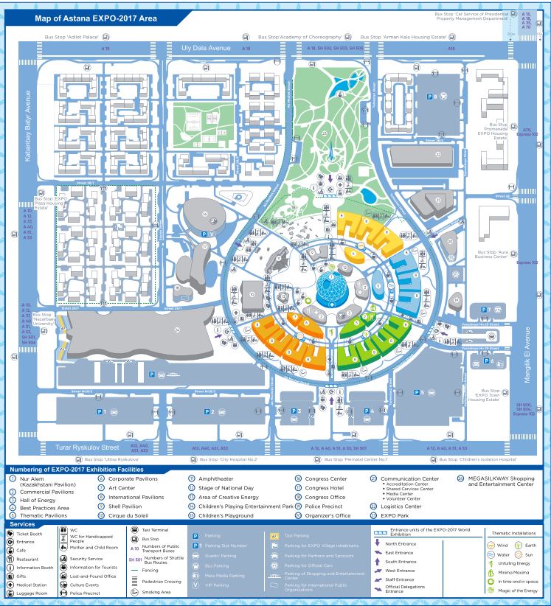  Descriptor:  - Creates the poster with famous sightseeing in Astana.  - Illustrates his/her poster showing what places a tourist should visit while in Astana  Feedback  Self assessment is carried out with the help of traffic light  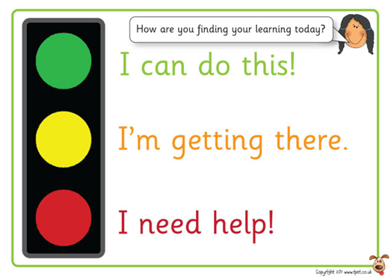 |  |  |  | Map of Kazakhstan  The cards of the direction  Copies with sentences  Presentation  Cards with verbs  Cards with tasks  Cards with tasks  Map of Astana
Homework
Additional information
Differentiation – how do you  plan to give more support?  How do you plan to  challenge the more able  learners?  Motivation  Response cards  Show of hands  Mimics  Smile  Enjoy learning English  Notice and support students |  | Assessment – how are you planning to check learners’ learning? Through the feedback. Students answer the questions by analyzing the lesson and themselves. |  |  | Health and safety check ICT links
Less able students more support by words , change the tasks each other, all work is planned by principle from easy to difficult  Connect the text by the meaning and give support to their peers. Solve problems to be responsible traveler  by means of prompts,  visuals or writing difficult words on the cards. Teach a friend  More able students –  independent work on definite  tasks, demonstrating key picture about geography of our Kazakhstan, for practical grammar learners are choosen the need variant. |  | Using the strategy of “Traffic lights”  Self assessment is carried out with the help of traffic lights. If the learner is sure that he / she acquired the lesson’s material completely, he/she ticks the green light. If the learner has some questions on the content of the lesson or he fells some doubts about his/her understanding, he ticks the yellow light. If the student fells, that he/she has many questions on the content of the lesson, he ticks red colour. |  |  | - Ensure proper ventilation  - Work with smart board not more then 10 minutes.
Reflection
Were the lesson objectives/learning objectives realistic?
Did the learners achieve the LO?
If not, why?
Did my planned differentiation work well?
Did I stick to timings?
What changes did I make from my plan and why?
Summary evaluation

- 1.What two things went really well (consider both teaching and learning)?

- 2.What two things would have improved the lesson (consider both teaching and learning)?

- 3.What have I learned from this lesson about the class or achievements/ difficulties of individuals that will inform my next lesson?

