Summative assessment for the term 4

Grade 4 Name___________________________

**Task . Writing. Give the answers. (4points)**

1. Write three things that are made of plastic…

2. Write two things that are used for writing…

3. Write two things that are made of wood…

4. Write three things that are made of metal…

**Task 2. Reading. Read and write (4points)**

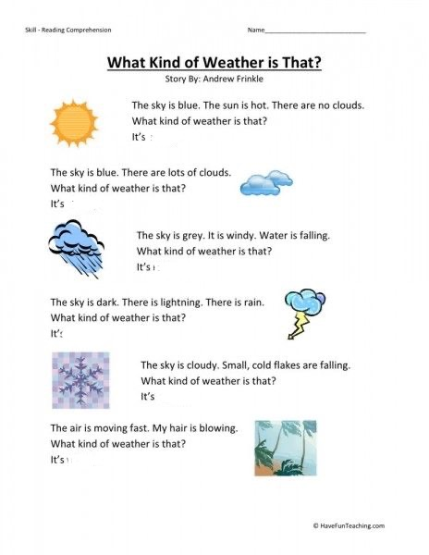

**Task 3.Listening (5points)**

**Listen and circle. circle the answer that doesn’t describe the weather now**.

**1)**  **a** It’s raining.

**b** It’s windy.

**c** It’s cloudy.

**2)**  **a** It’s cloudy.

**b** It’s nice.

**c** It’s sunny.

**3)**  **a** It’s cold.

**b** It’s warm.

**c** It’s snowing.

**4)**  **a** It’s icy.

**b** It’s nice.

**c** It’s raining.

**5)**  **a** It’s humid.

**b** It’s raining.

**c** It’s hot.

**Task 4. Speaking. Read and answer (3points)**

1. What is the weather like today?
2. Can you tell me the types of weather?
3. What is your favourite type of weather?