Геккеева А.Х.
студентка 1 курса Алматинского филиала
Санкт-Петербургского гуманитарного университета профсоюзов

ENGLISH IN AUSTRALIA VS.
ENGLISH IN THE UNITED STATES VS.
ENGLISH IN THE UNITED KINGDOM

Do British, Australian, and American English have any grammatical differences?
Yes, there are some. The biggest distinctions are in word choice and spelling.
1.Accent and pronunciation
- In American English, the letter 'r' is emphasized in pronunciation.
- In British English, vowels are pronounced simply, as are all consonants unless they are silent.
- Australian English has a proclivity for shortening words or obfuscating pronunciation. “Matter”, for example, is referred to as "maddah."
- The words' endings sound different as well. Consider the following scenario:

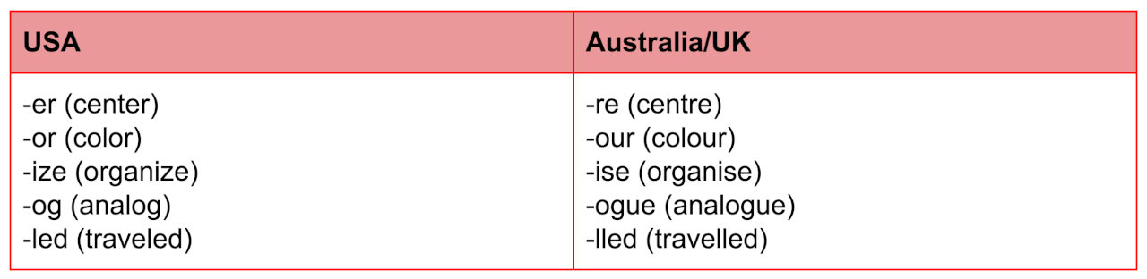

In addition to differences in word pronunciation, intonation (the pitch of your voice) varies greatly between countries. When someone asks a yes/no question in American English, for example, their voice rises at the end. However, if that question is asked in Australian or British English, the person's voice will be reduced!
2.Spelling and vocabulary
- American English has its own spelling system. The "u" is removed from a large number of nouns, which is noticeable.
- For example, in British/ Australian English, "neighbor" vs. "neighbour"
- British and Australian English use largely the same spelling with a few exceptions.
- For instance, "program" in the United Kingdom vs. "program" in Australia.
- The Americans use a number of vocabulary that the British and Australians don't, and the other way around.
- Australian words that have a different meaning in the United States
- Words from the United Kingdom that have a different meaning in the United States
- In American English, words containing the word 'our' are spelled with the letter 'or.'
Examples:
- British and Australian: Colour
- American: Color
- British and Australian: Favourite
- American: Favorite
However, in Australian and American English, most nouns with two or more syllables ending in '-ise' are spelled the same.
Examples:
- Exercise
- Surprise
- Enterprise
3. Auxiliary verbs
Auxiliary verbs are verbs that are used in addition to the main verb.
Another distinction between American and British English grammar is the use of auxiliary verbs. Auxiliary verbs, also known as assisting verbs, are verbs that assist in the formation of grammatical structures. They "assist" the main verb by providing time, modality, and voice information.
Consider the auxiliary verb shall. The word ”shall' is sometimes used in the UK to express the future.
- For example, “I shall go home now.”
Americans are familiar with the term shall, yet they rarely use it in speech. It appears to be quite formal. "I'm going home now," most Americans would say.
"Shall we start now?" a British person could ask, whereas an American would probably ask, "Should we start now?"
When Americans want to show a lack of obligation, they employ the assisting verb do followed by the word "need" but without the word "need."
- For example: “You do not need to work today.” Brits drop the helping verb and contract not. “You needn’t work today.”
The distinctions between Australian English, American English, and British English can be perplexing at times. But we should all remember that, in general, these three types of English are more similar than dissimilar, and that the small differences between them are what give each language its own "flavor"!

- englishdom.com
- Australian Encyclopedia. Angus and Robertson Limited, 1963. - 345 p.
- Oxford English Dictionary. - Oxford Unity Press, 2005. - 543 p.
- engblog.ru

