Lesson
Topic of the lesson:
Refraction of light. The law of refraction of light.
Date: |  | Teacher name: Filipov A.V.
CLASS: 8 |  | Number present: | Absent:
Learning objectives(s) that this lesson is contributing to | 8.5.1.6 - build a ray path in a plane-parallel plate;  8.5.1.7 - apply the law of light refraction when solving problems.
Lesson  objective | - build a ray path in a plane-parallel plate  - apply the law of refraction of light when solving problems
Success criteria | - knows, between which quantities establishes the relationship of the Snell law;  - formulates the law;  - records the mathematical expression of Snell's law;  - performs if necessary drawing to the task;  - notes the angles of incidence and refraction;  - records the law of light refraction for each of the considered interfaces between two media;  - makes the appropriate analysis and conclusion on the solution of the problem
Language objective | Key words and phrases:  Incident ray, refracted ray, angle of incidence, angle of refraction, Snell’s law, absolute and relative index of refraction.  Refraction of light occurs due to ...  The relative refractive index is called ...  The absolute refractive index is called ...  The relative and absolute refractive indices are related by the formula: ...  The law of refraction of light is formulated as: ...
Previous learning | Light. Reflection of light.
Necessary equipment and devices | Computer, video projector, model, information from the textbook.
Plan
Time | Planned activities |  |  | Resources
1min | Good day, children. I’m glad to see you. Sit down, please. How are you? Are you fine? Are you OK? Who is absent today?
2min | Creating a problem situation  Students, look at the pictures, what do you see?  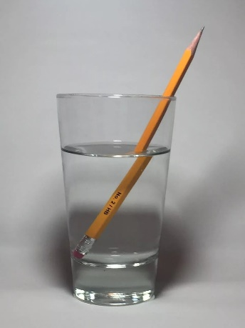 |  |  | Presentation
3-4min | Formulate the topic and objectives of the lesson together with the students  what is refraction?  the law of refraction  use the law of refraction in solving problems  Where have you seen the refraction of light?
5-6min | Terminology  incident ray – падающий луч,  refracted ray – преломленный луч,  angle of incidence – угол падения,  angle of refraction – угол преломления,  Snell’s law – закон Снелла,  absolute index of refraction – абсолютный показатель преломления,  medium – среда  denser – плотнее  protractor – транспортир  direction - направление |  |  | Vocabulary
7-29 | Video viewing and discussion  Why did the car change direction? (different speeds)  Почему машина сменила направление?  Когда свет переходит от одной среды в другую, он меняет свое направление. Это явление называется преломлением света. (When light passes from one medium to another, it changes its direction)  Преломление возникает из-за того, что свет имеет различные скорости в разных средах.  $$U=\frac{c}{n}$$  U – a speed of light in a medium  c=3*10⁸ m/s – the speed of light in vacuum  n - absolute index of refraction (page two hundred ninety seven)  experience demonstration. make a conclusion  you need to make a drawing and write that:  if the second medium is denser than the first medium, then the angle of refraction is less than the angle of incidence.  n1<n2, sinα>sinγ  if the first medium is denser than the second medium, then the angle of incidence is less than the angle of refraction  n1>n2, sinα<sinγ  we write the law of refraction of light (Snell's law)  $$\frac{sinα}{sinγ}=\frac{V_{1}}{V_{2}}=\frac{n_{2}}{n_{1}}$$  α - angle of incidence  γ - angle of refraction  U1 – a speed of light in a medium of first medium  U2 – a speed of light in a medium of second medium  n1 - absolute index of refraction of first medium  n2 - absolute index of refraction of second medium  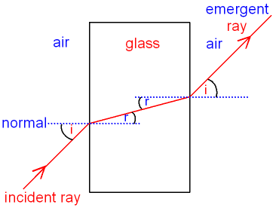 |  |  | Video 1
30-37 | Determine the speed of propagation of the light ray in ruby.  V=3*10⁸/1.75=1.71*10⁸  Literacy №4 (page one hundred thirty five)  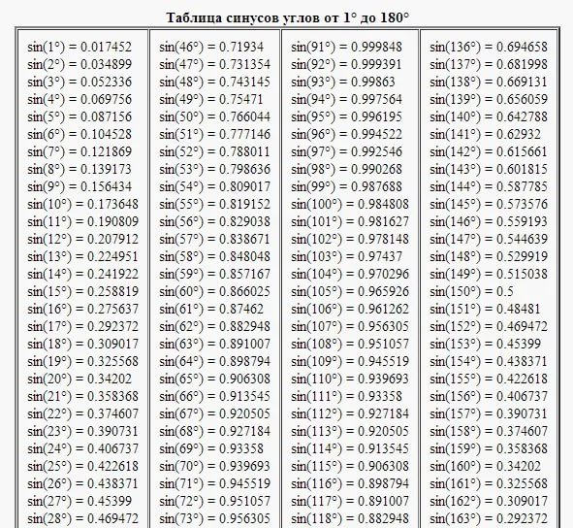 |  |  | p.135
 | Learn the terminology. §40
38-40 | Students summarize the lesson:  Была ли достигнута цель урока?  Какие новые слова сегодня узнал?  Что было трудно?
Summary evaluation The teacher, together with the students, gives an overall assessment of the lesson.

Needs to show more effort. You have made a lot of progress.

Terminology  incident ray – падающий луч,  refracted ray – преломленный луч,  angle of incidence – угол падения,  angle of refraction – угол преломления,  Snell’s law – закон Снелла,  absolute index of refraction – абсолютный показатель преломления,  medium – среда  denser – плотнее  protractor – транспортир  direction - направление | Terminology  incident ray – падающий луч,  refracted ray – преломленный луч,  angle of incidence – угол падения,  angle of refraction – угол преломления,  Snell’s law – закон Снелла,  absolute index of refraction – абсолютный показатель преломления,  medium – среда  denser – плотнее  protractor – транспортир  direction - направление
Terminology  incident ray – падающий луч,  refracted ray – преломленный луч,  angle of incidence – угол падения,  angle of refraction – угол преломления,  Snell’s law – закон Снелла,  absolute index of refraction – абсолютный показатель преломления,  medium – среда  denser – плотнее  protractor – транспортир  direction - направление | Terminology  incident ray – падающий луч,  refracted ray – преломленный луч,  angle of incidence – угол падения,  angle of refraction – угол преломления,  Snell’s law – закон Снелла,  absolute index of refraction – абсолютный показатель преломления,  medium – среда  denser – плотнее  protractor – транспортир  direction - направление
Terminology  incident ray – падающий луч,  refracted ray – преломленный луч,  angle of incidence – угол падения,  angle of refraction – угол преломления,  Snell’s law – закон Снелла,  absolute index of refraction – абсолютный показатель преломления,  medium – среда  denser – плотнее  protractor – транспортир  direction - направление | Terminology  incident ray – падающий луч,  refracted ray – преломленный луч,  angle of incidence – угол падения,  angle of refraction – угол преломления,  Snell’s law – закон Снелла,  absolute index of refraction – абсолютный показатель преломления,  medium – среда  denser – плотнее  protractor – транспортир  direction - направление
Terminology  incident ray – падающий луч,  refracted ray – преломленный луч,  angle of incidence – угол падения,  angle of refraction – угол преломления,  Snell’s law – закон Снелла,  absolute index of refraction – абсолютный показатель преломления,  medium – среда  denser – плотнее  protractor – транспортир  direction - направление | Terminology  incident ray – падающий луч,  refracted ray – преломленный луч,  angle of incidence – угол падения,  angle of refraction – угол преломления,  Snell’s law – закон Снелла,  absolute index of refraction – абсолютный показатель преломления,  medium – среда  denser – плотнее  protractor – транспортир  direction - направление

