DEVELOPING PUBLIC SPEAKING THROUGH DEBATES IN HIGH SCHOOL
Abdraimova Aikoz Erbulatkyzy
Kazakh Ablai khan University of International Relations and World Languages, Almaty
ajkozabdraimova@gmail.ru
INTRODUCTION
Public speaking is a vital skill that greatly enhances academic success, personal development, and professional readiness. For high school students, developing this skill is particularly vital as it builds confidence, encourages critical thinking, and fosters leadership qualities. Many students encounter challenges such as stage fright, unclear communication, and limited access to effective communication strategies. Structured activities, such as debates, have been recognized as an effective way to tackle these challenges and provide students with the necessary tools to thrive in various communication contexts (Edutopia, 2024).
Debates provide a unique platform for students to engage in structured argumentation, articulate their thoughts, and develop persuasive reasoning. They enable participants to investigate complex subjects, present well-researched arguments, and address counterpoints, which nurtures critical thinking and analytical abilities (Litan, 2020). The dual perspective nature of debates, where participants argue for and against a topic, teaches students to remain open-minded and develop empathy for diverse viewpoints. This is crucial in a world where understanding and respecting diverse perspectives is vital for effective communication (Field, 2021).
Moreover, debates promote classroom equity by allowing every student to express their opinions in a structured and respectful setting. Research shows that debate-based learning promotes inclusivity, particularly for English language learners, who gain confidence and fluency in expressing their ideas (SNFI, 2024). As Graham and Lynn (2020) note, debates empower students to overcome the fear of public humiliation and foster resilience, essential qualities for navigating high-pressure environments.
Debate activities also align with modern pedagogical approaches prioritizing experiential and project-based learning. Debates enhance literacy development and improve students' ability to synthesize and present complex information coherently, according to PBLWorks (Field, 2021). By integrating evidence-based research, diverse cultural perspectives, and collaborative teamwork, debates prepare students for real-world challenges. This makes debates an invaluable tool not only for developing public speaking skills but also for fostering civic engagement and preparing students for active participation in democratic processes (Edutopia, 2024).
Despite these advantages, incorporating debates into high school curricula requires thoughtful implementation. Teachers should provide clear guidelines, choose meaningful and age-appropriate topics, and ensure that students have the necessary research and communication tools. Successful debate programs rely on fostering an atmosphere of mutual respect, where students feel secure expressing themselves without fear of judgment or ridicule (Graham & Lynn, 2020). This study aims to explore how debates can be utilized as a tool to enhance public speaking skills among high school students. This research aims to analyze the outcomes of debate activities and their effects on students' confidence, communication skills, and critical thinking abilities. The findings will offer actionable insights for educators and contribute to the expanding knowledge on experiential learning. Additionally, it will provide practical recommendations for incorporating debates into foreign language teaching curricula.

METHODS
This study aims to explore how debate activities influence high school students' public speaking skills, particularly their confidence, argumentation abilities, and capacity to express thoughts clearly.. To achieve this, a descriptive qualitative research method was employed, which is designed to collect and analyze data through descriptive explanations. This approach facilitates a deeper understanding of participants' experiences and perspectives, which aligns with the research objectives (Nugrahani, 2018).
As part of the data collection process, an open-ended questionnaire was distributed among 30 high school students who participated in structured debate sessions over a period of five weeks. These debate sessions were conducted twice a week, with each session lasting approximately 60 minutes. The questionnaire was created to assess students’ views on their public speaking skills, their attitudes towards debate as a learning tool, and their perceived improvements in confidence and argumentation abilities.
The process of data collection and analysis adhered to the framework established by Miles and Huberman (1994). The first step, data reduction, involved selecting and simplifying raw data to identify recurring themes and patterns. This process helped refine the data into meaningful categories, such as confidence levels, speaking frequency, and perceived relevance of debates to real-world scenarios. The second step, data display, involved presenting the findings systematically using tables and charts to visualize the students’ responses. Finally, conclusions were drawn based on the identified patterns, ensuring that the interpretations were valid and relevant to the research objectives.
By employing a structured approach, the study aimed to provide reliable insights into the effectiveness of debates in enhancing public speaking skills among high school students.

RESULTS AND DISCUSSION
Results
This study analyzed the results of a survey conducted among high school students to examine their experiences and perceptions of debate as a method for improving public speaking skills. The survey included four open-ended questions aimed at understanding the participants’ self-assessed public speaking abilities, their attitudes toward public speaking, the contexts in which they find public speaking most necessary, and the frequency of their public speaking engagements.
The questionnaire was distributed among 30 high school student. Below are the summarized results.
Table 1. Survey Results on Public Speaking and Debates
Question | Response | Percentage
1. How do you rate your current level of public speaking abilities? | Low: "I lack confidence in speaking" | 30%
 | Average: "I can speak, but feel nervous" | 50%
 | High: "I am confident in public speaking" | 20%
2. Do you consider public speaking a key skill for educational activities? | Yes: "It is important for presentations, discussions, and leadership roles" | 90%
 | No: "I don’t think it’s essential" | 10%
3. In what situation do you think public speaking is most necessary? | Education: "For academic presentations and projects" | 60%
 | Business: "To convey ideas clearly in professional settings" | 25%
 | Personal: "To build confidence and connect with others" | 10%
 | Travel: "To communicate effectively in diverse environments" | 5%
4. How often do you have to speak in public? | Rarely: "Only during specific academic activities" | 40%
 | Occasionally: "Several times during the semester" | 45%
 | Frequently: "Weekly or more, as part of school or extracurricular activities" | 15%
Key Findings:
Current Public Speaking Abilities
Most students rated their current public speaking abilities as either average (50%) or low (30%). Only 20% considered themselves confident speakers. This highlights the need for structured activities like debates to improve their skills.
Importance of Public Speaking in Education
An overwhelming majority (90%) of students acknowledged the importance of public speaking for educational purposes, such as giving presentations and participating in discussions.
Contexts Where Public Speaking is Necessary
Public speaking was considered most necessary for education (60%), followed by business (25%). Fewer students viewed it as essential for personal growth (10%) or travel (5%).
Frequency of Public Speaking
While 40% of students reported rarely speaking in public, 45% spoke occasionally, and only 15% reported frequent public speaking.
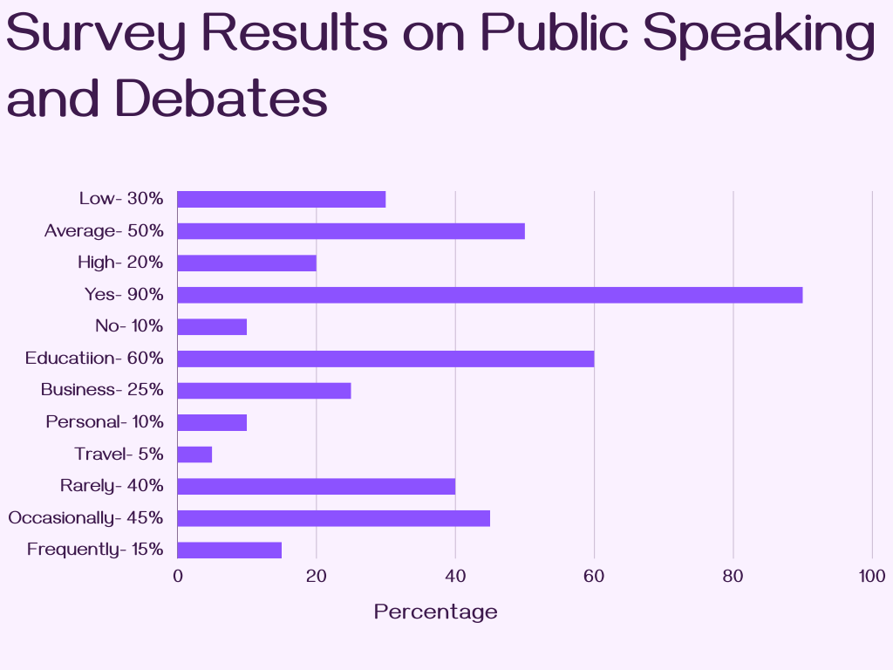
These findings indicate that while students recognize the importance of public speaking, many lack confidence and opportunities to practice. Debate-based activities could bridge this gap by providing a structured and supportive environment.

Discussion
The findings indicate that using debates as a method to enhance public speaking skills in high school students yields several positive outcomes. This discussion highlights the key results and links them to relevant literature, offering a thorough understanding of the benefits and challenges related to this approach.
a. Enhancing Public Speaking Confidence
The survey revealed that most students rated their public speaking abilities as moderate before engaging in debate practices. However, debates helped boost their confidence significantly, as evidenced by the students’ feedback. This supports Krieger's (2005) findings, highlighting that debate helps students articulate their ideas clearly, which boosts their confidence in public speaking.. Engaging in debates requires students to think critically and respond spontaneously, fostering a sense of self-assurance in their abilities.
b. Developing Communication Skills Relevant to Real-Life Contexts
The students identified academic settings and business environments as the most critical areas where public speaking skills are necessary. This result highlights the practical implications of debate training. According to Kennedy (2007), debates not only improve verbal fluency but also equip students with transferable skills such as argumentation and persuasion, which are essential for success in diverse professional and academic contexts. The structured format of debates allows students to develop clarity in communication, a skill highly valued in real-world scenarios.
c. Motivation Through Interactive Learning
Students expressed enthusiasm for participating in debates, reporting that the interactive nature of this method motivated them to engage more actively in their learning process. This finding is consistent with previous research by Bellon (2000), which highlights that debates increase student engagement by providing a dynamic and competitive learning environment. Furthermore, debates encourage students to take ownership of their learning, fostering intrinsic motivation as they prepare arguments and anticipate counterarguments.
d. Addressing the Challenges of Public Speaking
While the majority of students acknowledged the benefits of debates, a small fraction reported occasional discomfort when speaking in public. This finding resonates with the observations of Lucas (2011), who notes that public speaking anxiety is a common barrier for learners. However, Lucas also suggests that repeated practice through structured activities like debates can help students overcome this anxiety, transforming it into a manageable challenge.
e. Collaborative Learning and Critical Thinking
The survey results demonstrated that debates promote teamwork and critical thinking among students. Many participants highlighted the importance of collaboration during debates, as it helped them refine their ideas and gain new perspectives. Johnson and Johnson (1999) state that cooperative learning strategies, such as debates, enhance students’ critical thinking skills and improve group dynamics.Collaborative debate activities create an environment where students can challenge each other's viewpoints constructively, fostering a deeper understanding of the topics discussed.
f. Practical Implications for Educators
The findings of this study suggest that integrating debates into the high school curriculum can significantly enhance students' public speaking skills and overall academic performance. However, educators should ensure that debate topics are engaging and age-appropriate to maximize student interest and participation. Additionally, providing constructive feedback is crucial for helping students refine their skills and build confidence.
By correlating these findings with the broader literature on the pedagogical benefits of debates, it becomes evident that this method holds significant potential for preparing students for real-world challenges. Future research could explore longitudinal effects of debate practices and examine their impact on students’ long-term professional and academic success.

CONCLUSION
In conclusion, this research highlights the significant role of debates in developing public speaking skills among high school students. The findings indicate that involving students in debates improves their ability to express ideas confidently in public while also promoting critical thinking, collaboration, and adaptability.The results indicate that students who participated in debates reported an increased interest in public speaking and recognized its importance in both academic and real-life situations. Additionally, using a project-based approach to teach public speaking through debates is an effective way to enhance communication skills, as it offers students a meaningful and interactive learning experience. As a result, it is evident that debates serve as a valuable tool in the development of public speaking abilities, and their inclusion in high school curricula could contribute to the overall educational experience of students, preparing them for future success in various fields.
ACKNOWLEDGMENTS
I would like to express my sincere gratitude to my supervisor Adelia Alibekovna for her invaluable guidance and support throughout this research. I would like to thank my younger brother for assisting with the student survey at his school. I also extend my gratitude to the students who participated; their willingness to share their experiences and insights provided crucial data for this research. Additionally, I appreciate the authors and researchers whose work laid the foundation for this study. Without their contributions, this research would not have been possible. Thank you to everyone who supported me in completing this project.
REFERENCES
- Edutopia. (2024). Using debate as an educational tool. Edutopia. Retrieved from https://www.edutopia.org
- Field, T. (2021). Equity through debate: Transforming classrooms. PBLWorks. Retrieved from https://www.pblworks.org
- Litan, M. (2020). The benefits of debate for young learners. ASCD Resources. Retrieved from https://www.ascd.org
- Stanford National Forensic Institute (SNFI). (2024). Debate as a method for improving public speaking. SNFI Articles. Retrieved from https://snfi.stanford.edu
- Miles, M. B., & Huberman, A. M. (1994). Qualitative data analysis: An expanded sourcebook. Thousand Oaks, CA: Sage Publications.
- Nugrahani, F. (2018). The art of descriptive qualitative research. Journal of Language Teaching and Research, 9(3), 467-472. Retrieved from https://www.jltr.org
- Bellon, J. (2000). A research-based justification for debate across the curriculum. Argumentation and Advocacy, 36(3), 161–175.
- Johnson, D. W., & Johnson, R. T. (1999). Learning together and alone: Cooperative, competitive, and individualistic learning. Prentice-Hall.
- Kennedy, R. (2007). In-class debates: Fertile ground for active learning and the cultivation of critical thinking and oral communication skills. International Journal of Teaching and Learning in Higher Education, 19(2), 183–190.
- Krieger, D. (2005). Teaching debate to ESL students: A six-class unit. The Internet TESL Journal, XI(2).
- Lucas, S. E. (2011). The art of public speaking. McGraw-Hill Education.

