Unit 7. Reading for pleasure |  |  |  | School:
Date: |  |  |  | Teacher’s name:
Class: |  |  |  | Number present: | absent:
Theme of the Lesson: |  | The wonderful wizard of Oz
Learning objective(s) that this lesson is contributing to |  | 6.4.4.1 read independently a limited range of short simple fiction and non-fiction texts  6.4.2.1- understand independently specific information and detail in short, simple texts on a limited range of general and curricular topics;  6.4.5.1 deduce meaning from context on a limited range of familiar general and curricular topics, including some extended texts
Lesson objectives |  | - To read a story and work on new vocabulary  - To understand without support basic questions about the tales  - To discuss the story using new vocabulary
Assessment criteria |  | - ask and answer about the reading of the wonderful Wizard of Oz  - speak about the wonderful Wizard of Oz  - communicate and work well together in groups showing respect and being polite with each other
Value links |  | Respect value is instilled through the class discussions.
Cross curricular links |  | English, Kazakh, Russian Literature
Previous learning |  | Revision
Plan
Planned timings | Planned activities (replace the notes below with your planned activities) |  |  |  |  | Resources
Beginning  0-2  2-7 | Organizational moment  The teacher greets learners and introduces the lesson objectives in a simplified manner.  The teacher sets a positive atmosphere by asking some questions.  • Welcome, everybody!  • How are you today?  • What is the date today?  Warm-up  The teacher asks learners:  1. Do you like reading?  2. What do you prefer: fairy-tales, detective stories, fictions, legends or horror storries?  3. What is your favorite book?  Teacher shows the pictures and asks learners:  Do you know these characters and what book are they from?  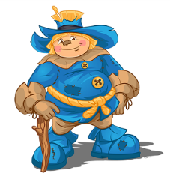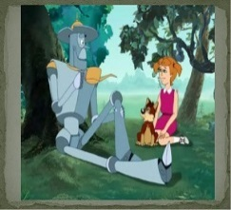  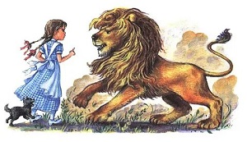  Teacher:  Today we are going to read a extract from the book The Wonderful Wizard of Oz by L.Frank Baum. |  |  |  |  | PPT Slide 2  PPT Slide 3
Middle  7-12  12-22  22-32  32-40 | Focus on reading  The teacher asks learners to read the information about L.Frank Baum, the author of the story The wonderful wizard of Oz  Then the teacher asks learners if they know a similar fairy-tale that was written by a Russian writer ("Wizard of Emerald City" written by famous writer Alexander Volkov)  Pre-reading  Work in pairs. The teacher asks learners to read the words and look up the meaning of words using dictionaries either online or paper.  The teacher checks if their answers are correct or not.  Field, scarecrow, wave, get back to, reply, brain, scare, real, axe, brick, poor thing, oil can, ground, fall in love, marry, far, coward, courage.  Reading  The teacher asks learners to read the story and focus on some key words. Then the teacher asks them to close the books and say the new words from the text that they have memorized.  Post reading  After learners have finished reading and saying the new words the teacher asks learners to make questions for these answers:  - Dorothy wanted the Great Oz to help her get back home.  - He lived in the Emerald City.  - The Scarecrow was the first who Dorothy met.  - Dorothy oiled the Tin Man.  - He wanted a new heart.  Answer keys:  - Why did Dorothy go to the Emerald City?  - Where did the Great Oz live?  - Who did Dorothy meet first?  - How did Dorothy help the Tin Man?  - What did the Tin Man want to ask the Great Oz for?  Find the mistake, underline it and write the correct word.  1.As Dorothy and Toto were playing on the riverbank, they saw a Scarecrow.  2.Together, they followed the green brick road into a village.  3.And the Scarecrow wants a new hat.  4.She asked the Wicked Witch of the east to turn me into a Wooden Man with no brain.  5.I don’t know how far it is, but I know it is a pleasant voyage.  6.I’m a hero. I’m not afraid of anything.  Answer keys:  1.As Dorothy and Toto were walking through beautiful fields, they saw a Scarecrow.  2.Together, they followed the yellow brick road into a forest.  3.And the Scarecrow wants a brain.  4.She asked the Wicked Witch of the east to turn me into a Tin Man with no heart.  5.I don’t know how far it is, but I know it is a dangerous journey.  6.I’m a coward. I’m afraid of everything.  Formative assessment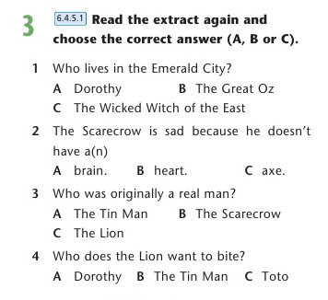  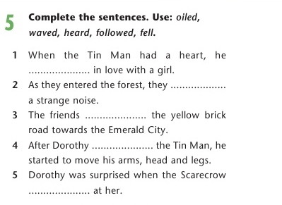  Answer keys:  Ex.3 Ex.4  1 – B 1 - fell  2 – B 2 - heard  3 – A 3 - followed  4 – C 4 – oiled  5 – waved |  |  |  |  | Excel  Grade 6  p.78-79  PT Slide 4  PPT Slide 5  PPT Slide 6  PPT Slide 5  PPT Slide 6  PPT Slide 7  Excel  Grade 6  p.79  PPT Slide 8
End  40-45 | The home task is ex. 1,3,4 p. 52 Workbook  At the end of the lesson, learners reflect on their learning:  - During the lesson I was - I am - I feel - I think - 5 new words from the lesson Active/ Passive Satisfied/not satisfied with my work Interested/bored Got/didn’t get the idea |  |  |  |  | PPT Slide 9
DIFFERENTIATION – how do you plan to give more support? How do you plan to challenge the more able learners? |  |  | ASSESSMENT – how are you planning to check learners’ learning? |  |  | Health and safety rules
More support can be given at the start and in middle of lesson by providing less-able learners with the vocabulary in a word list so they can read examples of words seen or heard. |  |  | Teacher observes learners when participating in discussion and during pair work and makes records to provide constructive feedback  Self –assessment  - I learnt at least 5 new words and can use them in sentences.  - I can use the structure “be going to” in speaking as well as in writing  - I can talk about healthy life style at least 1 minute |  |  | Short physical exercises between the activities

