Раздел: Unit 5: Exploring and inventions. |  |  |  |  |  | Школа: Gymnasium 21

Тема урока: Exploring space.
Исследовательский вопрос: Can you breathe in space?
Дата: 19.02.2021. |  |  |  |  |  | ФИО учителя: Mutalina D.M.
Класс: 3 B |  |  |  | Количество присутствующих: |  |  |  | отсутствующих:
Цели обучения, достигаемые на этом уроке |  |  | 3.L2 understand a limited range of short supported questions which ask for personal information.  3.S8 recount very short, basic stories and events on a limited range of general and some curricular topics  3.R5 understand the main points of short simple texts on a limited range of familiar general and some curricular topics by using contextual clues  3.W1 plan, write and check short sentences with considerable support on a limited range of personal, general and some curricular topics.
Цель урока |  | All learners will be able to:  Learn and pronounce new words with a teacher’s support.  Identify the planets with a teacher’s support.  Make up the sentences correctly with a teacher’s support.  Most learners will be able to:  Identify the planets with a little teacher’s support.  Make up the sentences correctly with a little teacher’s support.  Some learners will be able to:  Identify the planets without teacher’s support.  Make up the sentences correctly without teacher’s support.
Уровень мыслительных навыков |  | Knowledge, comprehension, application.  Знание, Понимание, Применение.
Критерии оценивания |  | - Reads the sentences without any mistakes.  - Uses the words from the box.  - Identifies planets.  - Makes up the sentences correctly and in order.
Языковые цели |  | I know… I live… I like… I remember…
Привитие ценностей |  | Respect, cooperation, sociability, mutual help. (Уважение, сотрудничество, коммуникабельность, взаимопомощь)
Межпредметные связи |  | Knowledge of the world.
Предварительные знания |  | Unit revision. (Musical instruments, My music, Arts.)
Ресурсы |  | Presentation, audio, video.
Ход урока
Этапы урока | Запланированная деятельность на уроке |  |  |  |  |  |  |  | Ресурсы
Beginning  5 min | - Organizational moment. Guessing the theme.  T: Good afternoon! How are you? How is your mood? What’s the weather like today? Now you should guess the theme. Let’s listen the sounds. Than you should guess the theme of our lesson. Well-done! Very good. Yes the theme of our lesson: “Exploring space”. And today we will:  - Learn new words, planets.  - Speak, answer the questions and read the dialogue.  - Listen to the song to the theme and write the planets.  - Make up and translate the sentences.  Phonetic exercise.  I like to read,  I like to play,  I like to study  Every day!  P should listen and repeat. |  |  |  |  |  |  |  | Audio:  The sounds of Saturn.  Звуки Сатурна.  PPT
Middle  23  minutes | - Speaking task.  - Do you know what space is?  - Can you breathe in space?  - What about the universe?  - Which Kazakhstan cosmonauts do you know?  - Evgenyi and Alisa prepared short information about our Kazakh cosmonauts.  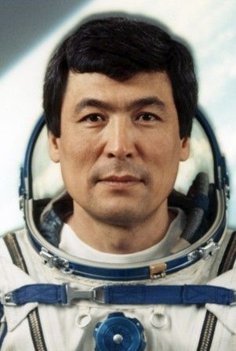  Tokhtar Aubakirov, the 1st cosmonaut of Kazakhstan. Let’s remember the cosmonauts from Kazakhstan. (Evgenyi)  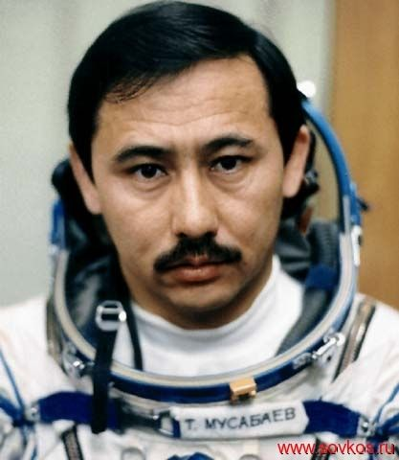  Talgat Mussabaev, the 2nd Kazakh cosmonaut, the lieutenant general of aircraft of the Republic of Kazakhstan. (Alisa)  - Now evaluate to youself.  - Vocabulary work.  Exploring – [ɪkˈsplɔːrɪŋ] -исследование  Space – [speis] – космос  Mercury – [ˈmɜːkjərɪ] - Меркурий  Venus – [ˈviːnəs] – Венера  Earth – [ɜːθ] - Земля  Mars – [mɑːz] - Марс  Jupiter – [ˈdʒuːpɪtə] - Юпитер  Saturn – [ˈsæt(ə)n] - Сатурн  Neptune – [ˈneptjuːn] – Нептун  Watching the video.  - Listen and repeat until 1 min (2 times).  https://youtu.be/UviSthdCzIk  АМО:  - Speaking task.  - Now find the scramble words. Say which words do you see.  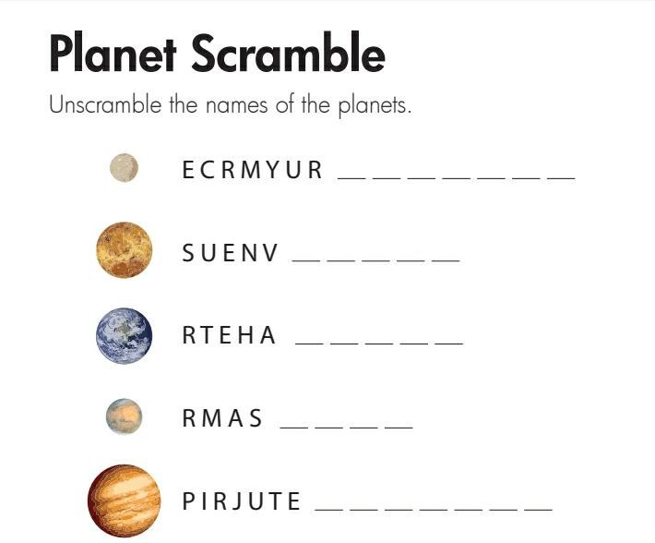  Venus  Mercury  Earth  Jupiter  Mars  Saturn  Uranus  Neptune  АМО:  4. Reading of the dialogue.  - Hello, …!  - Hello, …!  planets, Mars, small, Mercury, you.  - Where do … live?  - I live on the Earth.  - What is space?  - Space is empty zones of the Universe.  - What … do you know?  - I know 8: Earth, …, Venus, …, Jupiter, Saturn, Uranus and Neptune.  - Which the planet is your favourite?  - My favourite planet is Mars. It is … and red.  Descriptor:  - A learner reads the dialogue correctly.  - A learner chooses necessary words.  Criteria assessment:  1. Reads the sentences without any mistakes.  2. Uses the words from the box.  5 points  - Now evaluate to yourself.  5. Listening task. Writing.  https://youtu.be/Wd_EIdZrvaU  Put the planets in the order you hear. (Listening 2 times)  Saturn  Uranus  Earth  Mercury  Neptune  Mars  Jupiter  Venus  Descriptor:  - A learner identifies the planets.  - A learner put the planets in the order hear.  Criteria assessment:  1. Identifies the planets without any mistakes.  2. Puts the planets in the order hear.  5 points  6) Writing task.  - Now do this writing task.  Make up the sentences in correct order.  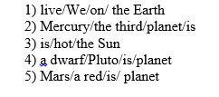  Descriptor:  - A learner makes up the sentences correctly.  - A learner writes in the correct order.  Criteria assessment:  - Makes up the sentences correctly and writes in the correct order. |  |  |  |  |  |  |  | PPT  Video  PPT  PPT  PPT
End  2 min | Feedback.  Our lesson is coming to the end. Let’s make the conclusion of our work – What did we explore? What useful did we get from this lesson? What did we learn from this lesson? Say, what you know.  Your mood after our lesson….  Excellent.  So-so.  Bad.  - Well done! The lesson is over. Thank you. Goodbye! |  |  |  |  |  |  |  | PPT
Дополнительная информация
Дифференциация – каким образом Вы планируете оказывать больше поддержки? Какие задачи Вы планируете поставить перед более способными учащимися? |  |  |  |  | Оценивание – как Вы планируете проверить уровень усвоения материала учащимися? |  | Здоровье и соблюдение техники безопасности
support will be given to weaker learners by giving them a modified worksheets in some tasks with greater support |  |  |  |  | -through formative task |  | - Physical activities used.
Рефлексия по уроку
Были ли цели урока/цели обучения реалистичными?
Все ли учащиеся достигли ЦО?
Если нет, то почему?
Выдержаны ли были временные этапы урока?
Какие отступления были от плана урока и почему?

Общая оценка:
Какие два аспекта урока прошли хорошо (подумайте, как о преподавании, так и об обучении)?
Что могло бы способствовать улучшению урока (подумайте, как о преподавании, так и об обучении)?
Что я выявил(а) за время урока о классе или достижениях/трудностях отдельных учеников, на что необходимо обратить внимание на последующих уроках?

