LESSON 22  Unit 2. Helping and Heroes |  |  | School: Secondary school #70 named after M.Gabdullin
Date: 19.10.2021 |  |  | Teacher name: Kulusheva Zhaniya
Grade: 6 B |  |  | Number present: |  | Number absent:
Theme of the lesson: |  | Helping other people
Learning objectives |  | 6.3.8.1- recount some extended stories and events on a limited range of general and curricular topics  6.1.8.1- develop intercultural awareness through reading and discussion  6.4.1.1 - understand the main points in a growing range of short, simple texts on general and curricular topics;  6.5.8.1- spell most high-frequency vocabulary accurately for a limited range of familiar general topics and some curricular topics  6.2.6.1- deduce meaning from context in supported extended talk on a range of general and curricular topics;
Lesson objectives |  | All learners will be able to:  use and pronounce some target language accurately in response to prompts and in controlled tasks with support  Most learners will be able to:  use and pronounce most target structures accurately in response to prompts and in controlled tasks with support  Some learners will be able to:  use and pronounce most target structures accurately in response to prompts and in controlled tasks with little support
Previous learning |  | Helping other people
Plan
Planned timings | Planned activities |  |  | Learners’ activities |  | Evaluation | Resources
Begining  5 min | ORGANIZATIONAL MOMENT  Teacher presents the lesson objectives, explains students what they would be able to do by the end of this lesson.  To revise rules of pronunciation of /t/, /d/, /Id/ (Past Simple verb endings) / Past Simple affirmative / Past Simple negative |  |  | Learners revise rules of pronunciation
Middle  30 min | To practise using the Past Simple interrogative  Explain the task and read out the example.  Ss complete the task. Check Ss’ answers by asking various Ss to ask and answer in front of the class.  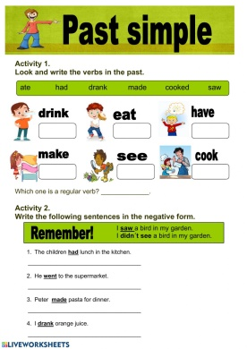  To ask and answer about the past using the Past Simple interrogative  Explain the task and ask two Ss to read out the example. Ss complete the task in pairs. Monitor the activity around the class and then ask some pairs to ask and answer in front of the class.  To ask and answer about the past using question words  Explain the task and ask two Ss to read out the example. Ss complete the task in pairs. Monitor the activity around the class and then ask some pairs to ask and answer in front of the class.  To practise using time expressions with the Past Simple  Explain the task and read out the example. Give Ss time to write similar sentences, then check Ss’ answer around the class.  To present and practise prepositions of movement  Go through the prepositions in the pictures. Point out that the pictures will help Ss complete the task.  Give Ss time to complete the text with the correct preposition. Then check Ss’ answers.  To write a short paragraph, personalize the topic  Give Ss time to complete the task in class and then ask various Ss to read out their completed paragraphs to the  class. |  |  | Learners practise using the Past Simple interrogative  Learners complete the task  Learners ask and answer about the past using question words  Learners write similar sentences  Learners present and practise prepositions of movement  Learners  write a short paragraph, personalize the topic |  | Verbal evaluation  Individual avaluation  Mutual avaluation
End  5 min | Self-assessment.  Students attach their boat in the appropriate area of the map that reflects their emotions and mood after the lesson.  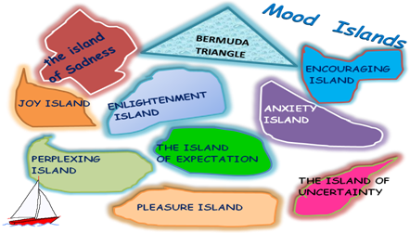  Saying goodbye |  |  |  |  | Self-assessment

