Short term plan

Unit of a long term plan : Values in Myths and Legends |  | School: 7
Date: |  | Teacher name: Satybaldina Laura Sabitkyzy
Grade: 4 |  | Number present: | absent:
Lesson title | People and places
Learning objectives | 4.3.5.1 understand the main points of short simple texts on a growing range general and some curricular topics by using contextual clues;  4.4.1.1 plan, write and check sentences with support on a range of basic personal, general and some curricular topics
Lesson objectives | - identify main idea of a text about Korkyt Ata.  - write with support short 4 sentences which describe a hero from the text

Stages / Time | Teachers actions | Students actions | Assessment | Resources
Beginning  5 min | Greeting  -Good morning, students!  -Good morning, teacher!  -How are you today?  -We are fine, thank you!  -What date is it today?  -What’s the weather like today?  -It is sunny/cold/rainy today | Students respond to greeting and take their places
Pre-reading  While reading | Let’s listen to a sound  Do you know this musical instrument?  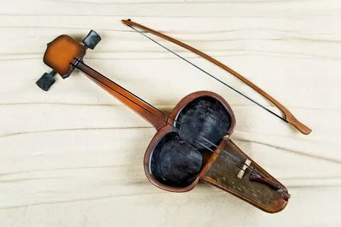  Can you play the kobyz?  Do you know who made a kobyz?  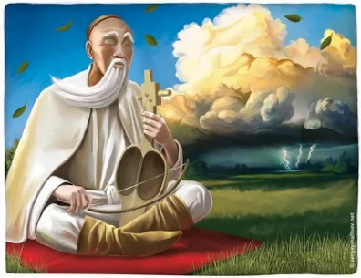  The first kobyz was made by Korkyt ata  Prereading activity:  Introduction of new words  Drilling  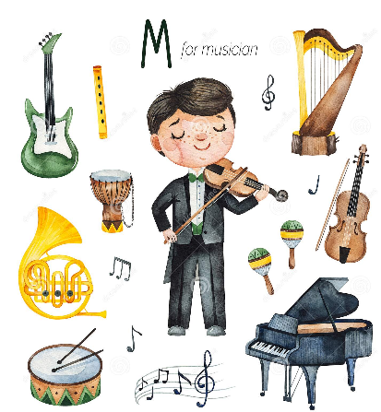  Musician  Well – known  Eclipse  Dream  CCQ-s questions  - Who can play musical instrument?  - A person who has a lot of money, followers, likes.  - Is there moon and sun in this picture?  - What you do at night?  2. Read 2 first sentences of the text about «The legend of Korkyt Ata»  Answer the questions:  - Who is the main hero of this text?  - What is the main idea of the text?  3. Complete the sentences  1. Korkyt ata was a famous akyn- poet and musician and the man …..  2. Before Korkyt ata was born……  3.In the dream angels told him…….  4.People from all over Kazakhstan heard……  Reflection “A bouquet of moods". Reflection process: At the beginning of the lesson, paper flowers are distributed: green and pink. A vase is drawn on the board. At the end of the lessons it is said: “If you liked the lesson and you learned something new, then attach a red flower to the vase, if you didn’t like it, or you didn’t understand the theme - blue”.  Giving homework: - Good job guys. Open your diary and write down homework.  The conclusion of the lesson I think all of us found some new information and some new words today. Ok guys today’s lesson is over Goodbye. | The pupils listen to a sound and answer the questions. Discussion with teacher  The pupils read and repeat  Writes homework in a diary  Students say goodbye to the teacher. | Assessment by a teacher with the feedback  Descriptors  A learner:  - Answers the question correctly  Assessment by a teacher  A leaner:  - identifies the meaning of the words correctly  - pronounces the words correctly  Peer assessment  A leaner:  - identifies the main hero correctly  - identifies the main idea of a text  Peer assessment:  Students assess each other’s work according to the keys  A leaner:  - complete sentences correctly  Self-assessment  with flowers | Youtube  https://youtu.be/8ygBhd7HKpQ  The text is taken  Smiles 4  Jenny Dooley  Series Consultant: Bob Obee  Translations by N.Mukhamedjanov  Pupil’s book  For Kazakhstan Grade 4 page 22 exercises 11

