Unit 4 Drama and comedy |  | Lesson 38
Teacher name: |  | Turebayeva A.A.
Date:
Grade: 6 |  | Number present: | absent:
Lesson title | Reading: Literary elements
Learning objectives | 6.2.5.1 understand most specific information and detail of supported, extended talk on a range general and curricular topics  6. 3. 3. 1 to express one's opinion in sentences with elements of reasoning within the framework of various general and educational topics;
Lesson objectives | Learners will be able to:  - create and utilize a vocabulary bank covering general and curricular topics  - identify specific information
Value links | Open-Mindedness – An open-minded person is someone who is always willing to hear new points of view and even change their own point of view if new arguments are highly convincing. It’s the opposite of stubbornness.
Plan

Stages / Time | Teachers actions | Students actions | Assessment criteria | Resources
Beginning of the lesson  Warming-up  3 min | Organization moment :  1.Greeting.  Ask about the weather.  The teacher sets the lesson objectives, letting students know what to anticipate from the lesson. | Ss great the teacher and answer the question about the weather. | The teacher to assess learners for their ability.  “Good job!  Well done!”  F.A.
Pre-learning  «Brainstorming» method  7 min. | Ask pupils to present their homework from the previous lesson.  Lead – In  Determines the topic and purpose of the lesson  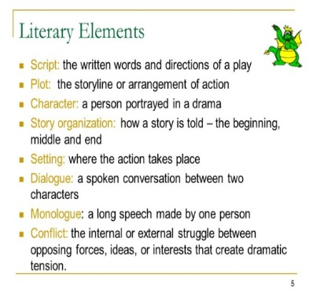 | Ss read ex-11, p.43  Students' attention is drawn to the lesson.  Students read the definitions and try to explain the key words ex-6, p.43 | Assessment criteria  Identify the main points of short texts using contextual clues on familiar topics. Good job!  Descriptor:  - read the definitions | Ex.copybooks  Student’s book  ex-6, p.43  cards
Middle of the lesson  Presentation part.  25 min  Conclusion  5 min | Ex: 6 P: 43  • Ask Ss answer the questions  • Check Ss' answers.  Ex: 9 P: 43 predict the next events about O.Twist  Ask Ss to discuss in pairs what they think will happen next.  Then ask some pairs to tell the class their ideas.  Ask Ss to check their answers listening to the audio ex -10, p.43  Ask Ss to say sentences using these words: hard, hungry, same food, enough, angry, thin and pale, ungrateful  During the lesson some tasks differentiated by outcomes of the students and by their abilities. | Ss answer the question.  ANSWERS  1 Oliver Twist, Mr Bumble and the Master.  2 In a workhouse.  3 The master gave the boys their soup; they ate the soup, but it wasn’t enough and they decided to ask for some more, they chose Oliver to go and ask for more soup, he asked master, but he refused and hit Oliver the head and called for Mr Bumble.  4 Oliver Twist was in conflict with the master and Mr Bumble  5. Yes, there was a dialogue between Oliver and master  ANSWERS  Students own answer  Ss listen to the ex.10  Suggested answers:  Life was hard in the workhouse. The boys were always hungry in the workhouse. They ate the same food every day, but it wasn’t enough. OliverTwist had pale and thin face. Master was angry. Mr Bumble said that Oliver was ungrateful.  Ex.6,some Ss answer orally, some ss can find answer in the text and do in written form | Descriptor:  - answer the question  Total: 5 point  Descriptor:  - work in pairs  - list the main events  Total: 2 point | Students book  Students book  https://youtu.be/MAr2jufHhrw?si=XJ_hkBLJyh5-Xiq8  youtube  cards
End of the lesson  5 min | FEEDBACK  Learners provide feedback on what they have learned at the lesson.  Home task: Ex: 11, p.43 | 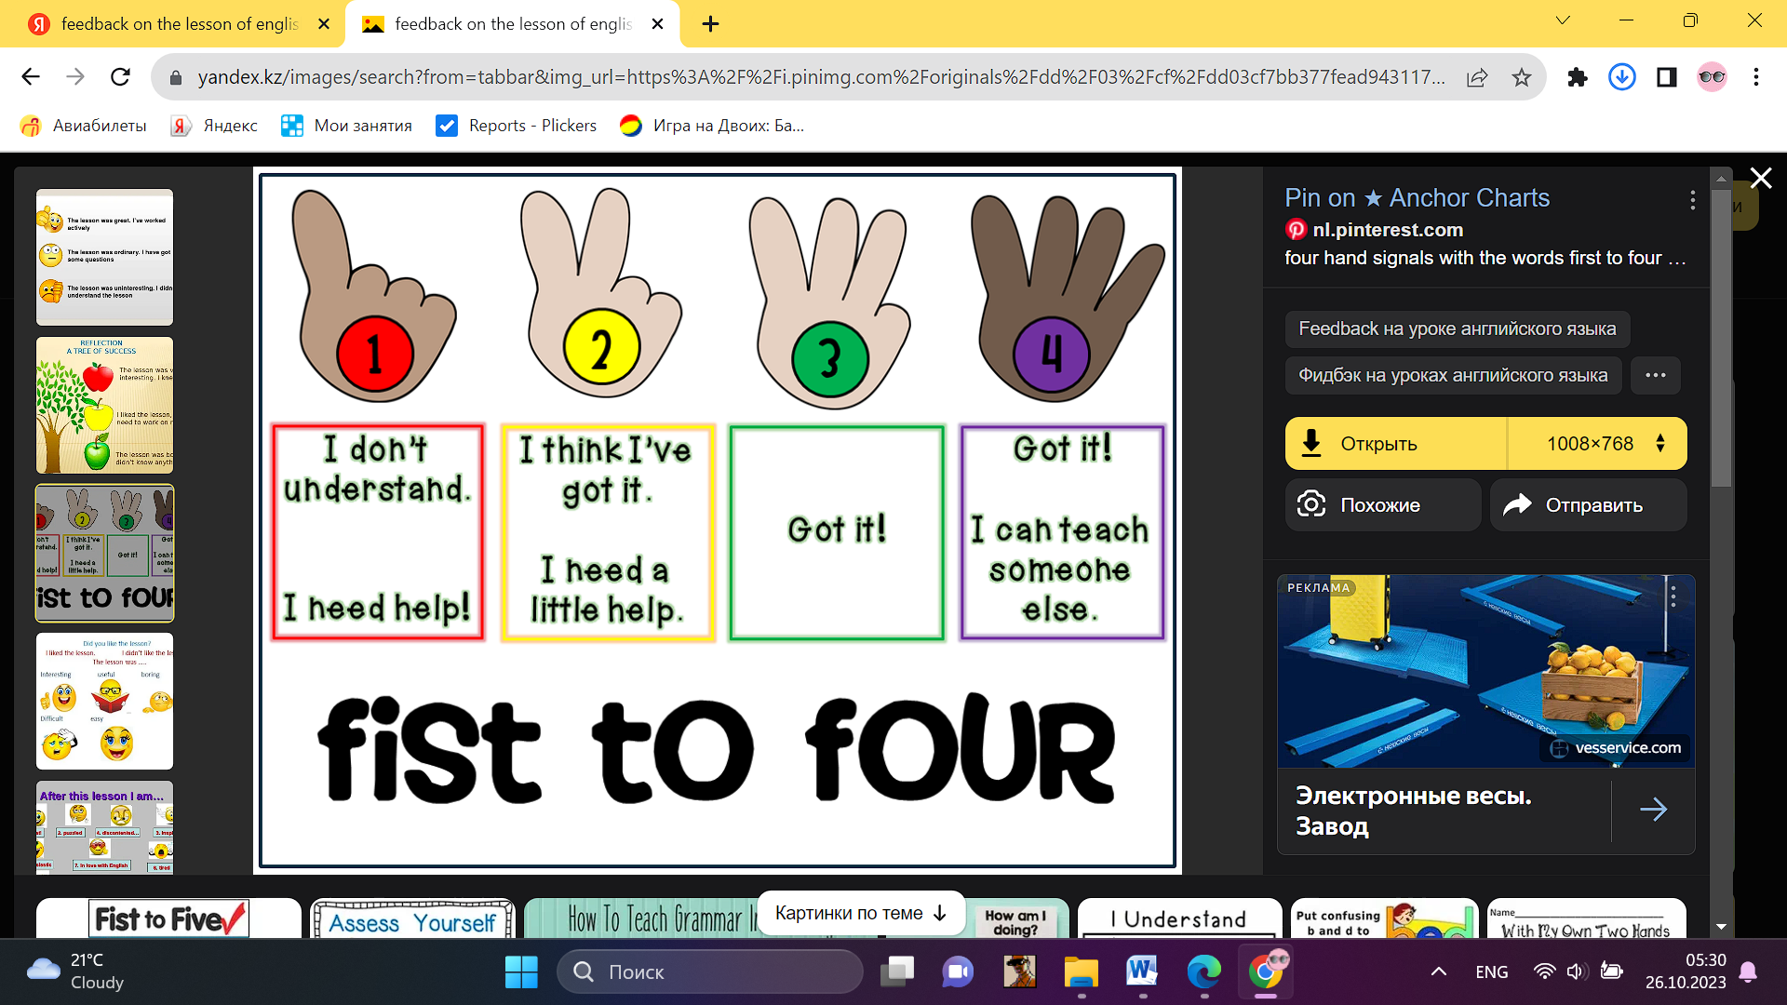 |  | Poster Success
Ex – 10. Typescript
He picked up poor Oliver by his shirt collar and began to shake him and beat him with his big stick then he took him
away and locked him in the cellar Oliver was cold and frightened and cried all night the next day Mr Bumble put a
notice on the door of the workhouse saying do you want a boy to learn a useful job we will give £5 to anyone who
takes him away for a week Oliver stayed alone in the cold dark Cellar and it was the worst week of his life poor Oliver cried all day and at night he couldn't sleep because he was cold unhappy and hungry

