LESSON: |  |  | School: #2
Date: 24.02 |  |  | Teacher name: Murtazina AT
CLASS: 3 A |  |  | Number present: |  | absent:
Learning objectives(s) that this lesson is contributing to |  | 3.R5 understand the main points of simple sentences on familiar topics by using contextual clues  3.R1 read and spell out words for others  3.S3 use a limited range of basic words, phrases and short sentences to describe objects, activities and classroom routines  3.S1 make basic statements related to personal information, people and objects on familiar topics and classroom routines
Lesson objectives |  | All learners will be able to:
 |  | identify some specific information in the text correctly and use some target language correctly in spoken and written production tasks with support
Most learners will be able to:
identify most specific information in the text correctly and use a range of target language correctly in spoken and written production tasks with support
Some learners will be able to:
identify all specific information in the text correctly and use a range of target language correctly in production tasks with little support
Previous learning |  | Question tags
Plan
Planned timings | Planned activities |  |  | Excel  Resources |  | Teacher  Notes
Beginning the lesson  6 min  2 min  Main Activities  3 min  7 min  2 min  6 min 26  3 min  7 min 36 | Org. moment  Greeting  Proverbs  - An apple a day keeps the doctor away.  - You are what you eat.  - A healthy mind in a healthy body.  Phonetic drill  - [i:] - cheeks, heel, knee, meat, eat, tea, clean, please  - [e] – health, healthy, bread, head, ready  - [d] - doctor, head, hand, should, shoulder  - [t] - foot, feet, tablet, vitamin  I. To describe pictures and predict the content of a text  Pre-reading  Direct Ss’ attention to the pictures and ask various  Ss around the class to describe them.  Elicit how many Ss have been to a street market.  - Look at the picture and try to say what we are going to talk about?  - Possible answers:  Student 1: I can see vegetables.  S 2: I can see fruit.  S 3: I can see burgers and pizza.  - Okay. Today we’re going to make a conversation about “Healthy lifestyle”.  II. New vocabulary.  Health [ helθ ] денсаулық  Good health – жақсы денсаулық  Bad health – жаман денсаулық  To do exercises – жаттығулар жасау  To keep fit – формада болу  To be on a diet – диета ұстау  Fruit [ fruːt] жеміс  Vegetables [ˈvedʒɪtəbəlz] көк-өністер  Healthy food – Пайдалы тамақ  Junk food – Зиянды тамақ  Now let’s check how you remember the words. Match the words from new vocabulary to the pictures.  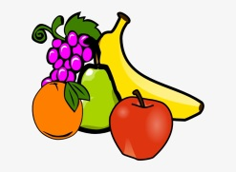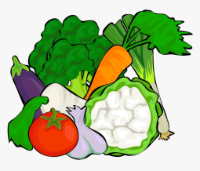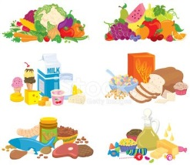  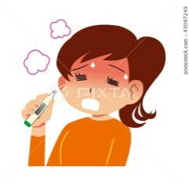  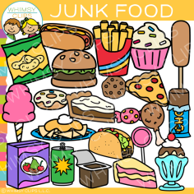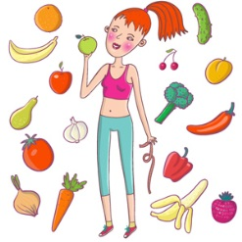  Assessment.  III. Now let’s watch the video about Good habits:  https://youtube.com/watch?v=UxnEuj1c0sw&feature=share  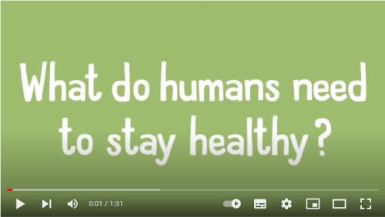  Now let’s play the game “Which one is healthy?” by watching the video.  https://youtu.be/GnfTHsdTodA  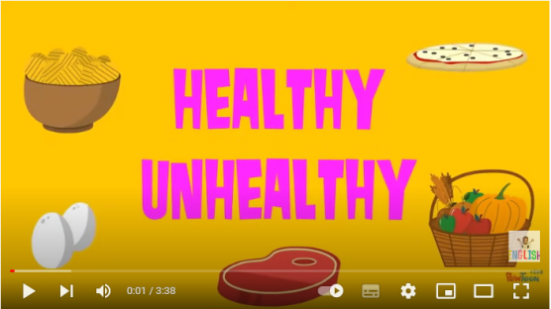  Assessment  IV. Now let’s remember the modal verbs.  T.: Modal verb must means that you are obliged to do something.  Must translates as “істеу қажет”  Mustn’t translates as “істеу қажет емес”  Let’s do an exercise.  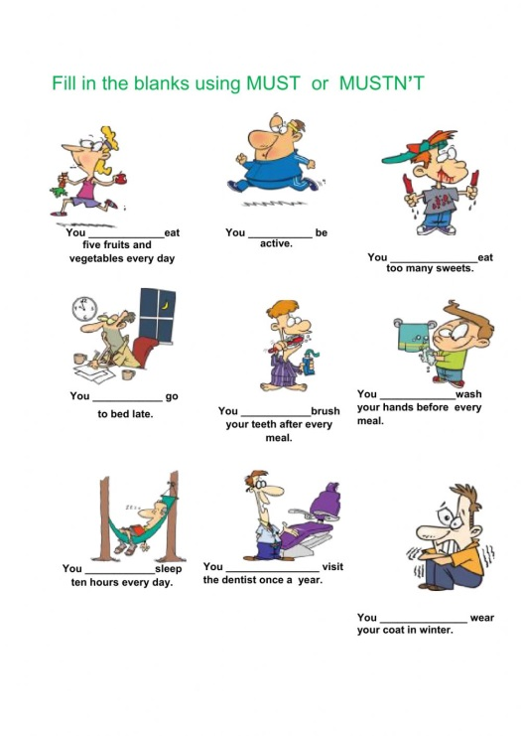  Assessment  https://learningapps.org/display?v=p0o32206a22  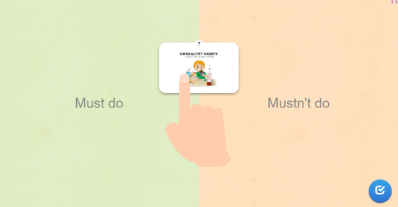  Assessment
Ending the lesson | To learn new words and new grammar.  Feedback  For each task the teacher gives 1 point and at the end the teacher will count all the points.  Criteria-based assessment is known.  1-4 points – “3”  5-7 points – “4”  8-10 points – “5”

 | Additional information
Differentiation – how do you plan to give more support? How do you plan to challenge the more able learners? |  | Assessment – how are you planning to check learners’ learning? |  | Cross-curricular links  Health and safety check  ICT links  Values links
provide support for writing task by providing less able learners with sentence starters |  | check answers in comprehension task using thumbs up or down technique and follow-up questions
 | monitor and challenge more able learners to justify their opinions in group task with probing questions | monitor pronunciation of new vocabulary in paraphrasing task and highlight any word-stress errors to board
 | Reflection  Were the lesson objectives/learning objectives realistic?  Did I stick to timings?  What changes did I make from my plan and why? |  | Answer the most relevant questions from the box on  the left about your lesson.

