|  |  |
| --- | --- |
|  | **Карточка ______________________** |

Реши примеры и расшифруй слова:

|  |  |  |  |  |  |
| --- | --- | --- | --- | --- | --- |
|  |  |  |  |  |  |
|  |  |  |  |  |  |

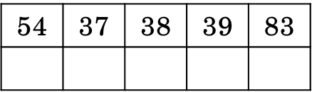 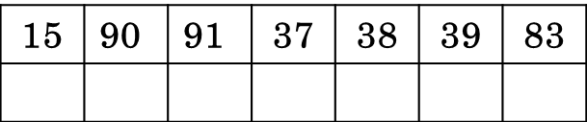



|  |  |
| --- | --- |
|  | **Карточка ______________________** |

Реши примеры и расшифруй слова:

|  |  |  |  |  |  |
| --- | --- | --- | --- | --- | --- |
|  |  |  |  |  |  |
|  |  |  |  |  |  |

 

