Бекітемін______________
мектеп директоры
Т.К.Кадыров

Ашық сабақ
Тақырыбы: Our planet`s treasure

Сынып: 4 г
Пән мұғалімі: Алимкулова А.М
Өтетін орны. № 32 кабинет
Мерзімі.22.11. сағ.11.40

2022-2023 оқу жылы

Unit: 3 | Treasure and heritage
Teacher name: | Alimkulova A.M
Date: | 22.11.2022
Grade:4 ”G” | Number present: 22 | Number absent: -
Lesson title: | Our planet’s treasure
Learning objectives | 4.S5 pronounce an increasing range of words, short phrases and simple sentences intelligibly  4.R3 recognize basic opinions in short, simple texts on an increasing range of general and some curricular topics  4.W4 write with support a sequence short sentences in a paragraph to give basic personal information 4.UE4 use determiners a, an, the, zero article to refer to things on a growing range of general and some curricular topics
Lesson objectives | Speak to provide sensitive feedback about our planet`s treasure.  Read and understand the main our planet`s treasure.  Use the indefinite and the definite article correctly in sentences.
Assessment criteria | Provide sensitive feedback about our planet`s treasure.  Explain and justify their own point of view about our planet`s treasure  To talk about natural features.
Level of thinking skills | Knowledge  Comprehension

Stages/Time | Teacher's actions | Students` actions | Assessment | Resources
Start | ORGANISATION MOMENT:  The lesson greeting  -Good morning children! How are you?  -I’m glad to see you  -Sit down please!  -What date is it today?  - What day of the week is today?  -What is weather like today?  Ok, if you are ready let’s start our lesson  Asking home task from previous lesson: learn numbers  Check the numbers with an umbrella by playing the game "Rain go away"  Well done!  Girls and boys let`s look at these pictures!  What can you see in these pictures?  What do you think? What are going to talk about today?  Well, today we are going to talk about Our planet’s treasure.  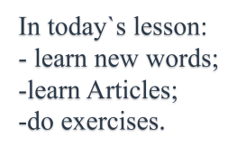 | Students respond to greeting and take their places  Students come to the blackboard and say numbers.  Pupils repeat the new words after the teacher | Formative assessment  ‘excellent’  ‘well done’  ‘good job’ | Books  Copybooks  Interactive board  Activity book  https://youtu.be/tdgQ5P1Qec0
Middle  End | MAIN PART  Our new words listen and repeat:  Write down the new words in your vocabulary  Waterfall- |ˈwɔːtəfɔːl|- сарқырама  Rainforest-|ˈreɪnfɒrɪst|-тропикалық орман  Desert -|ˈdezət| - шөлдала  Ocean- |ˈəʊʃn|- мұхит  Island- |ˈaɪlənd|- арал  Mountain- |ˈmaʊntɪn| - тау  River- |ˈrɪvə|- өзен  Lake- |leɪk|- көл  Very good!  Let1s play the game called “Wonderful doors ”  Well done!  Let`s take a virtual travel to different parts of the world.  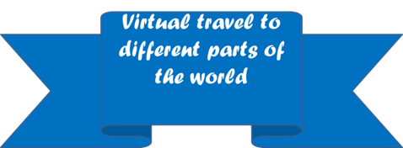  Which places would you like to visit?  Exercise 15 Read and choose the right word. They decide if the sentences are True or False. Correct the false statements.  Individual work  1.Part of the Amazon____Is in Mexico. True/False  A. rainforest B. river  2.Niagara Falls is a___. Part of it is in Canada. True/False  A. waterfall B. desert  3.Syr Darya is a____in Kazakhstan. True/False  A. rainforest B. river  4.Baikal is a _______in Egypt. True/False  A. river B. lake  5. Khan Tengri is a _____ in Kazakhstan. True/False  A. desert B. mountain  6.The Pacific ____is the largest in the world. True/False  A. Ocean B. Lake  Functional literacy question.  ‘The world is a great book, and those who do not travel read only one page.’ ‘St. Augustine’  What do think about this statement?  Do you agree with it?  Have a rest  Clap Your Hands  Clap, clap, clap your hands,  Clap your hands together.  Stamp, stamp, stamp your feet,  Stamp your feet together.  Touch, touch, touch your ears,  Touch your ears together.  Touch, touch, touch your cheeks (щеки),  Touch your cheeks together.  Shake, shake, shake your hands.  Shake your hands together.  Smile, smile at your friends,  Let us smile together.  Guys, we are going to talk about an Articles today.  What is it an Article?  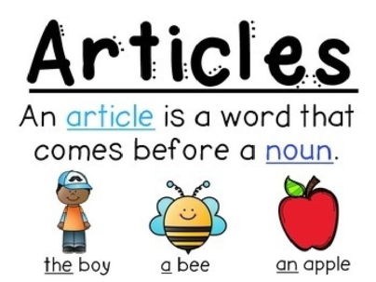  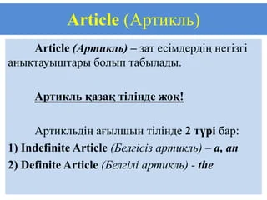  Do exercise to revise articles a, an, the:  Choose correct answers  Exercise 16  1.We visited ___ Turkey this summer!  A. a B. an C. the D. –  2. My uncle lives on ____ island in Italy.  A. a B. an C. the D. –  3. Where`s ____ Aralkum Desert?  A. a B. an C. the D. –  4 Malta is ____ small country in Europe.  A. a B. an C. the D. –  5. He bought a house near ____ Lake Baikal.  A. a B. an C. the D. –  Children must write articles where it is necessary.  ENDING THE LESSON:  Well, what did we do in our lesson?  Which places would you like to visit?  Reflection  The lesson was interesting.  Give me your emoticons.  Evaluation of the lesson  Give the home task  Home work  Ex 17 p 43 | Pupils watch the pictures to understand the theme correctly  Pupils do the quiz. They should read the sentences and find out the right variant then choose True/False  Pupils look at the board and listen to the teacher carefully to learn the grammar  Children talk and answers questions.  Pupils read and choose the right variant  Pupils answer to some questions to know how they understand the lesson  Pupils tell the class if they understand today’s lesson | Feedback  ‘super’  ‘brilliant’  ‘very well’  ‘excellent’  ‘good job’  ‘brilliant’ | Interactive  boards  https://youtu.be/emcKXT0ShZ4  Board  https://youtu.be/tdgQ5P1Qec0

