Unit of a long term plan: Creativity |  |  |  |  | School: №13 named by Navoi
Date: |  |  |  |  | Teacher’s name: Sulaimanova D
CLASS: 5 |  |  |  |  | Number present: |  | absent:
Lesson title |  | Music
Learning objectives(s) that this lesson is contributing to (link to the Subject programme) |  | 5.S4 respond with limited flexibility at sentence level to unexpected comments on an increasing range of general and curricular topics  5.S6 communicate meaning clearly at sentence level during, pair, group and whole class exchanges  5.R1 understand the main points in a limited range of short simple texts on general and curricular topics  5.UE3 use a growing variety of adjectives and regular and irregular comparative and superlative adjectives on a limited range of familiar general and curricular topics
Level of thinking skills |  | Higher order thinking skills
Lesson objectives |  | All learners will be able to: use comparative and superlative adjectives in answering the questions related to the text in group work  Most learners will be able to: use comparative and superlative adjectives in answering the questions related to the text with a little support.  Some learners will be able to: justifies the answers the question using comparative and superlative adjectives independently.
Assessment criteria |  | - Answer a variety of questions at sentence level with limited flexibility.  -Interact in class exchanges to identify the main idea in the text.  -Identify the attitude and opinion of the author and apply the rule for comparative and superlative adjectives in oral speech.
Values links |  | The strategy “Mangilik Yel”. To invite students to manage their time appropriately. To respect art crafts and heritage of our ancestors.
Cross-curricular links |  | Music, Art, languages
Previous learning |  | In previous lessons students have learned how to write coherent paragraphs about musical instruments and the sections of an orchestra.
Plan
Planned timings | Planned activities (replace the notes below with your planned activities) |  |  |  |  |  |  | Resources
Start  5min | Org. moment: a) Greetings;  b) Duties’ report  Introducing lesson objectives to the learners  Warm up: Make a circle sing a song “I’m so happy” and guess the theme of the lesson.  Dividing into two groups: Teacher divides learners into 2 groups with the help of magic sticks. Students who has marked sticks will be the first group, named piano and the second group will be violin. |  |  |  |  |  |  | Picture, sticks
Middle  25min | Presentation: Brainstorming strategy  (G)Task 1 How do you understand these words of famous people about music? “Music is the universal language” (Longfellow)  Teacher: What does the role of music in your life?  What do you feel when you listen to music?  AFL – Oral feedback  Revision of previous theme: Activity –Project work  - Teacher asks to write the names of musical instruments.  - Pupils were given tasks to prepare project works about styles of music  (I)Task 2  Each objectives has a comparative and superlative form. In each now, write two missing words and make a sentence.  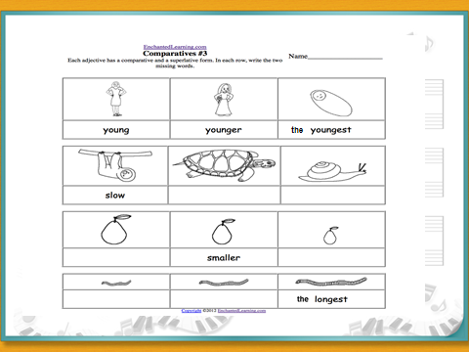  Descriptor: A learner  - writes the missing words.  - makes a sentence.  AFL – Numbers speak  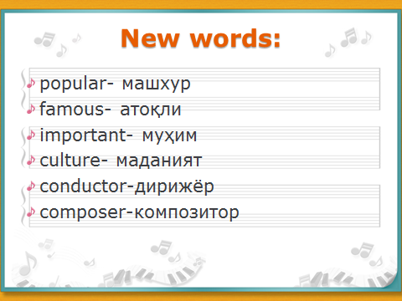  Task 3  (G) Activity -Jigsaw  Pre-reading: Teacher asks questions:  Look at the pictures. What do you see? What about will be the text.  Read the text and find the adjectives and give comparative and superlative form and answer the questions.  - group : the text about Gaziza Zhubanova  - group: the text about AkhmetZhubanov  Descriptor: A learner  - Reads the text  - Finds out adjectives  - Gives 3 forms of the adjective  - Answers the questions using the appropriate information from the text  AFL – Reflection Target  Let’s have a rest by listening to music- your classmate Ziyoda will play on the keyboard  Task 4 Ex 4 p78  Listening task .Listen and choose the correct answer  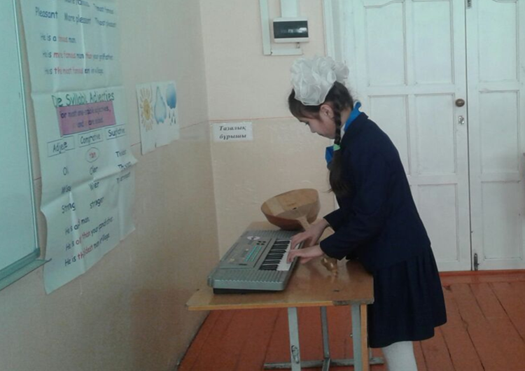  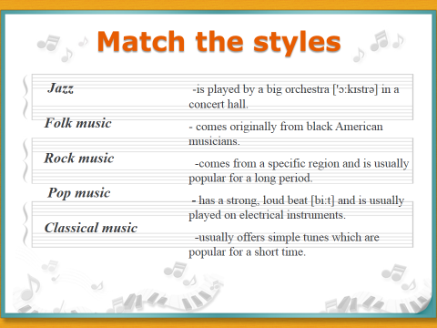 |  |  |  |  |  |  | pictures, cards  English plus 5, active board
End  10min | Conclusion: Pupils describe the famous singers with the help of superlative adjectives.  For. ex: M. Jackson is the most famous singer in the world.  Assessment:  Teacher assesses learners after each task through support, encourages and oral comments.  Feedback: Teacher asks learners to use weather to give their opinion about the lesson.  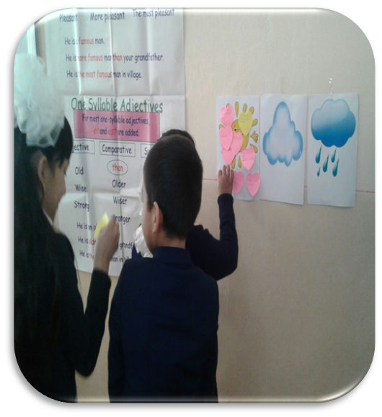 |  |  |  |  |  |  | Sunny Cloudy Rainy  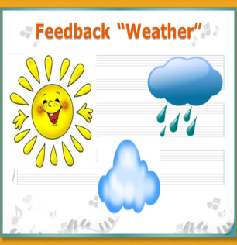
Additional information
Differentiation – how do you plan to give more support? How do you plan to challenge the more able learners? |  |  |  | Assessment – how are you planning to check learners’ learning? |  | Health and safety check
More support can be given at the start a from the video and the middle of lesson by providing less-able learners with picture and prepared parts of the words so they can make up sentence .  By asking questions, with the help of game. |  |  |  | With the help of support, encourages and oral comments and stickers with smiles. |  | Health saving technologies.  Using physical exercises and active activities.  Rules from the Safety Rules book which can be applied in this lesson.
Reflection  Were the lesson objectives/learning objectives realistic?  Did all the learners achieve the lesson objectives/ learning objectives? If not, why |  |  | Use the space below to reflect on your lesson. Answer the most relevant questions from the box on the left about your lesson.
Summary evaluation
What two things went really well (consider both teaching and learning)?
1:
2:
What two things would have improved the lesson (consider both teaching and learning)?
1:
2:
What have I learned from this lesson about the class or individuals that will inform my next lesson

Түркістан облысы, Түркістан қаласы
Әлишер Науаи атындағы №13 мектеп-
гимназияның ағылшын тілі пәні мұғалімі
Сулайманова Дильфуза Асатууллаевна

